- 選擇題：請將答案畫記於答案卡。 同時請於卡上畫記班級、座號。
Listening Comprehension Test (10%)
第一部分：看圖辨義(2%)
試卷上該題有一張圖片，請聽一個和該題相關的問題，與(A)、(B)、(C)三個英語敘述後，選一個與所看到圖片最相符的答案。
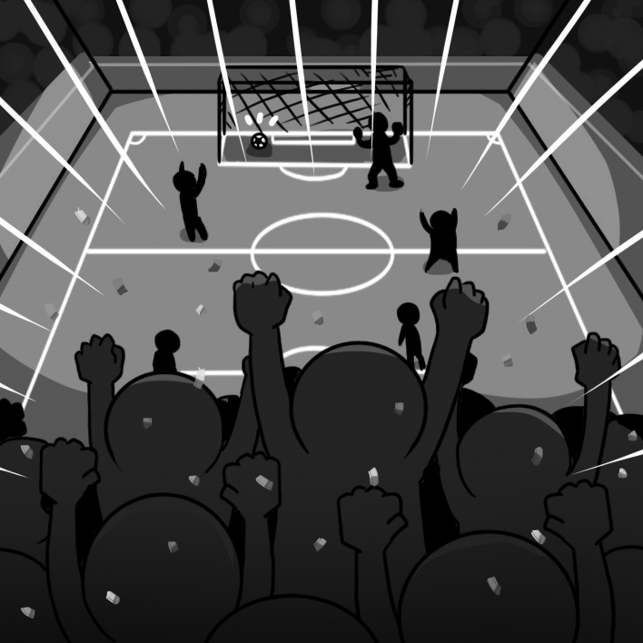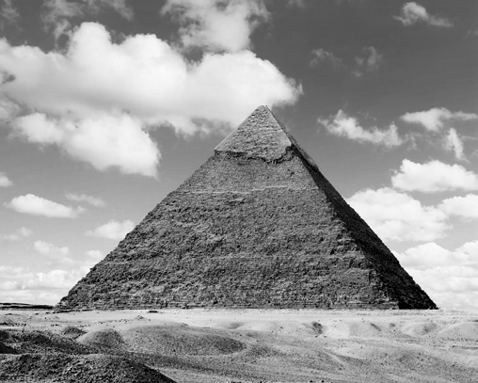
1. ______ 2_______

第二部分：問答(3%)
每題會播出一個問句或直述句，聽後請由試卷上(A)、(B)、(C)三個選項中，選出一個最適合的回答或回應。
3. ( ) (A) What an eager fan you are!
(B) How quickly the game ended!
(C) How amazing the team was!
4. ( ) (A) He did it with faith and determination.
(B) He finished it because of his physical disability.
(C) He completed it after he studied mathematics.
5.( ) (A) They will raise the roof.
(B) They get a small sum of prize money.
(C) They must be very keen to win.
第三部分：簡短對話(3%)
每題會播出一段對話及一個相關的問題，聽後請由試卷上(A)、(B)、(C)三個選項中，選出一個最適合的回答。

6. ( ) (A) A high school student.
(B) A university student.
(C) A designer.

7. ( ) (A) The speakers’ team won.
(B) The speakers’ team will go to the next round.
(C) The speakers’ team lost.
8. ( ) (A) It took over one hundred years to build.
(B) You can’t go to the top of it.
(C) When people see it, they think of France.
第四部分：短文聽解(2%)
每題有三個圖片選項。請聽題目，並選出一個最適當的圖片。
9. _______
(A) (B) (C)
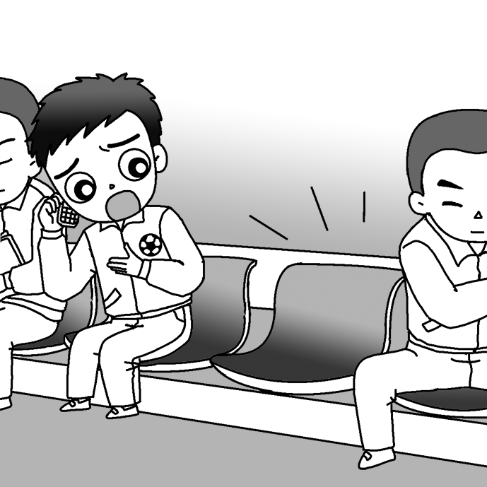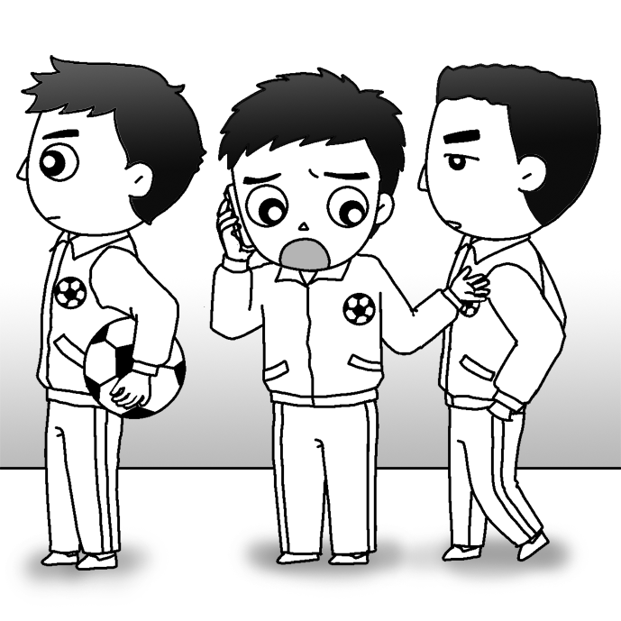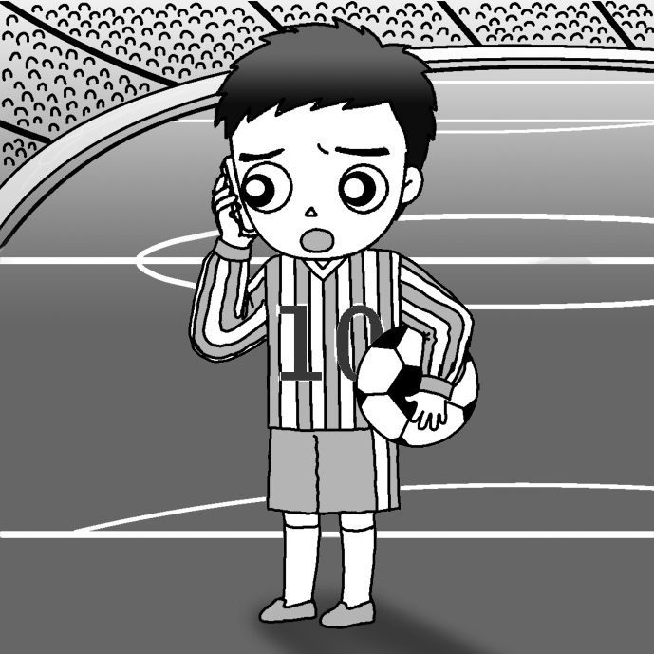

10. _______
(A) (B) (C)
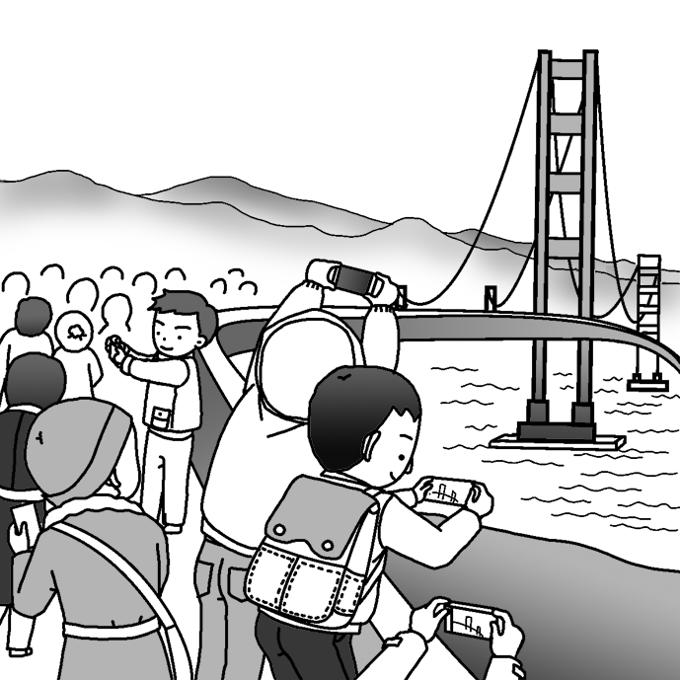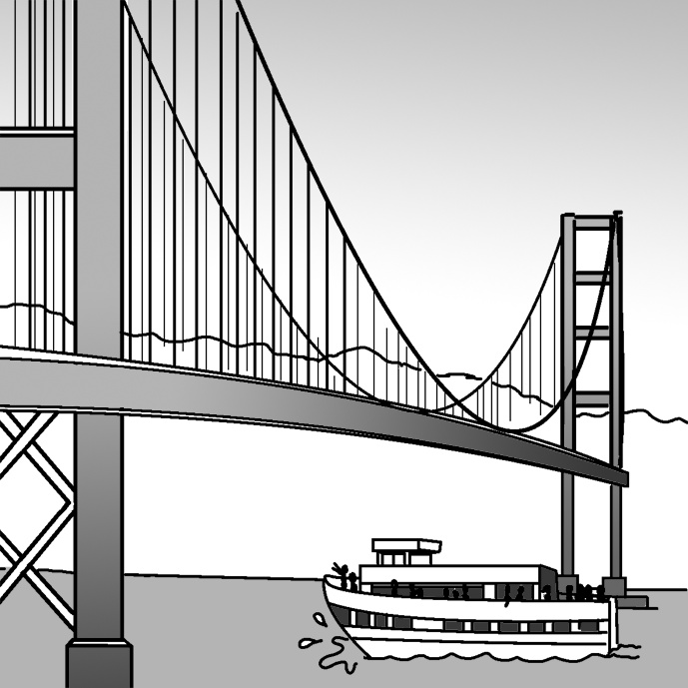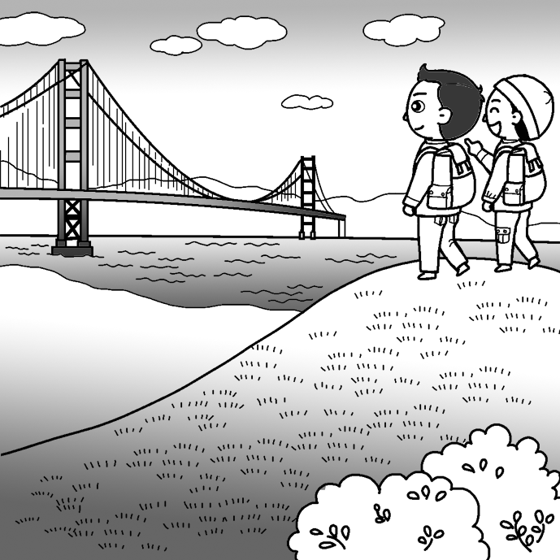

- 克漏字選擇10%(每題2分)
The Brooklyn Bridge is one of the most famous constructions in the world. Yet, during the 11. of building it, several accidents happened. Some engineers and workers died in the accidents, including John Roebling. Later, John Roebling’s son, Washington, also got seriously injured. 12. , he could neither talk nor walk. People at that time thought that the Roeblings would stop the construction project. Luckily, with the great help of Emily, Washington’s wife, the bridge 13. after 13 years. 14. you go to New York City, besides seeing the Statue of Liberty, do visit the Brooklyn Bridge. It is a 15. to the Roeblings’ great spirit and determination. Without their sacrifice, people living in Manhattan and Brooklyn might still cross the East River by boat.
( B ) 11. (A) disability (B) process (C) communication (D) code
( C ) 12. (A) Nevertheless (B) Instead (C) As a result (D) However
( A ) 13. (A) had completed (B) was completed (C) completed (D) is completed
( D ) 14. (A) Where (B) How (C) Which (D) When
( D ) 15. (A) dream (B) goal (C) connection (D) tribute

III. 單字選擇 5% (每題2分)
( )16 | Wow, your new haircut goes with your face perfectly!
 | (A) amazes | (B) entertains
 | (C) matches | (D) gains
( )17 | Kathy accepted a prize for returning the lost wallet to its owner.
 | (A) offered | (B) received
 | (C) gave | (D) expected
( )18 | Doctors believe that there is a close between smoking and lung cancer.
 | (A) construction | (B) connection
 | (C) collection | (D) selection
( )19 | It is almost to protect children from the influence of TV. It’s everywhere!
 | (A) likely | (B) fantastic
 | (C) impossible | (D) stressful
( )20 | You have to have trust in yourself. It’s the key to solving(解決) problems.
 | (A) doubt | (B) test
 | (C) pressure | (D) faith

- 文法選擇 30% (每題2分)
( )21 | No other in the world is taller than this building.
 | (A) buildings |  |  | (B) one building
 | (C) building |  |  | (D) the buildings
( )22 | I spoke loudly let everyone easily hear what I was saying.
 | (A) so as to |  | (B) because of
 | (C) due to |  | (D) so that
( )23 | Vicky is girl that I have ever seen. When I first met her, it was love at first sight.
(A) a most beautiful (B) a more beautiful
(C) the most beautiful (D) the more beautiful
( )24 | No other student studies as as Doris.
 | (A) hardly | (B) harder |  | (C) hard | (D) so hard
( )25 | As soon as the nervous singer foot on the stage, the crowd silent.
 | (A) set; will go | (B) set; went |  | (C) sets; went | (D) will set; will go
( )26 | Mr. Brown stopped at the gas station get some drinks and food.
 | (A) so that | (B) in order |  | (C) as a result of | (D) so as to
( )27 | Selina won the first prize in the singing contest. fantastic she was!
 | (A) What |  |  | (B) When
 | (C) How |  |  | (D) Who
( )28 | a wonderful thing it would be to travel around the world!
 | (A) How | (B) Why |  | (C) Which | (D) What
( )29 | Jessica ran to the fridge to look for new snacks as soon as she home.
 | (A) got | (B) gotten |  | (C) gets | (D) getting
( )30 | lovely the newborn baby is!
 | (A) Which | (B) What |  | (C) How | (D) Why
- 對話選擇 10% (每題2分)
( )36. Andy: It’s never easy to plan a trip.
Tom: You’re right. You need to learn about the place you are visiting.
Andy: That’s why I bought this book.
(A) It teaches you how to make pancakes.
(B) It tells a story of determination.
(C) It recommends many tourist spots.
(D) It includes many ways of improving English conversation skills.
( )37. Neil: Have you been to New York City?
Ted: Yes. It’s a fantastic city. Also, the climate is cool.
Neil: Well, I plan to go there next week.
Ted:
(A) I’m very sorry to hear that. 我很遺憾聽到這件事。
(B) I have no idea what that is.
(C) I think you should cross the river.
(D) I think you’ll have a good time there.
( ) 38. Susan: Nina, why do you often go abroad for sightseeing?
Nina: I really love to meet new friends and have different experiences.
(A) Well, it’s because the climate is mild.
(B) Not necessarily. It’s also fun to stay home.
(C) Oh, there is so much to see in the world.
(D) Really, I have never thought about that.
( )39. Meg: I don’t know what to buy for my mother’s birthday.
Gary: How about giving her something that you make yourself? It would be more special and valuable, don’t you think? don’t you think為反問法，提問者本身已預設了答案。
Meg: That’s a great idea! Thanks!
(A) I never thought of that. (B) You have to stop worrying me.
(C) What else did you buy? (D) Are you coming to my house?
( )40. Andrew: How many days are you staying in Tokyo?
Tony: Five. But I don’t think that’s enough.
Andrew: Well, next time you can stay longer! Enjoy your trip!
Tony: Thanks.
(A) You can say that again. 你說的對極了。 (B) There’s so much to see.
(C) It’s too crowded. (D) I will buy you a present.

閱讀測驗 10% (每題2分)

Do you know that humans can smell far more substances than they can taste? In one experiment, British scientists gave a group of people various food. Their eyes were covered and their noses were blocked. The test subjects were given tastes of foods and drinks such as coffee, chocolate, honey, and garlic. To those scientists’ surprise, none of the subjects were able to identify any of the food they tasted.
There is further evidence to prove this theory. You can even test it out for yourself. Next time you have a bad cold, close your eyes and try tasting different foods. You will most likey detect a total lack of flavor. That’s because the space behind your nose is filled with mucus, stopping the smells from getting through to your brain.
Realizing the importance of smells, many food producers add chemical smells to their food. Try to notice the tasty smell when you open a bag of potato chips. If you think that’s real cheese, onion, or chicken you are smelling, think again! But these smells make the food seem more delicious to our taste buds, and keep us wanting more.
Next time you eat some freshly baked bread, or take a bite of a big, juicy hamburger, think twice about why it tastes so wonderful!

Vocabulary:
substance 物質 test subject 受測者 evidence 證據 mucus 黏液
experiment 實驗 garlic 蒜頭 test …out 檢測 taste bud味蕾
block 阻塞 identify 辨別 detect 發現；察覺
( ) 41. What were the results of the British study?
(A) The subjects identified coffee, chocolate,honey, and garlic.
(B) The subjects preferred coffee to chocolate,honey, and garlic.
(C) The subjects were surprised about the flavor of coffee, chocolate, honey, and
garlic.
(D) The subjects didn’t know the difference between coffee, chocolate, honey, and garlic.
( ) 42. According to the article, what is the role of chemical smells in food?
(A) They can damage our taste buds.
(B) They have a major effect on the way food tastes.
(C) They make us think twice about which foods we will eat.
(D) They affect which chemicals we can taste in our food.
( ) 43. What will happen if you block your nose and then take a bite of chocolate?
(A) The chocolate will have a stronger smell.
(B) The chocolate will lack flavor.
(C) The chocolate will taste more like chemicals.
(D) The chocolate smell will stay in the passage behind your nose.
( ) 44. What does the author imply about bread and hamburgers at the end?
(A) They may not be very juicy.
(B) They may not be very delicious.
(C) They may contain chemical flavors.
(D) They may be less fresh than you think.
( ) 45. Which of the following is true based on the article?
(A) The coffee tastes better when you have a bad cold.
(B) Taking medicine will not influence the way you taste food.
(C) Some food tastes better because we add chemical to it.
(D) It’s not recommended to eat food with chemical smells.
請務必填寫考卷右上角的班級、姓名、座號，未寫扣5分。
- 非選擇題 (請作答於右半頁作答區)
A. 文義字彙 10% (請注意動詞變化、大小寫；每題2分)
1. This house is d ned to be very convenient and comfortable for the blind.
2. We can see many people pushing w y to get into the temple in order to plant the first incense stick on Lunar New Year’s Eve.
3. Applying to a university was an uneasy p s, but I finally completed it.
4. Patrick is good at sports, e y soccer.
5. P l appearance is something many teenagers care about, but they will find out that
inner beauty is more important.
B. 填空式翻譯 10% (請注意動詞變化；每題1分)
1. Paul，因為你不但勤勞又聰明，我確定你一定會實現進入研究所的夢想。
Paul, I’m sure you will (r) your (d) of entering
a graduate school because you are not only diligent but also intelligent.

2. 我們必須加快工作步調，快沒時間了。
We have to work against the clock. We are
time.

3. 一開始，我們不喜歡彼此。現在我們是最好的朋友。
In the (b) beginning , we didn’t like each other. Now, we are best friends.

4. 隨著汙染的問題愈來愈嚴重，愈來愈多人死於癌症。
As the problem of pollution is getting more serious, more and more people are _____ _____
cancer.

A. 文義字彙 10% (請注意動詞變化；每題2分)
1 | __________________ | 2 | __________________ | 3 | __________________
4 | __________________ | 5 | __________________

B. 填空式翻譯 10% (每題1分；每格只填一個單字)
1
2
3
4

C. 單字片語選填(選出最符合句意的單字或片語，並填入代號) 每題2分，10%
(A) pass on to | (B) in spite of | (C) kicked off
(D) yelling out | (E) ignored

( )1. Read the paper and ____ it ___ others. Share your opinions with one another.
( )2. The teacher’s voice cracked while she was _______“Be quiet!” to her students.
( )3. The celebration was ______ with a speech by the president of Taiwan.
( )4. Jack asked Rose out to see a movie last night, but Rose ___ the invitation and
did not show up.
( )5. Vincent has never given up the thought of becoming a painter _____all the
difficulties he has faced.

