市立新北高工108學年度第1學期英文第一次段考  老師： 班級： 語二甲乙 座號：______ 姓名：__________ | 分數欄
一、字彙與慣用語選擇(共15分,每題1分)
1. ( ) After a whole day’s work, Jacob is now taking the train; _____ back in the house, his wife is making dinner for him.
(A)unfortunately (B)rather (C)definitely (D)meanwhile
2. ( ) The username is already taken; please think up another to sign up for the _____.
(A)deal (B)background (C)comment (D)account
3. ( ) The critic _____ that there was nothing funny about the TV comedy.
(A)downloaded (B)remarked (C)filed (D)uploaded
4. ( ) The news about the bloody murderer gave me a _____ shock.
(A)remarkable (B)efficient (C)various (D)nasty
5. ( ) Unlike dogs and wolves that live on _____, horses and donkeys feed on plants.
(A)flesh (B)torture (C)commitment (D)anger
6. ( ) According to the law, companies have the right to cancel the memberships of those who _____ the terms of service.
(A)involve (B)switch (C)handle (D)violate
7. ( ) The National Palace Museum is _____ in the leafy suburb of Taipei City.
(A)sited (B)discovered (C)deleted (D)separated
8. ( ) Focusing on the screen for a long time is believed to be one of the major causes of decline in _____.
(A)comment (B)whisper (C)vision (D)robbery
9. ( ) _____ before getting into a marriage as not every relationship has a happy ending.
(A)Track down (B)Hit home (C)Drive off (D)Think twice
10. ( ) The office is _____ cold, so most people put on their jackets while doing their work.
(A)flat (B)shabby (C)due (D)freezing
11. ( ) Even though Miranda got 99 on the English test, she was not _____.
(A)content (B)worried (C)mutual (D)crucial
12. ( ) The _____ suitcase, after many years of use, has come to contain many happy memories.
(A)abusive (B)battered (C)frequent (D)chilly
13. ( ) Most people who die by _____ suffer from emotional problems or mental disorder.
(A)privacy (B)pregnancy (C)misery (D)suicide
14. ( ) The kind woman won 2 million dollars last month. Many of her neighbors said that it was a _____ from God.
(A)constancy (B)reward (C)vacancy (D)closure
15. ( ) The man sold his house to clear the enormous debts he _____ to the bank.
(A)owed (B)searched (C)chanted (D)repaid

二、綜合測驗(共15分,每題1分)
1. While I was driving on my way home, something wrong occurred to my car. Fortunately, a young man came to my ___16___ and fixed the problems. He was a real gentleman. When I asked him ___17___ I could repay his kindness, he just told me to help someone else in need. Later on, I went to a café to grab a bite and ___18___ the chill. A ___19___ waitress came to me and handed me a napkin to dry my wet hair. The warm smile on her face reminded me of the young man this morning. ___20___ that she was heavily pregnant and was still working, I left a huge tip on the table. I hoped that money could do her good and that she would help others in the way I helped her.
(16) ( ) (A) aid (B) blur (C) advantage (D) justice
(17) ( ) (A) why (B) how (C) which (D) that
(18) ( ) (A) pull up (B) roll down (C) come over (D) take off
(19) ( ) (A) creative (B) depressed (C) thoughtful (D) unemployed
(20) ( ) (A) Seen (B) Seeing (C) To see (D) Having seen
2. Many people rely on the Internet for daily activities such as banking and shopping. Most of the time, it is safe and easy. ___21___, there are some people who misuse technology and try to cheat others through dishonest means. A common trick is sending you an e-mail that seems ___22___ from your bank. This e-mail informs you that the bank has renewed its online services and asks you to click on a link to fill in your personal information. The bad news is the link will direct you to a fake ___23___. Once you enter your details, you will probably lose all the money in your ___24___.
Another common trick is selling something that looks completely different from those shown on their advertisements. Pictures do not always reveal the truth. By the time you ___25___ the trick, it is already too late. If you are buying goods over the Internet, make sure you are buying from a trusted source. Remember not to include your credit card information in an e-mail, and do not choose easy passwords such as your telephone number. Keep watch when shopping online if you don’t want to fall in the traps.
(21) ( ) (A) Meanwhile (B) However (C) Definitely (D) Miserably
(22) ( ) (A) come (B) coming (C) to come (D) to coming
(23) ( ) (A) site (B) clue (C) switch (D) comment
(24) ( ) (A) agency (B) background (C) account (D) bully
(25) ( ) (A) remark (B) record (C) delete (D) discover
3. “Let us be grateful for love by loving others.” These are the words of Mother Teresa, the great woman ___26___ devoted much of her life to charity work.
Ever since she was a little girl, Mother Teresa ___27___ up her mind that she wanted to help the poor. At 18, she joined the Roman Catholic Sisters and moved with them to Calcutta, India, where she began her lifelong mission. When she first arrived, she taught in a school ___28___ with poor children. Later, she spent her days feeding the hungry and taking care of the weak. Mother Teresa founded hundreds of schools and houses for helpless children ___29___ parents to look after them. When Mother Teresa ___30___ the end of her days, many were trying to find out the reason why she was so keen on helping people. Her answer was always the same—“the love of God.” In her, one sees strong faith and unfailing love.
(26) ( ) (A) who (B) whom (C) which (D) one
(27) ( ) (A) made (B) was making (C) had made (D) had been making
(28) ( ) (A) fill (B) filled (C) filling (D) to fill
(29) ( ) (A) with (B) through (C) without (D) from
(30) ( ) (A) abused (B) tortured (C) rewarded (D) approached

三、文意選填(共10分,每題1分)
“After Twenty Years” is a short story written by O. Henry. It begins with a policeman making his rounds to ensure everything is secure. Because of the ___31___ wind and the cold winter rain, there are few people on the street that night. The police officer notices a ___32___ figure standing in the dark doorway. In the ___33___ light of a lamp, the man tells the officer that his name is Bob and that he is waiting for his friend Jimmy Wells. Bob adds that twenty years ago when they parted as young men, they promised to meet at the place again. Back then they had different pursuits in life: While Jimmy felt ___34___ with the life in New York, Bob decided to travel out west to seek great wealth. Hearing this, the officer ___35___ away without saying a word.
Afterward, Bob is ___36___ by another man whom he believes is Jimmy. He gives the man details about his success in the West. While they are walking to find a place to eat, a bright light shines on the man's face. Bob then ___37___ it is another police officer. The officer arrests Bob for the crimes he committed in Chicago and ___38___ hands him a note from Jimmy. It says that the two friends did meet on time; ___39___, one has become a criminal. “After Twenty Years,” like many other short stories by O. Henry, has a ___40___ ending. Though both men start at the same place, their lives reach toward different directions.
(A) towel (B) blurred (C) trunk (D) approached (E) dim (AB) chilly
(AC) content (AD) surprising (AE) however (BC) later (BD) slides (BE) realizes
31. _____ 32. _____ 33. _____ 34. _____ 35. _____
36. _____ 37. _____ 38. _____ 39. _____ 40. _____

四、閱讀測驗(共20分,每題2分)
1. When Juan Mann returned home to Australia from London, he was not happy. His friends now lived across the world. His parents had ended their marriage. He had just broken up with his girlfriend. And his grandmother was ill. Then some miracle happened and turned
Juan’s frown into a smile — somebody hugged him. It was at the moment that Juan realized the great power of a warm embrace. Afterward, he made a sign that read FREE HUGS and walked each day through crowded areas, hoping to brighten a few people’s day. He never expected what would happen next.
People started helping Juan give out hugs. Then a band made a music video about Juan’s mission. It quickly spread over the Internet and people around the world started making their own signs to give out free hugs to people in their own cities. Juan Mann was even invited to appear on a popular TV talk show to talk about what he had started—he called it the Free Hugs Campaign.
Since then “FREE HUGS” signs have appeared in different languages around the globe. In October 2006 one even appeared in Taiwan. A university boy wandered the streets of Taipei giving hugs to anyone that didn’t run the other way. An annual International Free Hugs Day is now celebrated on the first Saturday in July.
Juan Mann is happy about what he has started, but doesn’t want people to focus on him. He believes that the campaign isn’t about him, but rather about brightening someone’s day by giving them a hug.
(41) ( ) The passage is most likely to appear in the ______ page of a newspaper.
(A) business (B) technology (C) society (D) sport
(42) ( ) According to the passage, free hugs were originally given to ______.
(A) make a music video
(B) increase exposure and popularity
(C) make other people happy
(D) increase video views on the Internet
(43) ( ) Which of the following is true about Juan Mann?
(A) He never felt depressed in his life.
(B) His parents got divorced.
(C) His parents made him realize the beauty of a hug.
(D) He always wants to be the center of attention.
(44) ( ) The word “annual” in the third paragraph is closest in meaning to ______.
(A) seasonal (B) occasional (C) monthly (D) yearly
(45) ( ) According to the passage, which of the following is NOT true about the Free Hugs Campaign?
(A) It was started by Juan Mann and his girlfriend.
(B) It became popular in many different countries.
(C) It was started in Taiwan by a university student.
(D) It is celebrated worldwide on a specific day.

2. It’s Christmastime. You go to the mall to shop for gifts. When you try to pay for the presents using your credit card, the clerk returns your card and tells you, “Your card has been rejected.” You ask the clerk to try again. The results are still the same. Embarrassed, you go home and find in the mail a letter that says you’ve just bought a house.
In fact, you’ve have fallen victim to identity theft (ID theft). That is, someone has stolen your identity and uses your personal information to commit crimes. You will be surprised to know it is rather easy to carry out ID theft. For example, someone could go through your trash, find a credit-card bill, copy some crucial details, and go on a shopping spree until your credit limit is reached. Even worse, they can also steal your driver’s license, passport, or even medical reports to achieve the goal.
ID theft costs people worldwide millions every year, but money isn’t the only issue here. If you’ve been a victim of ID theft, it’s hard to get companies and banks to trust your credit again. Thus, it’ll be more difficult for you to apply for loans. There are also other privacy issues to worry about.
So what can you do to prevent your identity from being stolen? For one, always tear up documents you throw into the garbage can—especially those with your personal information. Second, never give away private details in any informal occasion or to unknown website. Third, use the same credit card for all your Internet deals. Last, review your credit-card statements carefully. If there’s anything fishy, call your banks right away. Be on your guard and protect yourself from being taken advantage of.
(46) ( ) The passage is mainly about ______.
(A) file management (B) financial crimes
(C) bank credit advice (D) online shopping experiences
(47) ( ) According to the passage, “identity theft” is ______.
(A) the spreading of nasty rumors (B) a form of online bullying
(C) the stealing of personal details (D) a form of physical attack
(48) ( ) The word “spree” in the second paragraph can be replaced with ______.
(A) trip (B) clue (C) account (D) incident
(49) ( ) According to the passage, which of the following objects are more likely to be a target of an identity thief?
(A) Research papers. (B) Christmas presents.
(C) Designer handbags. (D) Bank statements.
(50) ( ) According to the passage, which of the following is NOT a way to prevent your identity from being stolen?
(A) Review bank statements and report problems to banks.
(B) Throw away key documents soon after receiving them.
(C) Use the same credit card for all the online shopping.
(D) Avoid providing personal information to unknown sites.

五、合併及改寫句子(共20分,每題4分)
51. We saw the injured people sent to the hospital. (以S + be + noticed/seen/heard/felt/etc. + V-ing完成句子)
The injured people ___________________________________________________________________
52. My company hires 100 workers. My competing company hires 300 workers.
(用as … as的倍數句型合併)
___________________________________________________________________
53. There are many high mountains on this island. But Mt. Everest is the highest mountain in the world. (以S + be + adj.-er/V + adv.-er + than + any N完成句子)
Mt. Everest is ___________________________________________________________________
54. Because Dan was criticized in front of the whole office, he flew into a rage. (用Being改寫)
___________________________________________________________________
55. Is the missing girl alive? It remains unknown. (用whether合併)
___________________________________________________________________

六、作文(共20分,每題20分)
56. 看圖作文提示：請根據下面四張圖的內容，加上自己的想像，編一個小故事，字數在120至150個單詞(words)之間。故事內容要涵蓋四張圖意，並力求情節完整。
1.  2. 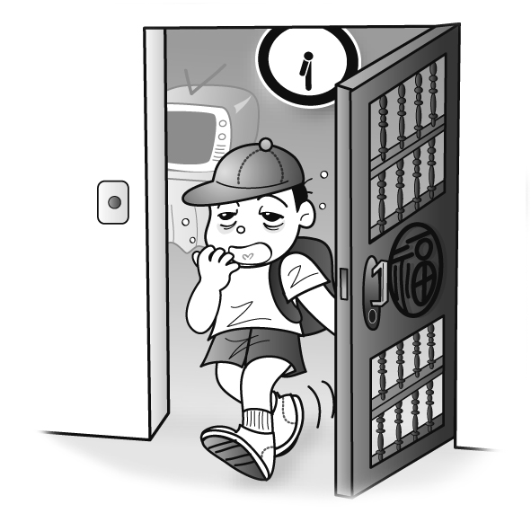 3.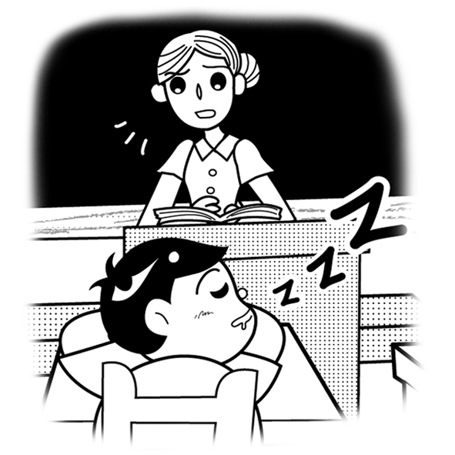 4. 





















