新北市立 新 北 高工 108 學年度 第一學期 期末考 |  |  |  |  |  |  | 班級 |  | 座號 |  | 成
科目 | 英文 | 年級 | 一 | 科別 | 模具科 |  | 姓名 |  |  |  | 績
請在答案卡上劃卡作答 共 40 題, 每題2.5分 請仔細核對題號!  - 聽力測驗  第一部分：看圖辨義試卷上該題有一張圖片，請聽一個和該題相關的問題，與(A)、(B)、(C)三個英語敘述後，選一個與所看到圖片最相符的答案。  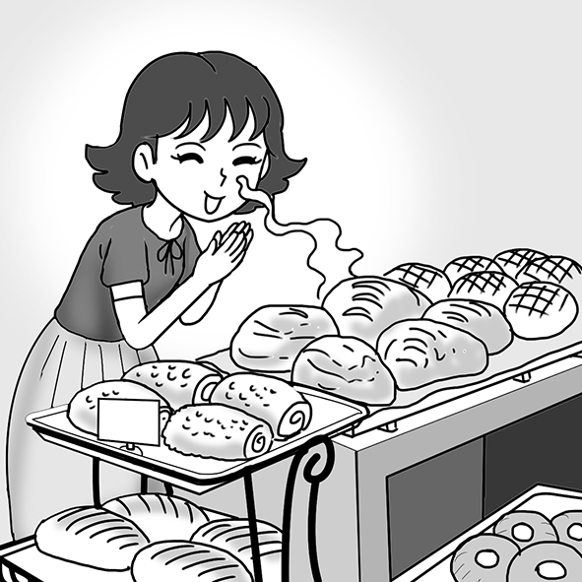 1. _________  第二部分：問答  每題會播出一個問句或直述句，聽後請由試卷上(A)、(B)、(C)三個選項中，選出一個最適合的回答或回應。  _______ 2. (A) I want to continue my homework.  (B) I’m going to bake bread with them.  (C) I bought them at the local market.  _______ 3. (A) My favorite animal is the rabbit.  (B) Yeah, it was really crowded.  (C) We adopted a dog.  _______ 4. (A) I just got chased by a dog on the street.  (B) I love petting my dog’s fur.  (C) To live like this is a blessing.  第三部分：簡短對話每題會播出一段對話及一個相關的問題，聽後請由試卷上(A)、(B)、(C)三個選項中，選出一個最適合的回答。  _______ 5.(A) Walk and feed the dog.  (B) Take the dog to a shelter.  (C) Find a family for the dog.  P1  - 字彙測驗選擇題  （ ）11. stage (A) 住民 (B) 員工 (C) 階段 (D) 景色  （ ）12. perform (A)衝突 (B) 演出(C) 通信 (D) 預報  （ ）13. education (A) 疾病 (B) 選擇(C) 紀錄 (D) 教育  （ ）14. international (A) 國際的 (B) 有野心的 (C) 渴望的(D) 不費力的  （ ）15. master (A) 墜毀 (B) 精通 (C) 參加 (D) 收集  （ ）16. 態度(A) attitude (B) fortune (C) disease (D)goal  （ ）17. 顧客(A) photographer (B) villager (C) customer (D) host  （ ）18. 克服 (A) collect (B) overcome (C) deal (D) regard  （ ）19. 成功的(A) pleased (B) competitive (C) ambitious (D) successful  （ ）20. 實現 (A) apply (B) fulfill (C) entertain (D) interact  （ ）21.Lee finally got sick because he drank too much.  (A) later (B) eventually (C) firstly (D) then  （ ）22. I love my job as a chef, and I think I will always work in the restaurants.  (A) then (B) later (C) finally (D) forever  （ ）23. Erin is afraid of cockroaches. She screams every time she sees one.  (A) surprised (B) bored (C) excited (D) scared  （ ）24. Many of my classmates are studying in the library because the final exams are ____.  - surprising (B) using (C) approaching (D) confirming  （ ）25.Davis was not ______ that his teacher was looking at him.  - crowded (B) aware (C) exhausted (D) effortless  （ ）26.Our store is always very ______ when everything is on sale.  (A) crowded (B) intense (C) offensive (D) effortless  （ ）27. Jenny has to take care of four babies at the same time and she feels _____.  (A) crowded (B) exhausted (C) classified (D) adopted  （ ）28. Benson was _______ by the horror movie and could not sleep.  (A) settled (B) blessed (C) crowded (D)terrified  （ ）29. Emma decided to get a pet from an animal ______ rather than from a pet store.  (A)shop (B) collection (C) shelter (D) crash  （ ）30. I’d better leave now; ________, I won’t be able to catch the train.  (A) likewise (B) otherwise (C) however (D) but  P2  IV. 對話測驗  - （ ）Emma: Hi, I’d like to adopt that stray dog but I don’t know how.  Bob: Just fill in these papers and you can take him home.  Emma: Many thanks.  Bob: ____________  (A) You can say that again. (B) No problem. (C) I can’t thank you enough. (D) I’m sorry.  - （ ）Grace: Dad, thank you for taking us to the animal shelter.  Meg: It’s so great that we found a nice dog there!  Dad: ____________ But remember, taking care of a dog is a big responsibility.  Grace & Meg: Yes, Dad.  (A) I’m glad you like it. (B) That was kind of you.  (C) I really appreciate it. (D) It is the best gift ever.  - （ ）Chris: I have work to do tonight. Could you take Cooper for a walk?  Paul: Sure. Just leave him to me.  Chris: Thank you so much.  Paul: ____________ I love dogs.  (A) I appreciate it. (B) I’m glad you like it. (C) That’s kind of you. (D) Don’t mention it.  44.（ ）Matthew: Hi, Dan! How was your trip to Japan?  Dan: It was great! Look! I brought back a box of chocolates for you.  Matthew: ____________ I love chocolate!  Dan: I’m glad you like it.  (A) That’s so kind of you! (B) I’m sorry!  (C) Don’t mention it! (D) It’s my pleasure!  45.（ ）Allan: Happy birthday, Rita! Open your gift!  Rita: Wow, a beautiful necklace! !  Allan: You are welcome!  Rita: It’s a fantastic gift. All right, let’s have some cake now!  (A) That’s all right. (B) Don’t worry. (C) I really appreciate it. (D) Don’t mention it.  P3 |  |  |  |  |  | _______ 6.(A) It looks the cutest.  (B) It has soft fur.  (C) It is afraid.  _______ 7.(A) The man will go shopping at a bakery.  (B) They will go out to eat together.  (C) The woman will teach the man something.  第四部分：短文聽解每題有三個圖片選項。請聽題目，並選出一個最適當的圖片。  8._______  (A) (B) (C)  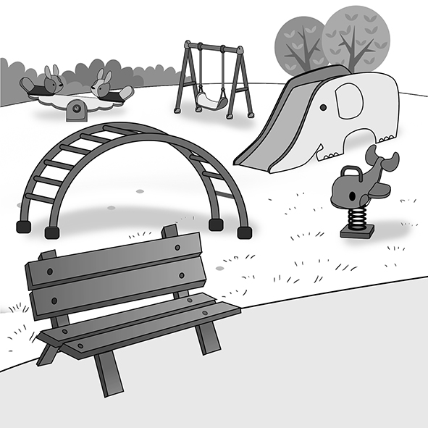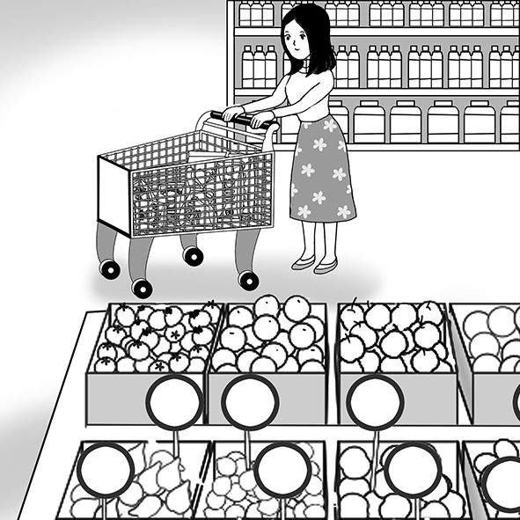  9._______  (A) (B) (C)  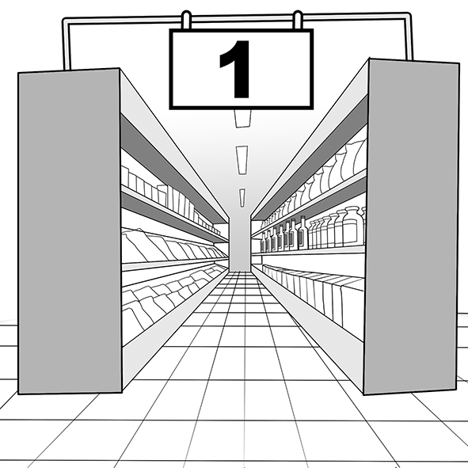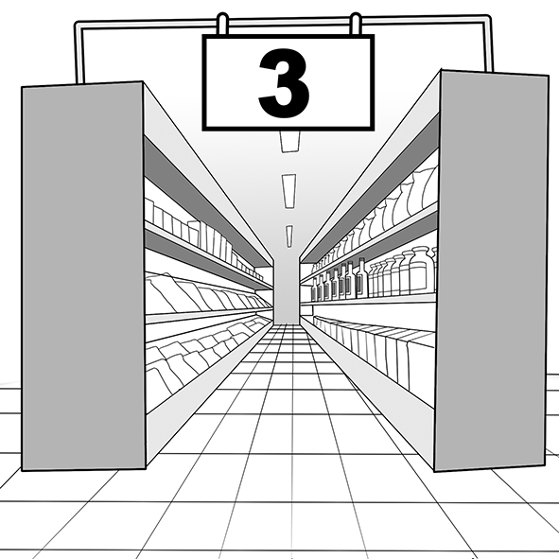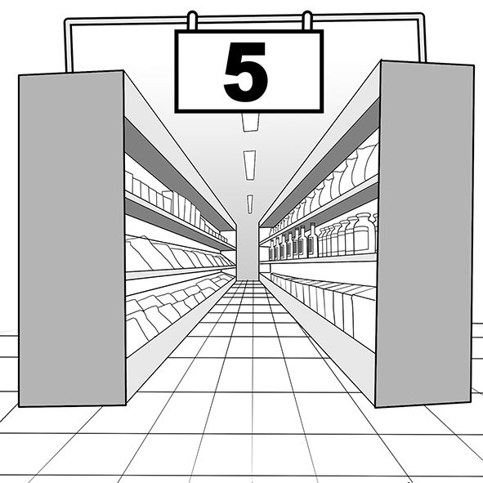  10.______  (A) (B) (C)  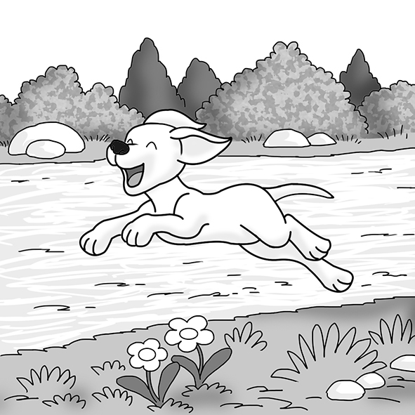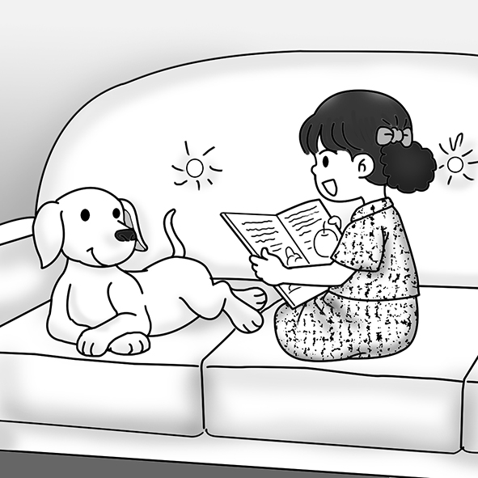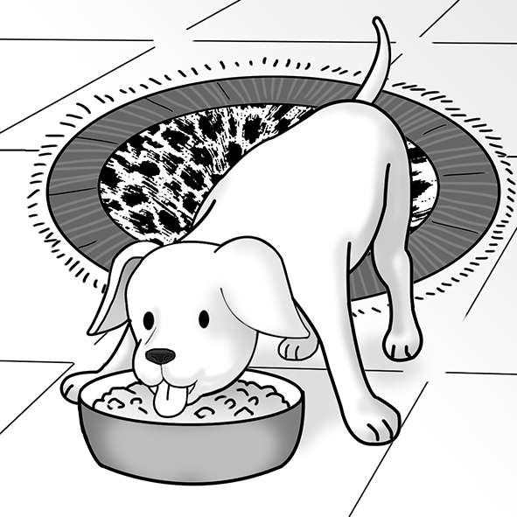  - 文法選擇  26.（ ）The art teacher’s decision to take the students to the art museum makes the students very ____________. (A) excite (B) excitement (C) exciting (D) excited  27.（ ）Surprisingly, ________ cola to clean a toilet works quitw well.  (A) use (B) uses (C) using (D) used  28.（ ）This musician is famous not only because of his talent but also for ____________.  (A) he hardly works (B) he works hard (C) his hard work (D) his hard-working  29. （ ）Mom used to ____________ bread from a bakery, but now she bakes it at home.  (A) bought (B) buying (C) buy (D) buys  30.（ ）If Martin went to that party, he ____________ Sarah to dance with him.  (A) asks (B) will ask (C) asked (D) would ask  31.（ ）Maria seems to know a lot about the world, but actually she knows ____________  about it. (A) little (B) few (C) a little (D) a few  32.（ ）Playing computer games _______ a lot of fun for Jamie.  (A) is (B) be (C) are (D) do  33.（ ）_______ we are young, we can really do something to save the Earth.  (A) However (B ) Although (C) Besides (D) N  34.（ ）The dog was ____________ by a naughty boy, and then it jumped over a wall.  (A) chasing (B) chased (C) chases (D) chase  35.（ ）To eat heathy food ____________ important for your body.  (A) are (B) does (C) be (D) is  IV. 克漏字測驗  - One day, my fellow street dogs and I saw “The Truck.” One of the other dogs told me that it took stray dogs ______36.______, never to be seen again. When it started getting closer, I felt very scared and ran. ______37.______, I was caught and taken to a shelter. I quickly realized ______38.______ the shelter was not a good place to be. It was full of sick, smelly, and angry dogs. I learned that ______39.______ nobody took me home, I would have to stay there forever. I just had to wait and hope that I would be ______40.______ by someone.  36.（ ）(A) away (B) down (C) under (D) up  37.（ ）(A) Luckily (B) Happily (C) Suddenly (D) Calmly  38.（ ）(A) that (B) where (C) which (D) how  39.（ ）(A) if (B) whether (C) until (D) although  40.（ ）(A) adopt (B) to adopt (C) adopting (D) adopted  What goes around, comes around.  善有善報，惡有惡報。  V. 閱讀測驗  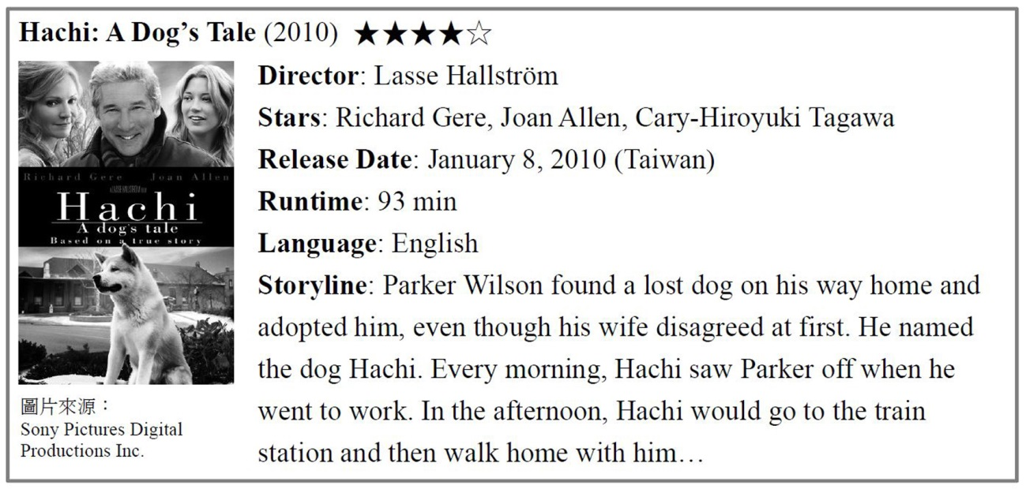  （ ） Where might you see this article? (A) On a hospital website (網站). (B) In a history book. (C) On a movie review web page. (D) In a supermarket.  （ ） Which of the following is NOT true? (A) Parker’s wife didn’t want to keep the dog at first. (B) The movie lasts over an hour. (C) Parker bought Hachi from a pet shop. (D) Joan Allen is an actress.  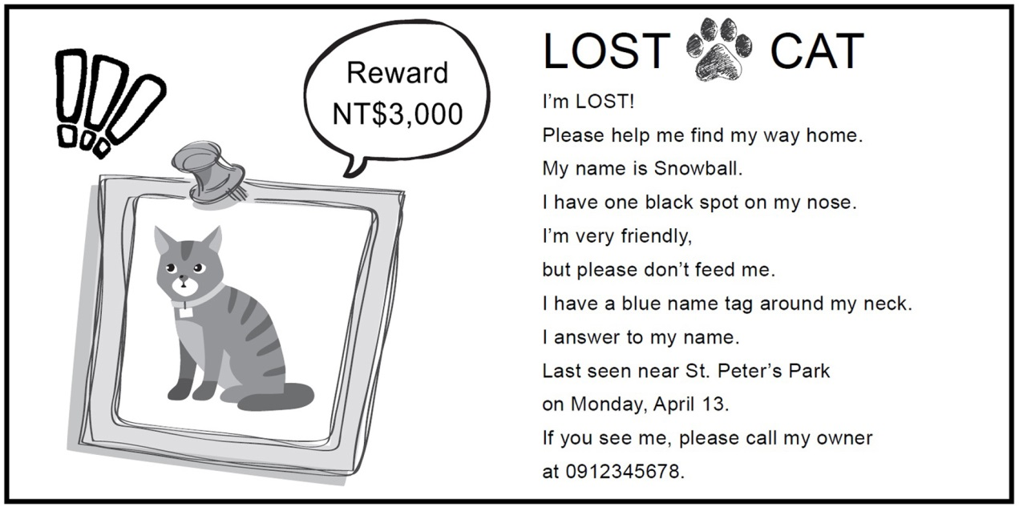  （ ）(1) Who made this poster? (A) The finder of Snowball. (B) A local police officer. (C) An animal doctor. (D) Snowball’s owner.  （ ）(2) Which of the following is NOT true? (A) The finder of Snowball can get NT$3,000. (B) Snowball is nice and you can feed her anything. (C) Snowball has a name tag which says her name. (D) After she left home, Snowball was seen near a park.  P3.  P3.
新北市立 新 北 高工 102 學年度 第二學期 期末考 |  |  |  |  |  |  | 班級 |  | 座號 |  | 成 | P.2
科目 | 英文 | 年級 | 一 | 科別 | 機鑄汽模圖電資 |  | 姓名 |  |  |  | 績 | P.2

新北市立 新 北 高工 102 學年度 第二學期 第二次 段考 一年級 英文 答案卷 P.3

班級 姓名 座號

得分 總分
VI. 文意字彙20%
1. | 2. | 3. | 4.
5. | 6. | 7. | 8.
9. | 10.

VII. 翻譯填空10%
11. | 12. | 13. | 14.
15. | 16. | 17. | 18.
19. | 20.

【請仔細核對題號 請在考卷及答案卷上都寫上姓名座號 答案卡請劃座號!!!!】

