新北市立 新 北 高工 108 學年度 第一學期 期末考 |  |  |  |  |  |  | 班級 |  | 座號 |  | 成
科目 | 英文 | 年級 | 一 | 科別 | 訊機鑄汽圖電資 |  | 姓名 |  |  |  | 績
請在答案卡上劃卡作答 共 50 題, 每題兩分 請仔細核對題號!  - 聽力測驗  第一部分：看圖辨義試卷上該題有一張圖片，請聽一個和該題相關的問題，與(A)、(B)、(C)三個英語敘述後，選一個與所看到圖片最相符的答案。  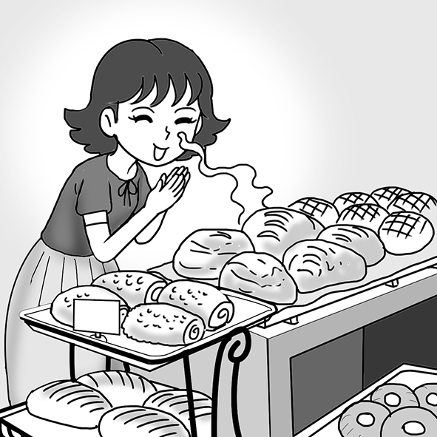 1. _________  第二部分：問答  每題會播出一個問句或直述句，聽後請由試卷上(A)、(B)、(C)三個選項中，選出一個最適合的回答或回應。  _______ 2. (A) I want to continue my homework.  (B) I’m going to bake bread with them.  (C) I bought them at the local market.  _______ 3. (A) My favorite animal is the rabbit.  (B) Yeah, it was really crowded.  (C) We adopted a dog.  _______ 4. (A) I just got chased by a dog on the street.  (B) I love petting my dog’s fur.  (C) To live like this is a blessing.  第三部分：簡短對話每題會播出一段對話及一個相關的問題，聽後請由試卷上(A)、(B)、(C)三個選項中，選出一個最適合的回答。  _______ 5.(A) Walk and feed the dog.  (B) Take the dog to a shelter.  (C) Find a family for the dog.  P1  - 字彙測驗選擇題  11.（ ）Lee finally got sick because he drank too much.  (A) later (B) firstly (C) then (D) eventually  12.（ ）Erin is afraid of cockroaches. She screams every time she sees one.  (A) excited (B) bored (C) surprised (D) scared  13.（ ）I love my job as a chef, and I think I will always work in restaurants.  (A) forever (B) then (C) finally (D) later  14.（ ）In many people’s view, Monet (莫內) was a skilled painter.  (A) fresh (B) regular (C) scared (D) master  15.（ ）Ashley loves playing with children very much, so she chose to be a kindergarten teacher.  (A) performed (B) educated (C) decided (D) overcame  16.（ ）The store was very ____________ because fans were waiting for the singer to show up.  (A) aware (B) crowded (C) surprised (D) terrified  17.（ ）The boys played basketball for hours, and they all felt ____________.  (A) alone (B) exhausted (C) scary (D) surprising  18.（ ）The ____________ girl couldn’t move when the police officer asked her name.  (A) regular (B) awake (C) aware (D) terrified  19.（ ）The final exams are ____________. More and more students are going to the school  library to study. (A) approaching (B) promising (C) confirming (D) inventing  20.（ ）It takes courage to begin a new ____________ of life.  (A) stage (B) shelter (C) ingredient (D) customer  21.（ ）The meeting didn’t ____________ for a long time. The final decision was made  quickly. (A) deicide (B) last (C) relax (D) perform  22.（ ）Hank stopped talking when he saw Anna. She ____________ that he was saying  something bad about her. (A) awoke (B) suspected (C) created (D) approached  23.（ ）Richard ____________ studying until bedtime. He was preparing for his final exam.  (A) continued (B) performed (C) adopted (D) fulfilled  24.（ ）For children, parents play an important role in their ____________.  (A) bread (B) practice (C) education (D) proof  25.（ ）To come up with a new idea is one thing. To ____________ it into a plan is another.  (A) continue (B) master (C) suspect (D) develop  IV. 對話測驗  - （ ）Emma: Hi, I’d like to adopt that stray dog but I don’t know how.  Bob: Just fill in these papers and you can take him home.  Emma: Many thanks.  Bob: ____________  (A) You can say that again. (B) No problem. (C) I can’t thank you enough. (D) I’m sorry.  - （ ）Grace: Dad, thank you for taking us to the animal shelter.  Meg: It’s so great that we found a nice dog there!  Dad: ____________ But remember, taking care of a dog is a big responsibility.  Grace & Meg: Yes, Dad.  (A) I’m glad you like it. (B) That was kind of you.  (C) I really appreciate it. (D) It is the best gift ever.  38.（ ）Chris: I have work to do tonight. Could you take Cooper for a walk?  Paul: Sure. Just leave him to me.  Chris: Thank you so much.  Paul: ____________ I love dogs.  (A) I appreciate it. (B) I’m glad you like it. (C) That’s kind of you. (D) Don’t mention it.  39.（ ）Matthew: Hi, Dan! How was your trip to Japan?  Dan: It was great! Look! I brought back a box of chocolates for you.  Matthew: ____________ I love chocolate!  Dan: I’m glad you like it.  (A) That’s so kind of you! (B) I’m sorry!  (C) Don’t mention it! (D) It’s my pleasure!  40.（ ）Allan: Happy birthday, Rita! Open your gift!  Rita: Wow, a beautiful necklace! !  Allan: You are welcome!  Rita: It’s a fantastic gift. All right, let’s have some cake now!  (A) That’s all right. (B) Don’t worry. (C) I really appreciate it. (D) Don’t mention it. |  |  |  |  |  | _______ 6.(A) It looks the cutest.  (B) It has soft fur.  (C) It is afraid.  _______ 7.(A) The man will go shopping at a bakery.  (B) They will go out to eat together.  (C) The woman will teach the man something.  第四部分：短文聽解每題有三個圖片選項。請聽題目，並選出一個最適當的圖片。  8._______  (A) (B) (C)  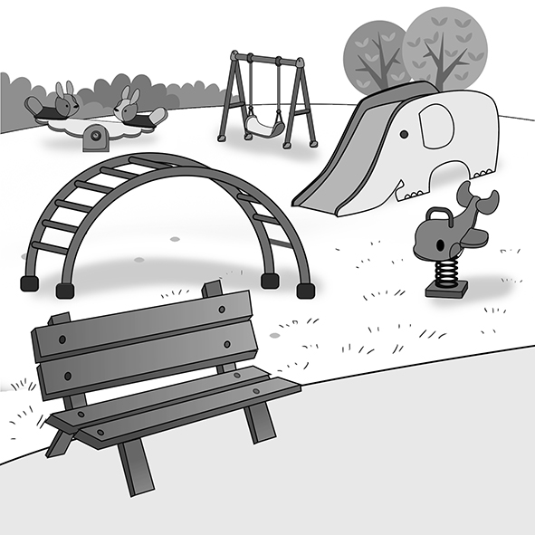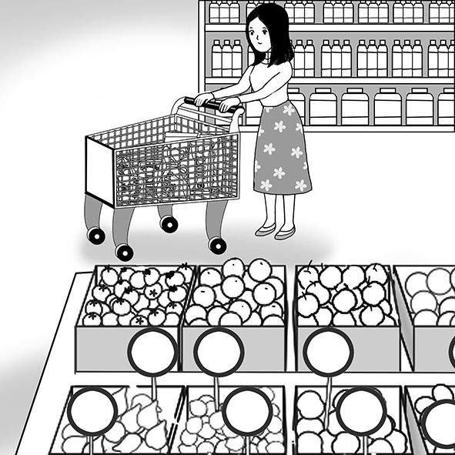  9._______  (A) (B) (C)  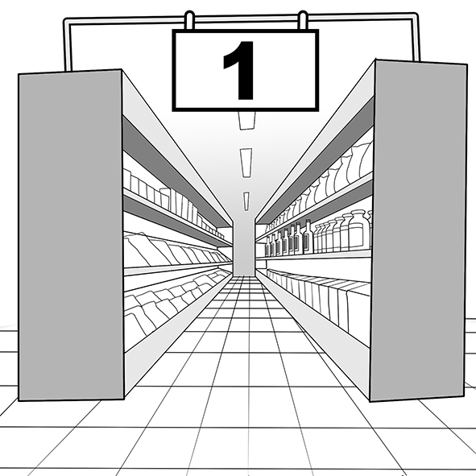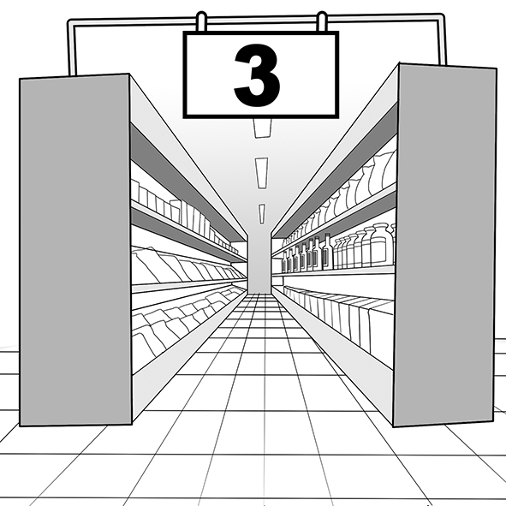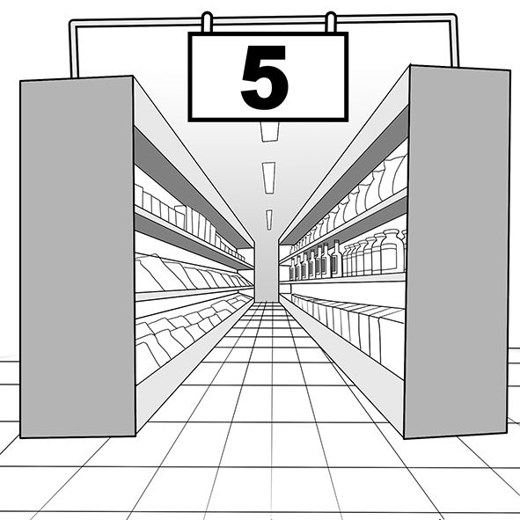  10.______  (A) (B) (C)  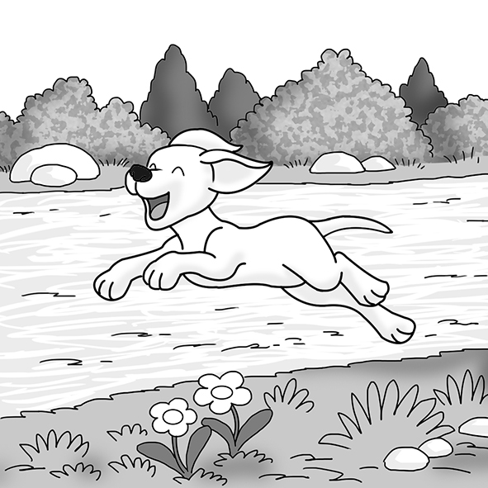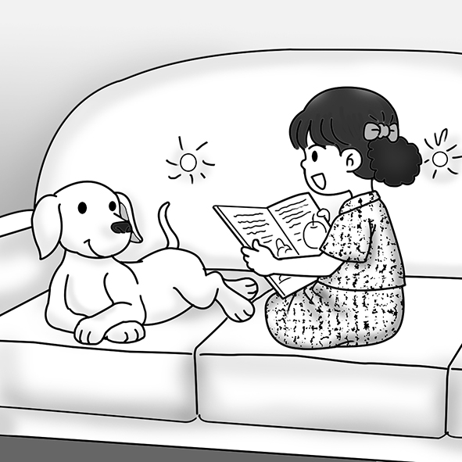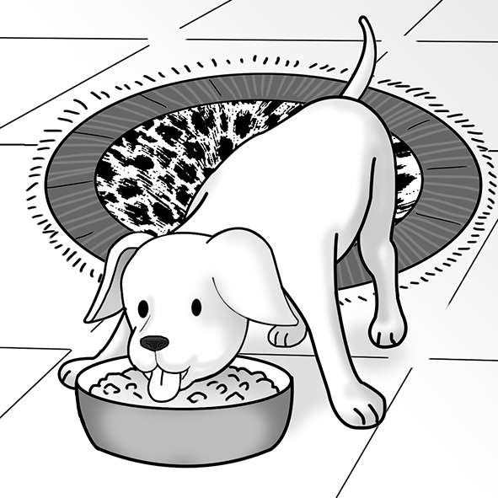  - 文法選擇  26.（ ）The art teacher’s decision to take the students to the art museum makes the students very ____________. (A) excite (B) excitement (C) exciting (D) excited  27.（ ）Not only I but also Steve ____________ interested in mountain climbing.  (A) are (B) is (C) am (D) were  28.（ ）This musician is famous not only because of his talent but also for ____________.  (A) he hardly works (B) he works hard (C) his hard work (D) his hard-working  29. （ ）Mom used to ____________ bread from a bakery, but now she bakes it at home.  (A) bought (B) buying (C) buy (D) buys  30.（ ）If Martin went to that party, he ____________ Sarah to dance with him.  (A) asks (B) will ask (C) asked (D) would ask  31.（ ）Maria seems to know a lot about the world, but actually she knows ____________  about it. (A) little (B) few (C) a little (D) a few  32.（ ）This interesting story ____________ by my brother.  (A)wrote (B) writes (C) was writing (D) was written  33.（ ）Our new teacher is not only friendly but also ____________.  (A) interests (B ) interestingly (C) interested (D) interesting  34.（ ）The concert ____________ in memory of the famous director.  (A) holds (B) was held (C) held (D) is holding  35.（ ）____________ a meal for ten people sounds like a difficult job to me.  (A) Cook (B) To cook (C) Cooked (D) To be cooked  P2.  V. 克漏字測驗  - One day, my fellow street dogs and I saw “The Truck.” One of the other dogs told me that it took stray dogs ______41.______, never to be seen again. When it started getting closer, I felt very scared and ran. ______42.______, I was caught and taken to a shelter. I quickly realized ______43.______ the shelter was not a good place to be. It was full of sick, smelly, and angry dogs. I learned that ______44.______ nobody took me home, I would have to stay there forever. I just had to wait and hope that I would be ______45.______ by someone.  41.（ ）(A) away (B) up (C) under (D) down  42.（ ）(A) Luckily (B) Suddenly (C) Happily (D) Calmly  43.（ ）(A) which (B) where (C) that (D) how  44.（ ）(A) although (B) whether (C) until (D) if  45.（ ）(A) adopting (B) to adopt (C) adopt (D) adopted  - Cooper was born in a pet shop. One day, he ______46.______ by his first owner, Jimmy. Cooper liked chewing everything. It was fun for him, but he ______47.______ that Jimmy’s parents weren’t happy at all. One night, they drove Cooper far away and left him there. ______48.______ a stray dog was terrible. Soon Cooper was dirty, tired, and ______49.______. Then he was picked up by “The Truck” and brought to a shelter. Luckily, Katrina took him home and treated him very well. Cooper ______50.______ a stray dog ______50.______, but a pet that was loved. He hoped that his friends on the streets could find sweet homes, too.  46.（ ）(A) buys (B) bought (C) is bought (D) was bought  47.（ ）(A) suspected (B) confirmed (C) decided (D) hoped  48.（ ）(A) Become (B) Became (C) He became (D) Becoming  49.（ ）(A) scare (B) scary (C) scared (D) scares  50.（ ）(A) was; anymore (B) wasn’t; anymore (C) not; anymore (D) no; more  What goes around, comes around.  善有善報，惡有惡報。  P3.  P3.
新北市立 新 北 高工 102 學年度 第二學期 期末考 |  |  |  |  |  |  | 班級 |  | 座號 |  | 成 | P.2
科目 | 英文 | 年級 | 一 | 科別 | 機鑄汽模圖電資 |  | 姓名 |  |  |  | 績 | P.2

新北市立 新 北 高工 102 學年度 第二學期 第二次 段考 一年級 英文 答案卷 P.3

班級 姓名 座號

得分 總分
VI. 文意字彙20%
1. | 2. | 3. | 4.
5. | 6. | 7. | 8.
9. | 10.

VII. 翻譯填空10%
11. | 12. | 13. | 14.
15. | 16. | 17. | 18.
19. | 20.

【請仔細核對題號 請在考卷及答案卷上都寫上姓名座號 答案卡請劃座號!!!!】

