一、聽力測驗(10%)
第一部分：看圖辨義
試卷上該題有一張圖片，請聽一個和該題相關的問題，與(A)、(B)、(C)三個英語敘述後，選一個與所看到圖片最相符的答案。
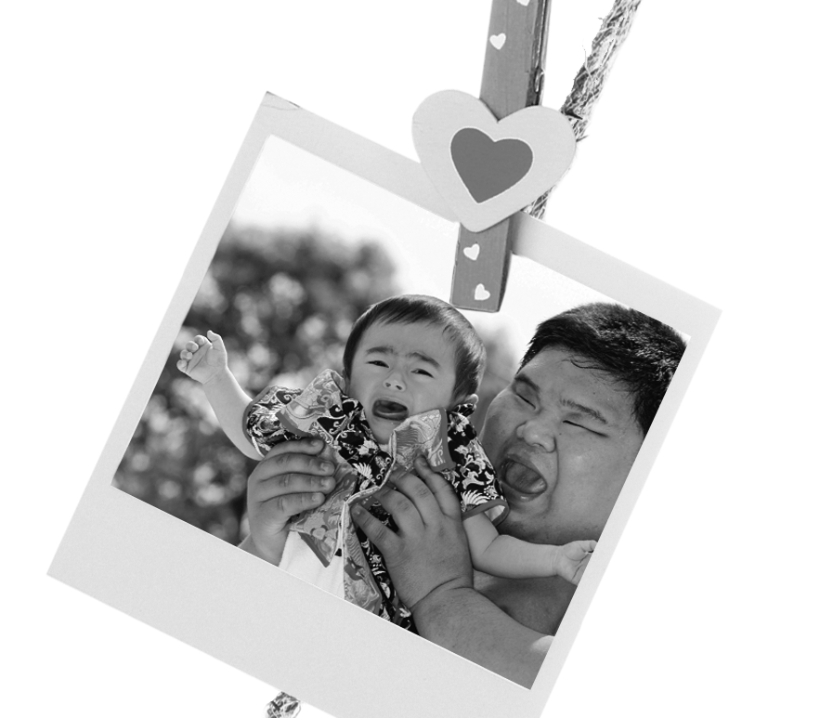 | 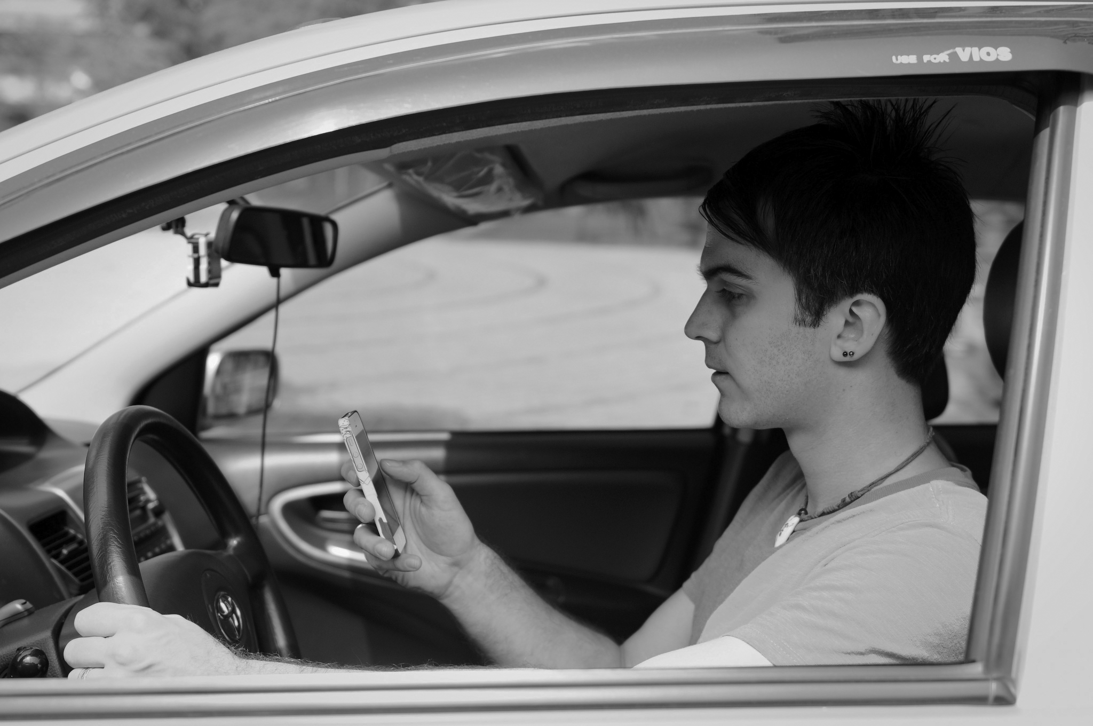
1. __________ | 2. __________
第二部分：問答 每題會播出一個問句或直述句，聽後請由試卷上(A)、(B)、(C)三個選項中，選出一個最適合的回答或回應。
_______ 3. (A) Since they plant the crops in summer, they are ready by fall.
(B) Since they pour the drinks first, it’s too bizarre for me.
(C) Since I work all day. I can’t get there on time.
_______ 4. (A) Because it doesn’t have an ancient civilization.
(B) Because it is packed with billions of people.
(C) Because religion is not very important here.
_______ 5. (A) I would recommend the smartphone shop downtown.
(B) I need to set up a new satellite navigation system.
(C) I’m not sure about my schedule yet. I’ll tell you later.
_______ 6. (A) Instead of watching the road, he was looking for the latest apps on his smartphone.
(B) His life flashed before his eyes when his car fell into the gorge.
(C) He had made no effort to spend time with the important people in his life.
_______ 7. (A) I usually set up my desktop computer.
(B) I go to my friends for support.
(C) I will leave for the airport tonight.
第三部分：簡短對話
每題會播出一段對話及一個相關的問題，聽後請由試卷上(A)、(B)、(C)三個選項中，選出一個最適合的回答。
_______ 8. (A) They only pour water on the babies, so it’s not cruel.
(B) He should be pleased to have the opportunity to watch the festival.
(C) They are actually asking for good luck for the babies.
_______ 9. (A) From the ticket vending machine.
(B) From the ticket window.
(C) The woman will help him buy it.
_______ 10. (A) They always go to that Italian ice cream shop.
(B) Ice cream is highly recommended on hot days.
(C) The girl wanted ice cream and the shop was nearby.

二、文意字彙 40%
11.（ ）The bride felt sad and wept in the wedding because she hadn’t got her father’s _____. (A) opportunity (B) blessing (C) survivor (D) symbol
12.（ ）Asia is the largest _____ in the world and many people live on it.
(A) civilization (B) climate (C) continent (D) celebration
13.（ ）Ken is a _____ and is famous for his generosity. He donates (捐贈) a lot of money to
charities. (A) civilization (B) cheer (C) character (D) billionaire
14.（ ）You should _____ your coat before you leave because it’s very cold outside.
(A) take off (B) set up (C) pick up (D) put on
15.（ ）Emily will _____ France to study science soon.
(A) leave for (B) reach out (C) turn to (D) pick up
16.（ ）Can you _____ something for me to eat in the middle of the night?
(A) support (B) comfort (C) recommend (D) request
17.（ ）The bag which was stolen by the man _____ rice. There wasn’t any money in it.
(A) was aware of (B) was good at (C) was close to (D) was packed with
18.（ ）Grandpa was entertaining the children by _____.
(A) making faces (B) making sure (C) making use (D) making up
19.（ ）Leslie is such a responsible person that her parents completely trust her. They are always _____ of any of her decisions.
(A) jealous (B) opposite (C) grateful (D) supportive
20.（ ）The man told the reporter that he had seen a UFO _____ across the sky when he
looked out his window the other day.
(A) screaming (B) attracting (C) flashing (D) planting
21.（ ）When the old woman saw the car accident, she _____ in fear.
(A) offered (B) recommended (C) screamed (D) concentrated
22.（ ）Lily always _____ deeply to relax herself before an exam.
(A) offers (B) supports (C) breathes (D) screams
23.（ ）Sarah rejected my proposal _____ and told me that she would never change her mind. (A) surprisingly (B) annually (C) responsibly (D) firmly
24.（ ）According to the chef, you should heat the oven to about 250 _____ first before you start to make this dish.
(A) schedules (B) recommendations (C) efforts (D) degrees
25.（ ）You can tell from the way the criminal committed the crime (犯罪) that he is a very
_____ man. He didn’t want to leave the victim any chance to escape.
(A) attentive (B) cruel (C) eager (D) religious
26.（ ）From Patty’s _____ smile I can tell that she doesn’t like the dress I bought her.
(A) false (B) supportive (C) pleased (D) salty
27.（ ）The _____ to the Moon was made by the U.S. It was not easy to create one.
(A) opportunity (B) planet (C) rocket (D) plant
28.（ ）Moments before the earthquake, there was a(n) _____ sight: many insects came up
from out of the ground. (A) false (B) annual (C) unusual (D) religious
29.（ ）My sister is crying, but I don’t know how to _____ her.
(A) blame (B) comfort (C) bring (D) introduce
30.（ ）Alex asked his father to _____ him _____ at the bus stop.
(A) set; up (B) pick; up (C) put; on (D) take; off

三、同義字 10%
31.（ ）Jill’s behavior to Michael is odd and unusual. Something bad must have happened
between them. (A) south (B) bizarre (C) stressful (D) touched
32.（ ）This company is known for providing an excellent work environment for its staff.
(A) offering (B) opposing (C) pouring (D) manufacturing
33.（ ）We have to be honest with each other if we want to deal with the problem together.
(A) truthful (B) cruel (C) extinct (D) messy
34. （ ）Zoe was selected the top salesperson in the annual meeting of her company.
(A) daily (B) weekly (C) monthly (D) yearly
35. （ ）Please focus on what teachers say when you are in class.
(A) rely (B) concentrate (C) broadcast (D) connect

四、語法 20 %
36. （ ）The mother held a birthday party at the fast food restaurant for her _____ daughter.
(A) ten-year-old (B) ten-years-old (C) year-old-tenth (D) old-ten-years
37. （ ） At the _____ of the planting season, farmers will work hard to grow crops.
(A) begin (B) begins (C) began (D) beginning
38. （ ）No matter _____ talented and smart you are, you still have to study hard and be
humble. (A) when (B) what (C) how (D) who
39. （ ）The movie will start _____ eight o’clock tonight. (A) in (B) on (C) with (D) at
40. （ ）Linda has two brothers. One is Jimmy; _____ is Tony.
(A) the other (B) one (C) other (D) others
41. （ ）_____ the weather is, the more clothing people put on.
(A) Coldly the (B) More cold (C) The colder (D) The cold
42. （ ）Karen seemed _____ when she heard the bad news, but actually she was shocked.
(A) calm (B) calming (C) calmly (D) calmness
43. （ ）_____ that five children were saved from being injured in the fire.
(A) Reported (B) It was reported (C) It was report (D) Reporting
44. （ ）The girl made faces at the boy _____ she didn’t like him.
(A) because of (B) and (C) since (D) but
45. （ ）Edward really loves his mother _____ takes good care of him.
(A) that (B) , which (C) ,who (D) whom

五、對話 10 %
46.（ ）Gina: I love your new smartphone.
Cindy: Thanks. My brother gave it to me on my birthday.
Gina: _____
Cindy: I’ll ask him where he got it.
(A) It’s impossible! (B) It looks expensive.
(C) You were lucky to find it. (D) I wish I could find one just like this.
47.（ ）John: Excuse me. _____
Passerby: You can take the MRT to Central Park Station and then transfer to Bus
No. 6.
John: Thank you.
(A) What can I do for you? (B) Can I park my car here?
(C) Where is Central Park Station? (D) How can I go to May’s Department Store?
48.（ ）Cindy: How much is the fare?
Philip: _____
Cindy: Do you take credit cards?
(A) Seventy dollars. (B) It’s awful. (C) Sign up. (D) Yes, I like it.
49.（ ）Carey: Hi, Hank. This is Carey. Do you want to have dinner together tonight?
Hank: _____ I was just thinking about asking you, too.
(A) Yes, I want to eat lunch with you. (B) What a coincidence!
(C) Who are you? (D) Hang on.
50.（ ）Luke: Is it possible to buy a round-trip ticket to Ruifang?
June: Of course. _____ It allows you to travel to more places.
(A) I would like a one-way ticket. (B) But it is better to purchase a daily pass.
(C) The fare is 52 dollars for one way. (D) It will be 118 dollars in total.

六、綜合測驗 10 %
In the past, firecrackers were always used to celebrate the coming of Lunar New Year. However, as they __51___ unfriendly to the environment, they are used much less nowadays. Many large cities even have laws against setting off firecrackers in the city. __52__ fewer firecrackers are now heard, Lunar New Year has become quieter and more peaceful. That is, the Lunar New Year now is different __53__ the Lunar New Year in the past. In addition to that, Chinese people always want to make sure that everybody is home for New Year’s Eve dinner. After dinner, children get red envelopes with money and feel very __54___. The color red is very important in Chinese culture. During Lunar New Year, families paint lucky characters on sheets of red paper and post them on their doors. It is believed ___55__ red is the color of happiness and luck. White, on the other hand, is the color of death and is used in funerals.
（ ）51. (A) are considered (B) are close to (C) are good at (D) are true to
（ ）52. (A) Because of (B) When (C) Since (D) But
（ ）53. (A) with (B) from (C) of (D) upon
（ ）54. (A) pleased (B) packed (C) worshiped (D) planted
（ ）55. (A) which (B) how (C) that (D) where

