請在電腦答案卡上劃上座號，並將選擇題答案劃卡作答,共55題，劃記不清者，扣總分
5分! 祝同學能有好成績，加油!!
一 、Listening Comprehension Test聽力測驗 10% (共10題) /@1
第一部分：看圖辨義
試卷上該題有一張圖片，請聽一個和該題相關的問題，與(A)、(B)、(C)三個英語敘述後，選一個與所看到圖片最相符的答案。
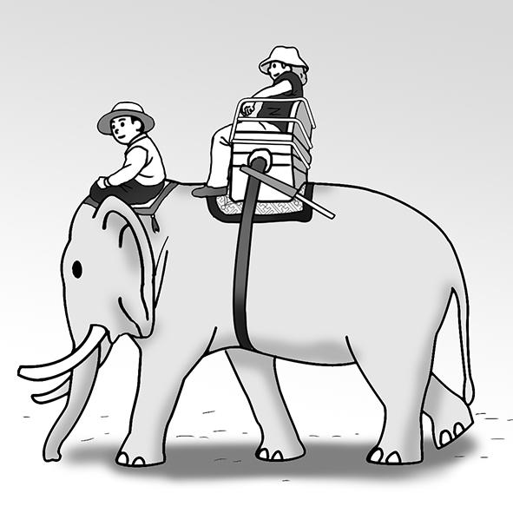 1. _________
第二部分：問答
每題會播出一個問句或直述句，聽後請由試卷上(A)、(B)、(C)三個選項中，選出一個最適合的回答或回應。
_______ 2. (A) You can check the invitation card.
(B) It will be at my house.
(C) I’m bringing drinks for everyone.
_______ 3. (A) Yes, I did.
(B) At 5 o’clock.
(C) I do it daily.
_______ 4. (A) We donate most of it.
(B) Yes, we make paper products.
(C) We sell them in stores.
第三部分：簡短對話
每題會播出一段對話及一個相關的問題，聽後請由試卷上(A)、(B)、(C)三個選項中，選出一個最適合的回答。
_______ 5. (A) A famous writer.
(B) Amy’s friend.
(C) A movie director.
_______ 6. (A) Emily.
(B) An elephant.
(C) A person in Thailand.
_______ 7. (A) Their special interests.
(B) Their travel experiences.
(C) Their favorite sports.
第四部分：短文聽解
每題有三個圖片選項。請聽題目，並選出一個最適當的圖片。
_______8.
(A) (B) (C)
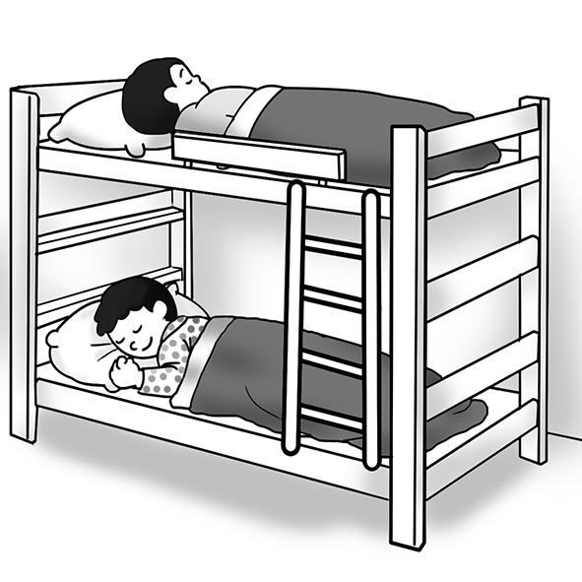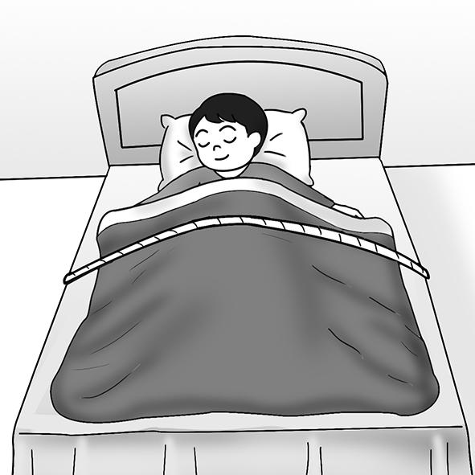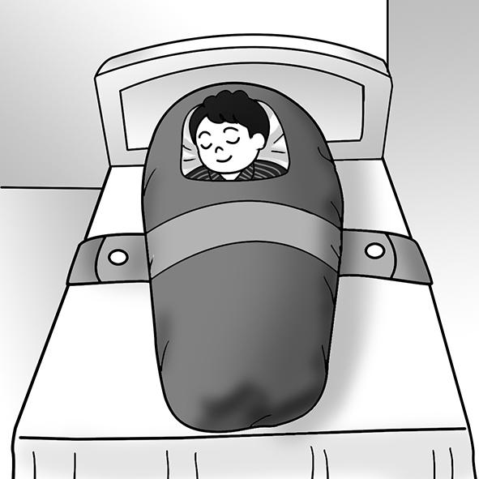

_______9.
(A) (B) (C)
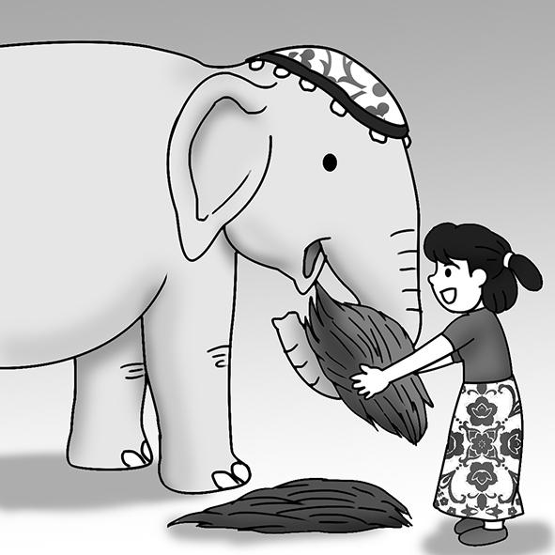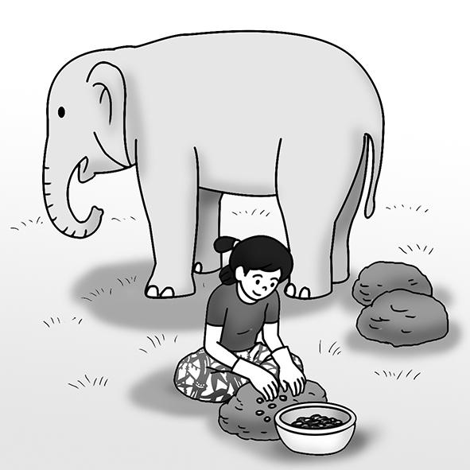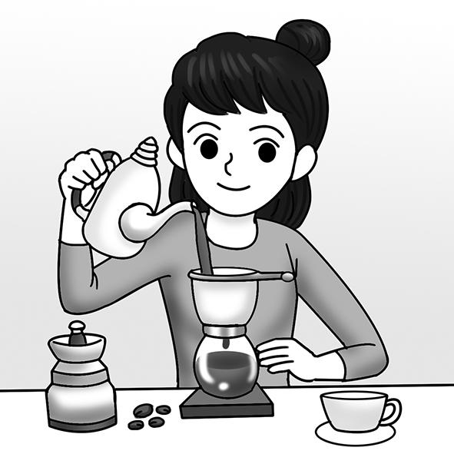
_______10.
(A) (B) (C)


- 文意字彙選擇 40% (11-30題)/@ 2
11. I went on a dolphin-watching tour and was lucky enough to see this playful in the wild.
(A) attempt (B) creativity (C) creature (D) design
12. The baby tiger is so weak that it needs its mother’s care and _______.
(A) profit (B) protection (C) collection (D) production
13. This house is _______ for Bruce. It is close to his office and within his budge.
(A) ideal (B) bitter (C) profitable (D) medical
14. My wool pants __ after they were washed in hot water yesterday.
(A) floated (B) produced (C) designed (D) shrank
15. Mr. Bullock developed a unique teaching to encourage students to work with one
another.
(A) alarm (B) disease (C) method (D) relation
16. Tanya’s grandmother suffered a _______ loss of memory as she got older.
(A) regular (B) gradual (C) powerful (D) thankful
17. Various _______ weather events have been caused by global warming.
(A) gradual (B) terrific (C) ordinary (D) extreme
18. My fear of snakes will never _______ be cause I think they are so scary.
(A) fade (B) float (C) cause (D) maintain
19. Girls _______ to be more considerate than boys.
(A) support (B) tend (C) lack (D) donate
20. Responding to e-mails is part of Gabby’s daily _______ at work.
(A) donation (B) invitation (C) preference (D) routine
21. Mr. Lin provided the poor people with a big meal before the Chinese New Year.
(A) 包含 (B) 解釋 (C) 提供 (D) 運輸
22. The old woman collected some PET bottles (寶特瓶) and sold them.
(A) 保護 (B) 收集 (C) 邀請 (D) 生產
23. The lifeguard (救生員) jumped into the swimming pool to rescue the kid.
(A) 收集 (B) 拯救 (C) 生產 (D) 獲利
24. Because of the band’s terrific performance in the concert (音樂會), I became their fan.
(A) 可怕的 (B) 精彩的 (C) 相似的 (D) 普通的
25. Tom didn’t have the strength to stand up after doing 100 frog jumps.
(A) 肌肉 (B) 體重 (C) 口味 (D) 力氣
26. bitter (A) 酸的 (B) 鹹的 (C) 苦的 (D) 甜的
27. muscle (A) 肌肉 (B) 維持 (C) 醫療 (D) 音樂
28. weight (A) 身高 (B) 體重 (C) 體積 (D) 氣候
29. century (A) 公分 (B) 創意 (C) 生物 (D) 世紀
30. include (A) 包括 (B) 邀請 (C) 發明 (D) 捐助

三、會話10% (31-35題) /@2
31. Maya: I heard elephant dung is very useful in keeping mosquitoes away.
Rebecca: I’d rather use a bug spray (防蟲噴霧).
Maya: Calm down, Rebecca. People use the smoke from burning the dry dung, they don’t apply it directly to their skin.
(A) Why not?
(B) Dig in!
(C) That’s gross!
(D) That’s wrong.
32. Bruno: Bottoms up, buddy!
Dave: Hey, this beer really has a rich flavor.
Bruno: Glad you like it. It was made with coffee beans which were collected from elephant dung.
Dave: No kidding? It sounds awful, but it tastes really good.
(A) My question is where I can buy it.
(B) The problem is it tastes too bitter.
(C) Actually, it’s the best I’ve ever drunk.
(D) In fact, I prefer tea to coffee.
33. Felix: Are you enjoying the book about space that I gave you?
Sandra: Well, to be honest, .
Felix: That’s too bad. I thought you would like it.
Sandra: I prefer books about romances.
(A) I need more space
(B) I hope you enjoy it
(C) It’s the best book of the year
(D) It’s not my thing
34. Aaron: Do you have time tonight? I heard a movie about space adventures is pretty awesome.
Vivian:
Aaron: That’s too bad, but may I ask why?
Vivian: I always think things in a space movie aren’t quite real to me.
(A) Well, it’s going too far.
(B) No, it’s against the law.
(C) I’d love to come.
(D) Sorry, it’s not my cup of tea.
35. Pan: Wanna watch the movie Back to Mars with me this weekend?
Fenny: Sure,
Pan: I’m sorry, but it’s not a sci-fi movie. But I think it will still be worth watching.
Fenny: Let’s find out. The movie title sounds interesting.
(A) I’m really into science fiction movies.
(B) I have a date with my boyfriend.
(C) I don’t like anything about space.
(D) I’m going abroad next week.
四、文法選擇 20% (31-40題) /@2
36. is reported two typhoons are moving slowly toward Taiwan.
(A) It; that (B) What; that (C) It; which (D) What; which
37. A strong typhoon hit the coast, suffered a great deal of damage during the storm.
(A) it (B) which (C) that (D) what
38. A terrible storm hit this area caused all flights to be cancelled.
(A) that (B) , that (C) which (D) , which
39. For Liam, grounding (禁足) his kids is used as a controlling them.
(A) mean of (B) means of (C) means to (D) mean to
40. there are still many large deep-sea animals that people haven’t discovered yet.
(A) Which says (B) What is saying (C) It is said that (D) It said which
41. The bread in this bakery is selling well. That’s because its bread _______ natural ingredients.
(A) is made of (B) is made by (C) is made from (D) is made up
42. Emily drew a big balloon on the back of calendar.
(A) a crowd of (B) a sheet of (C) a plate of (D) a bottle of
43. Horses were once used transportation.
(A) as (B) to (C) with (D) off
44. If the package weighs over , you will need to pay extra shipping fees.
(A) twenty kilograms (B) twenty kilogram
(C) kilograms twenty (D) kilogram twenty
45. It is that exercise makes people healthier and happier.
(A) believes (B) believing (C) believed (D) to believe
五、綜合測驗 20% (46-55題) /@2
(1)
Elephants are bigger than any other land animals. 46 hundreds of years, we have used them to carry heavy things and people. But now they can help us 47 their dung! 48 , elephant dung can be used to make paper. One company has started using elephant dung to make cards.
49 people who buy them, the cards don’t have a bad smell. Another use for elephant dung is making coffee. First, coffee cherries 50 by the elephants. Next, people collect the cherries from their dung. The coffee is really tasty, and that’s why it’s so expensive. These companies use some of the money they earn to help elephants.
46. (A) At (B) For (C) From (D) To
47. (A) by (B) in (C) to (D) with
48. (A) As a result (B) At last (C) For instance (D) Such as
49. (A) Due to (B) According to (C) For example (D) Instead of
50. (A) eat (B) ate (C) are eaten (D) are eating

(2)
The coffee cherries are first eaten by elephants and turned into dark, flavor-rich beans. This “black gold” is one of the most expensive coffees 51 the market. It is said that the coffee is 52 and not bitter at all, thanks to the elephants’ stomach acid. 53 Maximus and Black Ivory Coffee have turned elephant dung into profitable products. These companies also donate some of their profits to support the protection of elephants and to help provide medical care 54 these creatures. 55 , when you buy elephant dung products, you are helping rescue these amazing animals and save our forests at the same time.
51. (A) at (B) on (C) in (D) into
52. (A) extra smooth (B) smooth extra (C) smoothly extra (D) extra smoothly
53. (A) Which (B) Both (C) Either (D) Neither
54. (A) of (B) in (C) for (D) into
55. (A) First (B) At last (C) Therefore (D) However

