新北市立 新 北 高工 108 學年度 第二學期 期 末 考 |  |  |  |  |  |  |  |  |  |  |  |  | 班級 |  | 座號 |  | 成 | P.1
科目 | 英文 | 年級 | 二 | 科別 | 機鑄汽模圖電資訊 | 命題教師 |  | 陳玟如 | 審題教師 |  | 張哲瑋 |  | 姓名 |  |  |  | 績 | P.1
選擇題 共54題，請在答案卡上劃卡作答，並劃妥座號，未劃座號者酌扣五分!  I.聽力測驗8%第一部分：看圖辨義(2%) 試卷上該題有一張圖片，請聽一個和該題相關的問題，與(A)、(B)、(C)三個英語敘述後，選一個與所看到圖片最相符的答案。  第二部分：問答(3%)每題會播出一個問句或直述句，聽後請由試卷上(A)、(B)、(C)三個選項中，選出一個最適合的回答或回應。  - (A) It’s the trendiest tablet! (B) I’m just sending a LINE message.  (C) It’s all Greek to me!  - (A) I think Google is the best. (B) Jeremy Lin is the most influential player.  (C) I’m currently combining two words.  - (A) There’s a discount if you pay in cash. (B) My imagination is running wild.  (C) They are too plain-looking.  第三部分：簡短對話(3%)每題會播出一段對話及一個相關的問題，聽後請由試卷上(A)、(B)、(C)三個選項中，選出一個最適合的回答。  - (A) The dictionary he used was too old. (B) He copied words from an online dictionary.  (C) He made too many typing mistakes.  - (A) She will be a participant in a study. (B) She is trying to get a new job.  (C) She is trying to encourage her students.  - (A) It’s finished. (B) She quit the project.  (C) She needs to try doing it again.  II. 單片選擇46%  9. （ ）The of food safety has raised a lot of serious concerns in recent years.  (A) society (B) culture (C) issue (D) symbol  10. （ ）This new _____ will certainly help people with hearing problems to communicate with others more easily. (A) tourism (B) device (C) fashion (D) behavior  11. （ ）The science teacher brought the students to the lab where they could perform _____. (A) experiments (B) experiences (C) guesses (D) effects |  |  |  |  |  |  |  |  |  |  |  | 12. （ ）The athlete’s long-distance run through the Sahara Desert was a(n) _____ achievement. (A) impressive (B) regular (C) accurate (D) foreign  13. （ ）The blood samples were sent to the _____ for testing to find out what had caused the infection. (A) motivation (B) program (C) laboratory (D) profession  14. （ ）In chemistry class, the students _____ hydrogen (氫氣) with oxygen (氧氣) to form water. (A) demanded (B) combined (C) generated (D) promoted  15. （ ）When it comes to running a business, cost is the key _____ in making a profit.  (A) element (B) alert (C) trend (D) dialogue  16. （ ）Since my grandfather was sick, my father had to go _____ from his office to the hospital after he got off work. (A) accurately (B) powerfully (C) frequently (D) wildly  17. （ ）The construction of the MRT system greatly encouraged _____ in Kaohsiung.  (A) researcher (B) laboratory (C) symbol (D) tourism  18. （ ）Nothing can stay in fashion for long. For example, miniskirts used to be _____, but now they are old-fashioned. (A) alternative (B) mobile (C) current (D) trendy  19. （ ）The competition for first prize _____ my relationship with my best friend.  (A) impressed (B) alerted (C) performed (D) affected  20. （ ）Justin has to make _____ adjustments(調整) to his work attitude if he wants to survive in this competitive society.  (A) well-known (B) mobile (C) technological (D) major  21. （ ）This experienced babysitter (臨時褓母) _____ children and babies very well. She is quite popular among the parents. (A) conducts (B) handles (C) issues (D) grasps  22. （ ）These shirts come in various styles. You can choose the one you like.  (A) conduct (B) affect (C) select (D) capture (22-26選與畫線的字義最相近的選項)  23. （ ）This is a difficult situation. You had better seek expert advice before you take the next step. (A) alternative (B) brilliant (C) professional (D) current  24. （ ）What we can do is carry out a simple test, and then we’ll know if this product contains harmful substances. (A) defend (B) encounter (C) conduct (D) generate  25. （ ）Drinking one or two glasses of wine a week during pregnancy can have an impact on the baby’s brain. (A) excuse (B) agreement (C) option (D) influence  26. （ ）Warned by our dog barking at the window in the dead of night, Dad got up to check what was going on. (A) Alerted (B) Issued (C) Generated (D) Combined  27. （ ）I’m sorry, but you have the wrong number. I have never _____ that person before. (A) heard of (B) head from (C) looked up (D) looked at  28.（ ）My grandfather passed down the company to my father, and my father  passed it down to me. (A) on purpose (B) work on (C) turn out (D) in turn  (請翻面，背面尚有試題)
    1. ______ | 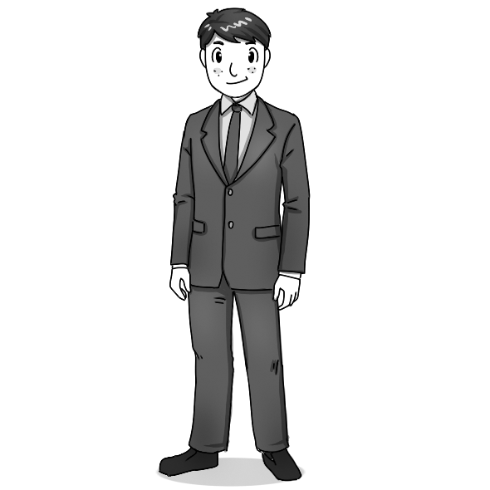  2. ______
新北市立 新 北 高工 108 學年度 第二學期 期 末 考 |  |  |  |  |  |  |  |  |  |  |  |  | 班級 |  | 座號 |  | 成 | P.2
科目 | 英文 | 年級 | 二 | 科別 | 機鑄汽模圖電資訊 | 命題教師 | 陳玟如 |  | 審題教師 | 張哲瑋 |  |  | 姓名 |  |  |  | 績 | P.2
29. （ ）The old man _____ for help after he fell down the stairs.  (A) called out (B) called off (C) called up (D) called in  30. （ ）There are so many words on this menu that I don’t know. I think I’ll have to _____ some of the words before I order. (A) hear up (B) hear out (C) look up (D) look out  31. （ ）The parents encouraged their daughter to let her passion for painting _____.  (A) dress up (B) run wild (C) go crazy (D) wear out  III. 文法選擇22%  32. （ ）I owe you many thanks. It was _____ that I could get through all the difficulties. (A) your help (B) you helped me (C) for you (D) because of your help  33. （ ）I wonder why those kids keep staring at me as if I _____ an alien. Is there something on my face? (A) am (B) were (C) have been (D) had been  34. （ ）We have done everything we can to solve the problem. All we can do right now _____ hope for the best. (A) is (B) was (C) has been (D) will  35. （ ）Edward is holding the dog _____ it belonged to him, but in fact it is Hank’s pet. (A) even if (B) so that (C) as though (D) rather than  36. （ ）_____ Robert is a successful businessman and very wealthy, he never looks down on others. (A) Though (B) Despite (C) Whether (D) Therefore  37. ( ) All you have to do is your teeth after every meal.  - brushing (B) brushes (C) brushed (D) brush  38. （ ）We should show the utmost respect to firefighters, _____ jobs require bravery and sacrifice. (A) whose (B) whom (C) which (D) who  39. （ ）In spite of _____ for many jobs, John hasn’t heard back from a single employer yet. (A) have applied (B) to apply (C) apply (D) applying  40. （ ）_____ Patricia was trying to be careful, she still cut her finger.  (A) Despite (B) In spite of (C) Although (D) If  41. ( ) It is my parents’ support me the confidence to keep going.  (A) which give (B) that gives (C) they give (D) that giving  42. ( ) I have two sisters. One of them is really tidy, but is very messy.  (A) others (B) another (C) the others (D) the other  IV. 對話10%  43. Clerk: Here you are. Size 6. May: Thank you. _____  Clerk: Of course. The fitting room is right this way.  (A) Could you give me a hand? (B) May I try it on?  (C) Is that a good one? (D) May I buy it online? |  |  |  |  |  |  |  |  |  |  |  | 44. Joanna: Do you have these jeans in a medium size? Clerk: Yes. Here you are.  Joanna: _____ How much are they? Clerk: They’re NT$780.  (A) They don’t fit me. (B) It beats me! (C) I turned them down. (D) I’ll take them.  45. Clerk: Good evening. What can I do for you? Andy: Oh! _____  Clerk: I see. Take your time. Please let me know if you need any service.  (A) This skirt is too flashy. (B) I am just looking around.  (C) It’s our latest style. (D) I will wrap it up for you.  46. Luke: May I pay by credit card? Clerk: Sure. _____  Luke: Oh, then I’ll pay in cash.  (A) But there is a 5% discount if you pay in cash. (B) All the items in the store are on sale.  (C) I can give you a special discount. (D) Credit cards are convenient to use now.  47. Helen: I’d like to return this hat. Clerk: _____  Helen: It’s too old-fashioned. Clerk: Would you like to exchange it for a more stylish one?  Helen: No, I’d like a refund, please.  (A) We’ll be happy to see you again. (B) What seems to be the problem with it?  (C) Which one do you like? (D) I’d like to expand the company.  V.克漏字14%  In the US, one school has set up a program 48. “Dress for Success” to take 49. of the power that clothes have over us. On Mondays, 50. jeans and T-shirts, the boys put on suits and the girls wear skirts and blouses to school. It seems that this change in their appearance has a 51. effect on the students. One of the teachers commented, “The kids  52. dress for success are already in that heads-up, shoulders-back, good-morning kind of  53. . When they have that attitude, their behavior is usually better 54. the rest of the day.”  （ ）(48) (A) which called (B) called (C) calling (D) that calling  （ ）(49) (A) researcher (B) advantage (C) profession (D) accuracy  （ ）(50) (A) besides (B) more than (C) as well as (D) instead of  （ ）(51) (A) significant (B) worst (C) normal (D) accurate  （ ）(52) (A) when (B) where (C) who (D) which  （ ）(53) (A) mood (B) wood (C) moon (D) book  （ ）(54) (A) over (B) on (C) since (D) for  選擇題 共54題 請仔細核對題號,並在答案卡劃上座號!! 未劃座號者酌扣五分

