請在電腦答案卡上劃上座號，並將選擇題答案劃卡作答,共55題，劃記不清者，扣總分
5分! 祝同學能有好成績，加油!!
一 、Listening Comprehension Test聽力測驗 10% (共10題) /@1
第一部分：Pictures看圖辨義 (每題播放兩遍)
試卷上該題有一張圖片，請聽一個和該題相關的問題，與(A)、(B)、(C)三個英語敘述後，選一個與所看到圖片最相符的答案。
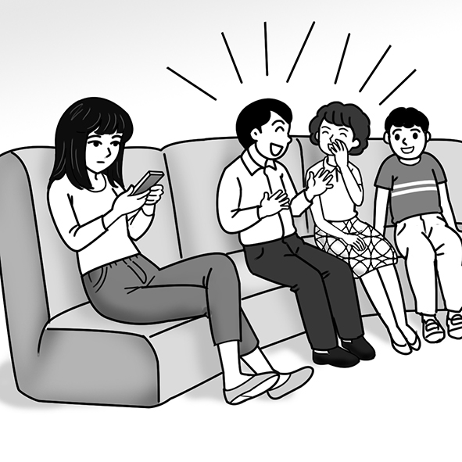 1. _________

第二部分：Best Response問答 (每題播放兩遍)
每題會播出一個問句或直述句，聽後請由試卷上(A)、(B)、(C)三個選項中，選出一個最適合的回答或回應。(劃卡2-4題)
_______ 1. (A) It’s very satisfying.
(B) Yes, we are dating.
(C) I met her last year.
_______ 2. (A) Yes, I did. Sorry I didn’t respond yet.
(B) No, I didn’t see her the other day.
(C) Sure, I’d like to meet up with you.
_______3. (A) Yes, she was the winner.
(B) I felt truly amazed.
(C) I can’t believe she lost.

第三部分：Short Conversations簡短對話 (每題播放兩遍)
每題會播出一段對話及一個相關的問題，聽後請由試卷上(A)、(B)、(C)三個選項中，選出一個最適合的回答。(劃卡5-7題)
_______ 1. (A) She can’t find the books she needs.
(B) She can’t think of what to focus on.
(C) She can’t understand the topic she chose.
_______ 2. (A) He was always too busy.
(B) He was always focusing on his phone.
(C) He didn’t really show his love to her.
_______ 3. (A) He’s upset.
(B) He’s fine.
(C) He’s worried.
第四部分：Short Talk短文聽解 (每題播放兩遍)
每題有三個圖片選項。請聽題目，並選出一個最適當的圖片。(劃卡8-10題)
1. _______
(A) (B) (C)
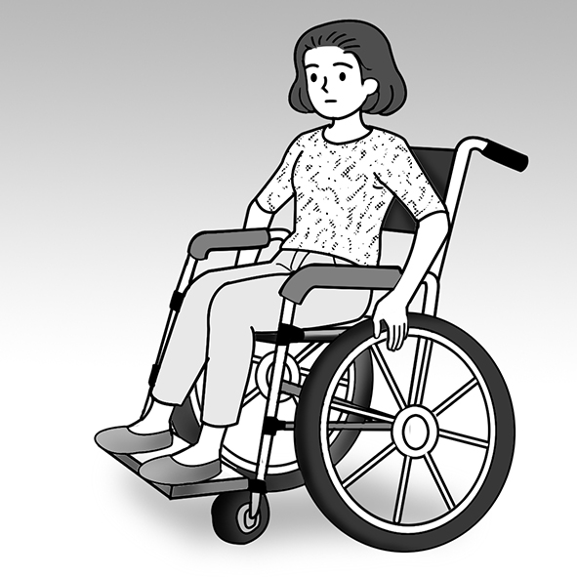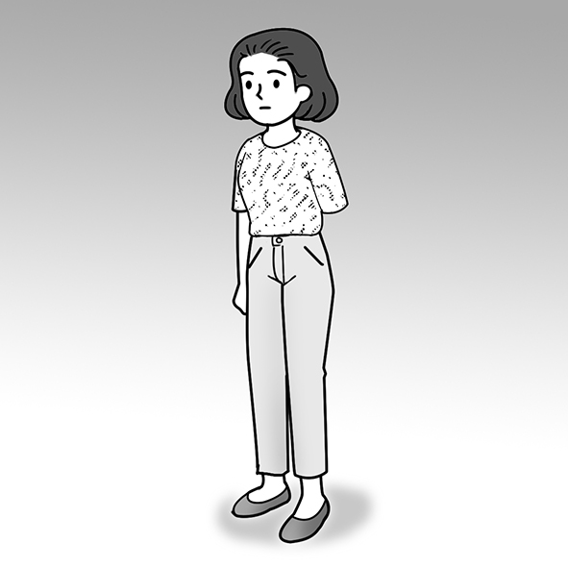
2. _______
(A) (B) (C)
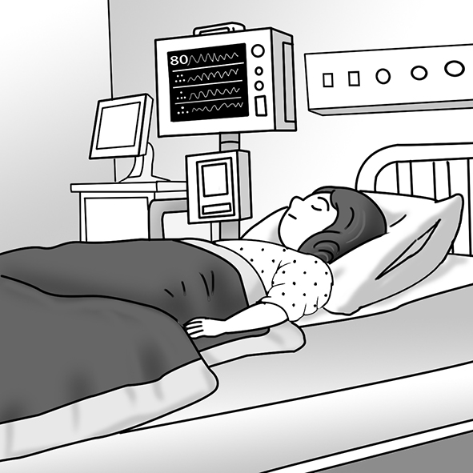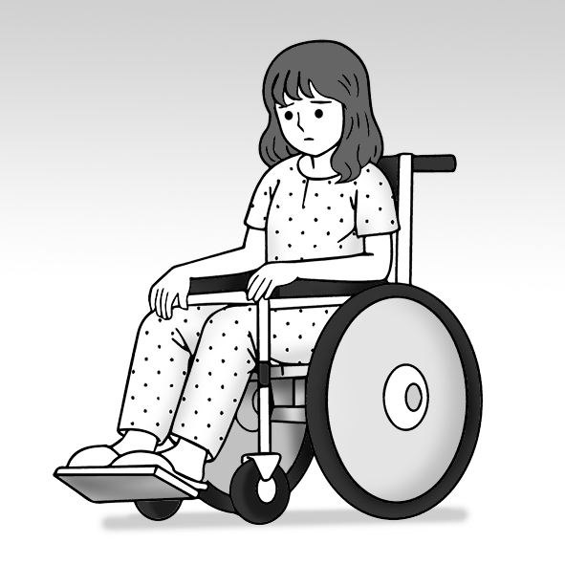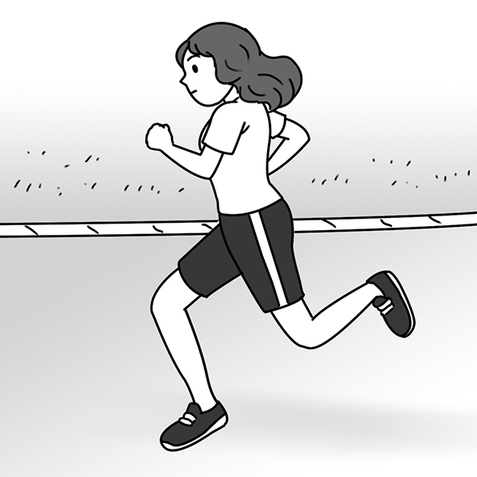
3. _______
(A) (B) (C)
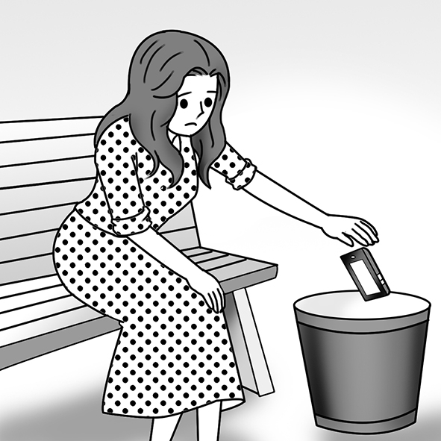

- 文意字彙選擇 16% (11-18題)/@2
- （ ）Luke was very ____________ because his parents flew over seven hours to attend his birthday party. (A) disabled (B) touched (C) enjoyable (D) inspiring

- （ ）Hugh will ____________ in the school play by playing the role of the big bad wolf. (A) believe (B) overcome (C) participate (D) introduce
- （ ）The fans ____________ loudly when the movie star showed up at the movie theater. (A) agreed (B) replied (C) promised (D) cheered
- （ ）Cynthia didn’t ____________ the smoke coming from the kitchen because she was talking on the phone. (A) notice (B) chase (C) describe (D) adopt
- （ ）My pain ____________ after I took some medicine and had a good sleep.
(A) encountered (B) disappointed (C) disappeared (D) experienced
- （ ）Thank you so much for driving for hours to attend my wedding; I’m truly moved!
(A) wonderful (B) touched (C) willing (D) strict
- （ ）Ann wants to have a(n) ordinary life because her family moves every year.
(A) normal (B) recent (C) proud (D) social
- （ ）Dolphins are very clever animals because they can understand what humans tell them to do. (A) humid (B) greedy (C) military (D) intelligent
三、會話14% (19-25題) /@2
- （ ）Ben: How are you feeling after your surgery?
Dave: Pretty good. I may be able to play tennis again after a few months.
Ben: That’s good news. ____________
Dave: Thank you, buddy.
(A) I don’t want to play tennis. (B) I wish you luck. (C) You’re doing me a favor.
(D) No news is good news.
- （ ）Emily: ____________
Jane: I hurt my ankle when I was coming down the stairs a few days ago.
Emily: It must be painful!
Jane: You bet. I’m hoping I can walk normally again pretty soon.
(A) How did you get here? (B) What’s wrong with your hands? (C) Why not watch some TV with me? (D) What’s going on with your foot?
- （ ）Dana: Hi, Elle. Thanks for coming over.
Elle: Of course. ____________
Dana: I’m just a bit worried. My boyfriend hasn’t called me today.
Elle: He’s probably just busy at work.
(A) Is everything OK with you? (B) Are you sure about that? (C) What’s the time? (D) Who are you talking to?
- （ ）Dr. Tucker: Good morning, Liz. ________________________
Liz: Fine, I guess. I feel better because I’m taking the medicine.
Dr. Tucker: Good. Now I’ll examine your throat. Please open your mouth.
(A) What’s going on? (B) How can I help you? (C) How’s everything? (D) What did the doctor say?
- （ ）Lisa: ________________________ You look pale (蒼白的).
Jonathan: I’m not feeling well. I think I might need to rest for a while.
Lisa: Maybe you should see a doctor.
(A) Where did you go? (B) Who’s there? (C) What’s going on? (D) How are you?
- （ ）School Nurse: Nick, ________________________ Did you see a doctor?
Nick: I did, Mrs. Feldman. But I just spilled (灑出) some water on my wound.
School Nurse: I’ll fix this...there you go. Remember to keep it dry.
Nick: Thank you, Mrs. Feldman.
(A) what did the doctor say? (B) is everything OK with you? (C) are you going to give up? (D) what did it feel like?
- （ ）Brett: Hey, Sarah. ________________________
Sarah: Pretty well, actually. My doctor said I can go home in three days.
Brett: That’s great! I’m really happy for you.
(A) How’s your recovery coming along? (B) What happened to you? (C) Did I miss anything while I was away? (D) Are you sure about leaving here?
四、文法選擇 30% (26-40題) /@2
- （ ）Father ____________ me plan my summer schedule (日程表) in order to use my time wisely. (A) ordered (B) asked (C) caused (D) had
- （ ）Zoe’s mother ____________ works as a nurse, came to our class to share some of her working experiences with us. (A) , who (B) , which (C) whose (D) who
- （ ）Joan bought the dress at Dream Mall ____________ is a famous department store
in Kaohsiung. (A) which (B) , which (C) who (D) , who
- （ ）We cheered loudly for the players ____________ were fighting for our class in our school basketball game. (A) which (B) , which (C) who (D) ,who
- （ ）The police officer made the driver ____________ over to the roadside.
(A) to pull (B) pulling (C) pulled (D) pull
- （ ）Watching the sad movie made Anita ____________. She was deeply moved.
(A) to cry (B) cry (C) cries (D) crying
- （ ）DisneySea____________ is located in Tokyo, attracts millions of visitors every year. (A) which (B) , who (C) ,which (D) who
- （ ）Sarah’s grandmother, ____________ was a skillful tailor (裁縫), taught her how to make clothes. (A) that (B) whom (C) × (D) who
- （ ）The boy’s mother has ____________ outside the grocery store (雜貨店).
(A) he wait (B) he to wait (C) him wait (D) him to wait
- （ ）Every summer vacation, I stay at my grandparents’ house, ____________ my great-grandfather built seventy years ago.
(A) whom (B) that (C) which (D) ×
- （ ）Elsa was born ____________ an eye problem, so she can’t see things very clearly. (A)of (B) in (C) at (D) with
- （ ）Rick’s parents noticed ____________ Rick’s eyes would move with them. (A) it (B) what (C) which (D) that
- （ ）I would love to take part ____________ the game, but I still have a lot of work to do. Maybe next time. (A) in (B) on (C) × (D) at
- （ ）Peter tripped (絆倒) at the beginning of the race and finished ____________.
(A) next last (B) beside last (C) two to last (D) second to last
- （ ）The plum (梅) flower is known ____________ our national flower. (A) as (B) for (C) to (D) by
五、綜合測驗 20% (41-50題) /@2
(a.)
Dick Hoyt and his son Rick were a racing team. Rick was born (41)____________ a disease, so he couldn’t move or speak easily. The doctors didn’t think he could live a regular life. However, his parents thought (42)____________ he was smart and could share his ideas with others. At age 15, Rick wanted to enter a race. Dick had Rick sit (43)____________ his wheelchair and he pushed his son along. Together they finished the race. Since then, the father-son team (44)____________ more than 1000 races. They’ve also created an organization that aimed to make others like Rick (45)____________ happier. Their main idea was, “Yes, you can!”.
（ ）(41) (A) for (B) in (C) with (D) to
（ ）(42) (A) what (B) where (C) how (D) that
（ ）(43) (A) under (B) above (C) in (D) on
（ ）(44) (A) has finished (B) to finish (C) finishing (D)finish
（ ）(45) (A) to feel (B) feel (C) feeling (D) to feeling

(b.)
Rick Hoyt was born with cerebral palsy. He has difficulty __(46)__ and speaking. Doctors said Rick would never get better, but his parents did not __(47)__. When Rick was fifteen, he told his father, Dick, that he wanted to run in a race. Dick pushed Rick in a wheelchair, and they finished __(48)__.
Now Dick and Rick are __(49)__ as “Team Hoyt.” They have completed more than 1,000 races. They even raced across the US! Their goal is to make disabled young people __(50)__ strong. They want to tell everyone, “Yes, you can!”
（ ）(46) (A) to move (B) moves (C) moved (D) moving
（ ）(47) (A)give to (B) give away (C) give up(D) give off
（ ）(48) (A) second to last (B) last to second (C) last second to (D) to second last
（ ）(49) (A) known (B) knew (C) knowing (D) know
（ ）(50) (A) feeling (B) feel (C) to feel (D) felt
六、閱讀測驗10% (51-55題) /@2
(1.)
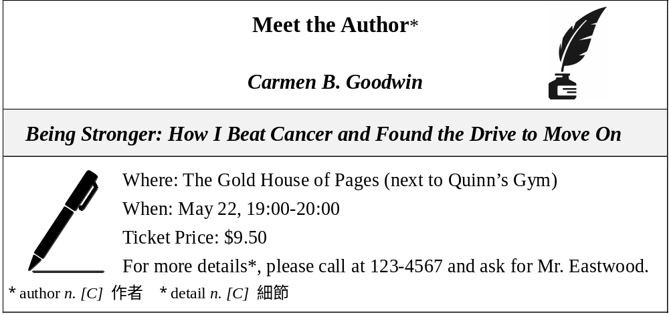
（ ）(51) What kind of event is the poster probably advertising (廣告)? (A) A store opening. (B) A book signing. (C) A pop-shop fair. (D) A dance club party.
（ ）(52) According to the poster, which of the following is true? (A) There will be two speakers. (B) The event is free. (C) The event lasts for one hour. (D) The event will be held in a gym.

(2) Terry Fox was born in Canada on July 28, 1958. As a teenager, Fox loved to play sports. In 12th grade, he won the award* for best athlete* of the year. In college, he studied to become a gym teacher. Everything changed for Fox in 1977, though. That’s when the doctors told him he had bone cancer. To remove the cancer, the doctors had to cut off his right leg above the knee. They said he probably wouldn’t be able to play sports again.
Amazingly, Fox was already playing sports a few weeks after his surgery! He used an artificial* leg to walk, and he won three national awards while playing on a wheelchair basketball team. But Fox wanted everyone in the world to know about cancer. He decided to run across Canada to raise people’s awareness. In the end, he raised nearly two million dollars for cancer research*. Sadly, he had to stop his cross-country running because of the pain, and he died on June 28, 1981 at the age of 22. He will forever be remembered as a national hero.
* award n. [C] 獎項 * athlete n. [C] 運動員 * artificial adj. 人工的 * research n. [U] 研究

（ ）(53) What is the purpose of the passage?
(A) To raise money. (B) To explain a disease.
(C) To encourage us to play sports. (D) To introduce a brave man.
（ ）(54) When did Terry Fox undergo (經歷) surgery to remove his cancer?
- In 1981. (B) In 1958. (C) In 1977. (D) In 12th grade.

（ ）(55) According to the passage, which of the following about Terry Fox is NOT true?
(A) He wanted to become a PE teacher after college.
(B) He once played wheelchair basketball.
(C) He was seen by Canadians as a national hero.
(D) He raised money for his cancer treatment.
*********試題結束*******

