請在電腦答案卡上劃上座號，並將選擇題答案劃卡作答,共50題，劃記不清者，扣總分
5分! 祝同學能有好成績，加油!!
一 、Listening Comprehension Test聽力測驗 10% (共10題) /@1
第一部分：Pictures看圖辨義 (每題播放兩遍)
試卷上該題有一張圖片，請聽一個和該題相關的問題，與(A)、(B)、(C)三個英語敘述後，選一個與所看到圖片最相符的答案。
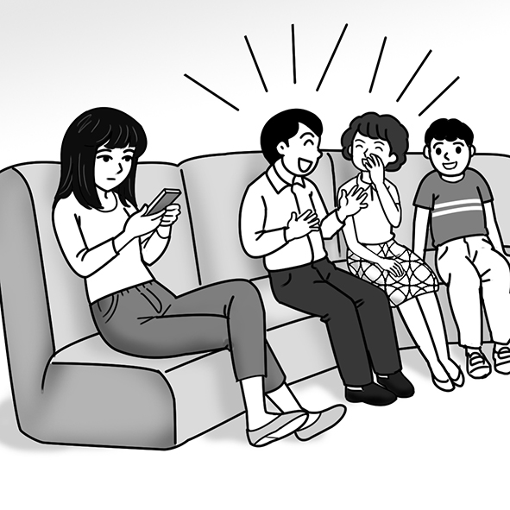 1. _________

第二部分：Best Response問答 (每題播放兩遍)
每題會播出一個問句或直述句，聽後請由試卷上(A)、(B)、(C)三個選項中，選出一個最適合的回答或回應。(劃卡2-4題)
_______ 1. (A) It’s very satisfying.
(B) Yes, we are dating.
(C) I met her last year.
_______ 2. (A) Yes, I did. Sorry I didn’t respond yet.
(B) No, I didn’t see her the other day.
(C) Sure, I’d like to meet up with you.
_______3. (A) Yes, she was the winner.
(B) I felt truly amazed.
(C) I can’t believe she lost.

第三部分：Short Conversations簡短對話 (每題播放兩遍)
每題會播出一段對話及一個相關的問題，聽後請由試卷上(A)、(B)、(C)三個選項中，選出一個最適合的回答。(劃卡5-7題)
_______ 1. (A) She can’t find the books she needs.
(B) She can’t think of what to focus on.
(C) She can’t understand the topic she chose.
_______ 2. (A) He was always too busy.
(B) He was always focusing on his phone.
(C) He didn’t really show his love to her.
_______ 3. (A) He’s upset.
(B) He’s fine.
(C) He’s worried.
第四部分：Short Talk短文聽解 (每題播放兩遍)
每題有三個圖片選項。請聽題目，並選出一個最適當的圖片。(劃卡8-10題)
1. _______
(A) (B) (C)
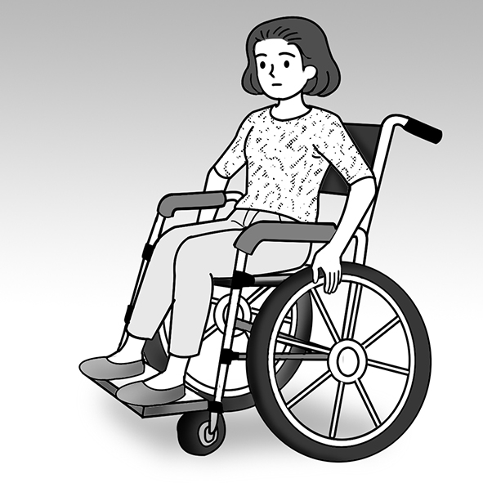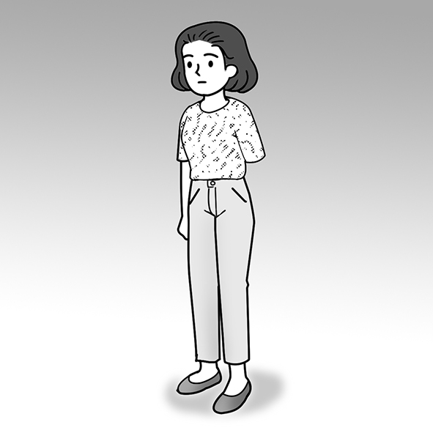
2. _______
(A) (B) (C)
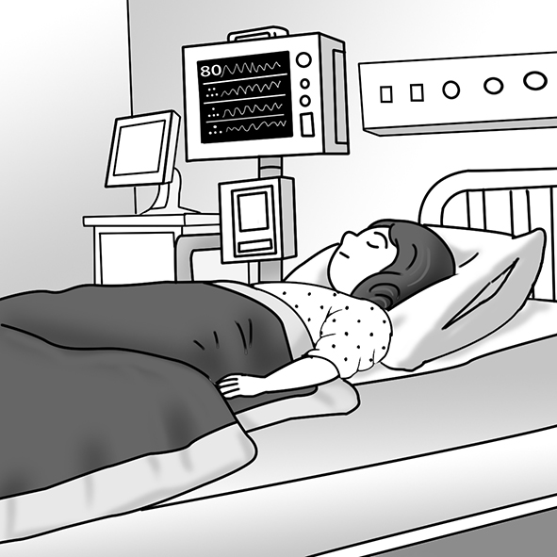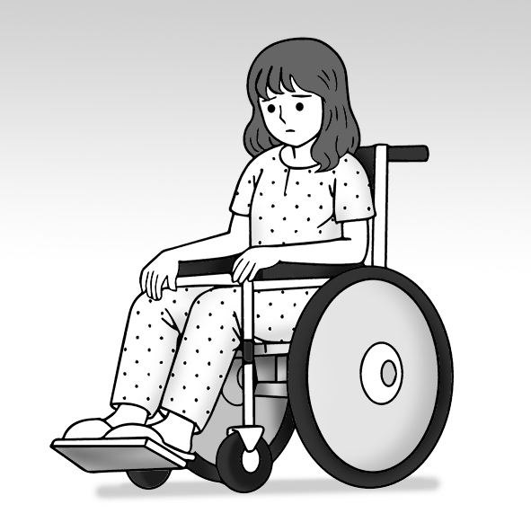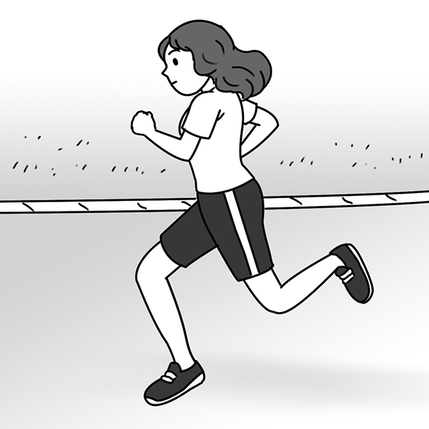
3. _______
(A) (B) (C)
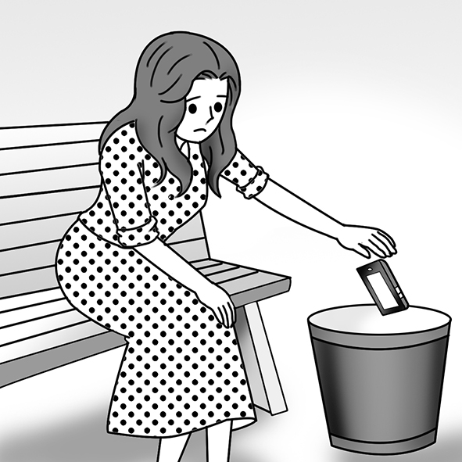

- 文意字彙選擇 10% (11-20題)/@1
- （ ）Luke was very ____________ because his parents flew over seven hours to attend his birthday party. (A) disabled (B) touched (C) enjoyable (D) inspiring
- （ ）Hugh will ____________ in the school play by playing the role of the big bad wolf. (A) believe (B) overcome (C) participate (D) introduce
- （ ）The fans ____________ loudly when the movie star showed up at the movie theater. (A) agreed (B) replied (C) promised (D) cheered
- （ ）Cynthia didn’t ____________ the smoke coming from the kitchen because she was talking on the phone. (A) notice (B) chase (C) describe (D) adopt
- （ ）My pain ____________ after I took some medicine and had a good sleep. (A) encountered (B) disappointed (C) disappeared (D) experienced
- （ ）The global warming talk ____________ many of the students to care more about the Earth. (A) introduced (B) impressed (C) inspired (D) ignored
- （ ）Tracy ____________ the printer to her computer, and then printed out some family photos. (A) confirmed (B) connected (C) considered (D) continued
- （ ）Leah ____________ her boyfriend Nicholas to her parents at the Christmas party. (A) introduced (B) inspired (C) ignored (D) imagined
- （ ）Thank you so much for driving for hours to attend my wedding; I’m truly moved! (A) wonderful (B) willing (C) touched (D) strict
- （ ）Ann wants to have a(n) ordinary life because her family moves every year. (A) normal (B) recent (C) proud (D) social

三、會話10% (21-25題) /@2
- （ ）Ben: How are you feeling after your surgery?
Dave: Pretty good. I may be able to play tennis again after a few months.
Ben: That’s good news. ____________
Dave: Thank you, buddy.
(A) I don’t want to play tennis. (B) I wish you luck. (C) You’re doing me a favor. (D) No news is good news.
- （ ）Emily: ____________
Jane: I hurt my ankle when I was coming down the stairs a few days ago.
Emily: It must be painful!
Jane: You bet. I’m hoping I can walk normally again pretty soon.
(A) How did you get here? (B) What’s wrong with your hands? (C) Why not watch some TV with me? (D) What’s going on with your foot?
- （ ）Dana: Hi, Elle. Thanks for coming over.
Elle: Of course. ____________
Dana: I’m just a bit worried. My boyfriend hasn’t called me today.
Elle: He’s probably just busy at work.
(A) Is everything OK with you? (B) Are you sure about that? (C) What’s the time? (D) Who are you talking to?
- （ ）Lisa: ________________________ You look pale (蒼白的).
Jonathan: I’m not feeling well. I think I might need to rest for a while.
Lisa: Maybe you should see a doctor.
(A) Where did you go? (B) Who’s there? (C) What’s going on? (D) How are you?
- （ ）Brett: Hey, Sarah. ________________________
Sarah: Pretty well, actually. My doctor said I can go home in three days.
Brett: That’s great! I’m really happy for you.
(A) How’s your recovery coming along? (B) What happened to you? (C) Did I miss anything while I was away? (D) Are you sure about leaving here?
四、文法選擇 20% (26-35題) /@2
- （ ）Father ____________ me plan my summer schedule (日程表) in order to use my time wisely. (A) ordered (B) asked (C) caused (D) had
- （ ）Zoe’s mother ____________ works as a nurse, came to our class to share some of her working experiences with us. (A) , who (B) , which (C) whose (D) who
- （ ）Joan bought the dress at Dream Mall ____________ is a famous department store
in Kaohsiung. (A) which (B) , which (C) who (D) , who
- （ ）The police officer made the driver ____________ over to the roadside. (A) to pull (B) pulling (C) pulled (D) pull
- （ ）Watching the sad movie made Anita ____________. She was deeply moved. (A) to cry (B) cry (C) cries (D) crying
- （ ）Sarah’s grandmother, ____________ was a skillful tailor (裁縫), taught her how to make clothes. (A) that (B) whom (C) × (D) who
- （ ）The boy’s mother has ____________ outside the grocery store (雜貨店). (A) he wait (B) he to wait (C) him wait (D) him to wait
- （ ）William travels to Japan almost every summer. He ____________ there more than
seven times already! (A) was (B) had been (C) has been (D) would be
- （ ） I ____________ from my classmate Julia since we graduated from high school. (A) haven’t heard (B) didn’t hear (C) not hear (D) am not hearing
- （ ）In Taiwan, it is unusual and even illegal ____________ a child to leave school and start to earn money. (A) forces (B) to force (C)forced (D) to forcing
五、綜合測驗 20% (36-45題) /@2
Dick Hoyt and his son Rick were a racing team. Rick was born (36)____________ a disease, so he couldn’t move or speak easily. The doctors didn’t think he could live a regular life. However, his parents thought (37)____________ he was smart and could share his ideas with others. At age 15, Rick wanted to enter a race. Dick had Rick sit (38)____________ his wheelchair and he pushed his son along. Together they finished the race. Since then, the father-son team (39)____________ more than 1000 races. They’ve also created an organization that aimed to make others like Rick (40)____________ happier. Their main idea was, “Yes, you can!”.
（ ）(36) (A) for (B) in (C) with (D) to
（ ）(37) (A) what (B) where (C) how (D) that
（ ）(38) (A) under (B) above (C) in (D) on
（ ）(39) (A) has finished (B) to finish (C) finishing (D)finish
（ ）(40) (A) to feel (B) feel (C) feeling (D) to feeling

Rick Hoyt was born with cerebral palsy. He has difficulty __(41)__ and speaking. Doctors said Rick would never get better, but his parents did not __(42)__. When Rick was fifteen, he told his father, Dick, that he wanted to run in a race. Dick pushed Rick in a wheelchair, and they finished __(43)__.
Now Dick and Rick are __(44)__ as “Team Hoyt.” They have completed more than 1,000 races. They even raced across the US! Their goal is to make disabled young people __(45)__ strong. They want to tell everyone, “Yes, you can!”
（ ）(41) (A) to move (B) moves (C) moved (D) moving
（ ）(42) (A)give to (B) give away (C) give up(D) give off
（ ）(43) (A) second to last (B) last to second (C) last second to (D) to second last
（ ）(44) (A) known (B) knew (C) knowing (D) know
（ ）(45) (A) feeling (B) feel (C) to feel (D) felt

六、閱讀測驗10% (46-50題) /@2
(1.)
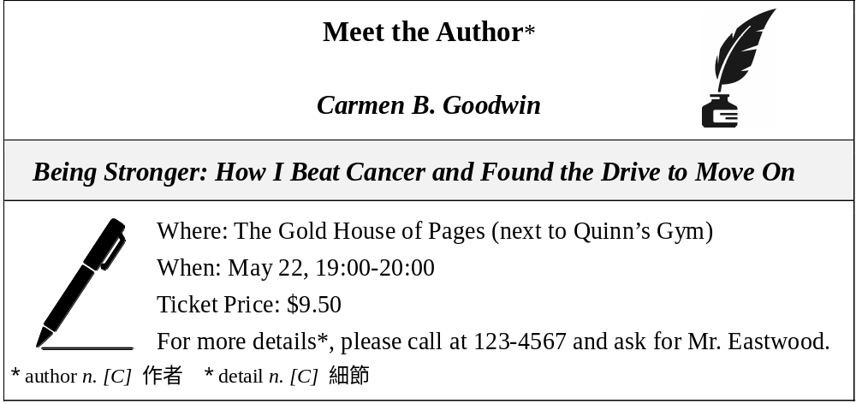
（ ）(46) What kind of event is the poster probably advertising (廣告)? (A) A store opening. (B) A book signing. (C) A pop-shop fair. (D) A dance club party.
（ ）(47) According to the poster, which of the following is true? (A) There will be two speakers. (B) The event is free. (C) The event lasts for one hour. (D) The event will be held in a gym.

(2) Terry Fox was born in Canada on July 28, 1958. As a teenager, Fox loved to play sports. In 12th grade, he won the award* for best athlete* of the year. In college, he studied to become a gym teacher. Everything changed for Fox in 1977, though. That’s when the doctors told him he had bone cancer. To remove the cancer, the doctors had to cut off his right leg above the knee. They said he probably wouldn’t be able to play sports again.
Amazingly, Fox was already playing sports a few weeks after his surgery! He used an artificial* leg to walk, and he won three national awards while playing on a wheelchair basketball team. But Fox wanted everyone in the world to know about cancer. He decided to run across Canada to raise people’s awareness. In the end, he raised nearly two million dollars for cancer research*. Sadly, he had to stop his cross-country running because of the pain, and he died on June 28, 1981 at the age of 22. He will forever be remembered as a national hero.
* award n. [C] 獎項 * athlete n. [C] 運動員 * artificial adj. 人工的 * research n. [U] 研究
（ ）(48) What is the purpose of the passage? (A) To raise money. (B) To explain a disease. (C) To encourage us to play sports. (D) To introduce a brave man.
（ ）(49) When did Terry Fox undergo (經歷) surgery to remove his cancer? (A) In 1981. (B) In 1958. (C) In 1977. (D) In 12th grade.
（ ）(50) According to the passage, which of the following about Terry Fox is NOT true? (A) He wanted to become a PE teacher after college. (B) He once played wheelchair basketball.(C) He was seen by Canadians as a national hero.
(D) He raised money for his cancer treatment.

*請同學務必將手寫部分填寫在A4答案卷上，並寫上
班級、座號、姓名，否則不予計分，謝謝!

七、文意字彙及片語引導翻譯填充20% (1-20格)/@1
- Ellen couldn’t c____________t her smartphone to a Wi-fi network.
- Hey Wilson, may I i____________e you to my new boss and his wife?
- I can’t f____________s on my studies now because I didn’t sleep well last night.
- All of us were a____________d to see a killer whale jumping out of the water. It was a pleasant surprise.
- The party was w____________l. Everyone had a good time, and the food was good, too.

- The filmmaker (電影製作人) felt c____________t about his new movie and believed that most people would love it.
- Spencer is an i____________t dog; he learns new instructions (指示) quickly and can follow them almost every time.
- The John Tung F____________n reminds the public of how smoking can ruin their health.

- 很抱歉，請別認為這是針對你。我認為你的報告應該做些修正。
I am so sorry. Please don’t ①____________ this ②____________. I think you should make some changes in your report.
- 在你簽任何合約以前，記得要仔細閱讀所有的細節。
Remember to ①____________ ②(t)____________ all the details before you sign any contract.
- 這個桌球選手努力練習，目標是成為今年的全國冠軍。
This table tennis player practices hard and ①____________ ②____________ become the national champion this year.
- Tom非常認真地研讀這次的期末考；因此，他輕鬆地通過了。
Tom studied very hard for the final exam; ①____________ ②____________ ③(r)____________, he passed it easily.
- 去年夏天Mason參加了度假打工的計劃並且度過很棒的假期。
Last summer, Mason ①____________ ②____________ ③____________ a working holiday program and enjoyed a wonderful vacation.

********************試題結束**********************

