- 選擇題：請將答案畫記於答案卡。 同時請於卡上畫記班級、座號。
第一部分：看圖辨義(2%) 1~10 每題1分(共10分)
試卷上該題有一張圖片，請聽一個和該題相關的問題，與(A)、(B)、(C)三個英語敘述後，選一個與所看到圖片最相符的答案。
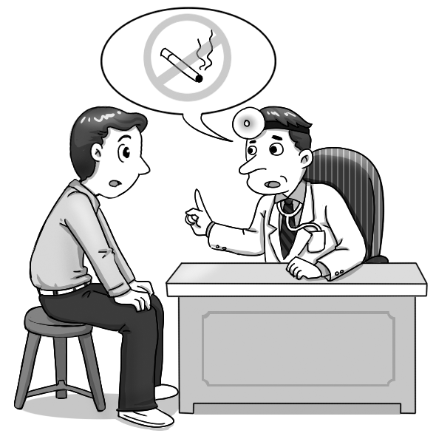  1. ______ | 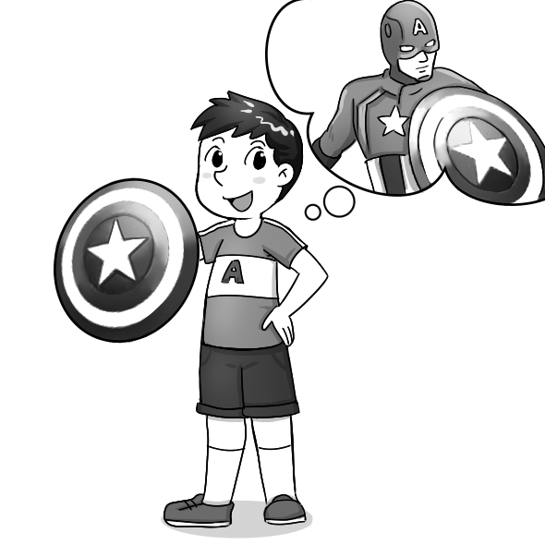  2. _____
第二部分：問答(3%)
每題會播出一個問句或直述句，聽後請由試卷上(A)、(B)、(C)三個選項中，選出一個最適合的回答或回應。
( )3. (A) He violated some of the rules.
(B) He was fired by the manager.
(C) He knows how to use the equipment.
( )4. (A) He received several injections from a scientist.
(B) He had great physical strength.
(C) He protected his people from harm in World War II.
( )5. (A) I might travel around the world.
(B) I would turn into an ugly frog.
(C) I would be known for my unique voice.

第三部分：簡短對話(3%)
每題會播出一段對話及一個相關的問題，聽後請由試卷上(A)、(B)、(C)三個選項中，選出一個最適合的回答。
( )6. (A) He’s a customer and wants to complain.
(B) He’s a manager and wants to be transferred.
(C) He’s an intern and wants to call in sick.
( )7. (A) To a park to play baseball.
(B) To a restaurant to have dinner.
(C) To her house to do some homework.
( )8. (A) A coffee club.
(B) A cosplay club.
(C) A music club.

第四部分：短文聽解(2%)
每題有三個圖片選項。請聽題目，並選出一個最適當的圖片。
( )9.
(A) (B) (C)
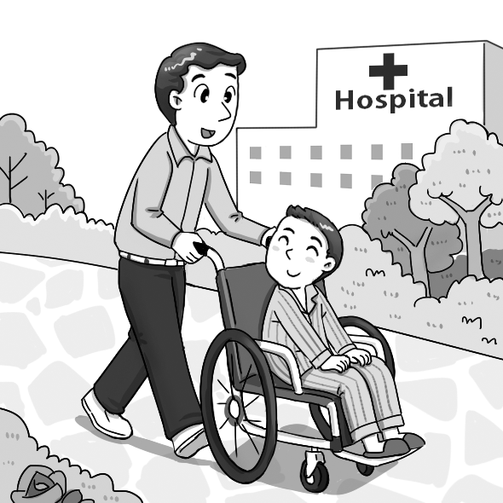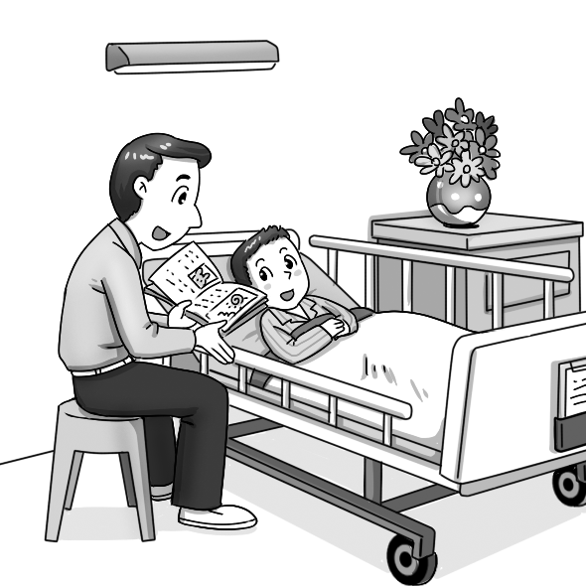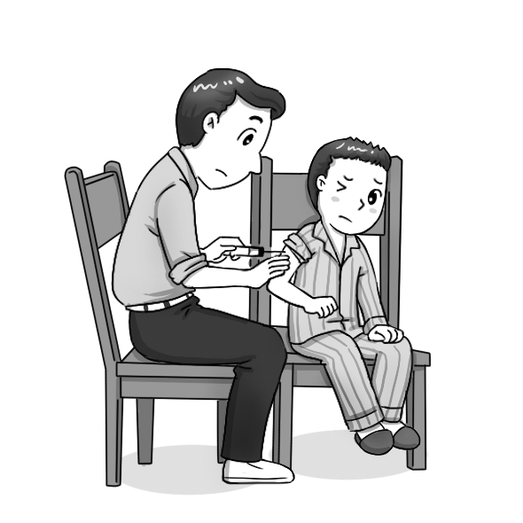

( )10.
(A) (B) (C)
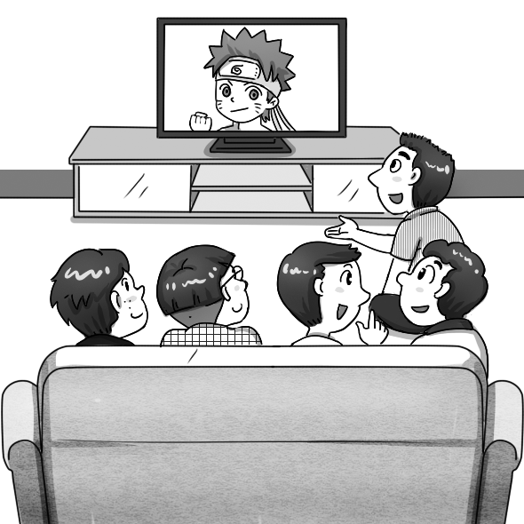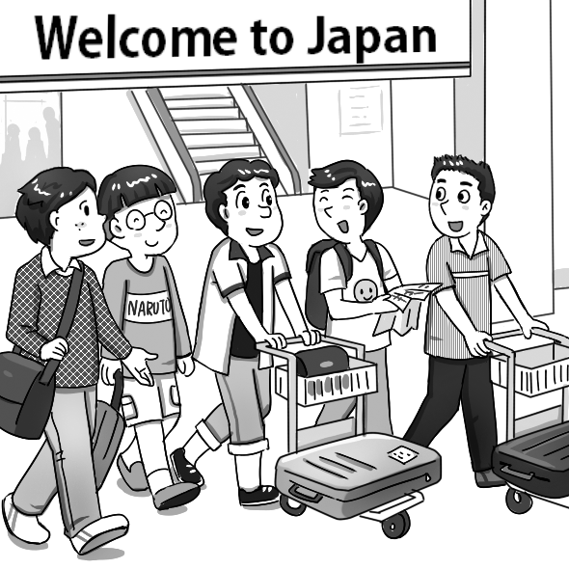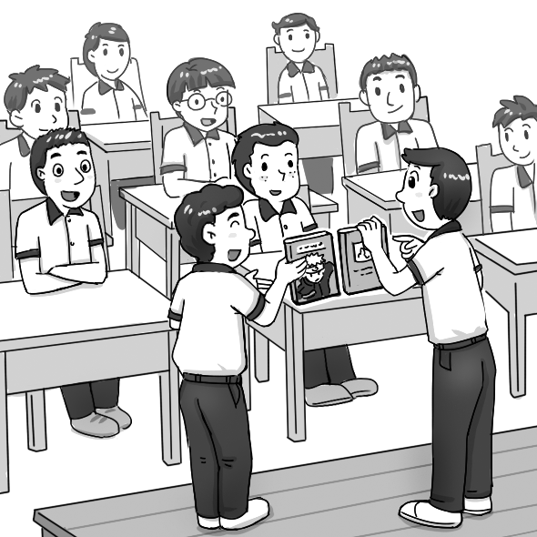

I. 單字選擇 6% (每題1分)
( )11 | Language and math classes are basic requirements in high school. (選同義詞)
 | (A) societies | (B) communities
 | (C) abilities | (D) necessities
( )12 | The dentist advised the patient to quit drinking coffee and come back to have his teeth cleaned again in six months. (選同義詞)
 | (A) remained | (B) ignored
 | (C) suggested | (D) respected
( )13 | The soldier used a shield to defend himself from the enemy’s attack. (選同義詞)
 | (A) struggle | (B) protect
 | (C) restrict | (D) protest
( )14 | With training, the athlete had built up the strength to lift 50 kg. (選同義詞)
 | (A) shield | (B) weapon
 | (C) power | (D) quote
( )15 | The average temperature in Kaohsiung in winter is between 18 and 24 degrees.  (選同義詞)
 | (A) emotional | (B) confident
 | (C) catchy | (D) ordinary
( )16 | After a hard struggle, I decided to ignore the rule. (選反義詞)
 | (A) disobey (B) break | (C) follow (D) violate
II克漏字選擇14%(每題2分)
Katie enjoyed her restaurant job more than the jobs she 17 before. She especially liked the weekly visit to the children’s hospital on behalf of the restaurant. 18 she did so, she felt happy. Although she was told not to touch the child patients, she was happy enough that she could make them smile for at least a short while.
One day, Katie heard a weak voice 19 her during her hospital visit. She turned around and saw a little kid with all kinds of machines 20 to his little body. “I’m Billy,” said the boy excitedly. “I like you and can’t wait 21 you a hug!”
Upon 22 this, Katie’s heart melted. She really wanted to hold the kid even though this would get her 23 . She was struggling inside. She needed this job, but how could she say no? When Billy opened his arms, Katie broke the rule, leaned forward, and hugged him tightly.

( B) 17. (A) has (B) had had (C) had (D) has had
( C) 18. (A) Whatever (B) Wherever (C) Whenever (D) However
( A) 19. (A) calling (B) called (C) to call (D) had called
( D) 20. (A) turned off (B) made up (C) was about (D) hooked up
( D) 21. (A) to give (B) giving (C) gave (D) for give
( A) 22 (A) heard (B) to hear (C) hearing (D) hear
( B) 23. (A) fired (B) fire (C) firing (D) to fire
III. 文法選擇 20% (每題2分)
( )24 | The train passengers demanded that they their money back due to the  three-hour delay.
 | (A) get |  |  | (B) got
 | (C) to get |  |  | (D) shoud got
( )25 | Upon the burning house, all the firefighters stayed cautious and watched out for danger.
 | (A) enter |  | (B) entered
 | (C) entering |  | (D) to enter
( )26 | Mary thanked Mrs. White for of her baby when she was sick.
 | (A) take care | (B) took care |  | (C) taking care | (D) taken care
( )27 | The boss ordered that the workers on time for the important meeting.
 | (A) to be | (B) being |  | (C) be | (D) were
( )28 | The teacher insisted that our hands _____ before very meal.
 | (A) should wash | (B) be washed |  | (C) wash | (D) be washing
( )29 | Hurry up! The musical show _______ start in five minutes. (選出錯誤者)
 | (A) is about to | (B) will |  | (C) is able to | (D) is going to
( )30 | When we were on our way to school this morning, we heard someone ____ for help in the park.
 | (A) screamed (B) screams |  |  | (C) to scream (D) screaming
( )31 | A rule required that I _____ the kids since I might give them my germs.
 | (A) don’t touch (B) not touching |  |  | (C) not touch (D) didn’t touch
( )32 | The vet suggested that the cat ____ an injection to calm it down.
 | (A) be given | (B) give |  | (C) giving | (D) gave
( )33 | On ____ into the campus, the students are _______ to wears masks.
 | (A) going ; require | (B) go ; required |  | (C) going ; requiring (D) going ; required

IV. 對話選擇 10% (每題2分)
( )34. Jessica: Hello, this is Jessica speaking. Is Mr. Johnson available?
Steve: Can you leave a message?
(A) That’s a hint.
(B) That’s a deal.
(C) I can’t wait.
(D) I’m afraid not.
一言為定。
( )35. Lynn: I’m not feeling well. .
Rachel: Don’t worry. I’ll tell the boss. Take care.
(A) I’ve heard a lot about it. (B) I won’t make it today.
(C) I’m having a good time. (D) I can’t wait.
( )36. Boss: What happened to Patty? She’s been absent for three days.
Jenny: She fell off her bike and broke her legs.
Boss: I see.
(A) I’m sorry to hear that.
(B) How is her doing?
(C) That’s a deal.
(D) Leave her alone.
( )37. A: Please wait a moment. I need to grab a pen to write down your message.
B: Sure.
(A) I hope not. (B) It’s so crowded.
(C) Take your time. (D) Take care of yourself.
( )38. Vincent: My trip to Japan in April is canceled due to the spread
of Wuhan(武漢) Coronavirus.
Vicky: ___________
(A) What a coincidence. (B) Why don’t you wear a mask?
(C) Well, health matters. (D) You stay away from me!

V. 閱讀測驗 10% (每題2分)
Read the passages and answer the follow up questions according to the readings.
Part 1
Dear Daniel,
If you'd like to improve your English, one thing you can do is to build up your vocabulary. In order to do this, you have to practice a lot. I’m afraid there is not a short cut for this. But there are many effective ways. First of all, you should read a lot. You can read short stories, comics, newspapers, magazines etc. depending on your English level. As you read, you can try to guess the meanings of unknown words from the context of the sentence. If you cannot, then look up the definition in a dictionary. English to English dictionary should be your first choice and keep the translator as last. Another way of building vocabulary is to watch movies in English which will also help with pronunciation. Try to be involved with the language as much as you can. Keep a vocabulary notebook and write down a few words each day. Keep in mind that you have to revise them regularly. In my opinion, to communicate with people all you need is words. Even if you just say the words one after another, people most likely will understand what you mean regardless of the order of the words and grammar.
39. What is the main point of this e-mail?
(A). What can we do to improve our English
(B). Difficulties of learning English
(C). Problems of learning a second language alone
(D). What's the best way of learning English

40. Which of the followings is incorrect?
(A). We should use a translator for all the unknown words.
(B). We should read a lot.
(C). We should take notes when we learn new words.
(D). We should practice as much as we can.

41. What is the most important thing to communicate with people according to the writer?
(A). Grammar
(B). Vocabulary
(C). Order of the words used
(D). Advanced English course
Part 2
Dear Matilda,
It’s been a month I haven’t heard from you. I hope you are well. I had a terrible day at school yesterday. My friends and I were playing volleyball in the school yard when I suddenly fell and twisted my ankle. At first I didn’t feel much pain, but later on it started hurting badly. I had difficulty walking so my friends helped me around. They took me to a hospital and stayed with me until my mom and dad arrived. The doctor said it was broken and I needed to rest for a month. We came home last night and I feel better now. This incident also made me realize how valuable friendships are. I don't know what I would do without them. So I want to say I feel very happy to have such good friends like you.
42. Which of the followings is incorrect?
(A). She hurt her arm.
(B). She injured her ankle.
(C). Her friends helped her get to a hospital.
(D). She won't be able to go to school for a month.

43. What does the girl want to emphasize in her e-mail?
(A). She should stop playing volleyball.
(B). The importance of friendship.
(C). The terrible day she had.
(D). The importance of school.

- 非選擇題 (請作答於A4作答紙)
A. 文義字彙 10% (請注意動詞變化；每題2分)
1. Bill Gates set up a non-profit o n aiming to help children who live in poverty all
over the world.
2. People in this village worship s_________l power such as the Wind God, the River
Goddess, and so on.
3. Kobe Bryan, a l_________y NBA player, died last month in a plane crash.
4. The boss was so generous that he treated his e______es to a one-week trip to Italy.
B. 填空式翻譯16 % (請注意動詞變化；每題2分)
1. Tanya拒絕了Jason一起去跳舞的邀請，這令他心碎。
Tanya (t)______ ________ Jason’s invitation to go to the dance with him, which
broke his heart.

2. 士兵值勤時不可以使用手機。
Soldiers are not allowed to use cellphones when they are _______ (d)_______.

3. 這個大城市是從一個小漁村開始發展的。
The big city (s)__________ __________ as a small fishing village.

4. 據氣象報導，明天溫度將驟降十度。
(B)_________ _______ the weather report, the temperature will drop by 10 degrees tomorrow.

請務必填寫考卷右上角的班級、姓名、座號，未寫扣5分。
A. 文義字彙 4% (請注意名詞複數變化；每題1分)
1 | __________________ | 2 | __________________
3 | __________________ | 4 | __________________

B. 填空式翻譯 16% (請注意動詞變化與大小寫；每題2分；每格只填一個單字)
1
2
3
4

C. 單字片語選填(選出最符合句意的單字或片語，並填入代號) 每題2分，10%
(A) equipped with | (B) known for | (C) hooked up to
(D) on my own | (E) made a great difference

( )1. The boy was _______ more medical equipment than I had ever seen.
( )2. All the classrooms are ________ a computer, a projector, a TV screen, an air conditioner and two speakers.
( )3. Miaoli(苗栗), a county in central Taiwan, is ________ its Hakka culture
and leopard cats.(石虎)
( )4. My parens won’t offer me any help. I have to do it ______.
( )5. The invention of the Internet has ______ in our lives.

