市立 新 北 高工 109 學年度 第二學期 第二段考 |  |  |  |  |  |  | 班級 |  |  | 座號 |  |  | 出題 | 高麗雯老師
科目 | 英文 | 年級 | 一 | 科別 | 模具科 |  | 姓名 |  | 劃卡 |  | 是 |  | 審題 | 陳旻旻老師
- I. 聽力測驗第一部分：看圖辨義 (試卷上該題有一張圖片，請聽一個和該題相關的問題，與(A)、(B)、(C)三個英語敘述後，選一個與所看到圖片最相符的答案。)每題二分  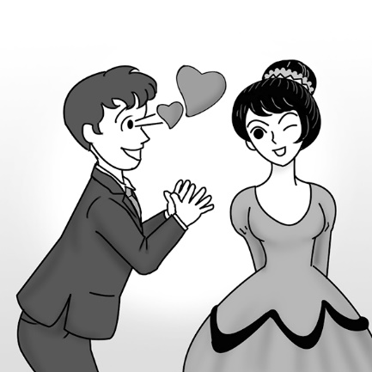 1. _________  第二部分：問答(每題會播出一個問句或直述句，聽後請由試卷上(A)、(B)、(C)三個選項中，選出一個最適合的回答或回應。)  _______ 2. (A) Yes, I have some.  (B) David is my brother.  (C) I think he’s upstairs.  _______ 3. (A) It’s the custom in my country.  (B) I don’t have much of an appetite.  (C) I would be honored.  _______ 4. (A) I’ll bring you one right away.  (B) I don’t know how to use chopsticks.  (C) That one is for eating dessert.  第三部分：簡短對話(每題會播出一段對話及一個相關的問題，聽後請由試卷上(A)、(B)、(C)三個選項中，選出一個最適合的回答。)  _______ 5. (A) Start eating.  (B) Help her with something.  (C) Prepare a dish.  _______ 6. (A) Study more.  (B) Calm down.  (C) Feel excited.  - II. 字彙及同義字選擇 (每題二分)  - 11.（ ）It is ____________ that some people smoke next to where the children play in the park.  - (A) cheerful (B) wonderful (C) shameful (D) intelligent  - 12.（ ）That table is ____________ for a group, so we can’t sit there.  - (A) attempted (B) reserved (C) completed (D) disagreed  - 13.（ ）George was ____________ for beating over 100 other participants in the race.  - (A) informed (B) focused (C) ignored (D) praised  - 14.（ ）Elsa is ____________ about her clothes. She buys them from only a few stores that she  - likes. (A) particular (B) confident (C) romantic (D) normal  - 15. （ ）You need to save some money before you study ____________. Living in another  - country can be expensive. (A) abroad (B) ahead (C) already (D) anywhere  - 16. （ ）Bill is seen as the best student in my class because he is hard-working and also willing to  - help others. (A) recorded (B) puzzled (C) included (D) regarded  - 17. （ ）Ian is watching out for any taxi which may be passing by right now.  - (A) keeping an eye out for (B) making ends meet (C) paying off (D) taking action  - 18.（ ）The firefighters were respected for saving the old woman from the burning house.  - (A) doubled (B) honored (C) controlled (D) accepted  - III. 文法選擇(每題二分)  - 19.（ ）Tim is tall and heavy, ____________ his brother Alex is short and thin.  - (A) because (B) since (C) while (D) so  - 20.（ ）Mt. Jade is the ____________ of all the mountains in Taiwan.  - (A) higher (B) high (C) much higher (D) highest  - 21.（ ）One of my goals for this year is to work ____________ than before.  - (A) harder (B) hard (C) hardest (D) to hard  - 22.（ ）Eve and I haven’t met for years. Now she is ____________ and ____________ than  - before. (A) tall; beautiful (B) taller; more beautiful  - (C) more tall; more beautiful (D) much tall; beautiful  - 23.（ ）There were ____________ people in the theater. I could count them on just one hand.  - (A) a little (B) little (C) a few (D) few  - 24.（ ）The teacher believed ____________ Kevin was not lying.  - (A) if (B) what (C) that (D) how  - 25.（ ）When it comes to ____________ an English poem, Wendy is the best in my class.  - (A) create (B) created (C) creation (D) creating  - Around the world, different places have different food customs. You may find __36.__ some of them are quite surprising. For example, the Japanese eat noodles very loudly. Doing so __37.__ their way to say the food is tasty. It shows they can’t wait __38.__ the food in their mouths.  On the __39.__ hand, Koreans don’t rush so much. Their custom is to show respect for older people. Young people must not eat until older people start __40.__. Korea is one of the most traditional Asian countries. However, traditional or not, every country has its own special customs.  （ ）36. (A) it (B) that (C) this (D) which  （ ）37. (A) is (B) are (C) was (D) were  （ ）38. (A) to get (B) got (C) gets (D) gotten  （ ）39. (A) another (B) others (C) every (D) other  （ ）40. (A) eaten (B) eats (C) ate (D) eating  VI. 素養題(每題二分)  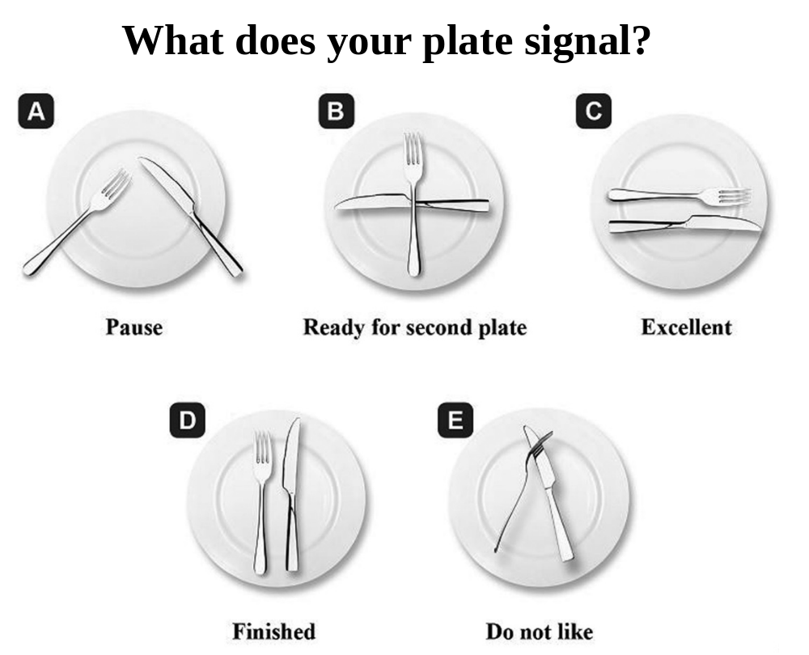  （ ）41. What does the word “signal” possibly mean? (A) To color something.  (B)To teach something. (C) To hold something. (D) To show something.  （ ）42. If you would like to praise the food, which “plate” can do this for you?  (A) A (B) B (C) C (D) E  （ ）43. If you would like to have some more food, which “plate” can do this for you? (A) A (B) B (C) C (D) E |  |  |  |  |  | _______ 7. (A) Wash the dishes.  (B) Wash his hands.  (C) Eat the food.  第四部分：短文聽解(每題有三個圖片選項。請聽題目，並選出一個最適當的圖片。)  8. _______  (A) (B) (C)  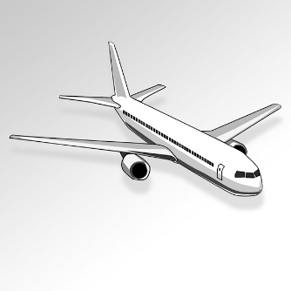  9. _______  (A) (B) (C)  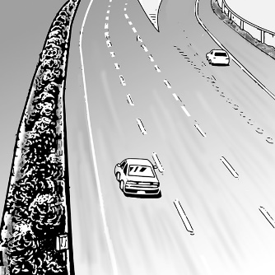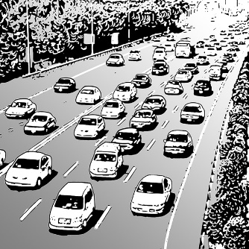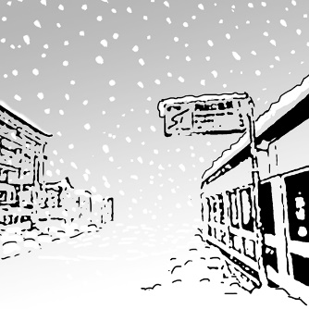  10. _______  (A) (B) (C)  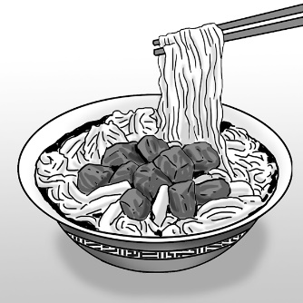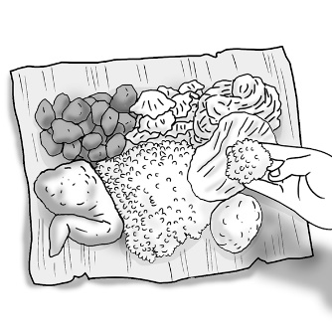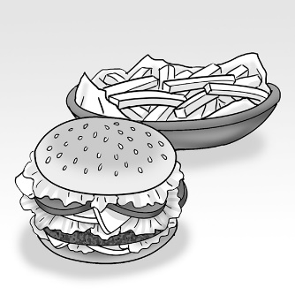  P1  - IV. 對話 (每題二分)  26.（ ）Lee: I heard this local Taiwanese restaurant is famous for its seafood fried rice.  Vincent: Really? ____________ But I don’t use chopsticks very well.  Lee: Don’t worry. The good thing is you can still use a spoon for your fried rice.  Vincent: That’s good news!  (A) I’m on a diet. (B) It’s up to you. (C) I didn’t mean it. (D) I’ll give it a try someday.  27.（ ）Lisa: In Taiwan, it is not okay to leave your chopsticks upright in a bowl of rice.  Zoe: Really? Why not?  Lisa: ________________________  (A) You can use a fork. (B) It is polite to do so.  (C) It is a taboo in the local culture. (D) That’s interesting.  28.（ ）Ethan: I just found NT$10,000 on the ground. Today is my lucky day!  Rita: ________________________ Don’t you think you should take the money to the police station?  (A) How do you do? (B) Calm down. (C) Here you go. (D) How did that happen?  29.（ ）Lee: Thanks for inviting me to your place for Christmas!  David: ________________________ Is this your first Christmas in the UK?  Lee: Yes, it is! I’m so excited.  (A) I’m fine, thank you. (B) My pleasure.  (C) Bless you. (D) I’m ready to give it a shot.  30.（ ）Iris: Have you tried fried insects before?  Jacob: No, I haven’t, and ________________________.  Iris: Why not?  Jacob: They just look disgusting to me.  (A) please excuse me (B) I will never give them a try.  (C) they must be delicious (D) I don’t think so  V. 綜合測驗(每題三分)  - Different countries have different customs when it comes to eating. Speaking of the “other hand,” Indians are far more particular than most people about how __31.__ their food into their mouths. The locals believe that this is __32.__ satisfying way to enjoy a meal. However, they also believe that it is shameful to use one’s left hand __33.__ the food. For Indians, the left hand is regarded as the “dirty” hand because it is reserved _34.__ cleaning themselves after they use the restroom. Therefore, remember __35._ it right at mealtime in India! Always be sure to keep an eye out for the local customs in the places you visit.  （ ）31.(A) did they put (B) they put (C) put they (D) they have put  （ ）32.(A) more (B) the more (C) most (D) the most  （ ）33. (A) touch (B) to touch (C) touching (D) touched  （ ）34.(A) to (B) for (C) as (D) of  （ ）35.(A) get (B) got (C) getting (D) to get  P2  2.  - Although Mahata and Kimi are pen pals, they have very different cultures. These are some differences they have learned about each other’s countries in their letters.  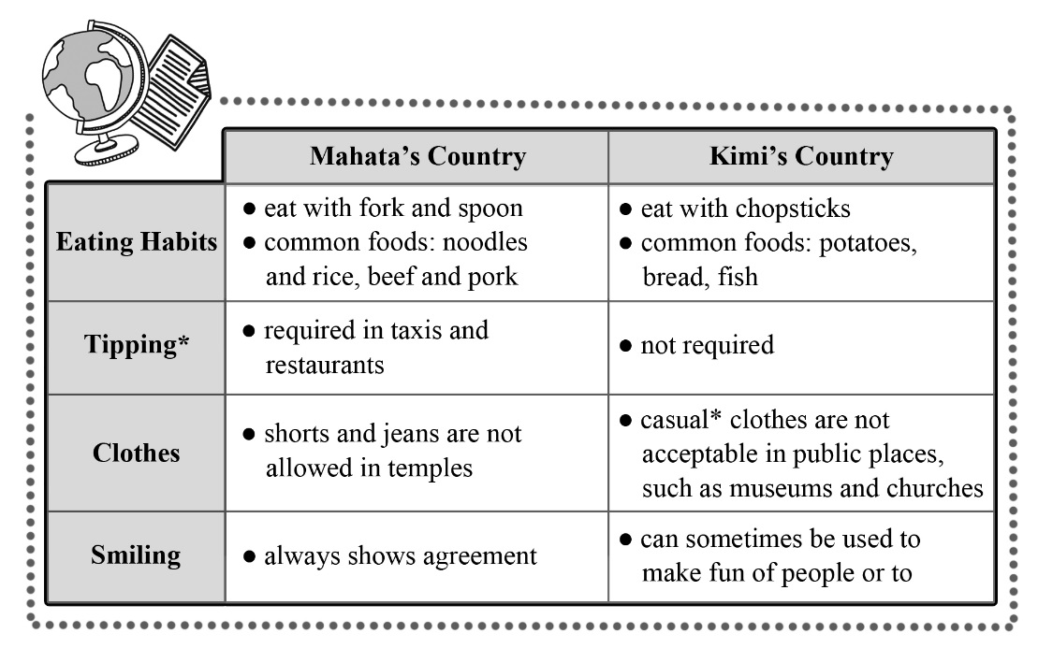  * tip vi. 給小費 * casual adj. 休閒的  （ ）44. According to the passage, which of the following customs is similar in Mahata’s and Kimi’s countries? (A) Tipping. (B) Eating habits.  (C) Clothes. (D) Smiling.  （ ）45. What is the purpose of this information? (A) To show cultural differences.  (B) To introduce two languages. (C) To explain the eating habits of two countries.  (D) To sell a tour package.  A bad workman always blames his tools.  P3  P3.
新北市立 新 北 高工 102 學年度 第二學期 期末考 |  |  |  |  |  |  | 班級 |  |  | 座號 |  |  | 成 | P.2
科目 | 英文 | 年級 | 一 | 科別 | 機鑄汽模圖電資 |  | 姓名 |  |  |  |  |  | 績 | P.2

新北市立 新 北 高工 109學年度 第二學期 第二次 段考 一年級 英文 答案卷 P.4

班級 姓名 座號

得分 總分
VI. 文意字彙10%
51.. | 52. | 53. | 54.
55. | 56. | 57. | 58.
59. | 60.

VII. 翻譯填空10%
61. | 62. | 63. | 64.
65. | 66. | 67. | 68.
69. | 70.

【請仔細核對題號 請在考卷及答案卷上都寫上姓名座號 答案卡請劃座號!!!!】

