市立 新 北 高工 109 學年度 第二學期 第二段考 |  |  |  |  |  |  | 班級 |  |  | 座號 |  |  | 出題 | 高麗雯老師
科目 | 英文 | 年級 | 一 | 科別 | 訊機鑄汽圖電資 |  | 姓名 |  | 劃卡 |  | 是 |  | 審題 | 陳旻旻老師
- 聽力測驗第一部分：看圖辨義 (試卷上該題有一張圖片，請聽一個和該題相關的問題，與(A)、(B)、(C)三個英語敘述後，選一個與所看到圖片最相符的答案。)每題一分  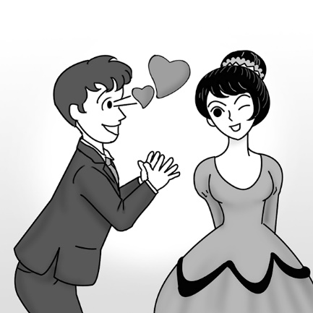 1. _________  第二部分：問答(每題會播出一個問句或直述句，聽後請由試卷上(A)、(B)、(C)三個選項中，選出一個最適合的回答或回應。)  _______ 2. (A) Yes, I have some.  (B) David is my brother.  (C) I think he’s upstairs.  _______ 3. (A) It’s the custom in my country.  (B) I don’t have much of an appetite.  (C) I would be honored.  _______ 4. (A) I’ll bring you one right away.  (B) I don’t know how to use chopsticks.  (C) That one is for eating dessert.  第三部分：簡短對話(每題會播出一段對話及一個相關的問題，聽後請由試卷上(A)、(B)、(C)三個選項中，選出一個最適合的回答。)  _______ 5. (A) Start eating.  (B) Help her with something.  (C) Prepare a dish.  _______ 6. (A) Study more.  (B) Calm down.  (C) Feel excited.  - 字彙及同義字選擇 (每題一分)  - （ ）11. Everyone was ____________ about why Sarah had quit her job all of a sudden.  - (A) normal (B) curious (C) apparent (D) amazed  - （ ）12. Katy stayed at the party ____________. She didn’t want to stay long because she was tired. (A) clearly (B) completely (C) accidentally (D) briefly  - （ ）13. That table is ____________ for a group, so we can’t sit there. (A) attempted (B) completed (C) reserved (D) disagreed  - （ ）14. You need to save some money before you study ____________. Living in another country can be expensive. (A) anywhere (B) ahead (C) already (D) abroad  - （ ）15. It is ____________ that some people smoke next to where the children play in the park. (A) cheerful (B) wonderful (C) shameful (D) intelligent  - （ ）16. Bill is seen as the best student in my class because he is hard-working and also willing to help others. (A) recorded (B) puzzled (C) included (D) regarded  - （ ）17. Clearly the joke was funny because most of the people are laughing.  - (A) Directly (B) Probably (C) Accidentally (D) Apparently  - （ ）18. It is important to keep calm when you give a speech in public.  - (A) remain (B) agree (C) cheer (D) clear  - （ ）19. Ian is watching out for any taxi which may be passing by right now.  - (A) keeping an eye out for (B) making ends meet (C) paying off (D) taking action  - （ ）20. Scientists questioned the report because they found no evidence (證據) to support it. (A) attempted (B) challenged (C) depended (D) symbolized  - 對話 (每題二分)  21.（ ）Lee: I heard this local Taiwanese restaurant is famous for its seafood fried rice.  Vincent: Really? ____________ But I don’t use chopsticks very well.  Lee: Don’t worry. The good thing is you can still use a spoon for your fried rice.  Vincent: That’s good news!  (A) I’m on a diet. (B) I’ll give it a try someday. (C) I didn’t mean it. (D) It’s up to you.  22.（ ）Lisa: In Taiwan, it is not okay to leave your chopsticks upright in a bowl of rice.  Zoe: Really? Why not?  Lisa: ________________________  (A) You can use a fork. (B) It is polite to do so.  (C) That’s interesting. (D) It is a taboo in the local culture.  35. ( ) The government must come up with a solution ____________ our serious parking  problem. (A) of (B) with (C) to (D) for  36. ( ) ____________ the MRT is cheaper than driving to work.  (A) Bringing (B) Sitting (C) Driving (D) Taking  37. ( ) When it comes to ____________, Billy is an excellent swimmer.  (A) swimming (B) swims (C) swam (D) swum  38. ( ) My aunt doesn’t believe money can buy everything, and I don’t, ____________.  (A) too (B) neither (C) either (D) so  39. ( ) There were ____________ people in the theater. I could count them on just one hand. (A) a little (B) little (C) a few (D) few  - ( ) The sad movie made many people ____________.  (A) crying (B) cried (C) cry (D) had cried  V. 綜合測驗(每題二分)  - Different countries have different customs when it comes to eating. Speaking of the “other hand,” Indians are far more particular than most people about how __41.__ their food into their mouths. The locals believe that this is __42.__ satisfying way to enjoy a meal. However, they also believe that it is shameful to use one’s left hand __43.__ the food. For Indians, the left hand is regarded as the “dirty” hand because it is reserved _44.__ cleaning themselves after they use the restroom. Therefore, remember __45._ it right at mealtime in India! Always be sure to keep an eye out for the local customs in the places you visit.  （ ）41.(A) did they put (B) they put (C) put they (D) they have put  （ ）42.(A) more (B) the more (C) most (D) the most  （ ）43. (A) touch (B) to touch (C) touching (D) touched  （ ）44.(A) to (B) for (C) as (D) of  （ ）45.(A) get (B) got (C) getting (D) to get  - Around the world, different places have different food customs. You may find __46.__ some of them are quite surprising. For example, the Japanese eat noodles very loudly. Doing so __47.__ their way to say the food is tasty. It shows they can’t wait __48.__ the food in their mouths.  On the __49.__ hand, Koreans don’t rush so much. Their custom is to show respect for older people. Young people must not eat until older people start __50.__. Korea is one of the most traditional Asian countries. However, traditional or not, every country has its own special customs.  （ ）46. (A) it (B) that (C) this (D) which  （ ）47. (A) is (B) are (C) was (D) were  （ ）48. (A) to get (B) got (C) gets (D) gotten  （ ）49. (A) another (B) others (C) every (D) other  （ ）50. (A) eaten (B) eats (C) ate (D) eating |  |  |  |  |  | _______ 7. (A) Wash the dishes.  (B) Wash his hands.  (C) Eat the food.  第四部分：短文聽解(每題有三個圖片選項。請聽題目，並選出一個最適當的圖片。)  8. _______  (A) (B) (C)  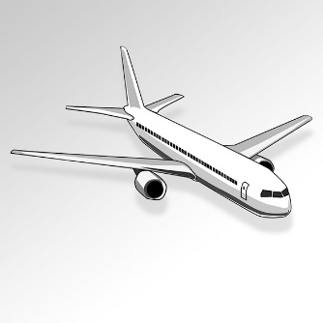  9. _______  (A) (B) (C)  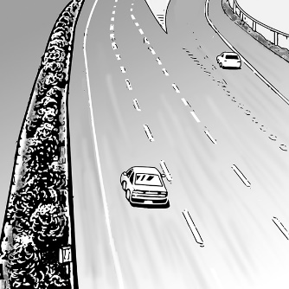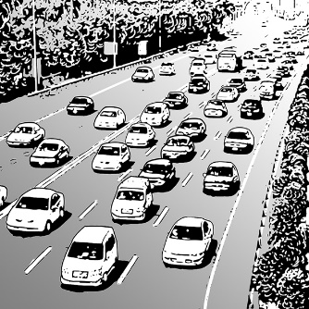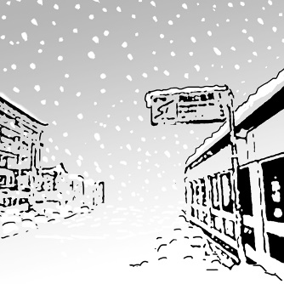  10. _______  (A) (B) (C)  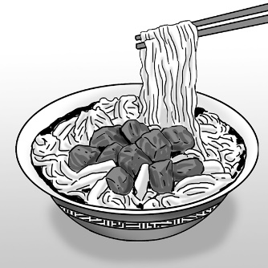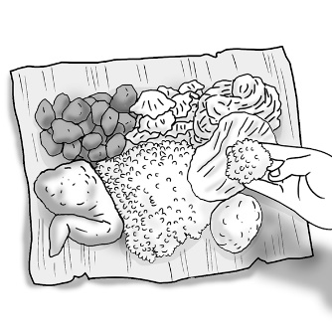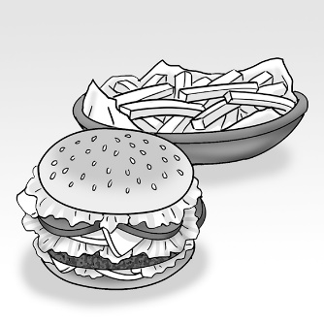  P1  23.（ ）Ethan: I just found NT$10,000 on the ground. Today is my lucky day!  Rita: ________________________ Don’t you think you should take the money to the police station?  (A) How do you do? (B) Here you go. (C) Calm down. (D) How did that happen?  24.（ ）Lee: Thanks for inviting me to your place for Christmas!  David: ________________________ Is this your first Christmas in the UK?  Lee: Yes, it is! I’m so excited.  (A) I’m fine, thank you. (B) Bless you.  (C) My pleasure. (D) I’m ready to give it a shot.  25.（ ）Iris: Have you tried fried insects before?  Jacob: No, I haven’t, and ________________________.  Iris: Why not?  Jacob: They just look disgusting to me.  (A) please excuse me (B) I will never give them a try.  (C) they must be delicious (D) I don’t think so  - 文法選擇(每題二分)  26. ( ) One of my goals for this year is to work ____________ than before. (A) harder  (B) hard (C) hardest (D) to hard  27. ( ) Daphne loves Japanese food, ____________ her husband likes Italian food.  (A) while (B) after (C) because (D) so  - ( ) Fans were surprised to learn ____________.  (A) Chiling Lin’s husband is who (B) who is Chiling Lin’s husband  (C) who Chiling Lin’s husband is (D) Chiling Lin’s husband who is  29. ( ) Anna wondered ____________ she should stop her classmate from cheating.  (A) what (B) how (C) where (D) whether  - ( ) Eve and I haven’t met for years. Now she is ____________ and ____________ than  before. (A) tall; beautiful (B) taller; more beautiful (C) more tall; more beautiful (D) much tall; beautiful  - ( ) Jack is ____________ student in my class. Everybody likes him.  (A) popular (B) more popular (C) the most popular (D) most popular  32. ( ) Most of the time, traveling by train is ____________ than traveling by bus.  (A) faster (B) fast (C) fastest (D) the fastest  33. ( ) I thought your joke was ____________ than Lily’s.  (A) funny (B) funnily (C) funnier (D) the funniest  34. ( ) The winner of the lottery looks very ____________.  (A) happier (B) happy (C) happiest (D) happiness  P2  VI. 單字片語填空 (每題一分)  51. Every student is asked to participate in group d____________ns in the history class..  52. When people travel in another country, it is important to r____________t the local customs.  53. The player made an a____________pt to catch the soft baseball, but she fell and missed it.  54. To a____________d heavy traffic during rush hour, I decided to take a shortcut to work.  55. After the PE class, students all had a huge a____________e.  56. People in this town are quite t____________l, so they still keep many old customs.  57. The heart is a s____________l of love in almost every culture.  58. Many p____________s coins are on display in the museum. Most of them are very rare.  59. The teacher e____________ned the difficult math problem to his students again to help them understand.  60. Jack was caught in an awkward si____________n when he told a joke and no one laughed.  總統可能下個月拜訪高雄。  The president ______61.______ (l)____62.________ ______63.______ visit Kaohsiung next month.  既然Mike完成了大學學業，他得找份全職工作了。  ______64.______ _______65._____ Mike has finished university, he needs to find a full-time job.  我正在尋找以前屬於我曾祖母的項鍊。  I am looking for the necklace which (b)_____66._______ to my great-grandmother.  Jason即將主修英文，因為他想當英文老師。  Jason is (s)_______67._____ _____68._______ major in English, because he wants to be an English teacher.  當談到學習日文，莎莉總是很興奮的分享她練習口說技巧的方法。  When it comes _____69._______ (l)____70.________ Japanese, Sally is always excited to share how she practices her speaking skills.  A bad workman always blames his tools.  P3.  P3.
新北市立 新 北 高工 102 學年度 第二學期 期末考 |  |  |  |  |  |  | 班級 |  |  | 座號 |  |  | 成 | P.2
科目 | 英文 | 年級 | 一 | 科別 | 機鑄汽模圖電資 |  | 姓名 |  |  |  |  |  | 績 | P.2

新北市立 新 北 高工 109學年度 第二學期 第二次 段考 一年級 英文 答案卷 P.4

班級 姓名 座號

得分 總分
VI. 文意字彙10%
51.. | 52. | 53. | 54.
55. | 56. | 57. | 58.
59. | 60.

VII. 翻譯填空10%
61. | 62. | 63. | 64.
65. | 66. | 67. | 68.
69. | 70.

【請仔細核對題號 請在考卷及答案卷上都寫上姓名座號 答案卡請劃座號!!!!】

