閱讀測驗 100% (共20題；每題5分)
Read the passages and answer the follow up questions according to the readings.
Although Mahata and Kimi are pen pals, they have very different cultures. These are some differences they have learned about each other’s countries in their letters.
*tip vi.給小費 *casual adj.休閒的
1. According to the passage, which of the following customs is similar in Mahata’s and Kimi’s countries?
(A). Eating habits.
(B). Clothes
(C). Tipping
(D). Smiling

2. What is the purpose of this information?
(A). To introduce two languages.
(B). To sell a tour package.
(C). To explain the eating habits of two countries.
(D). To show cultural differences.

India is one of the world’s largest countries. People in different parts of India eat different kinds of food. But there’s one custom they all share: eating with their hands.
In the south of India, rice is the most important dish. One common way to serve food is to put it on a large banana leaf instead of a plate. A pile of rice and several side dishes are placed on each person’s leaf. Diners then mix the side dishes with the rice and scoop up* bites with the fingers of their right hand. Because southern India is near the sea, fish is also commonly eaten.
In the north of India, bread is more common. Each person is served a large, round piece of bread, and the dishes come in metal bowls and are shared. Diners rip off* pieces of their bread and use them to scoop up bites of the dishes.
If you travel to India, eating might just be the best part of your trip. Don’t be afraid to take food with your hands; it is part of the experience!
*scoop up舀出、挖出 *rip off 撕掉
3. What is this passage mainly about?
(A). The weather in northern and southern India.
(B). The history of Indian foods.
(C). The eating customs in different parts of India.
(D). The importance of rice and bread in India.

4. Which of the following statements is true about the south of India?
(A). People there eat with chopsticks.
(B). Side dishes are mixed with rice.
(C). Bread is more common than rice.
(D). It is far from the sea.
5. According to the passage, what do people use to pick up food in the north of India?
(A). Banana leaves. (B). Bread.
(C). Bowls. (D). Spoons.

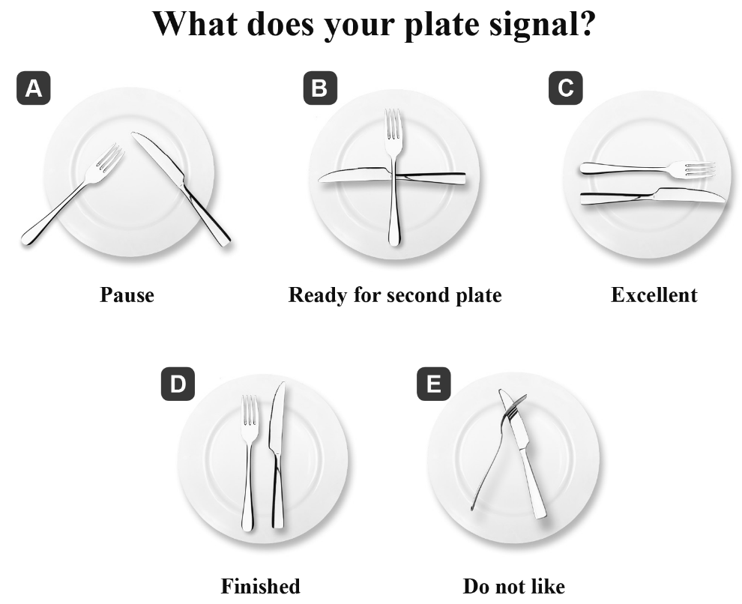
6. What does the word “signal” possibly mean?
(A) To color something. (B) To teach someth.
(C) To show something. (D) To hold something.
7. If you would like to praise the food, which “plate” can do this for you?
(A) A (B) B (C) C ( D) E

The tradition of birthday parties began in Europe thousands of years ago. Back then, birthdays were considered a time when bad spirits were able to harm you. To protect the birthday person, friends and family members would give them their good wishes and gifts. Today, most people celebrate birthdays with a cake, candles, and a birthday song.
The origin of the birthday cake is thought to date back to ancient Greece. Greek people honored the moon goddess* Artemis by baking round cakes to represent the full moon, and putting candles on the cake to make it glow*. Smoke from the candles was believed to carry prayers to the gods up in the sky. This is where the modern custom of making a wish and blowing out the candles came from.
At first, only kings and queens were important enough to have birthday celebrations. But nowadays*, everyone in the world celebrates their birthday. What’s more, in countries like Korea, India, and Ecuador*, people actually celebrate two birthdays! Next time it’s your birthday, you may want to follow some of the fun birthday traditions from around the world.
＊goddessn. [C]女神 ＊glowvi.發光 ＊nowadaysadv.如今 ＊Ecuadorn.厄瓜多爾

8. What’s the best title for this passage?
(A). King’s and Queen’s Birthdays.
(B). It’s All About Birthdays!
(C). Blowing Out Candles to Drive Evil Spirits Away.
(D). The Origin of the Birthday Cake.

9. According to the passage, why were birthday candles blown out?
(A). To send people’s prayers up to the gods.
(B). To drive evil ghosts away.
(C). To celebrate the birthdays of gods.
(D). To let people know the date of their birthday.

10. What does the word “represent” possibly mean?
(A). Be an example of something.
(B). Be a detail of something.
(C). Be a title of something.
(D). Be a symbol of something.

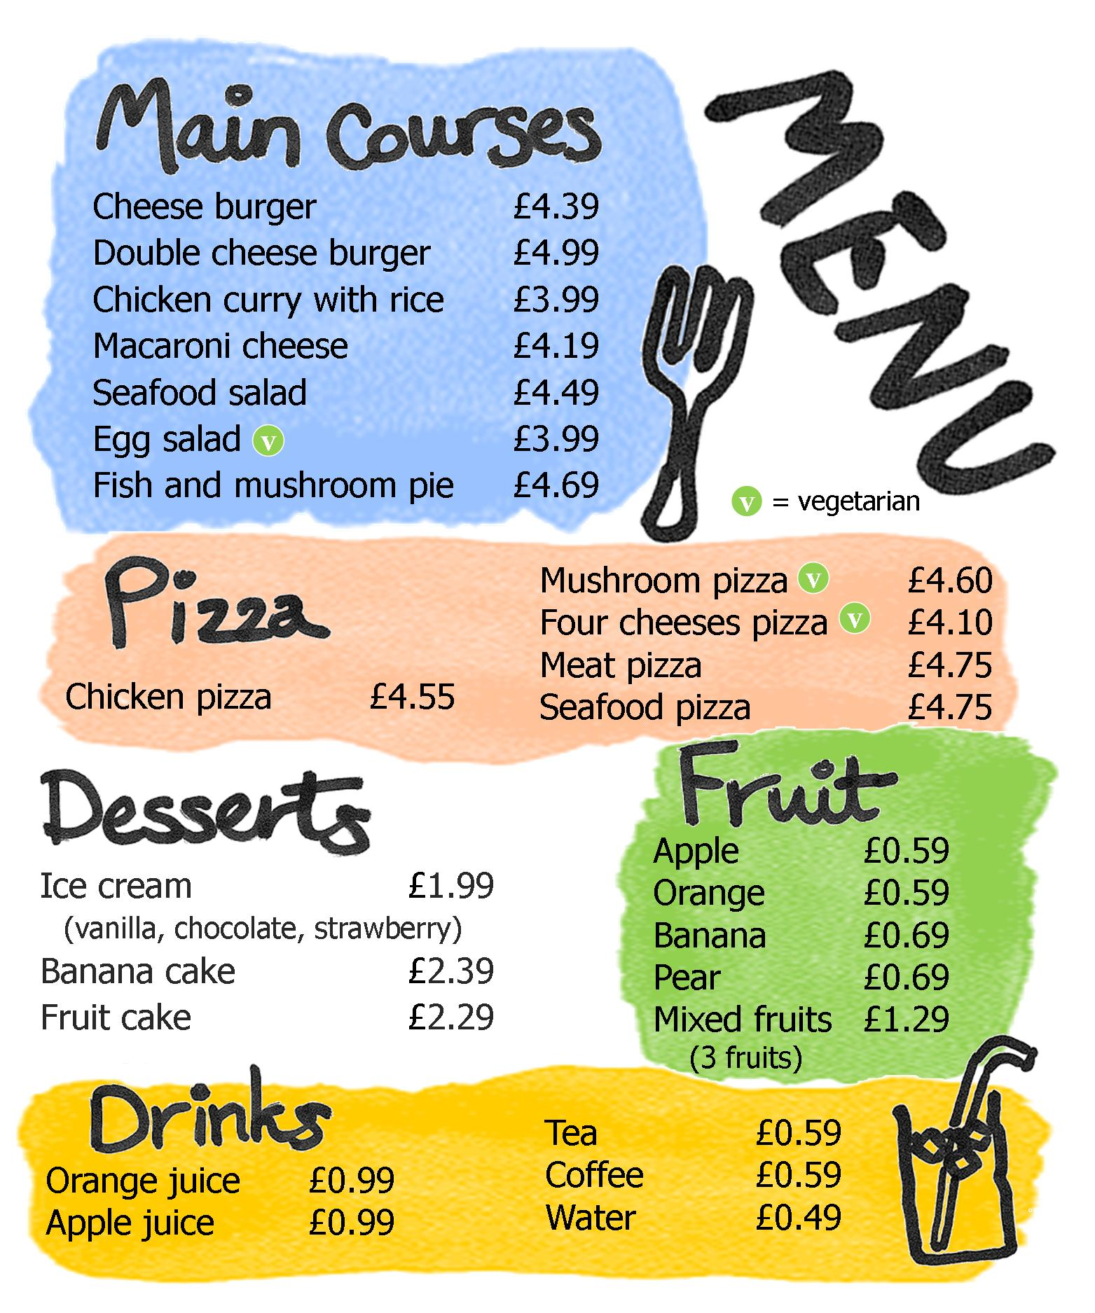

*vegetarian 素食的
11. You can eat salad in this restaurant.
(A). True. (B). False.
(C). We are not sure. (D). Yes, there are three types of salad.

12. Vincent is a vegetarian, he can order________.
(A). Macaroni cheese and banana cake. (B). Double cheese burger and orange juice.
(C). Mushroom pizza and coffee. (D) Egg salad and Cheese burger.

13. If you want to order more than two fruits, you can order ___ to spend less money.
(A). apple, orange, and banana
(B). pear, orange, and apple
(C). mixed fruits
(D). orange, banana, and pear

14. Bob ordered one item(項目) from the main courses and one item from the fruit, he
spent 5.28 dollars. What might he order?
(A). Chicken curry with rice and apple.
(B). Seafood salad and mix fruits.
(C). Double cheese burger and pear.
(D) Egg salad and mix fruits.

15. Which of the following is correct?
(A). The restanuant provides free water.
(B). Banana cake is the most expensive in the desserts.
(C). Chicken curry with rice is the cheapest in the main courses.
(D). There are more than five types of pizza.

Raven Steals the Light
In the beginning there was no light in the world, because an old magician kept it hidden in a box inside his house. Raven, who was always hungry, didn’t like the darkness because it was difficult to find food. One day he was looking for food near the old magician’s house. He heard a voice saying, “I have a box, and inside this box is another box, and inside this there is another box, and inside the smallest box is all the light in the world.” Raven decided to steal the light.

Raven waited until the old man’s daughter went down to the river to collect water. Just as she was dipping her basket into the river, he changed himself into a *hemlock needle. The needle floated into her basket. When the girl drank some water, she swallowed Raven too.
Inside the girl’s belly, Raven took the form of a human baby. He grew and grew, and in time she gave birth to a funny looking child with black eyes and a big nose. The old man loved his grandson so much that he gave in to the child’s every wish. Raven became spoilt and greedy. He was bored with all his toys, and wanted to play with the box that held the light. Finally the grandfather opened the box and tossed the glowing ball of light to Raven.
As soon as Raven caught the light, he immediately changed into his bird form. Holding the light in his beak, he flew up the chimney hole into the dark world. The magician was angry. He wanted to get the light back into his box. He flew after Raven.
The light was heavy in Raven's beak, and he was getting tired. The magician was coming closer. Raven broke off some pieces of the light and threw them into the sky. They became the stars. The magician was still coming closer, so Raven broke off another piece of the light and threw it into the sky. It became the moon. Finally Raven became so tired that he tossed the last and biggest piece of the light into the sky. It became the sun; and that is how daylight came to the world.
steal 偷 ; raven烏鴉 ; dip浸入; float漂浮 ; belly肚子 ; take the form of 以…形態出現
give birth to生小孩 ; give in to讓步 ; spoilt受寵的 ; greedy貪心的 ; toss丟擲
immediately快速地 ; beak鳥喙
* hemlock needle 鐵山針葉
16. Why was the world dark in the beginning?
(A). It was midnight.
(B). There was no sun and moon.
(C). An old magician kept the light.
(D). The raven ate the light in the beginning.

17 Where did the magician keep the light?
(A). in a hole in the ground
(B). in a box in his house
(C). in a basket in a tree
(D). in the chimney in his house

18. Why didn't raven like the darkness?
(A). He felt loney in the darkness.
(B). He couldn't see colors.
(C). He couldn't see where he was going.
(D). It was difficult to find food.
19. What did Raven change himself into?
(A). a little girl
(B). a hemlock needle
(C). a hemlock tree
(D). a basket
20. How did the stars, moon, and sun get into the sky?
(A). Raven said," Let there be light."
(B). The magician threw the light into the sky and the light became stars, moon, and sun.
(C). The light was too heavy,so Raven broke off some pieces and threw them into the sky.
(D). The light fell out of Raven's beak and broke into pieces.

