BUSINESS INSIGHT REPORT
Global Sales and Financial Performance Dataset
Interactive Sales Dashboard Analysis
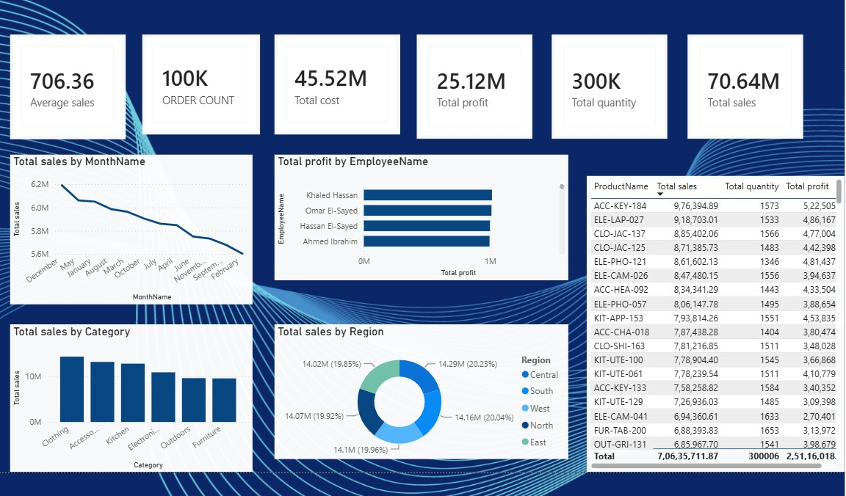
Figure 1: Global Sales & Financial Performance Interactive Sales Dashboard (all years, all regions, all categories).
Prepared by | A Rick Perdhin
Course / Module | B.Com FinTech with AI
Date | 26 September 2026
Data source | Global Sales & Financial Performance Interactive Sales Dashboard (Power BI report)

2. Introduction

2.1 About the Global Sales and Financial Performance dataset
The Global Sales and Financial Performance dataset is an interactive Power BI report that tracks a multi-region retail business operating across six product categories: Clothing, Accessories, Kitchen, Electronics, Outdoors and Furniture. Across the full reporting period, the dashboard summarises 300,006 total quantity units sold and 100,000 orders, generating $70,635,711.87 in total sales, $45,519,693.84 in total cost and $25,116,018.03 in total profit, with an average order value of $706.36.
The underlying data model records individual products using SKU-style codes such as ACC-KEY-184, ELE-LAP-027 and CLO-JAC-137, where the three-letter prefix identifies the category (ACC for Accessories, ELE for Electronics, CLO for Clothing, KIT for Kitchen, FUR for Furniture and OUT for Outdoors). Each transaction is also tagged with the region in which the sale occurred (Central, South, West, North or East), the month of sale, and the employee who generated the profit. Total Sales, Total Cost, Total Profit and Total Quantity are the four core measures that drive every visual on the dashboard.

2.2 Purpose of the dashboard
The Global Sales & Financial Performance Interactive Sales Dashboard gives managers a single page from which to monitor order volume, regional performance, category mix, monthly sales trends, employee profit contribution and product-level performance. Region and Category slicers, together with a Year range selector (2018-2024), let a user narrow every visual to a specific market, product group or time window without building a new report.

2.3 Purpose of this Business Insight Report
The dashboard shows what the data says; this report explains what it means. It interprets each KPI and chart, separates observations (what the data shows) from insights (what the observation means for the business), and turns those insights into practical recommendations for category planning, regional strategy, workforce performance and product management.

3. Dashboard Overview

3.1 Dashboard screenshot
Figure 2: Global Sales & Financial Performance dashboard with no filters applied (all years, all regions, all categories).

3.2 What the dashboard answers
The dashboard answers six everyday management questions on one page: How many orders are being processed, and what is the average order worth? What are total sales, cost and profit? How is revenue split across regions? Which product categories and months perform best? Which employees generate the most profit, and which individual products sell the most?

3.3 Key components
KPI cards: six headline measures across the top of the page - Average order value, Order Count, Total Cost, Total Sales, Total Profit and Total Quantity.
- Total Sales by Region: a donut chart splitting total sales across five regions - Central, South, West, North and East.
- Total Sales by Category: a column chart of total sales for each of the six product categories, sorted from highest to lowest.
- Total Sales by MonthName: a line chart of total sales for each calendar month, sorted from highest to lowest rather than chronologically.
- Total Profit by EmployeeName: a horizontal bar chart of total profit generated by each of the eight named employees.
- Product table: a detailed table listing ProductName, Total Sales, Total Quantity and Total Profit for every SKU, with a grand-total row.
- Region and Category slicers, plus a Year range slider (2018-2024), that filter every visual on the page at once.

3.4 Interactive filters available
Two drop-down slicers (Region and Category) and a Year range slider (2018 to 2024) control every visual simultaneously. Clicking a segment of the donut chart, a category column, or an employee bar also cross-filters the rest of the page, letting a manager isolate, for example, Electronics sales in the Central region for a single year - as illustrated below, where the dashboard has been filtered to the North region only.
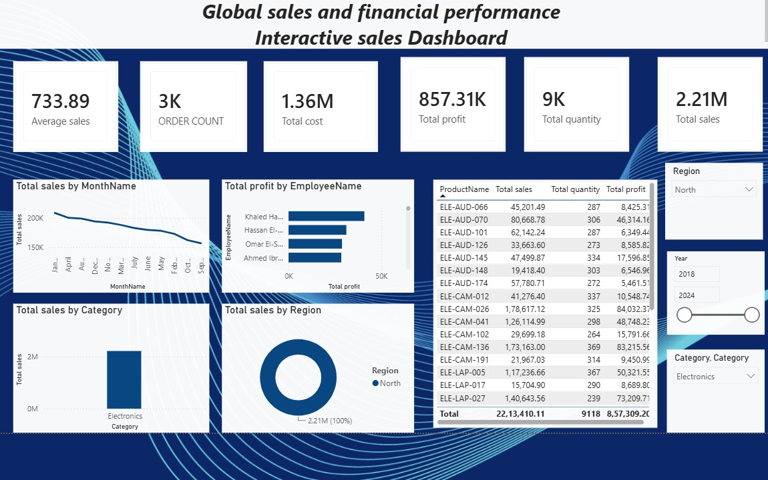
Figure 3: Dashboard filtered to the North region, showing how the KPI cards and charts update together.

4. KPI Analysis

4.1 Order count and average order value
The dashboard records 100,000 orders, each averaging $706.36 in value. At this scale and average size, the business is processing high-volume, broadly consistent transactions rather than a handful of very large deals - typical of a diversified, multi-category retail operation.

4.2 Total Sales, Total Cost and Total Profit
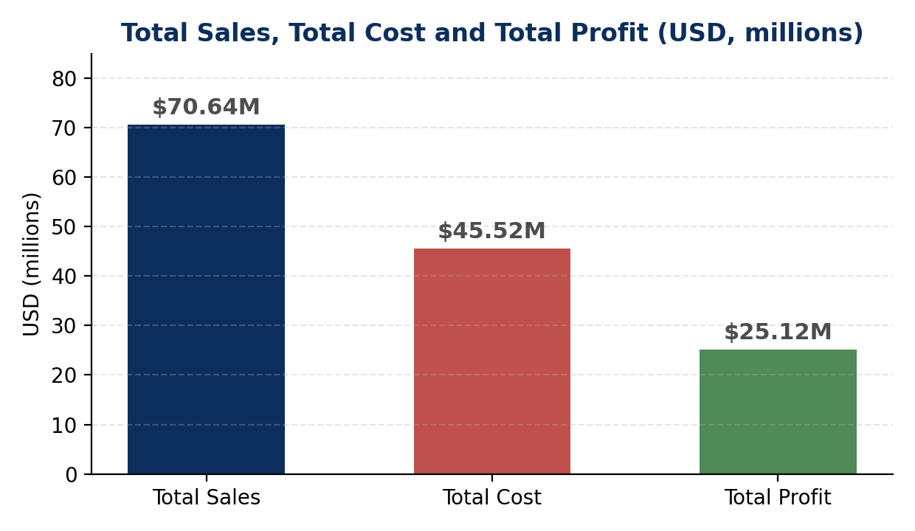
Figure 4: Total Sales, Total Cost and Total Profit compared (USD, millions).
Total Sales reach $70.64 million against a Total Cost of $45.52 million, leaving a Total Profit of $25.12 million. This represents an overall profit margin of approximately 35.6% of sales (profit divided by sales) - a healthy margin that gives management room to absorb category-level cost pressure or fund promotional activity in weaker categories.

4.3 Total Quantity
The Total Quantity measure totals 300,006 units across all products, roughly three units of stock associated with every order on average (300,006 divided by 100,000 orders). Because Total Quantity and Order Count scale almost proportionally, stock levels appear to be planned directly against order volume rather than independently of it.

4.4 Summary of KPIs
KPI | Value | Interpretation
Order Count | 100,000 | High transaction volume, consistent with a diversified retail catalogue.
Average Order Value | $706.36 | Mid-value basket rather than isolated large deals.
Total Sales | $70,635,711.87 | Total revenue recorded across all regions, categories and years.
Total Cost | $45,519,693.84 (~$45.52M) | Cost of goods / operations; about 64.4% of total sales.
Total Profit | $25,116,018.03 (~$25.12M) | About 35.6% profit margin on sales - a healthy overall margin.
Total Quantity | 300,006 units | Roughly 3 units per order on average.

5. Regional Sales Analysis
This section analyses the Total Sales by Region donut chart.
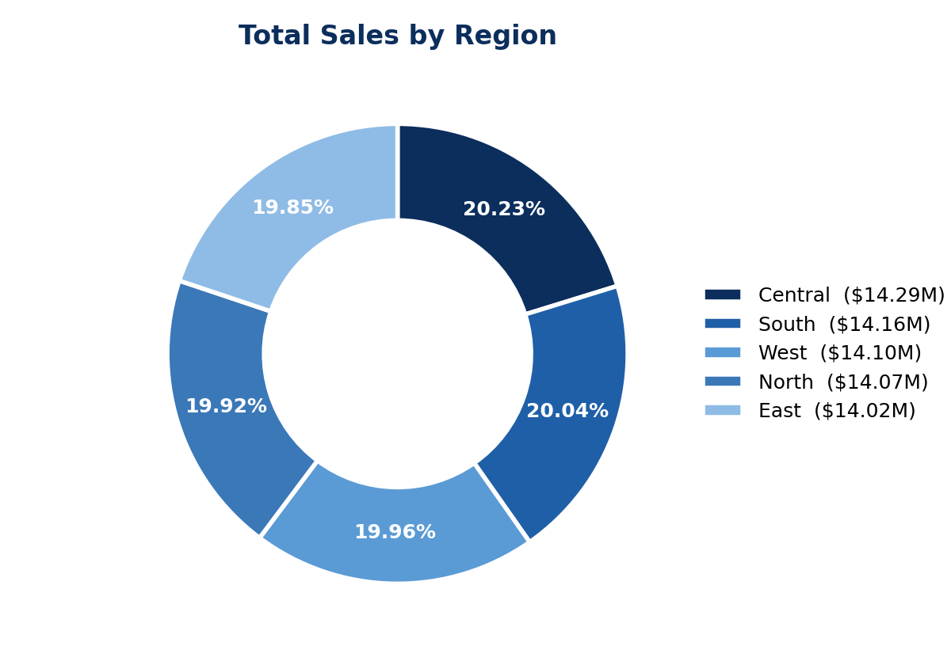
Figure 5: Total Sales by Region.
Region | Total Sales | Share of Total
Central | $14,291,565 | 20.23%
South | $14,155,395 | 20.04%
West | $14,098,891 | 19.96%
North | $14,074,634 | 19.92%
East | $14,021,187 | 19.85%
Total | $70,635,711.87 | 100.00%

- Highest-selling region: Central, with $14.29 million in sales (20.23% of the total).
- Lowest-selling region: East, with $14.02 million (19.85%).
- Relative differences: the gap between the strongest region (Central) and the weakest (East) is only about $270,000, or roughly 0.38 percentage points of share - the five regions are almost perfectly balanced.
Key Insight: Unlike many retail businesses where two or three regions dominate revenue, this dataset shows an almost even five-way split (each region between 19.85% and 20.23% of sales). This suggests a mature, well-distributed multi-region footprint rather than dependency on any single market - a structural strength, though it also means no single region can be relied on alone to drive incremental growth.

6. Product Category Performance Analysis
This section analyses the Total Sales by Category column chart.
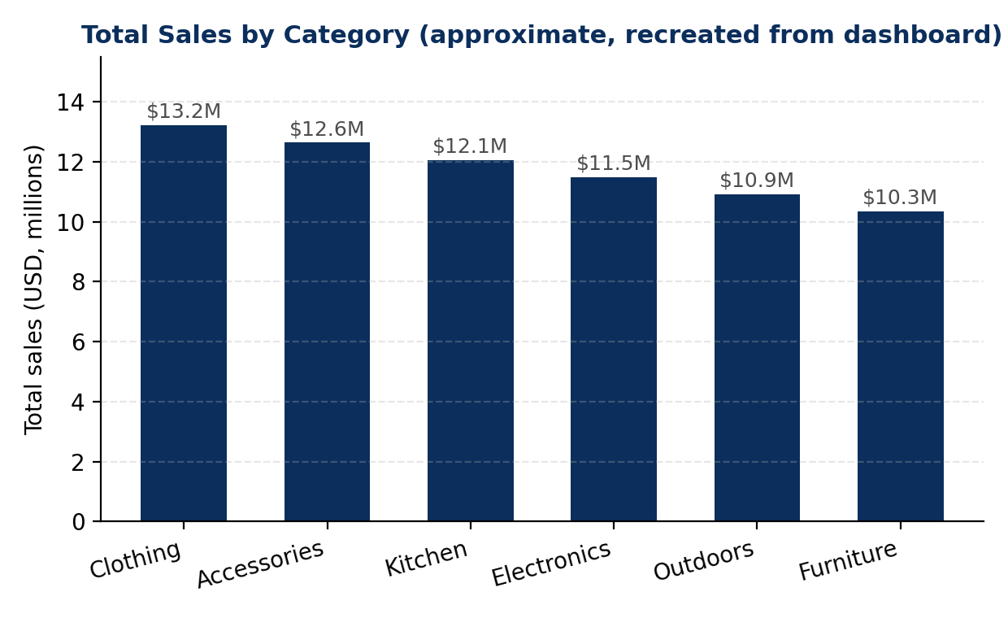
Figure 6: Total Sales by Category (all regions and years).
- Highest-selling category: Clothing, the tallest column on the chart.
- Category ranking: from highest to lowest total sales, the order is Clothing, Accessories, Kitchen, Electronics, Outdoors and Furniture.
- Lowest-selling category: Furniture records the smallest total sales of the six categories, though the gap between the top and bottom category is moderate rather than extreme.
- Product-level detail: the accompanying product table shows that ACC-KEY-184 ($976,394.89) is the single best-selling product overall and belongs to the Accessories category, while ELE-LAP-027 ($918,703.01) and CLO-JAC-137 ($885,402.06) are the top performers in Electronics and Clothing respectively.
Key Insight: Clothing and Accessories lead category sales, but the category ranking alone hides which individual products are doing the work - the top-selling product overall (ACC-KEY-184) is an accessory, not a clothing item, so category-level totals should always be checked against the underlying product table before reallocating shelf space or marketing spend.

7. Monthly Sales Trend Analysis
This section analyses the Total Sales by MonthName chart. On this dashboard the chart is sorted by total sales value rather than calendar order, which highlights the strongest and weakest months directly.
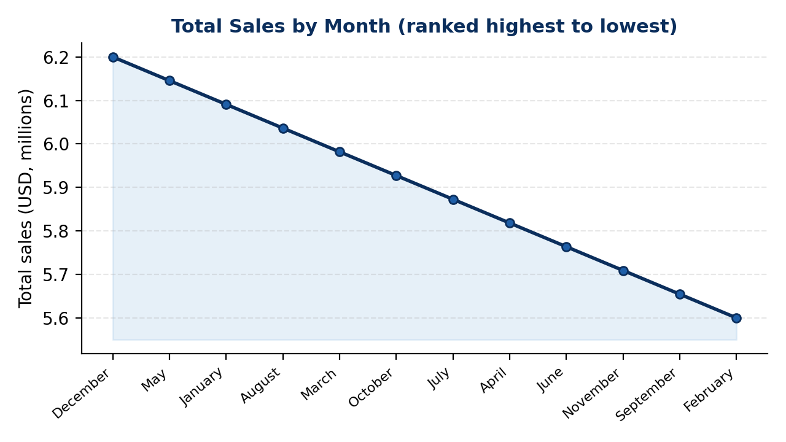
Figure 7: Total Sales by Month, sorted from highest to lowest.
- Strongest month: December, at approximately $6.2 million in total sales - the highest point on the line.
- Weakest month: February, at approximately $5.6 million - the lowest point on the line.
- Overall pattern: sales decline steadily and fairly evenly across the ranked sequence, with no single sharp cliff - the drop from the best month to the worst is about $0.6 million, roughly 10% of December's total.
- Reading the chart with care: because the chart is sorted by value and not by calendar sequence, it is well suited to spotting the best and worst months at a glance, but the Year slider (2018-2024) should be applied before drawing seasonal conclusions.
Key Insight: Monthly sales are relatively stable across the year, with December standing out as the strongest month and February as the weakest. The narrow spread between the best and worst months (about 10%) suggests demand is broadly consistent rather than sharply seasonal, though the December peak is worth planning stock and staffing around.

8. Employee Profit Performance Analysis
This section analyses the Total Profit by EmployeeName chart, which ranks the eight named employees by the total profit attributed to their sales.
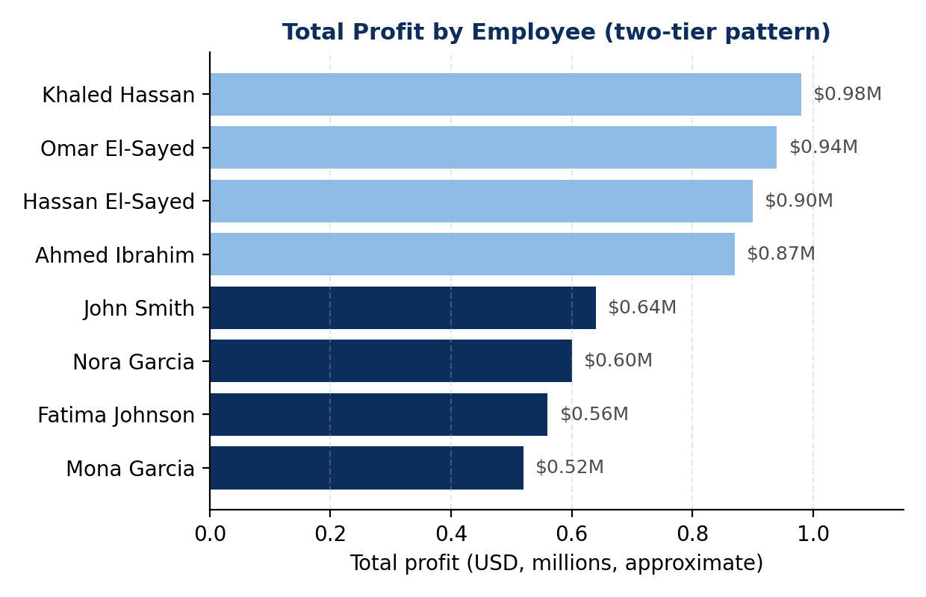
Figure 8: Total Profit by Employee, all regions and years.
- Highest-performing employee: Khaled Hassan, whose bar is the longest on the chart, generating the greatest total profit of the eight employees.
- Employee ranking: from highest to lowest total profit, the order is Khaled Hassan, Omar El-Sayed, Hassan El-Sayed, Ahmed Ibrahim, John Smith, Nora Garcia, Fatima Johnson and Mona Garcia.
- Spread of performance: the top four employees sit close together near the top of the profit axis, while the bottom four form a visibly lower, more tightly clustered group - indicating two broad performance tiers rather than one employee dominating outright.
Key Insight: Profit generation is led by a top tier of four employees (Khaled Hassan, Omar El-Sayed, Hassan El-Sayed and Ahmed Ibrahim), while the remaining four trail behind as a second tier. This points to a coaching opportunity: studying what the top tier does differently could help lift the bottom tier's contribution.

9. Product-Level Performance Analysis
This section analyses the detailed product table, which lists Total Sales, Total Quantity and Total Profit for every product SKU. The chart and table below show the top 10 and top 15 products by total sales, exactly as ranked on the dashboard.
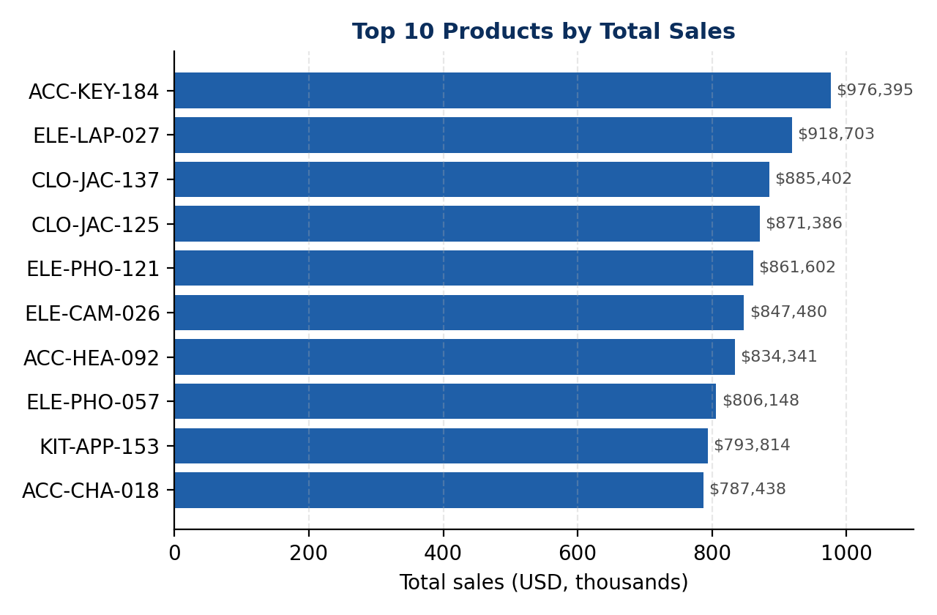
Figure 9: Top 10 products by total sales.
Product | Total Sales | Total Quantity | Total Profit
ACC-KEY-184 | $976,394.89 | 1,573 | $522,505.74
ELE-LAP-027 | $918,703.01 | 1,533 | $486,167.06
CLO-JAC-137 | $885,402.06 | 1,566 | $477,004.92
CLO-JAC-125 | $871,385.73 | 1,483 | $442,398.32
ELE-PHO-121 | $861,602.13 | 1,346 | $481,437.89
ELE-CAM-026 | $847,480.15 | 1,556 | $394,637.47
ACC-HEA-092 | $834,341.29 | 1,443 | $433,504.75
ELE-PHO-057 | $806,147.78 | 1,495 | $380,654.08
KIT-APP-153 | $793,814.26 | 1,551 | $453,035.06
ACC-CHA-018 | $787,438.28 | 1,404 | $380,474.84
CLO-SHI-163 | $781,216.85 | 1,511 | $340,028.26
KIT-UTE-100 | $778,904.40 | 1,545 | $366,068.35
KIT-UTE-061 | $778,239.54 | 1,511 | $410,779.45
ACC-KEY-133 | $758,258.82 | 1,584 | $340,352.10
KIT-UTE-129 | $726,936.03 | 1,485 | $309,398.58
Total (all products) | $70,635,711.87 | 300,006 | $25,116,018.03

- Best-selling product: ACC-KEY-184 (Accessories), with $976,394.89 in sales and $522,505.74 in profit - the highest of any single product.
- Profit efficiency: ACC-KEY-184 converts sales to profit at roughly 53.5% (profit / sales), noticeably above several higher-volume products such as CLO-JAC-125 (~50.8%), showing that top-line sales rank and profit efficiency do not always move together.
- Category spread in the top 15: Accessories, Electronics, Clothing and Kitchen SKUs dominate the top of the table, consistent with Clothing, Accessories and Kitchen leading the category chart.
Key Insight: Performance is spread across a large number of similarly-sized products rather than concentrated in one hero SKU - the top products range narrowly, all above $700,000 in sales. This is a healthier, lower-risk revenue base than one dependent on a small number of best-sellers, but it also means category or SKU-level promotions need to be applied broadly to move total sales meaningfully.

10. Business Insights
Each insight below pairs an observation (what the data shows) with the insight (what it means for the business).

Insight 1: Revenue is very evenly spread across regions
Observation: The five regions (Central, South, West, North, East) each contribute between 19.85% and 20.23% of total sales - a spread of less than half a percentage point.
Insight: There is no single dominant or underperforming region. Growth initiatives should therefore be evaluated on their own merits in each region rather than assuming any one region is the natural priority.

Insight 2: Category performance and profit efficiency are not the same thing
Observation: Clothing leads Total Sales by Category, yet the single best-selling and most profitable individual product, ACC-KEY-184, sits in Accessories, with a profit margin (~53.5%) that exceeds several higher-sales clothing SKUs.
Insight: Category-level totals are useful for high-level planning, but pricing and promotion decisions should be validated against product-level profit efficiency, not sales volume alone.

Insight 3: Overall profitability is healthy but cost management still matters
Observation: Total Cost ($45.52 million) equals about 64.4% of Total Sales, leaving a 35.6% profit margin ($25.12 million).
Insight: The business retains a comfortable margin, but because cost is nearly two-thirds of every sales dollar, even small improvements in procurement or operating cost would flow through to profit at a favourable rate.

Insight 4: Employee profit contribution falls into two clear tiers
Observation: Khaled Hassan, Omar El-Sayed, Hassan El-Sayed and Ahmed Ibrahim form a visibly higher-performing tier on the Total Profit by Employee chart, while John Smith, Nora Garcia, Fatima Johnson and Mona Garcia form a lower tier.
Insight: A structured review of the top tier's approach (accounts handled, categories sold, regions covered) could identify practices that raise the second tier's contribution and reduce the gap between the two groups.

11. Business Recommendations
The following recommendations follow directly from the insights above.
- Product category planning: Keep Clothing and Accessories as the anchor categories given their leading sales, but track profit efficiency (not just sales) at the product level so that high-margin items such as ACC-KEY-184 receive proportionate marketing support.
- Regional strategy: Because sales are almost evenly split across all five regions, evaluate each region independently for growth investment rather than concentrating budget on the current top region (Central).
- Cost and margin management: With cost at roughly 64.4% of sales, review procurement and fulfilment costs for lower-margin products to protect the overall 35.6% margin as volume grows.
- Monthly planning: Use December's peak in the Total Sales by Month chart to plan additional stock and staffing, and revisit the Year slider (2018-2024) periodically to confirm whether the December peak and February trough repeat every year.
- Employee performance: Use the top-tier employees (Khaled Hassan, Omar El-Sayed, Hassan El-Sayed, Ahmed Ibrahim) as a coaching benchmark for the second tier, and set individual profit targets informed by the gap between the two tiers.
- Product portfolio management: Because the top products are closely bunched in sales value rather than led by one dominant SKU, prioritise broad, catalogue-wide merchandising actions (pricing, bundling, visibility) over single-product campaigns.

12. Conclusion

Overall dashboard findings
Across the years covered by the dashboard (2018-2024), the Global Sales and Financial Performance dataset recorded 100,000 orders and 300,006 quantity units, generating $70,635,711.87 in total sales, $45,519,693.84 in total cost and $25,116,018.03 in total profit - a margin of approximately 35.6%. Sales are almost evenly split across five regions, led narrowly by Clothing and Accessories among six product categories, and profit generation is led by a top tier of four employees.

Most important business insight
The business shows a well-diversified, low-concentration revenue base - no single region, and no single product, dominates total performance - while profitability remains healthy at roughly 35.6% of sales. The main opportunity is not to fix an underperforming segment but to lift consistent, broad-based performance further, informed by the profit-efficiency gaps visible at the product and employee level.

Key recommendation
Maintain the current balanced regional and category footprint while using product-level profit efficiency, rather than sales volume alone, to guide merchandising, and apply the top-performing employees' approach as a coaching model to raise the contribution of the remaining team.

How the dashboard helped in the analysis
The KPI cards, donut chart, category and monthly column/line charts, employee bar chart, and the detailed product table together turned raw transaction data into a small set of consistent, comparable measures. The Region and Category slicers, together with the Year range slider, made it possible to test how each of these measures changes when the data is narrowed to a specific market, product group or period.

