Shadow Armada · build 6 · captured at 1920×1080
Every screen,
and what every part of it is for.
A hidden-information naval duel wagered on Solana, documented plate by plate: 47 screens photographed from the running game, with 105 callouts naming what each element is, what it does, and why it was built that way.

47  Plates | 105  Callouts | 10  Chapters | 1920×1080  Capture

Reading the screens
A palette, a type scale and six conventions carry every plate that follows. Learn these and the rest of the document explains itself.
■ Gold  Money and charges. Spent on nothing else, anywhere — a gold thing is always a number about value. | ■ Green  Go. Commit, play, confirm — and a landed win.
■ Red  Damage, loss, refusal. Hits on a hull, a defeat banner, an error border. | ■ Attack  Card role: shells and patterns. Salvo, Lance, Burst, Rake, Breaker.
■ Intel  Card role: knowledge, not damage. Ping, Echo, Sounding. | ■ Control  Card role: taking things away. Jam, Siphon — and NERF ships.
■ Prediction  Card role: reading them. Mirror, Ambush — and REACT ships. | ■ Water  Playable board. Both grids, in the same blue, on every screen.

The type scale
Eight steps, defined once as tokens. Every text element in the game maps to one of them and nothing invents a ninth.
88 The wordmark, and the champion slam. Nothing else in the game is allowed this size. | 64 One per screen: the battle clock, the result verdict, the collision slam, a sink stamp.
48 Screen titles, phase cards, the round stamp inside the wipe. | 32 Panel headings, stat values, the large charge gem.
24 Card names at full size, the commit button. | 18 The sentence that matters on a screen; the default button.
15 Running text and UI default. | 13 Labels, pips, fine print, board coordinates.
A card, every time
One component draws every card in the product — draft, hand, result, opponent strip. Portrait 2:3, framed in its role colour, art window across the top 60%, name banner through the middle, the compressed rule on the face, and the gold charge gem in the bottom-right corner as the largest number on the object. The full rule text arrives on hover. A player learns this shape once.
A ship, every time
Landscape, with the ship’s glyph, its length as pips, and its type — ACTIVE, NERF or REACT — in the type’s own colour. The unrevealed enemy version is the same card admitting only a length, because a length is all the rules make public until that ship acts or sinks.
A cell, and what it remembers
Board cells carry state: gold outline for what you are about to fire at, red for a hit, white for a miss, cyan for a cell intel exposed as occupied, and steel for your own hull on your own board. Every mark is a fact you have earned; none of them are ever guesses the interface made for you.
Numbers are display objects
Charge counts, the round clock and hull totals are set in an outlined display face at sizes no ordinary interface would use. They are the numbers a player checks under time pressure from across a desk, so they are built to be read at a glance rather than inspected. Every one of them uses tabular figures, so a value updating in place does not shove its row about.
Two families, eight sizes
Baloo 2 carries display, headings and every numeral; Nunito carries body and UI. JetBrains Mono is not a third voice but a utility, reserved for four things a player compares character by character: wallet addresses, commitment hashes, transaction signatures, and board coordinates. Both rules are enforced by a test that fails the build — a scale written down is a suggestion, a scale a test can fail is a system.
Chrome is permanent, feedback is not
The rule the whole build turns on. Anything that occupies screen while it has nothing to say is chrome and had to justify itself; anything that appears, says one thing and leaves does not. That is why a duplicated hull readout was removed and a “+1” that floats for 600ms was added in the same pass — the second occupies no permanent space at all.

Arrival
What a player meets before they have decided anything. Nothing here asks for a wallet, and nothing here costs money — the first job of these screens is to let someone find out whether they like the game.
You have not decided anything yet. You do not know what the game is, whether it costs money, or whether you are any good at it. Everything on these screens exists to let you answer the first two without answering the third — and to make sure that when you do put money down, you already knew the price.
Plate 01 11 7 callouts

Main menu
Four ways to play, each wearing its money story on its face. What a mode costs is the first thing a player choosing between them wants to know, so the price is never a click away.
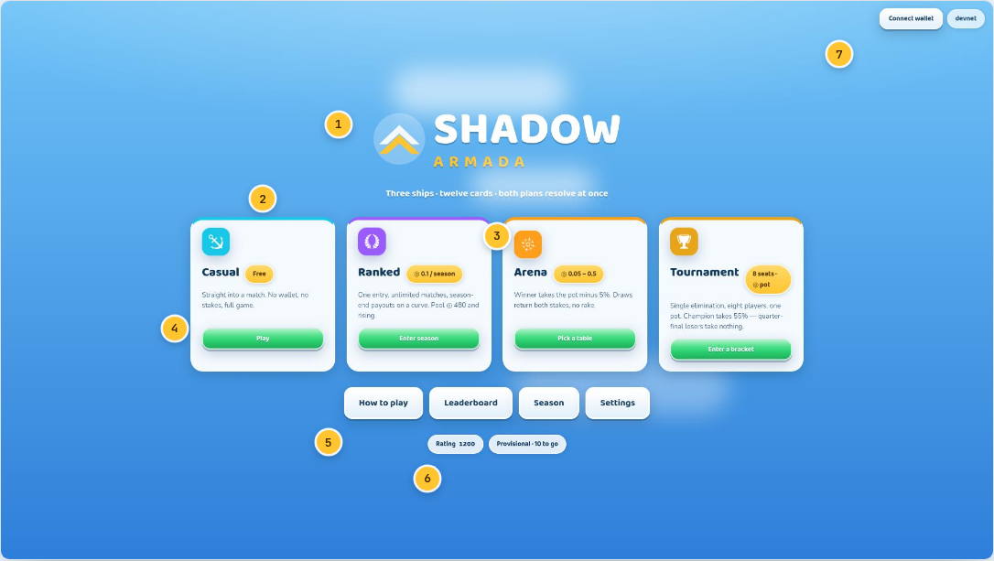
1 Wordmark  Two chevrons in a circle — a fleet in echelon. Drawn in code, so it stays sharp at any size and needs no asset. Set at 88px: the one element in the game allowed that size. | 2 Four doors, four prices  Casual is free and complete. Ranked is one season entry. Arena is per-match stakes. Tournament is eight seats and one pot. Each card states its own terms, including the unflattering ones — the tournament card admits that quarter-final losers take nothing. | 3 Stake pill  Gold, always. Gold is spent on money and charges in this game and on nothing else, so a gold pill anywhere means “this is a number about value”.
4 Mode CTA  Green means go, everywhere in the product. The verb changes with state — “Enter season” becomes “Play ranked” once the entry is paid. | 5 Secondary row  How to play, Leaderboard, Season, Settings. Quiet white pills: reachable, never competing with the four money cards. | 6 Rating  One pill. A season-rank pill stood beside it until Build 6 — a rank is a rating read against the pool, which is the same fact and one click away on the Season screen.
7 Wallet chip
On every screen. Short address, live devnet balance, and a faucet link the moment the balance falls under the cheapest table.
Plate 02

How to play · the draft
The one rule nobody arrives already knowing, taught first and taught by hand: you both see the same four, you both pick in secret, and a shared pick goes to both of you.
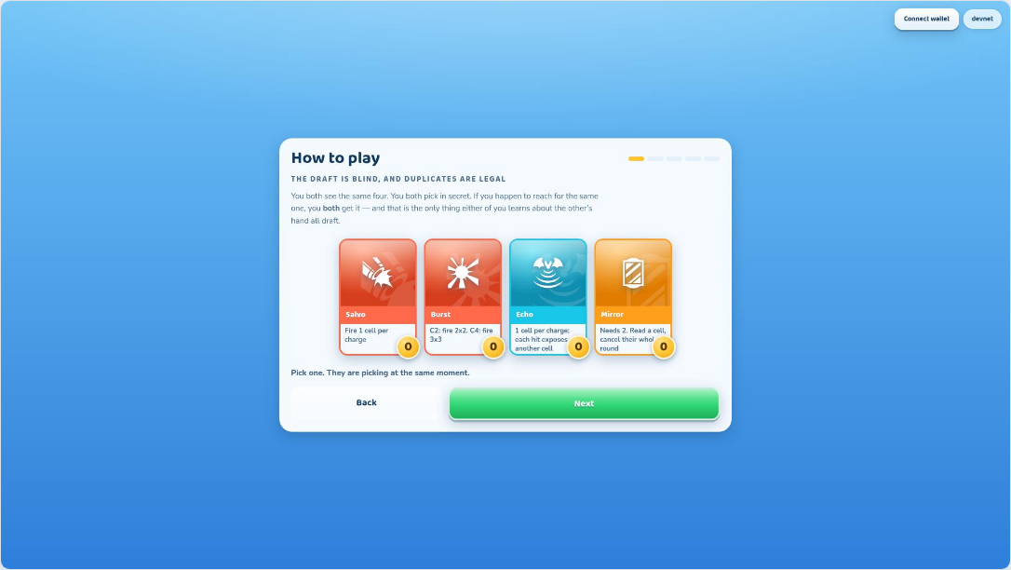
- New in Build 6, and placed first because it happens first. Blind simultaneous picking with legal duplicates is unusual, and until now the game never explained it anywhere.
- The cards are live. Pick one and the opponent’s card slides in beside it — face down if you differed, face up if you collided. The rule is demonstrated rather than asserted.
- The opponent’s pick is fixed rather than random. A tutorial that behaves differently on two readings teaches two different rules.
Plate 03

How to play · charging
Five things you do, not five things you read. The cards in this panel are live: clicking one charges it and the gem pops, so the rule is learned by hand.
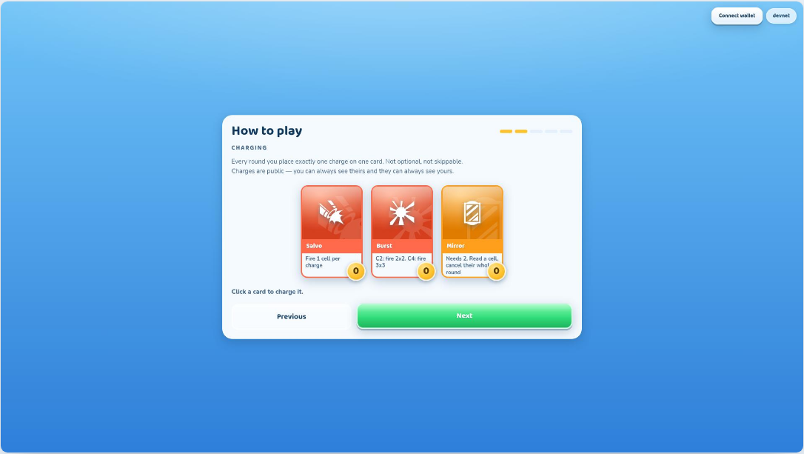
- Each round you place exactly one charge. Charges are public — both players can see what the other is building, which is what makes the bluff possible.
- The card components here are the same `GameCard` the battle screen uses, at the same proportions. A player learns the object once and meets it everywhere.
Plate 04

How to play · firing
The rule that catches everyone out, taught before it can cost anything: firing spends every charge on the card and destroys the card for good.
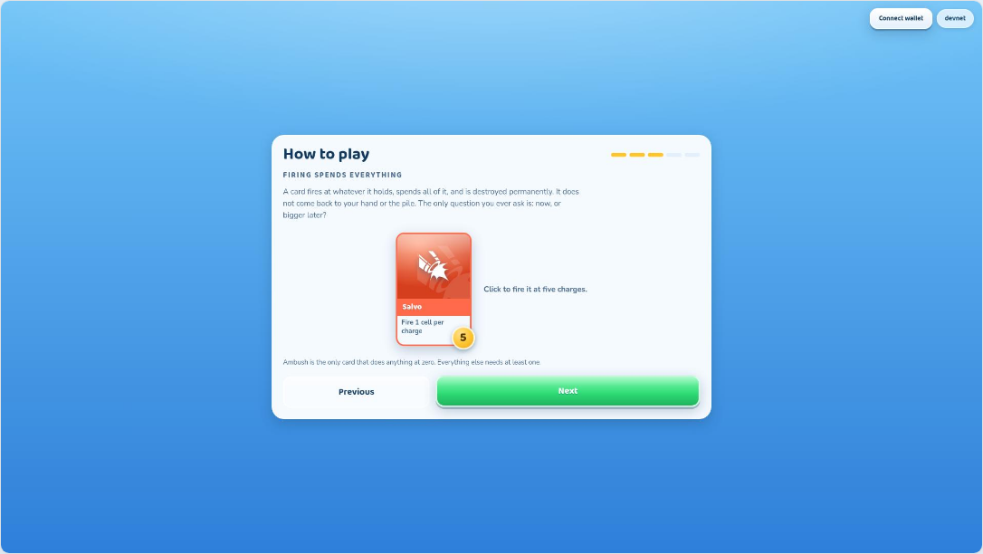
- A card is a resource you grow and then spend once. There is no discard, no reshuffle, no second copy — the tension in the whole game lives in “one more round or now?”.
- The step order is deliberate: draft, then charge, then fire, then simultaneity, then sinks. Each step only assumes what the previous one taught.
Plate 05

How to play · sinks
A sink announces a length and never a name. Every fleet is one 4, one 3 and one 2, so the length names the slot and leaves the candidates open.
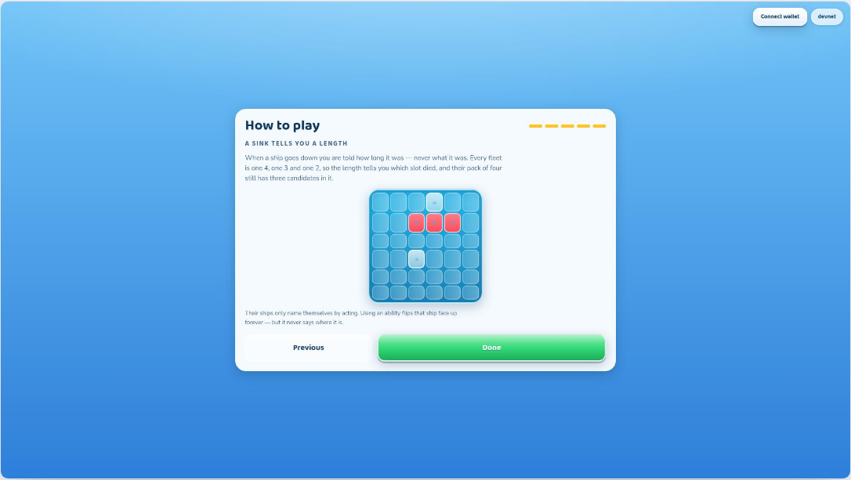
- This is the hidden-information rule in one sentence. Sinking their 3 tells you which slot went down, not which of the four possible 3-length ships it was.
- That gap is the deduction surface the whole game rests on — and the reason the opponent’s hand renders as card backs everywhere else in this guide.
Plate 42

The desktop gate
Below 1280×720 the game does not attempt a squeezed layout. Logo, one sentence, nothing else — a polished refusal beats a broken board.
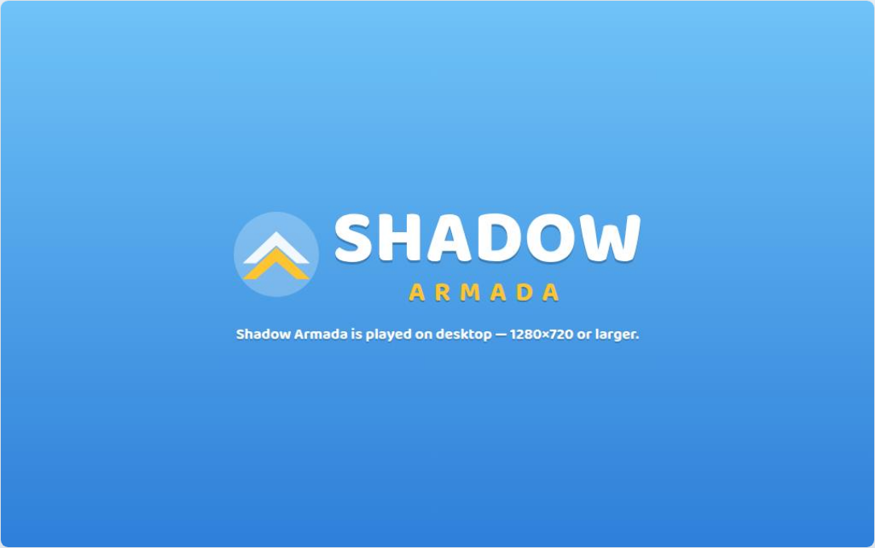
- Enforced in CSS with a media query, not a resize listener, so there is no JavaScript state that can fall out of sync with the viewport.
- The game is 16:9 desktop by decision: the battle screen puts two boards, two hands and a clock on screen at once, and that composition has nowhere to go on a phone.

Money on the table
Every surface where value moves. These are the screens a wagered game is judged on, so each one states the amount, the rake, and the way out before anything is committed.
You have decided to play for something. From here until settlement, every screen owes you three things before you press anything: what it costs, what it pays, and how you get out. You do not yet know who you are playing — that comes in the next chapter, and deliberately after the money, because the stake is the decision and the opponent is not.
Plate 06

Season entry
The season as a purchase decision: the price, exactly what it buys, the pool so far, and one confirm. A short balance is warned about here, not discovered at settlement.
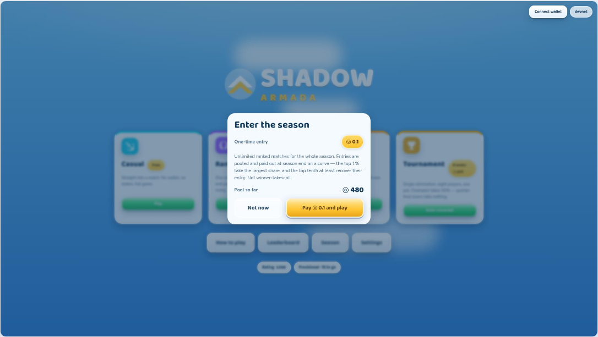
- One entry buys unlimited ranked matches for the season. Entries are pooled and paid out at season end on a curve, which the modal says in plain words.
- Two buttons only — “Not now” and “Pay ◎0.1 and play”. A money dialog with three ways forward is a money dialog someone clicks by accident.
Plate 07

Arena tables
Four stake tables and what a win actually pays at each. Tiers a provisional account cannot enter are visibly locked and now say what unlocks them.
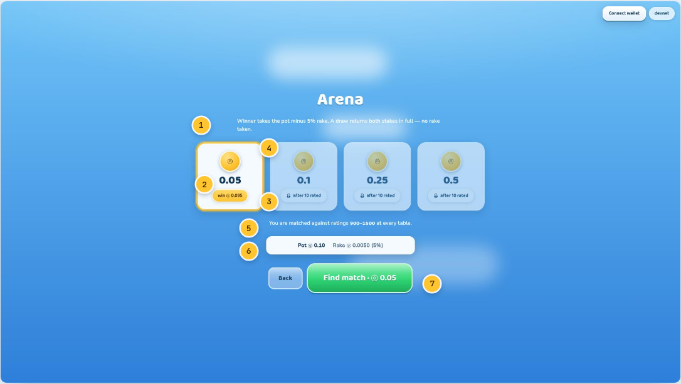
1 The rule, above the choice  Winner takes the pot minus 5%. A draw returns both stakes in full and takes no rake — the one outcome that has to stay costless. | 2 Stake tier  The stake as the largest number on the card, with the gold gem above it. Four tiers: ◎0.05, ◎0.1, ◎0.25, ◎0.5. | 3 What a win pays  The post-rake number, computed the same way the on-chain program computes it — not an estimate rounded for display.
4 Selection  A gold ring and a lifted shadow. Gold again, because the thing being selected is an amount of money. | 5 The matchmaking band, once  This line was printed on all four tier cards until Build 6 — and it was the same range on every one, because it is a property of your rating and not of the table. | 6 Pot and rake  The arithmetic of the selected tier. “To winner” used to sit here too; it is pot minus rake, both of which are on this row, and the figure is already on the card you are choosing between.
7 Find match
The commit control, carrying the stake in its own label. You cannot press this without having read the number.
Plate 08

A locked table, explaining itself
Hovering a table you cannot sit at says what would unlock it and how far away that is. A disabled control that says nothing was the single most confusing gap in the build.
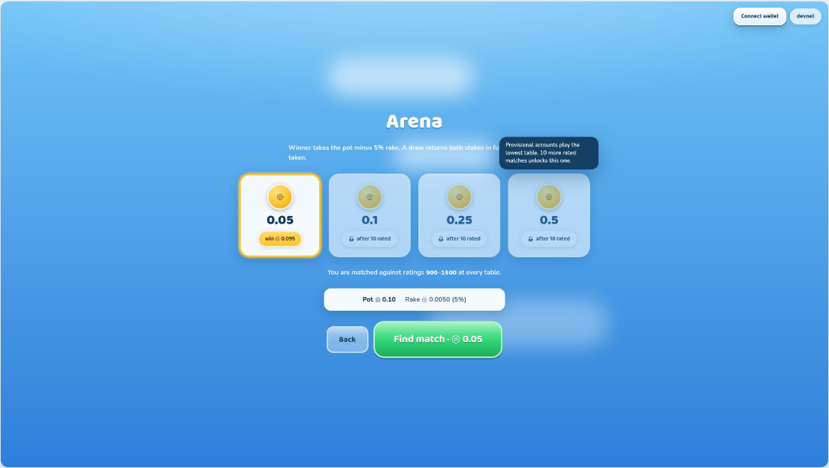
- The reason is computed from your own record — “3 more rated matches unlocks this one” — rather than a fixed sentence about provisional accounts.
- The same mechanism (`WhyNot`) covers the inert Fire control, the disabled Commit, and the deployment button. It wraps the control and takes the pointer events itself, because a disabled button never fires them.
- It costs nothing when the pointer is elsewhere: no permanent chrome is added to say what is only relevant on hover.
Plate 09 5 4 callouts

Not enough SOL
The error state as a human sentence: what the table needs, what the wallet holds, a working faucet link, and a way down to a cheaper table.
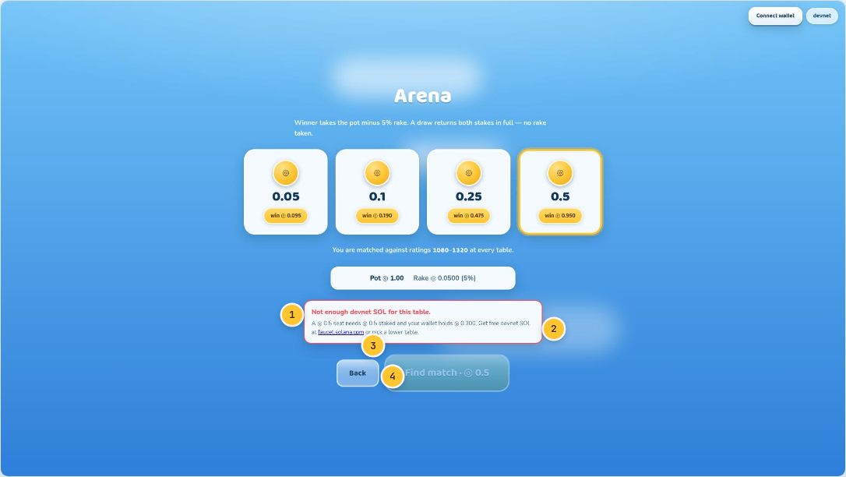
1 What went wrong  “Not enough devnet SOL for this table.” Named in the first four words, before any explanation. | 2 Both numbers  What is required and what is held, side by side. An error that states only one of them makes the player go and look up the other. | 3 The fix  A live link to the devnet faucet. The alternative fix — pick a lower table — is named in the same sentence.
4 Inert, not hidden
The commit button greys out and stops breathing rather than disappearing, so the layout never jumps and the goal stays visible.
Plate 10

The escrow forming
The stakes landing in view — your chips in, theirs following, the pot growing between them. The reclaim rule is on the screen while the money is moving, not in a FAQ.
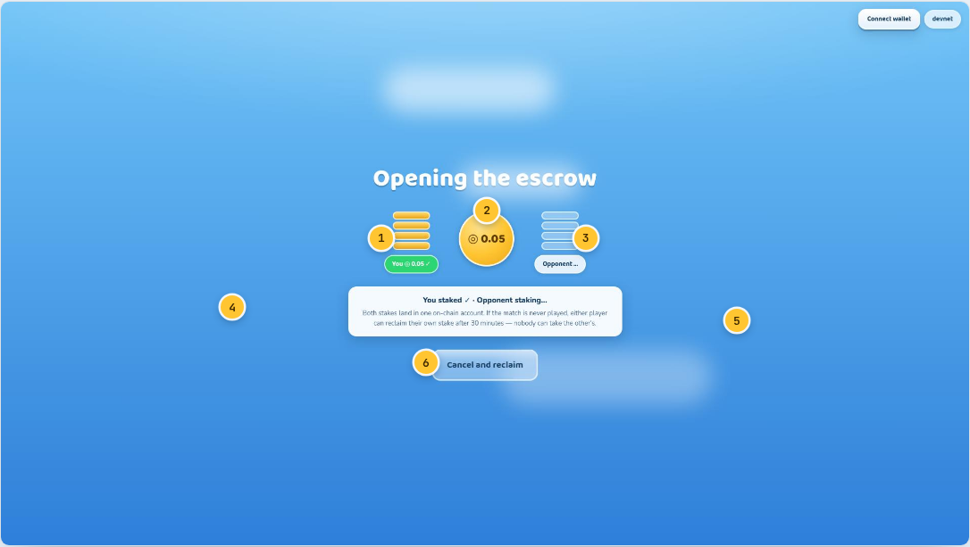
1 Your stake  A stack of gold chips that fills as the transaction confirms. Green tick and amount underneath when it has landed. | 2 The pot  The central gem carries the live total and scales up as the second stake arrives. Both stakes land in one on-chain account. | 3 Their stake  Pale until it confirms. A half-funded match is not a state the program can reach — both stakes move in the same transaction.
4 Status line  “You staked ✓ · Opponent staking…” — which half of the escrow is waiting, in words. | 5 The reclaim rule  If the match is never played, either player reclaims their own stake after 30 minutes and nobody can take the other’s. Stated here because this is the moment it matters. | 6 Cancel and reclaim  The way out, available while the escrow is still forming.
Plate 38

Bracket tiers
The same tier picker as the arena, re-priced for eight seats: the whole payout curve is stated before entry, including the part that pays nothing.
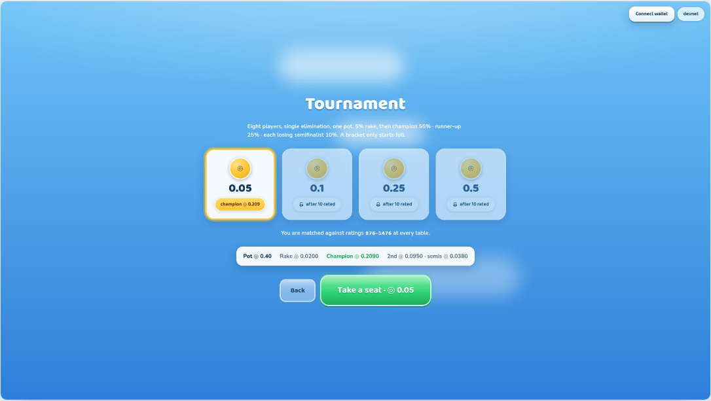
- Eight stakes pool into one escrow. 5% rake off the pot, then champion 55%, runner-up 25%, and 10% to each losing semifinalist.
- Quarter-final losers take nothing. That is the mode’s whole proposition — the curve is steeper than the arena’s, which is the reason to sit down here instead.
- The gold pill on each tier card shows the champion’s share at that stake rather than a generic “win” figure.
Plate 39

Seats filling
Eight seats staking in view. A bracket only ever starts full — byes cannot exist — and if it never fills, every stake reclaims and no rake is taken.
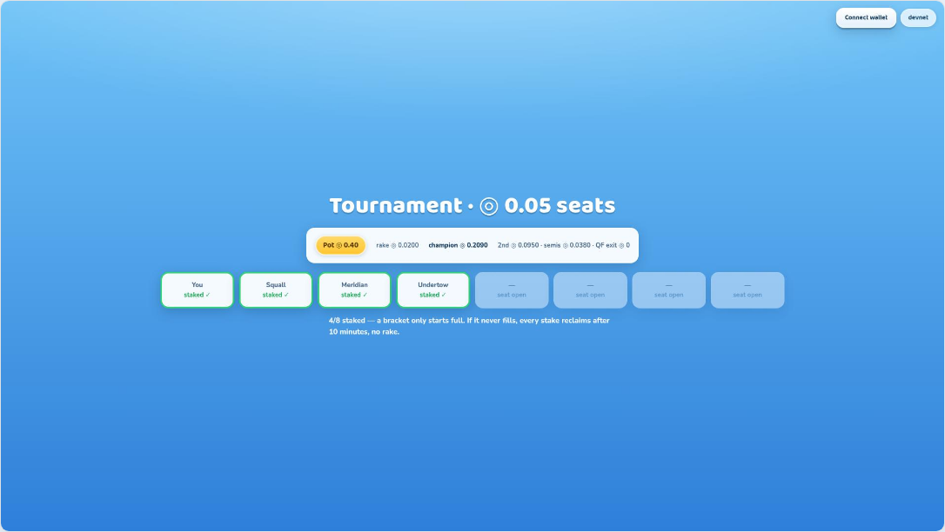
- Each seat is a card: dashed and faded while open, solid with a green border and a tick once that entrant’s stake has landed. The amount used to be printed on all eight; it is the same figure on every seat and it is in the title.
- The counter beneath reads “N/8 staked”. The eighth stake is what starts play, on-chain as well as in the interface — the program refuses a ninth join.
- If ten minutes pass without a full bracket, every seat recovers its own stake through a permissionless path. The escrow cannot strand funds even if the server dies.

The beats between
Four moments that did not exist before Build 6. Each is about 1.5 seconds, skippable with a click, and off entirely from one Settings toggle — and each carries a fact the player needed anyway.
The match used to jump-cut. You pressed a button and were standing in pack one with no idea who you were facing, and later you were on the battle screen with no memory of having agreed to anything. These four beats fill those cuts. They also earn their keep twice over: the phase cards replaced the permanent headers that sat on the draft and deploy screens forever, so the game now names a phase once, loudly, instead of continuously, quietly.
Plate 11

Match found
Who you are about to face and for how much, in the gap between paying and drafting. A player thrown straight into pack one knows neither, and both change how they draft.
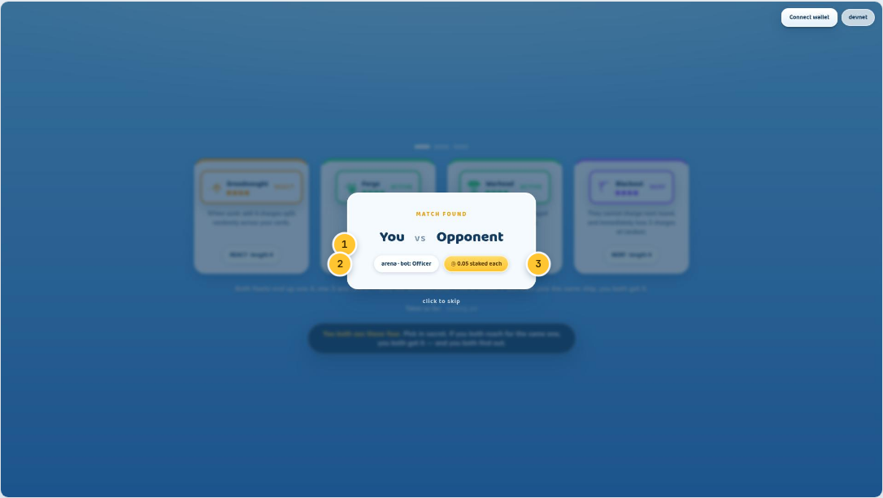
1 The pairing  You and them, named. In a networked match this is their real handle; against the local bot it says so. | 2 Told the truth about the opponent  A local opponent is a bot and is named as one, with its strength. Inventing a rating for it would be the first lie the product tells, on the screen whose whole job is saying who you are playing. | 3 The stake, restated  The last time the number appears before it is at risk. Casual reads “no stake” rather than showing nothing.
Plate 12

Phase card
The phase named once, with one line on what it asks of you. Four of these — SHIP DRAFT, CARD DRAFT, DEPLOY, BATTLE — replaced four permanent page headers.
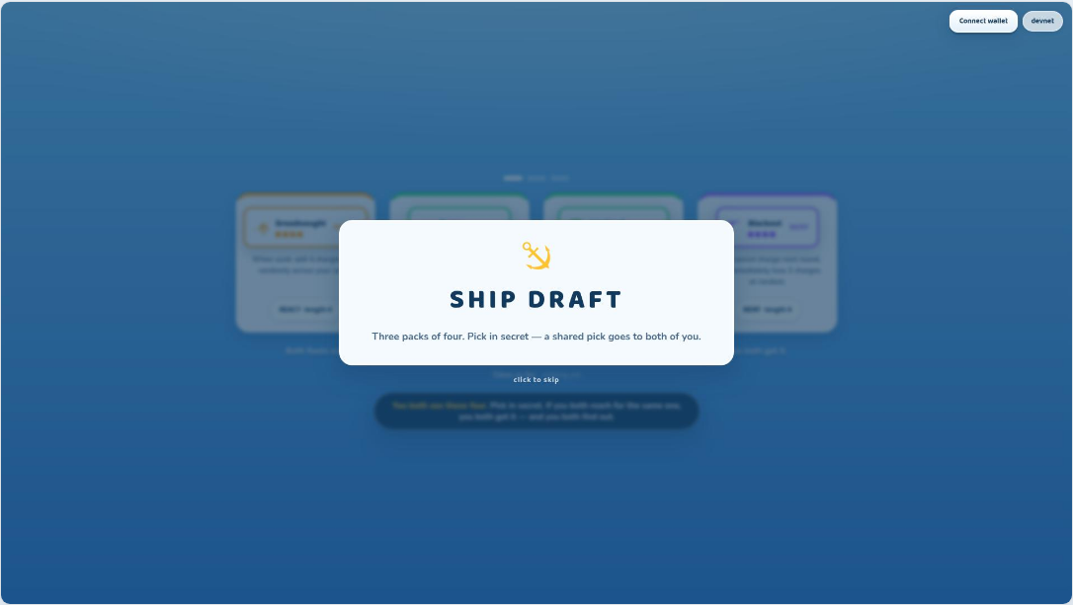
- The trade is the whole build in miniature: a header occupies screen for the entire phase and says the same thing on the last second as on the first. A card occupies screen for a second and a half and then never again.
- The vertical space this freed on the deployment screen went straight into the board.
Plate 17

Fleet assembled
The moment a player finds out what they drafted. Three ships picked one pack at a time had never appeared together anywhere — you learned your own fleet by playing it.
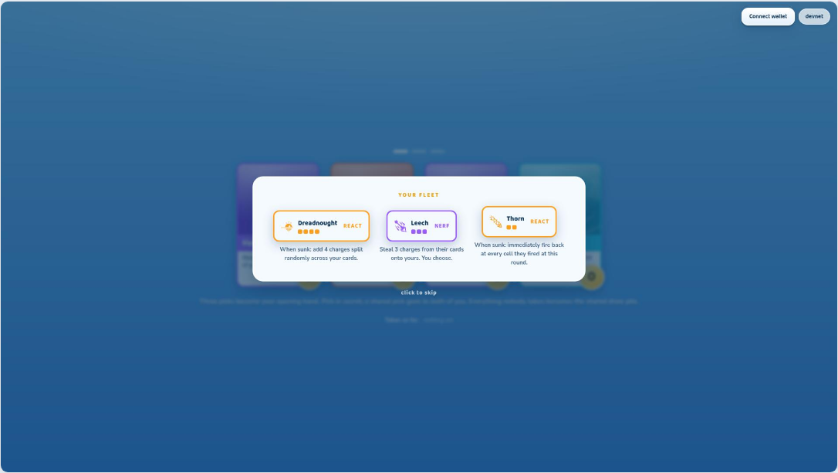
- The three abilities are readable side by side for the first and only time before the match. This is where a player works out what their plan is.
- The cards stagger in at 130ms apart, which reads as a fleet forming rather than three boxes appearing.
Plate 22

Both committed
Two hashes, written before a shot is fired and checkable by anyone afterwards. It is the thing the whole product rests on, and until Build 6 it had no moment at all.
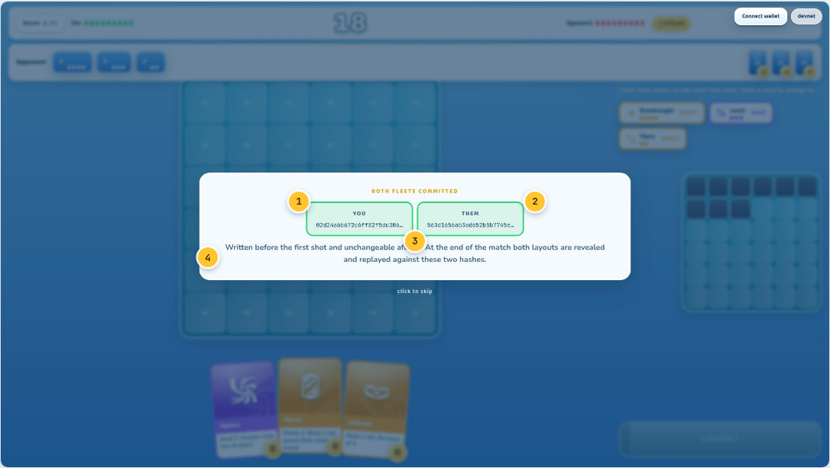
1 Your commitment  The SHA-256 of your layout and a secret nonce. Published deliberately: a commitment exists so the other side can hold you to it later. | 2 Theirs  Arrived at the same instant. Neither hash tells the other anything about where a hull sits — that is what makes it safe to show. | 3 The seal  Both boxes go from dashed to solid green together, 620ms in. A commitment that is not yet sealed and one that is should not look the same.
4 What it buys
At the end of the match both layouts are revealed and replayed against these two hashes. A fleet that “moved” mid-match fails that check publicly.

The draft
Both fleets end up one 4, one 3 and one 2 — only the abilities differ. Picks are blind and simultaneous, and the only thing a draft ever leaks is a collision.
Six decisions, made blind, in about ninety seconds. You know exactly what is on the table — all four cards are face up to both of you — and nothing at all about what they took, unless you took the same thing. That asymmetry is the entire game: by the end of the draft you will know sixteen possible fleets they might be sailing, and the rest of the match is narrowing that down while they narrow you down.
Plate 13 8 7 callouts

Ship draft
A pack of four, face up to both players. You pick in secret; duplicates are legal and carry no penalty.
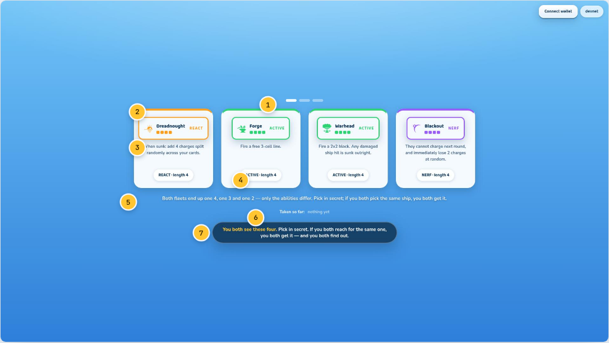
1 Pack progress  Three packs, three picks. The filled pip is the pack on screen — a three-step process shown as three steps. This is the one fact the phase card cannot carry, because it changes twice while you stand here. | 2 Type stripe  The card’s top edge is coloured by ability type: purple NERF, orange REACT, green ACTIVE. The same colours mean the same things everywhere. | 3 The whole ability  Full rule text on the face. Nothing about a draft pick is hidden behind a hover — you are choosing, so you get everything.
4 Type · length  The two facts that decide where the ship sits in your fleet, restated at the point of decision. | 5 The mechanism, permanently  One line under the pack, not a panel. New in Build 6: the rule was never stated anywhere before, and a header saying “Ship draft” was not the same as explaining it. | 6 Taken so far  Your own picks accumulate here, flagged “· both!” where a collision made a pick public.
7 The first-run coach
Pack one only, on a player’s first ever draft. It dismisses itself on the first pick and never returns — the mechanism has three teachers and only this one is temporary.
Plate 14

Beat 2 · your pick
The confirmation beat. The card you took lifts and holds; the other three dim and recede. This has to land clearly, because it is the only acknowledgement a blind pick can get.
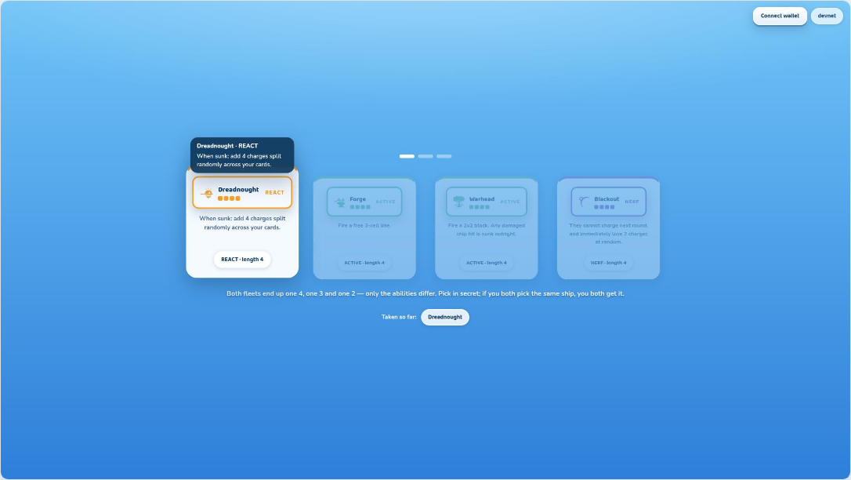
- Beat 1 is the deal-in: four cards arc in from off-screen, staggered 80ms, settling with a small bounce. The whole five-beat sequence runs about two seconds.
- Everything is skippable with a click, and `prefers-reduced-motion` collapses the sequence to a cross-fade.
- The pick reaches the engine on the click, not at the end of the animation. Holding the engine back for theatre would hold the opponent back too.
Plate 15

Beat 3 · their pick
A card back slides in beside yours and both sit there for a moment. This is the tension beat, and until Build 6 it did not exist — the screen went straight from your click to a verdict.
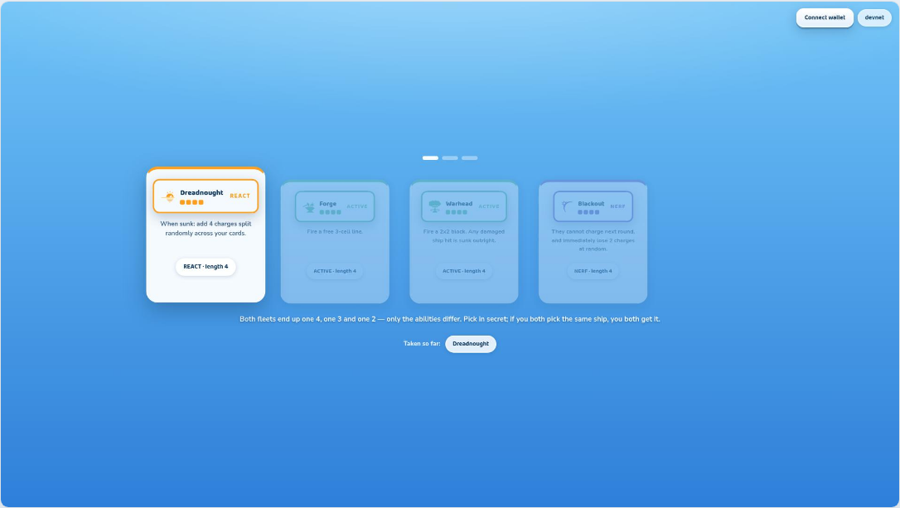
- The back is the same face-down design used for the draw pile and the opponent’s hand. A player learns one “this is hidden” object.
- The pause is the point. A blind simultaneous pick has a moment of not-knowing in it, and an interface that skips that moment throws away the only drama the draft has.
Plate 16

Beat 4 · resolve
No collision: their card back flips away and yours flies to the tray. Nothing is announced. A collision instead flips both face up together into the gold slam.
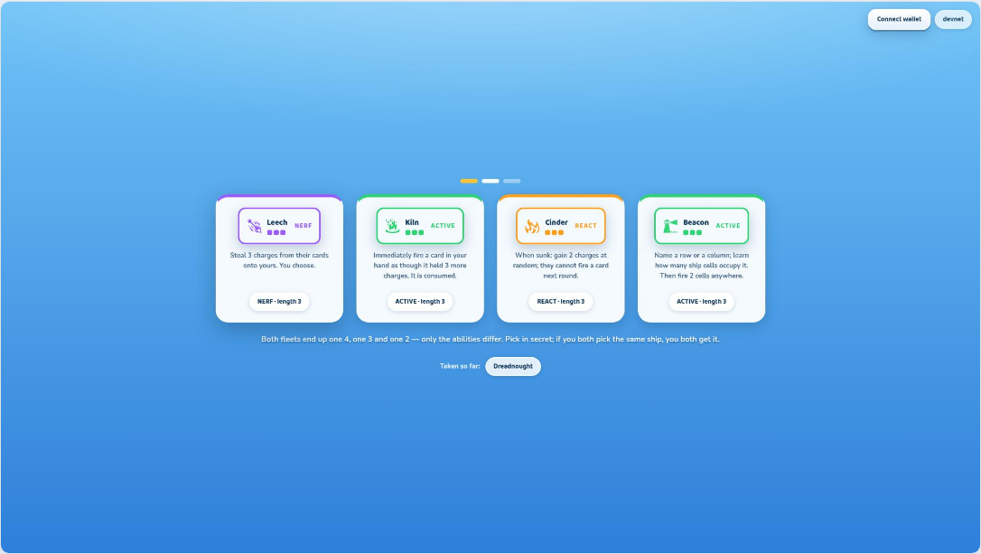
- Build 6 deleted the “PICKS DIFFER” screen entirely. It announced the absence of information, which is the default state of every pack and therefore not news — a player who sees no collision already knows the picks differed.
- The collision keeps its slam. It is the only thing a draft ever tells you, so it should be the only thing that interrupts.
- Because a collision makes a card public, it is also the only case where that card later renders face-up in the opponent’s hand during battle.
Plate 18 7 5 callouts

Card draft
The same mechanism, second time, now with real cards — so the interaction is learned once and used twice. Everything nobody takes becomes the shared draw pile.
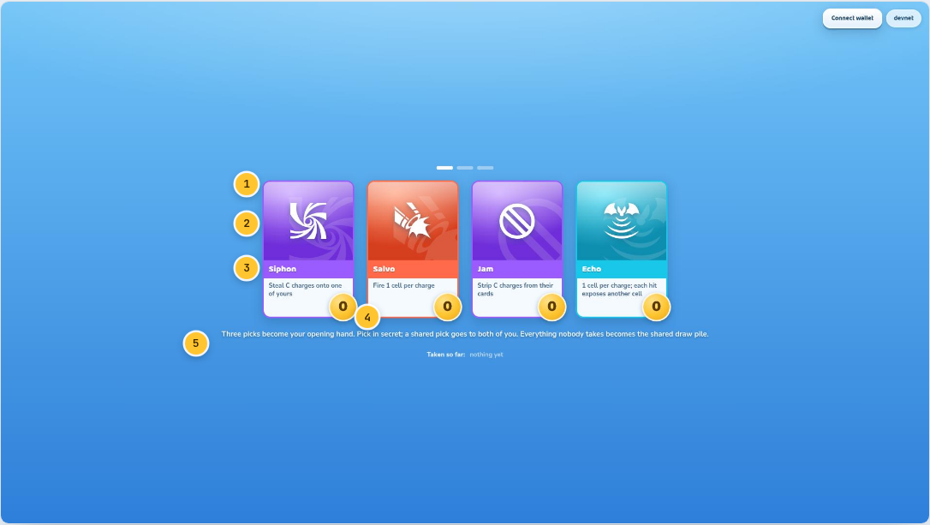
1 Role border  Every card is framed in its role colour: red attack, cyan intel, purple control, amber prediction. Colour tells you what a card is before you read it. | 2 Art window  The top 60% of the card. A composed role gradient with the glyph today; generated illustration drops in here later without touching the layout. | 3 Name banner  Across the middle in the role colour, white on colour — the card’s identity at a glance in a fanned hand.
4 Charge gem  Bottom-right, gold, and deliberately the biggest number on the card. Charges are the currency of every decision in the match. | 5 The pile rule  Whatever neither player takes becomes the shared draw pile — so the cards you pass are the cards you may both draw later.
Plate 19

Card hover
Hover lifts the card and floats the full rule. The desktop pattern used everywhere a card appears — draft, hand, result, inventory.
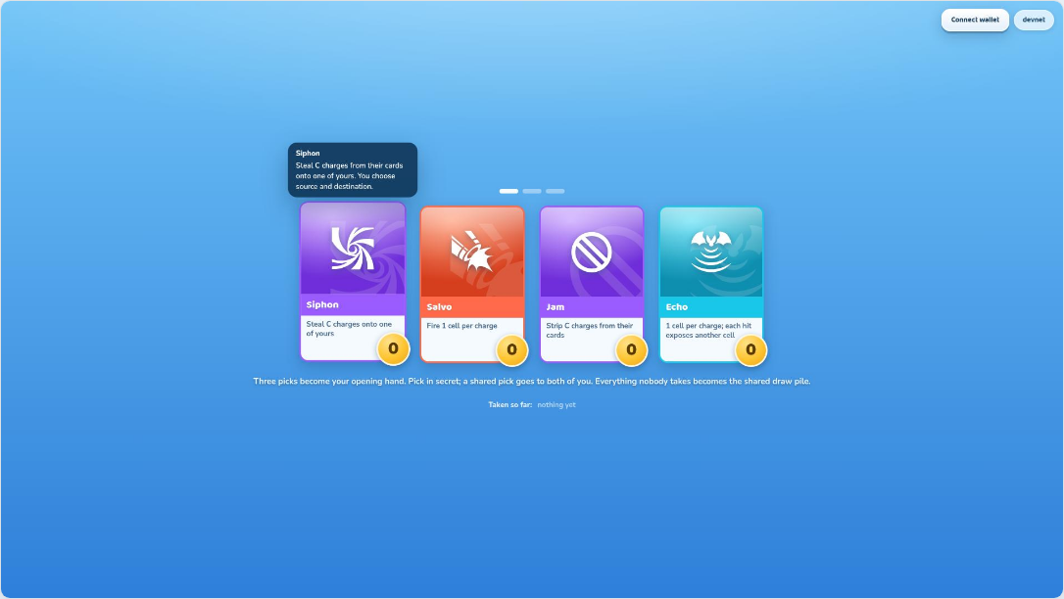
- The lift is a transform, not a layout change, so nothing around the card reflows and the pointer never loses its target.
- This is why the card face can carry a compressed rule: the complete text is always one hover away, and the two never disagree because both come from the same card definition.

Deployment
Where your fleet actually sits — the last decision made in private, and the one that gets hashed and written before a single shot is fired.
One decision, and it is the only one in the match you cannot revisit. Everything after this is played against a board you fixed in the next sixty seconds. The interface’s job here is narrow: show you what is legal, never say no, and make it obvious that pressing the button is a commitment rather than a save.
Plate 20 8 7 callouts

Deploy
Your water large in the centre, the fleet as cards in a side tray. Hovering the board previews a legal placement before you commit to it.
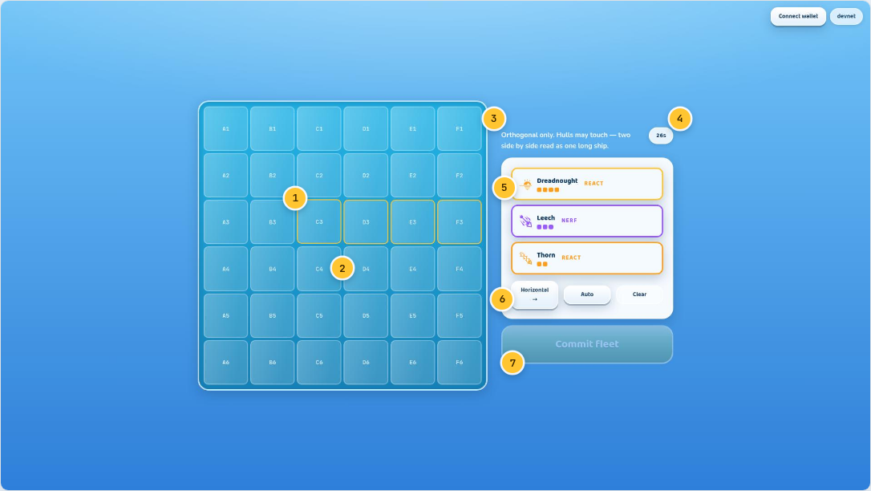
1 Your board  Six by six, lettered columns and numbered rows. The same coordinate language the resolve log speaks: “C2”, “E4”. | 2 Placement preview  The gold outline is the run the selected ship would occupy from the hovered cell. An illegal run simply does not preview — the interface never has to say no. | 3 The placement rule  Orthogonal only, and hulls may touch. Two ships side by side read as one long ship for several rounds, which is a real defensive choice.
4 Phase clock  The deployment window. Let it lapse and the fleet auto-places and commits — the match never stalls on a player who walked away. | 5 Fleet tray  Your three drafted ships as landscape cards. The heading “Your fleet” sat above them until Build 6, labelling three of your own ships, in a tray, on the deployment screen. | 6 Orientation and shortcuts  Horizontal/vertical toggle, Auto for a legal random layout, Clear to start over.
7 Commit fleet
Disabled until all three ships are legally placed, and hovering it then says how many are left. The paragraph explaining the commitment hash used to sit below this button; it moved to the beat where the hashes are actually shown sealing.
Plate 21

Fleet placed
All three ships down, the commit button live. What happens on press is a cryptographic commitment, not a save.
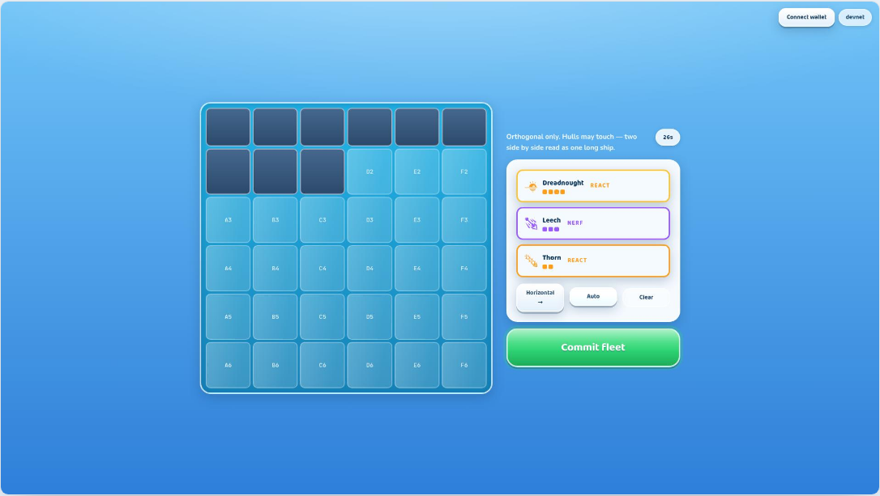
- The client hashes the layout with a secret nonce and publishes only the hash. The opponent — and the server — learn nothing about where anything sits.
- At the end of the match the layout and nonce are revealed, and anyone can check the hash. A fleet that “moved” mid-match would fail that check publicly.
- In a staked match the same commitment is written on-chain, which is what lets a stranger audit the match weeks later.

The fight
The screen the game is built around. Both players plan at the same time, in secret, and both plans resolve together — so nothing here is a turn you wait through.
Twenty seconds, up to twenty times. Each round you must place exactly one charge, you may aim one free shot, and you may fire one card and use one ship ability. You are doing that while reading nine pips, three gems, a board of thirty-six cells and a clock — which is why Build 6 spent itself removing everything on this screen that said the same thing twice. What is left says each fact once, and the loudest object on it is the number you are spending.
The restraint pass

Before and after
The battle screen as it stood at the end of Build 5, and as it stands now. Eight elements removed, four of them replaced by nothing at all.
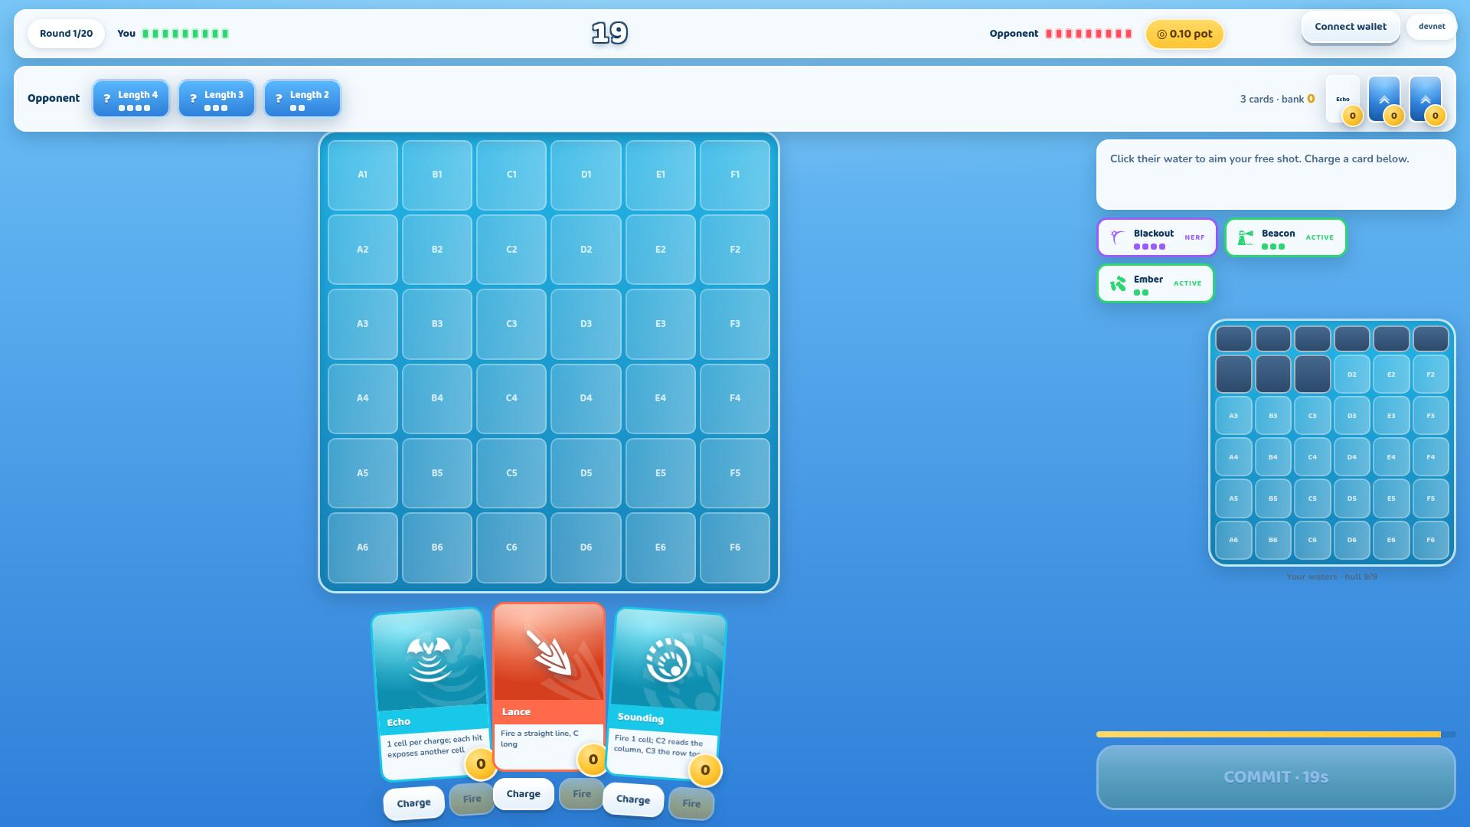  Before · Build 5 | 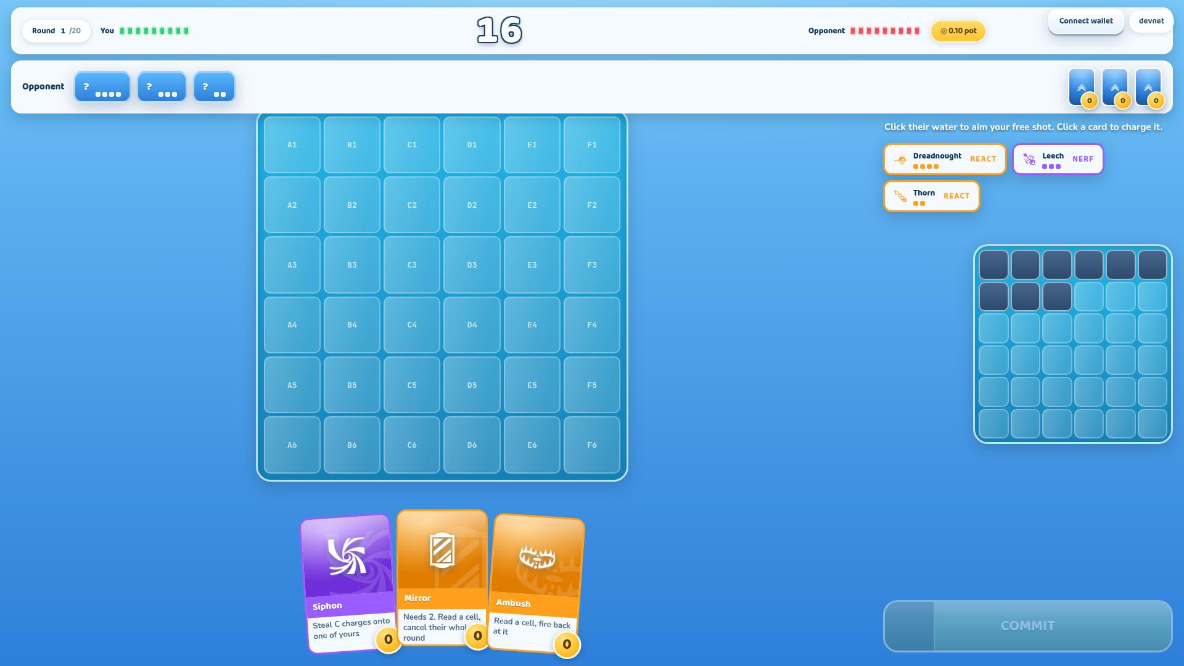  After · Build 6

Removed — 8  − The hull readout under your own board  The nine pips in the top bar are the same number, larger, and never leave the screen.  − The timer bar above the commit button  A second countdown eighteen inches from the first. The commit button now drains as the window runs out — one element, two jobs.  − “3 cards · bank 0” in the opponent strip  Both are sums of things already on that row. You can count their cards; every gem prints its own number.  − The prompt panel’s surface  One of the heaviest objects on screen, for one sentence. The sentence stayed; the panel went.  − Four of the six hand buttons  Three cards carried a permanent Charge and a permanent Fire each. The card is the charge control now, and Fire appears only on the hovered card, only when legal.  − “Length 4 / 3 / 2” on their unrevealed ships  Beside four pips, the words are the same fact twice — and the pips are the half that scans without reading.  − Coordinate labels on the compact board  You never name a cell on your own water. You cannot click it and you never refer to it by letter.  − The “· 14s” suffix on the commit button  Three statements of the same number, on a screen that now sets the clock at 64px. | Arrived — 3  + The clock, at 64px  The screen’s one level-1 element. Every decision here is a decision about how to spend that number.  + A draining commit button  The pressure the removed timer bar carried, moved into the control it was about.  + One hover-scoped card control  Six competing buttons became one, on the card under the pointer — and when the card cannot fire, the same slot says why.
Plate 24 18 12 callouts

Battle · the full anatomy
Their water dominant and centre-left; your own board small at lower right; your hand fanned along the bottom; the pot in gold in the top bar; and the clock now the largest thing on the screen.
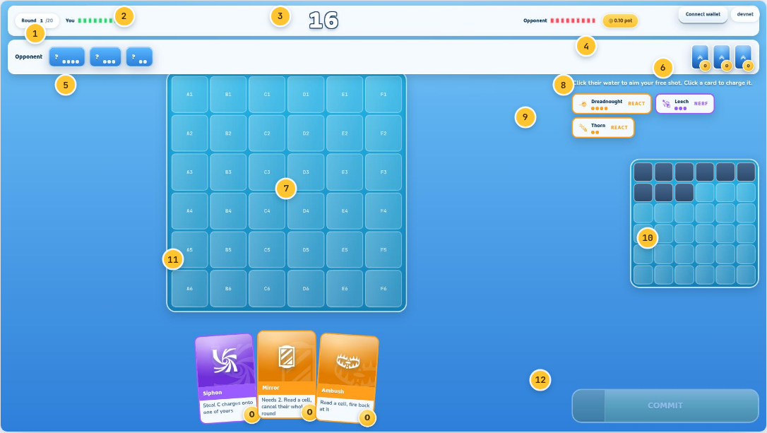
1 Round counter  Which round of a maximum twenty. A match that reaches the cap is decided on remaining hull cells. | 2 Hull, both sides  Nine pips each, one per hull cell across three ships. Yours green, theirs red. Theirs is not a leak: every fleet is nine cells and you know which of your shots landed. | 3 The clock  The plan window, and the screen’s primary element at 64px. Under five seconds it turns red, pulses and ticks audibly. In a networked match the server owns this clock and the client renders an estimate.
4 The pot  In gold, always visible in a staked match. You never have to leave the board to remember what is riding on it. | 5 Their fleet  Three ship cards showing only what the rules make public: a length, as pips. A card flips face-up the moment that ship uses an ability or sinks. | 6 Their cards  Card backs with readable gold charge gems. Charges are public on both sides — the bluff is built on shared information. An identity shows here only if a draft collision already made it public.
7 Their water  The biggest single element on screen — this is where you act. Click a cell to aim your free shot; cells remember hits, misses and intel. | 8 The prompt  What the next click does, in words, directly on the water. It had a panel behind it until Build 6 and was one of the heaviest objects on the screen for one sentence. | 9 Your ships  Your three, face up to you, with their type and whether the once-per-match ability is still available.
10 Your water  Compact and lower-right: this is damage arriving, not a place you act. Your hulls are the dark cells. No coordinates — you never name a cell here. | 11 Your hand  Real cards, fanned, lifting on hover. Clicking one charges it. Three at a time, one drawn per round while the shared pile lasts. | 12 Commit  The largest control in the product. It drains as the window runs out, breathes while a plan is complete, and goes flat grey when it is not. Pressing it seals your plan as a hash — theirs is already sealed too.
Plate 25 5 4 callouts

A plan half-built
The same screen mid-decision: a free shot aimed on their water, one card carrying this round’s charge, and the prompt updated to match.
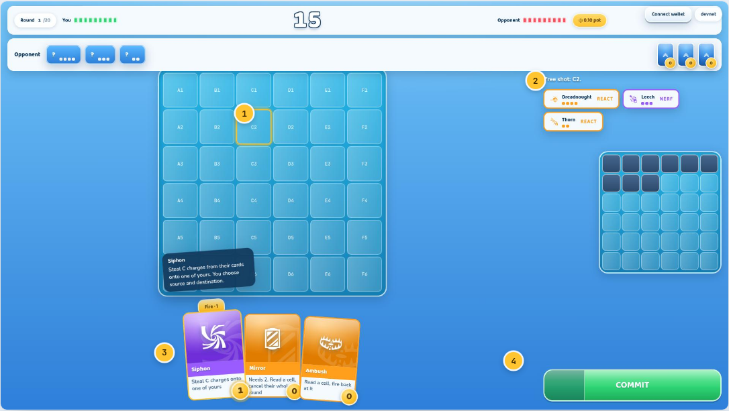
1 The aimed cell  Outlined in gold on their board. Gold marks intent — this is where your free deck gun fires when the round resolves. | 2 Plan readout  The prompt now reads back what is planned — “Free shot: C2.” — rather than what to do next. | 3 Charged card  The gem has ticked to 1 and pulses. The pitch of the click rises with the count, so a fifth charge sounds different from a first.
4 Armed
With a complete plan the commit button pulses. Both plans are held sealed until both have arrived — there is no window in which a late plan can be informed by an early one.
Plate 27

One control, on one card
The Fire affordance appears only on the card under the pointer, and only when that card holds enough charges to be legal. Six permanent buttons became one conditional one.
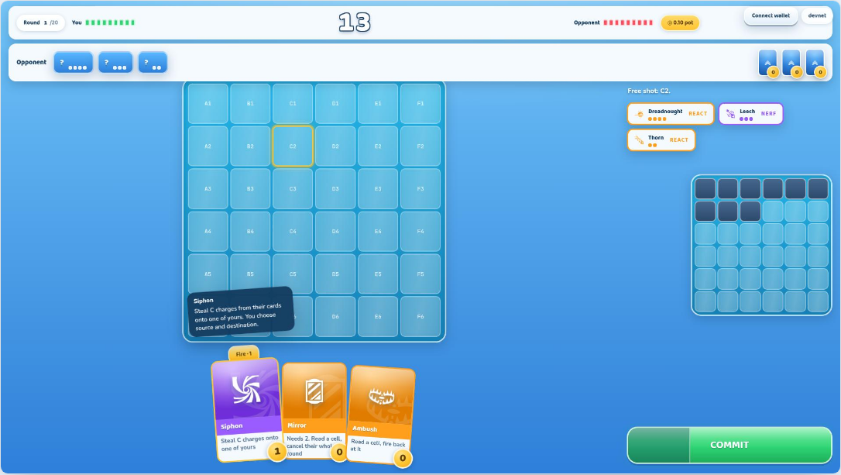
- It carries the charge count it would fire at — “Fire · 3” — so the decision and its size are the same object.
- It sits above the card rather than below it: the hand rests on the bottom edge of the viewport, and anything under a card there is off the screen.
- The card’s own rule tooltip moves up to clear it. Two things wanting the same 30 pixels was the first bug this control produced.
Plate 26

And when it cannot
The same slot, on a card that cannot fire, says why in a sentence. This was the single most confusing gap in the build: a greyed-out control that named no rule.
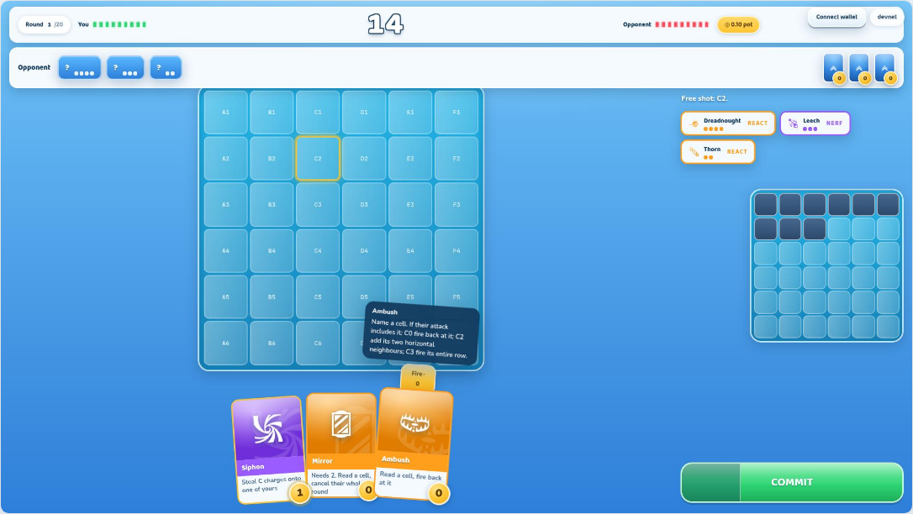
- The reason given is always the *first* rule that stops the action. A card that is both pinned and under-charged says “pinned”, because lifting the pin is what you would have to do first.
- Three reasons cover the Fire control: your cards are locked this round; you have already declared a card; or this card needs N charges and holds M.
- Nothing is added to the screen when the pointer is elsewhere. That is the whole rule the restraint pass and the feedback layer agreed on — feedback is transient, chrome is not.
Plate 28

Pattern preview
Aiming a card previews the exact pattern it would cover, before anything is locked. Twelve cards aim twelve ways; none of them should require memorised geometry.
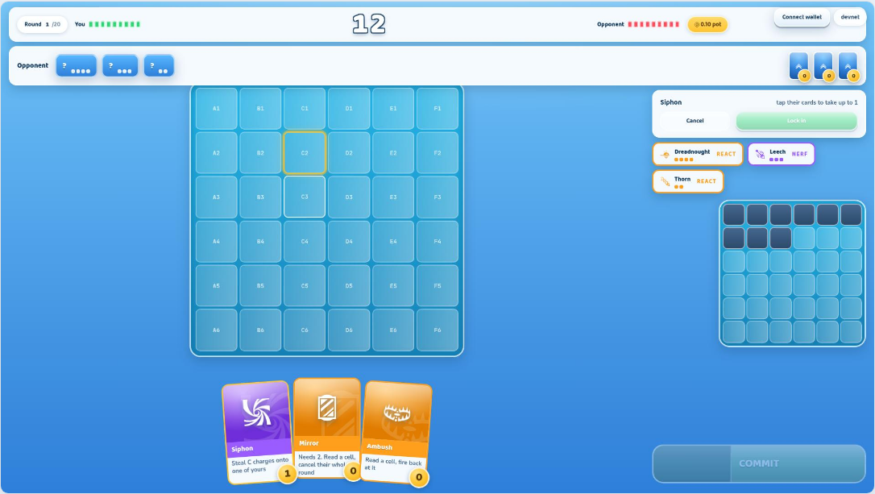
- Burst covers a 2×2 block — and a 3×3 at four charges. Lance runs a straight line whose length is its charge count. Rake takes three in a row, plus one per extra charge.
- The preview uses the same gold aim state as the free shot, so “this is what I am about to do” always looks the same.
- Cancel and Lock in sit under the prompt: nothing is committed by hovering, and nothing is committed by aiming either.
Plate 30

The resolve
Both plans turn face up and the round plays out beat by beat, in the exact order the rules resolve it — so a player can see why something happened, not just that it did.
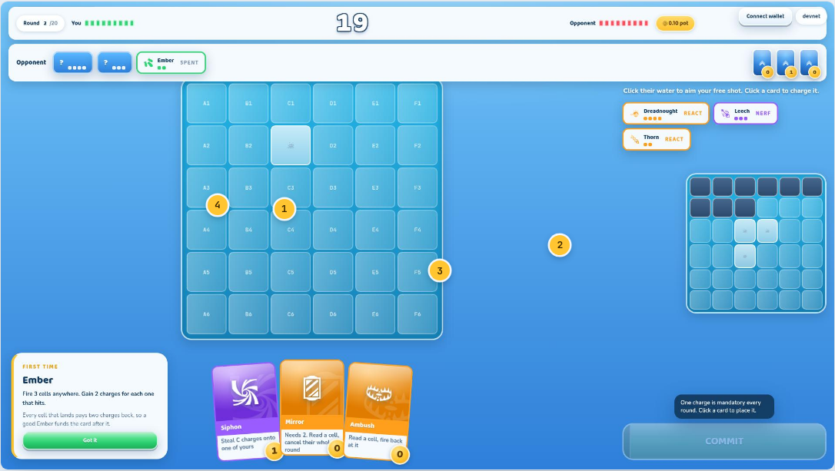
1 Step marker  “4 · ATTACKS”. The resolve has a fixed order — reveal, control effects, predictions, attacks, sinks, reactions, charges — and the overlay names which step you are watching. | 2 What just happened  Plain language, always. “Your deck gun at C2 — miss.” Never “P0 basic → miss”. | 3 Click to skip  The whole sequence can be skipped, and a Settings toggle collapses it to about a second permanently.
4 Board stays visible
The panel is small and the boards dim rather than disappear, so each described shot lands where you can see it land — and the floaters rise over the top of it.

What the game tells you
Three tiers of feedback, ordered from wordless to explanatory, and a budget that keeps them from becoming noise. All of it new in Build 6, and all of it transient by construction.
Until this build a player watched things happen to them without being told why. A Thorn went off and shots appeared from nowhere. Fire was greyed out and nothing said which rule was stopping them. The three tiers below answer that, and they are designed to get quieter: floaters and named lines never stop, but the explanations stop the moment a mechanic is no longer new to you. The teaching load decays to zero instead of becoming permanent noise — which is the mechanism that lets the middle tier stay to one line.
Plate 29

Tier 1 · board floaters
Short-lived text rising from the exact cell or object it belongs to, then gone. No panels, no dismissal, no reading required — and a veteran still wants them.
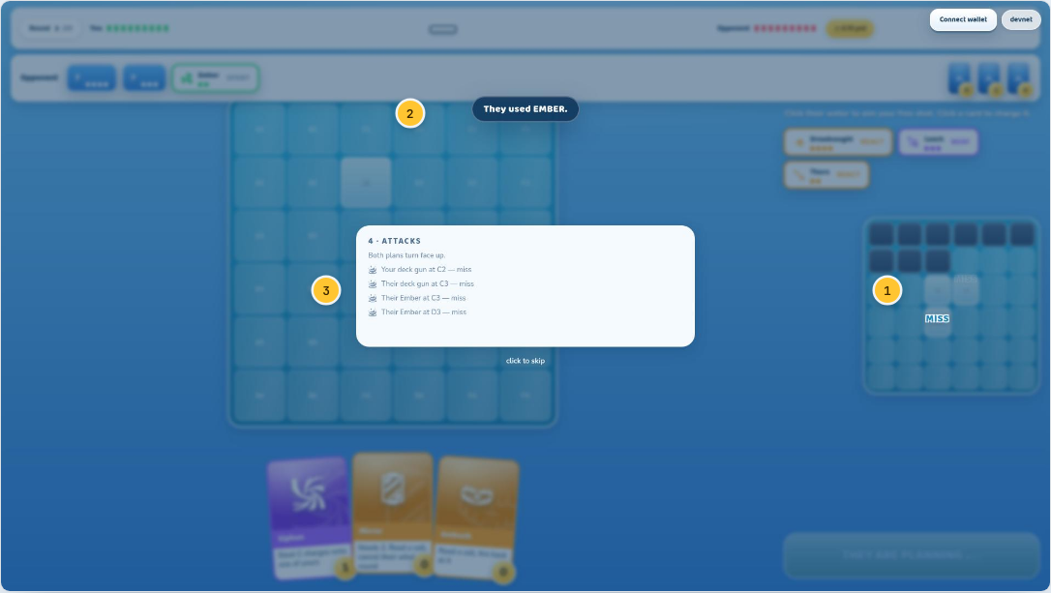
1 HIT / MISS  On the cell that took the shot, on whichever board it landed on. Six cells resolving spawn six floaters staggered 55ms apart with the projectiles, rather than queueing. | 2 A named event, above  Tier 2, running at the same time: one line for a change with a name behind it. The two tiers are designed to co-exist because they answer different questions — what happened, and what caused it. | 3 The overlay, underneath  Floaters draw above the resolve overlay. They are anchored by a measured screen rectangle, so a HIT rises off its cell while the overlay narrates the same beat over the top of it.
- Six floaters in the vocabulary: HIT, MISS, SUNK · N, +N to a card that gained charges, −N off one that lost them, and BLOCKED where a Mirror cancellation ate a shot.
- Each lives 600ms. Nothing here can be interacted with and nothing waits for the player.
- BLOCKED is the one that cannot come from the event stream: a cancelled attack fires no shots and so leaves no trace at all. It uses the aim the local player themselves declared, and nothing else.
Plate 32

Tier 2 · named events
One line, fixed position, for the things that have a name and would otherwise be mysterious — where the board changes for a reason that is not on screen.
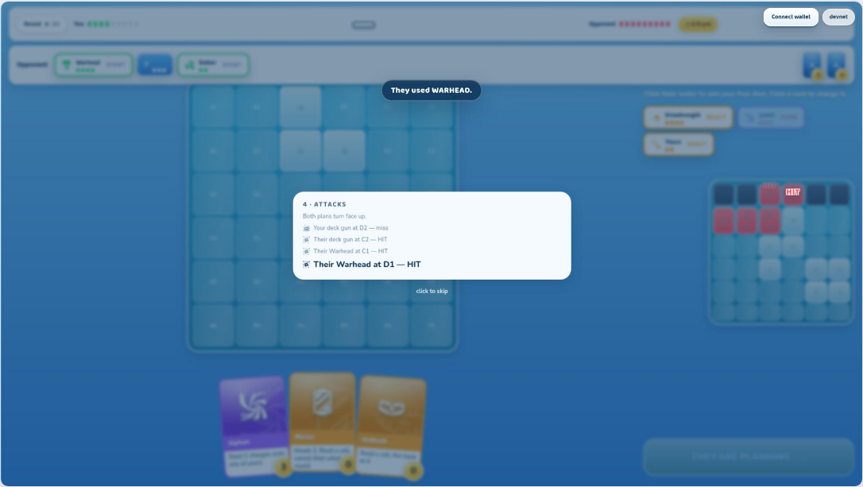
- Eleven of them: the four REACTs, both predictions landing either way, the two restrictions, and an ability activation on either side.
- Never stacking more than two deep, never blocking, gone in 2.2 seconds.
- The wording rule: say what happened to the board, in the plain register the resolve overlay uses. “THORN — firing back at every cell they hit”, never “THORN triggers REACT”.
Plate 31

Tier 3 · first-time explainers
The first time each mechanic happens in that player’s history, a fuller card explains why. Once ever, then never again — and every one of them is resettable from Settings.
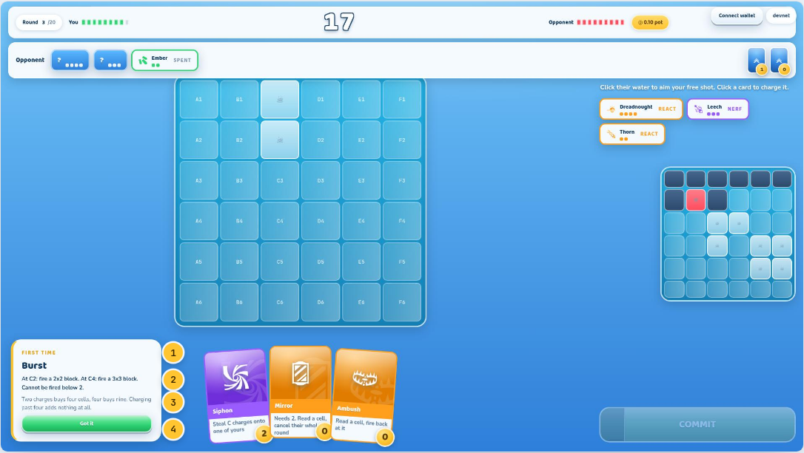
1 The kicker  “FIRST TIME”. It tells you the card will not be back, which is what makes it acceptable to interrupt with at all. | 2 The rule  Read straight out of the ship and card definitions the engine runs on, so it cannot drift from what actually happens. | 3 Why it matters  The one authored sentence: the consequence, which no data file can derive. “Sinking it costs them next round’s card fire and hands them two charges.”
4 Got it
The only thing in the feedback layer that waits for a click. Dismissing it marks the mechanic seen, in local storage, per player.
- Twenty-eight in total: each of the twelve cards, each of the eight ACTIVE/NERF abilities, each of the four REACTs, plus the hull tiebreak, a draw, a timer strike and the first draw from the shared pile.
- The budget is one Tier-2 line and one Tier-3 card on screen at once. A mechanic crowded out stays unmarked — it is still first-time, so it gets its explanation next time rather than losing it silently.
- Settings shows how many of the twenty-eight have been seen and can make all of them first-time again.

Settling up
What a match is worth, and the proof that it was played honestly. Both fleets are revealed here and nowhere earlier.
The match is over and every secret in it is now worthless, so all of them are shown at once. This is also the screen where the product’s central claim gets checked rather than asserted: the client re-runs the whole match from the seed and the signed transcript, and either gets the same result or says loudly that it did not.
Plate 33 9 7 callouts

Result and receipt
The outcome, both fleets revealed, and a settlement receipt that shows the arithmetic — pot, rake, net — with the transaction and a replay check beside it.
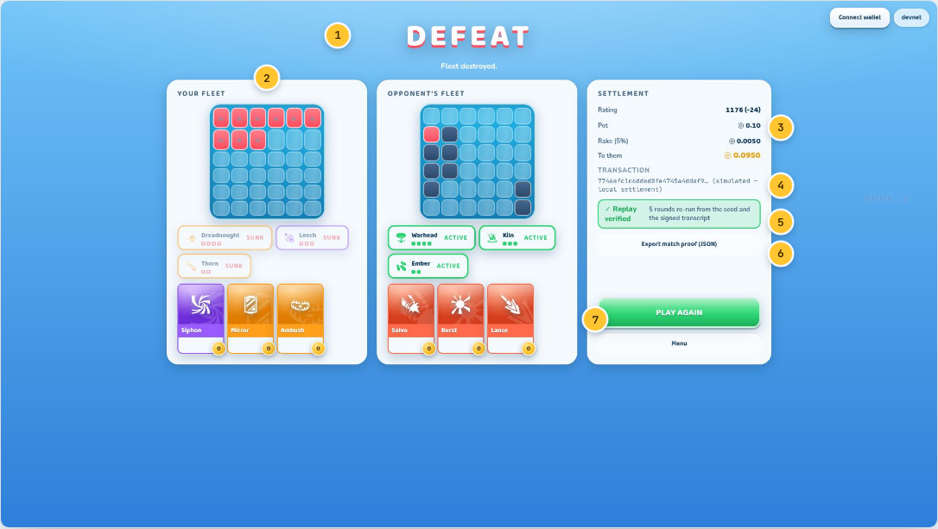
1 The verdict  VICTORY, DEFEAT or DRAW at 64px — the screen’s one primary element. The line underneath names how it ended: fleet destroyed, hull count, mutual elimination. | 2 Both fleets, revealed  Layouts, ships and spent cards for both sides. The first and only moment their identities become visible; sunk ships show hollow pips. | 3 The arithmetic  Pot, the 5% rake on its own line, and the net in gold. A draw replaces these with “stakes returned — no rake”.
4 Transaction  The settlement signature, in the mono face because it is a string you compare character by character. On devnet it links to the explorer; on the local adapter it is labelled “(simulated)” rather than dressed up as real. | 5 Replay verified  The client re-ran the entire match from the seed and the signed transcript and got the same result. This badge is the product’s core claim, checked rather than asserted. | 6 Export match proof  Downloads the transcript as JSON. Anyone can verify it independently — the check does not depend on this client.
7 Play again
One button. REMATCH and NEXT OPPONENT stood side by side here calling the same function: the queue finds whoever is available, so there was never a rematch to offer.
Plate 40 7 5 callouts

The bracket
Eight seats, three rounds, one pot. Your path is picked out in gold, and the payout split never leaves the screen.
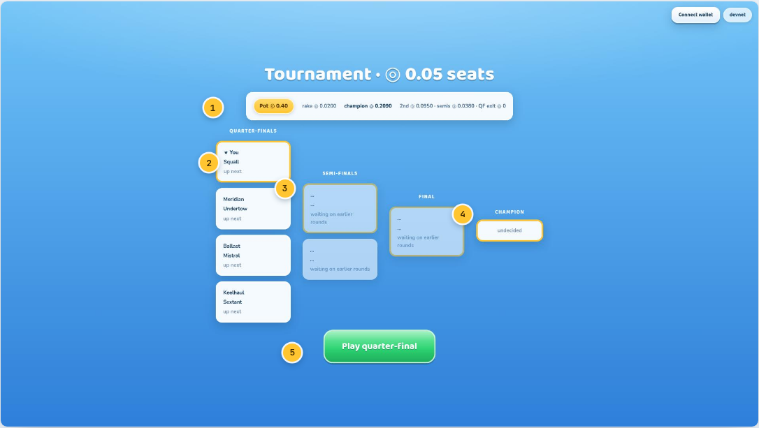
1 Pot and split  The pot, the rake, and every share — champion, runner-up, semifinalists, and the explicit “QF exit ◎0” — always visible while you play. | 2 Your match  Gold border and a star against your name. In a bracket of eight, the first thing you need is to find yourself. | 3 Rounds  Quarters, semis, final. Losers are struck through, winners ticked green, and undecided slots say what they are waiting on. A decided match used to also say “decided”.
4 Champion slot  Undecided until it is not. Gold framed, because that is where the 55% goes. | 5 Play your round  One green button when it is your turn, naming which round you are about to play.
Plate 41

Champion
The loudest screen in the game, and the mode’s whole reason to exist: eight entered, one takes 55% of the pot.
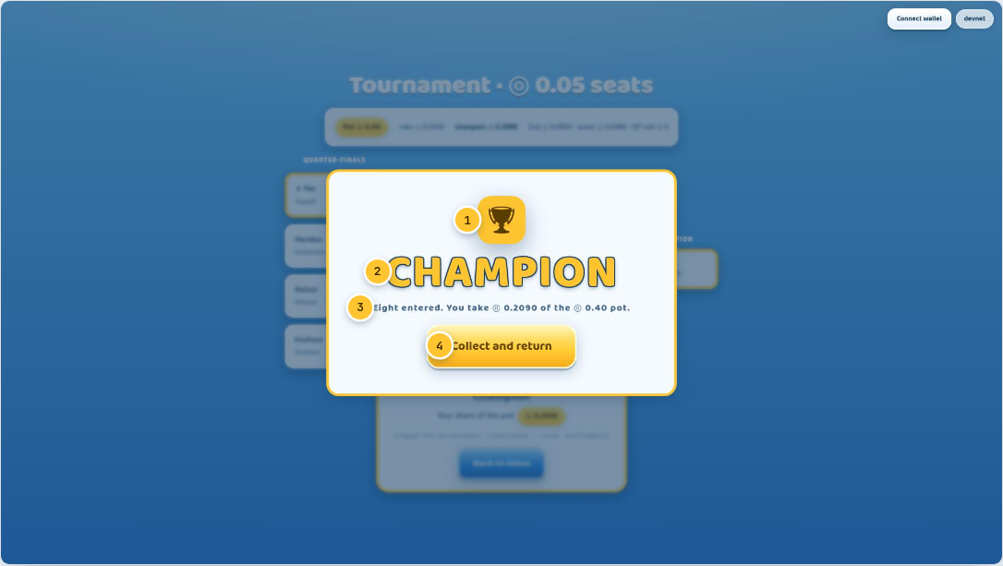
1 Trophy  Gold on gold, slammed in with the banner animation used for nothing else. | 2 CHAMPION  Set in the outlined display numerals at 88px — the only place in the game that shares a size with the wordmark. | 3 The number  What you actually take, against the pot it came from. The celebration and the receipt are the same sentence.
4 Collect and return
One way onward. The settlement already happened on-chain; this is acknowledgement, not a transaction.

The ladder and the shelf
Where a season stands, what the game is made of, and who made the parts that were not made here.
These are the screens a player visits between matches rather than during them, which is exactly why the restraint pass was hardest here: a screen nobody is under time pressure on will happily accumulate things nobody reads. The payout curve used to be drawn twice, on two different screens, in the same shape.
Plate 34 6 3 callouts

Leaderboard
The standings, and your own row pinned wherever you actually rank. The payout curve moved out — it is the Season screen’s entire job, and it was being drawn twice.
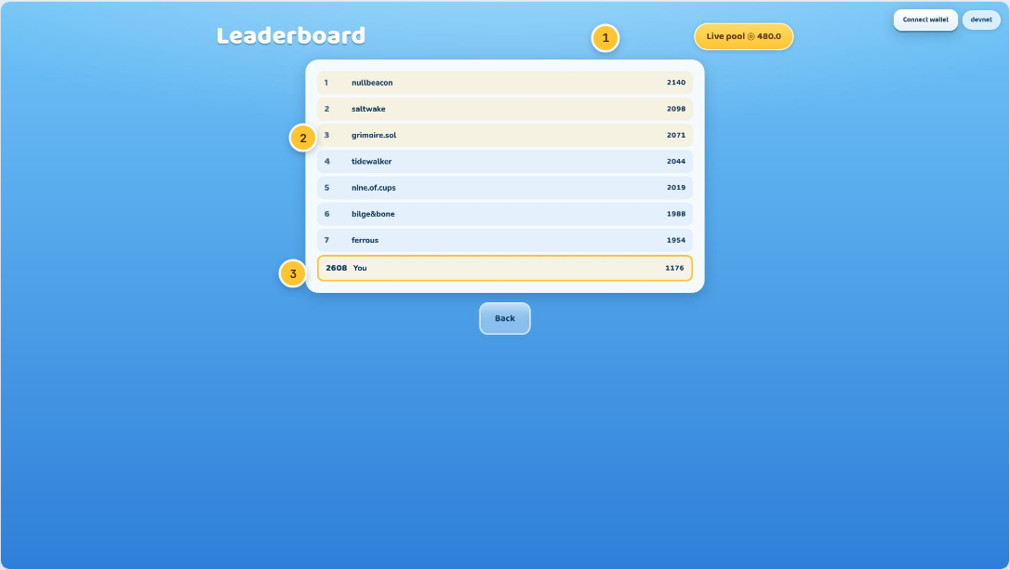
1 Live pool  What all the season entries add up to right now, in gold. | 2 The top of the ladder  Rank, handle, rating — in tabular figures, so the numbers line up as a column rather than drifting as they update. | 3 Your row, pinned  Ranked 2608th and still on screen. A ladder that only shows the top eight tells almost every player nothing.
Plate 35

Season
Days left, the live pool, where you stand, what that position would pay if the season ended now — and the curve that produces the number.
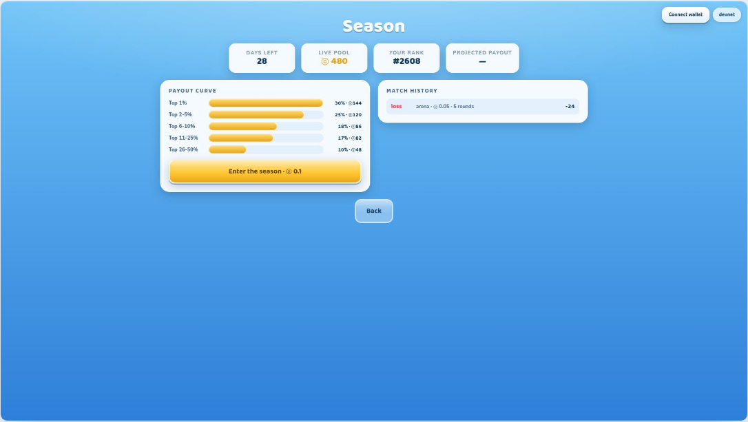
- The projection is computed from the same curve drawn beneath it, against your current rank — not a marketing number.
- The curve’s shape is the argument: the top 1% take the largest share, and the top tenth at least recover their entry. A ladder nobody below the podium can profit from stops being a ladder.
- Match history sits alongside: result, rating delta, rounds, mode and stake for every recent match.
Plate 36 8 6 callouts

Settings
Wallet, sound, the two Build 6 toggles, and a running journal of everything the chain adapter actually did — because a staking product should never make you guess.
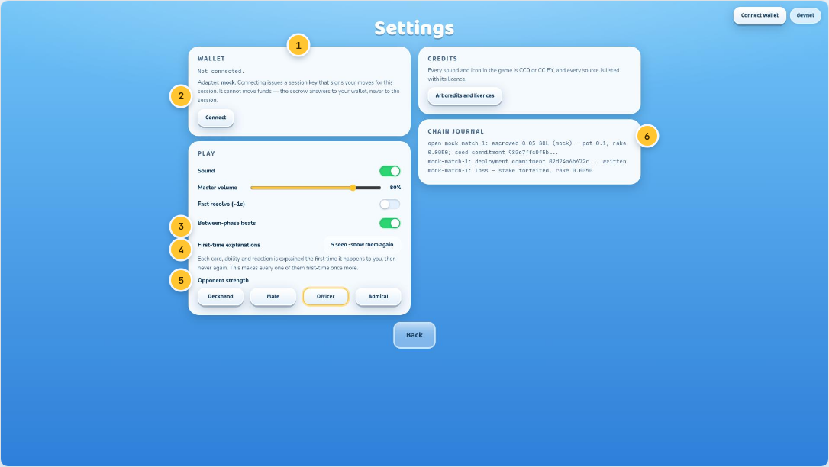
1 Wallet  Connect and disconnect. The adapter in use is named — “mock” here, “devnet” against a real cluster. The address is set in mono, because an address is compared character by character. | 2 What a session key is  Connecting issues a key that signs your moves for the session. It cannot move funds: the escrow answers to your wallet and never to the session. That claim is enforced by the program and proven by a test. | 3 Between-phase beats  New in Build 6. The four transitional moments, off in one click for a player who has seen them enough.
4 First-time explanations  How many of the twenty-eight mechanics have been explained to you, and a button that makes every one of them first-time again. | 5 Opponent strength  Four bots: Deckhand plays at random, Admiral models your fleet distribution and predicts your next shot. | 6 Chain journal  Every escrow, commitment and settlement the adapter performed this session, in order, with amounts and hashes. A debug readout of the last sound cues sat beneath it until Build 6 — a player does nothing differently for that.
Plate 37

Credits and licences
Thirty-seven icons under CC BY, fifteen sounds under CC0, three typefaces under the OFL — each with its author and source, in the build itself.
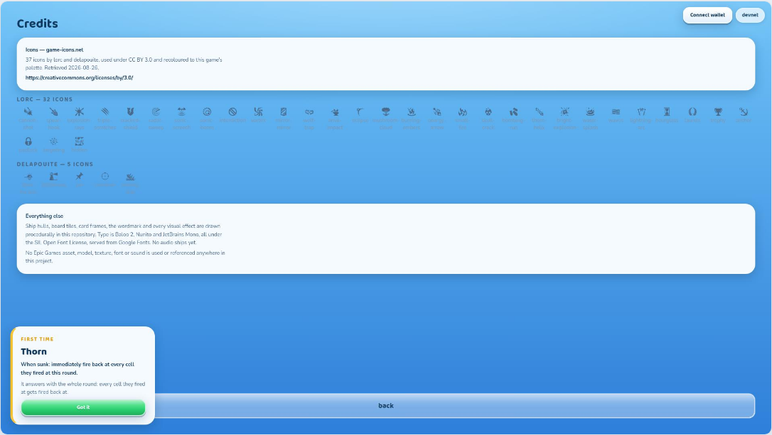
- Attribution is a licence condition for the icon set, so the screen is part of the product rather than a document kept alongside it.
- The list is generated by the same script that downloads the assets, so the credits cannot drift from what actually shipped.
- No Epic Games asset, model, texture, font or sound is used or referenced anywhere. “Stylised 3D” is a visual target, not a source.

When the wire breaks
Real network play means real network failure. Five states a player is owed the truth about — three of them while money is on the table.
Everything in this chapter happens to a player who did nothing wrong. That constrains the writing more than any other screen in the product: the sentence has to say what has happened, what it will cost, and what is being done about it, without softening any of the three. A staked player who does not know they are about to forfeit is a player losing money to a wording choice.
Plate 43

Reconnecting
The socket dropped mid-match. The server holds your seat for the grace period, and the client says exactly that while it retries.
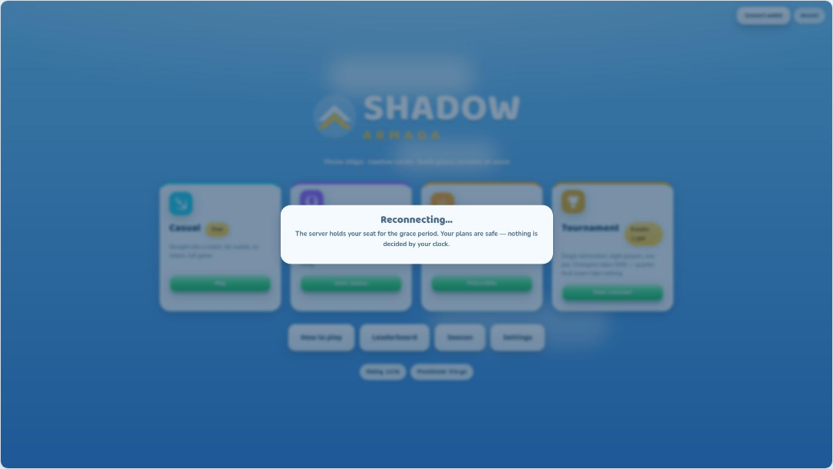
- Input is blocked while this shows: acting on a stale view would only queue intents the server will refuse.
- “Your plans are safe — nothing is decided by your clock” is the important sentence. Every deadline is server-side; a slow or backgrounded client changes nothing about when the server acts.
Plate 44

Connection lost
Reconnection gave up. Said plainly, with the consequence spelled out and exactly one useful button.
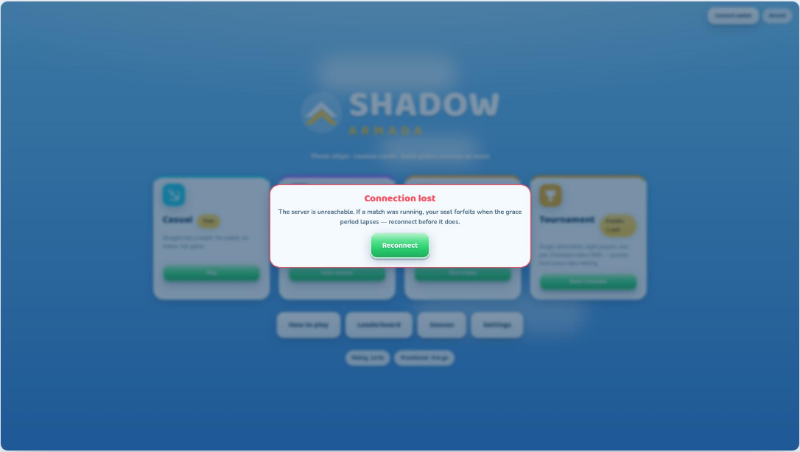
- The consequence is named rather than softened: if a match was running, the seat forfeits when the grace period lapses.
- A staked player who does not know that is a player about to lose money to a wording choice.
Plate 45

Opponent disconnected
Their socket, their problem — but you are told, and the match holds rather than hanging.
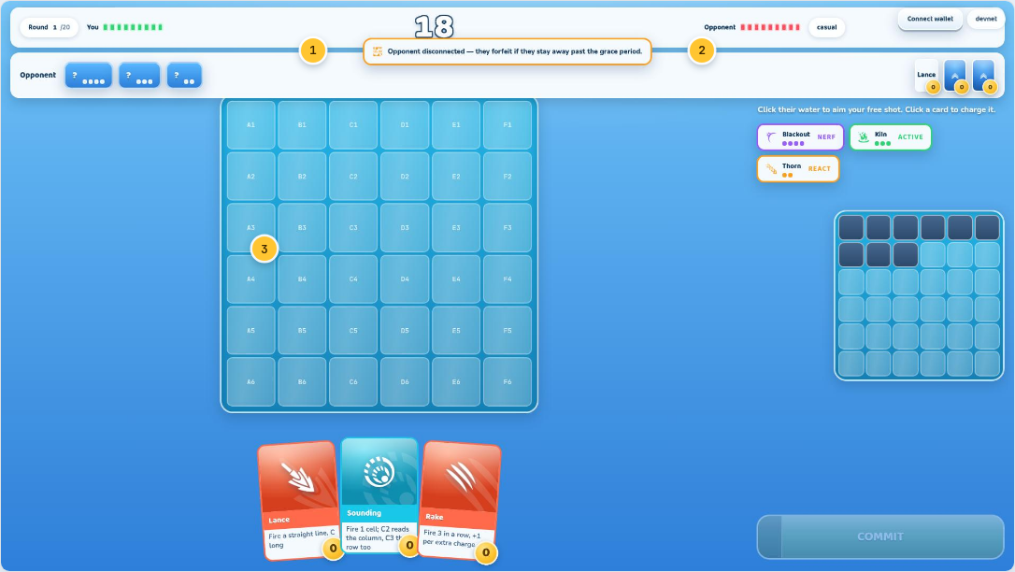
1 The banner  Amber, non-blocking, at the top of the board. You can keep planning; the round resolves as normal. | 2 The rule, stated  They forfeit if they stay away past the grace period — and with real money that path is exercised in the tests, not assumed. | 3 Play continues  The board stays live underneath. A disconnect is not a modal that stops the game for the player who is still there.
Plate 46

Server error
A refusal from the server surfaces as a sentence. Codes travel on the wire; humans get words.
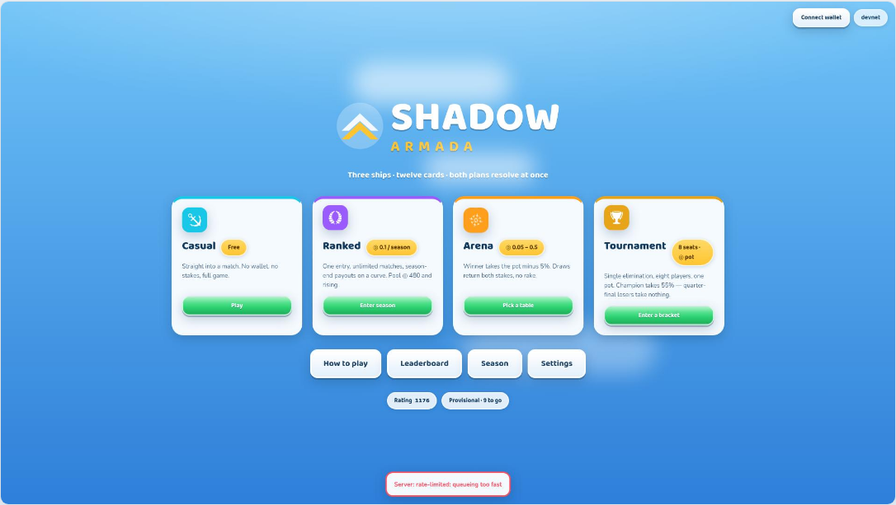
- The protocol carries a machine code — `rate-limited`, `provisional`, `stale-round` — and the interface renders the message beside it rather than the code alone.
- Non-blocking, bottom of the screen: a refusal you can read and act on without losing the screen you were on.
Plate 47

Queue timeout
Nobody in your band joined in time. The stake was never taken — and a staked player is never silently handed a bot.
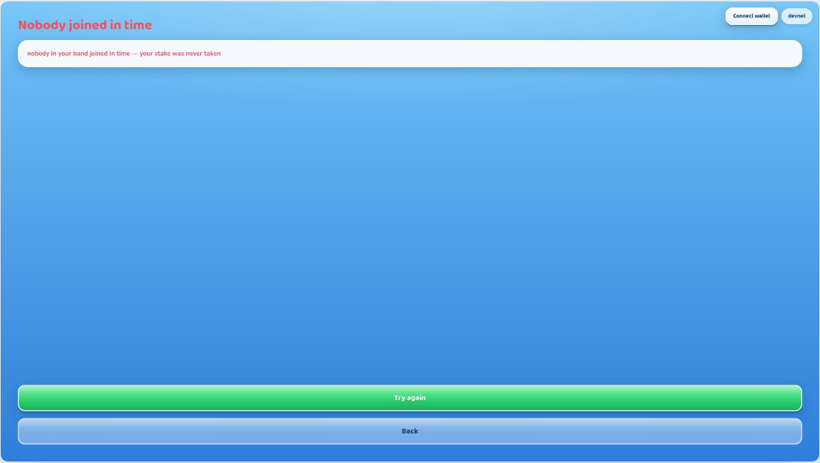
- Casual falls back to a bot after a few seconds and says so in the match-found beat. Staked queues never do; they time out loudly instead.
- Quietly substituting a bot for a paying opponent would be the single worst thing this product could do. The queue is built so it cannot.

How these were made. Every plate is a real screenshot taken by `npm run screens`, which drives a browser through the actual game — queueing, drafting, deploying, planning rounds, settling — and photographs what is on screen. Nothing here is a mock-up of a screen that does not exist. The callout numbers are composited from the same rendered page the HTML and PDF versions use, so a pin sits in the same place in all three.
Shadow Armada · devnet only · 47 plates

