Day 09 – part1

Elves tracking the tail of a rope (or is it a snake)?
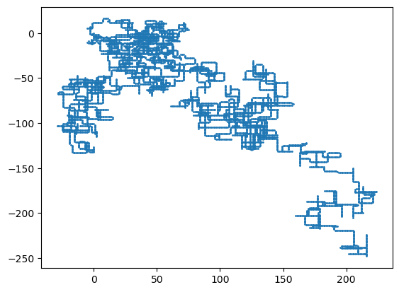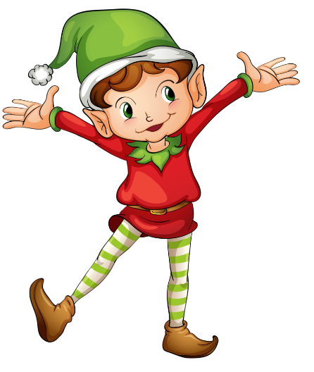
The problem is a bit like the snake game:
- tail follows head according to some rules.
- Tail leaves trail
- Keep track of trail (locations it visited)
After completing movements, add the number of locations that tail has visited
Input as a text box, Put your input (head movement instructions) inside this box

