Student number: G06352027

Comparison of thick and thin wall

Introduction

The thin-walled assumption simplifies the stress equations by assuming that the radial stress is negligible and that the hoop stress (circumferential stress) is constant across the wall thickness.
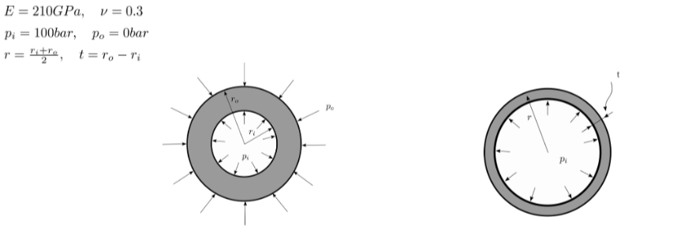
The code attached analyzes the error between the thin-walled and thick-walled (Lame's) hoop stress equations for a cylinder. Here’s what it shows about the relationship between thickness and pressure for thin-walled cylinders:
- Thin-walled approximation is valid when the wall thickness is much smaller than the radius (r>>>t), the code finds the critical value of s where the error is less than 1%.
- As thickness increases, the error in the thin-walled approximation increases, meaning the thin-walled formula becomes less accurate for thicker cylinders.
- Pressure difference also affects the error, but for thin walls (small thickness), the thin-walled formula remains accurate across a range of pressures.
Equation Definitions.
- Thin cylinder equations(Approximate hoop stress for thin-walled cylinders):
$$σ_{φ, thin}= \frac{{(P}_{i}-P_{o})*R}{t}$$
- Python function: def thin_approx()
- Thick cylinder equation (Exact hoop stress for thick-walled cylinders (Lame's equations).):
$$σ_{φ,thick}= \frac{P_{i}r_{i}^{2}- P_{o}r_{o}^{2}}{r_{o}^{2}-r_{i}^{2}}+ \frac{{(P}_{i}- P_{o})r_{i}^{2}r_{o}^{2}}{{(r}_{o}^{2}-r_{i}^{2})r}$$
- Python function: def lame_stress()

- Error calculation:
$$error= \frac{σ_{φ,thick}-σ_{φ,thick}}{σ_{φ,thick}}$$

Results

Error against radius ratio
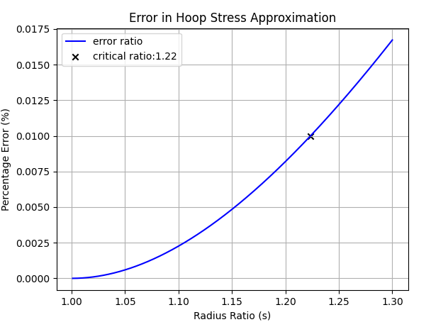
Critical radius ratio for acceptable error: 1.223
As the thickness ratio increases the error also increases. The thin cylinder equation is valid only when (r>>>t), this graph shows that thickness increases the thin cylinder equation approximation no longer holds.
The error made by the thin-walled assumption for the maximal circumferential stress is smaller than 1% when the ratio of outer to inner radius, S, is approximately 1.223. This means that for cylinders with a thickness-to-radius ratio (t/r) of about 0.2 or less, the thin-walled assumption is highly accurate and can be used with confidence.

Error against magnitude of pressure difference and average pressure
When considering the case with non-zero external pressure, the relationship between the error and the pressure difference (pi - po) remains consistent with the previous findings.
The error is primarily a function of the geometric ratio S, and the magnitude of the pressure difference scales the stress values but does not fundamentally alter the percentage error's dependence on the geometry.
This confirms that the geometric assumption is the dominant factor in determining the accuracy of the thin-walled model.
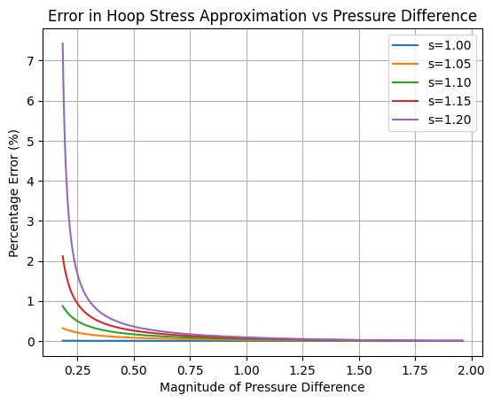

Conclusion
The exercise demonstrated the limitations and applicability of the thin-walled cylinder theory. The results clearly show that the thin-walled assumption is a valid and accurate simplification only for cylinders where the wall thickness is very small relative to the radius. Specifically, the error for the maximal circumferential stress is less than 1% only for S<1.22.
For S>1.22, the error increases significantly, making the thick-walled cylinder theory, based on Lame's equations, a necessary and more accurate approach. The analysis confirms that a cylinder's geometry (the S-ratio) is the most critical factor in determining whether the thin-walled or thick-walled model should be used. The magnitude of the internal and external pressures affects the stress values but does not change the fundamental relationship between the geometry and the accuracy of the thin-walled assumption.

