## **Key concepts on Deep Neural Networks**

**Question 1: What is the "cache" used for in our implementation of forward propagation and backward propagation?**

(***X***) We use it to pass variables computed during forward propagation to the corresponding backward propagation step. It contains useful values for backward propagation to compute derivatives.

( )It is used to keep track of the hyperparameters that we are searching over, to speed up computation.

( )We use it to pass variables computed during backward propagation to the corresponding forward propagation step. It contains useful values for forward propagation to compute activations.

( )It is used to cache the intermediate values of the cost function during training.

**Question 2: Among the following, which ones are "hyperparameters"? (Check all that apply.)**

[***X***] number of iterations

[***X*** ] activation values *a*[*l*]

[***X***] size of the hidden layers *n*[*l*]

[***X***] number of layers *L* in the neural network

[***X***] learning rate *α*

[] bias vectors *b*[*l*]

[] weight matrices *W*[*l*]

**Question 3:Which of the following statements is true?**

(***X***)The deeper layers of a neural network are typically computing more complex features of the input than the earlier layers.

The earlier layers of a neural network are typically computing more complex features of the input than the deeper layers.

**Question 4:Vectorization allows you to compute forward propagation in an L-layer neural network without an explicit for-loop (or any other explicit iterative loop) over the layers l=1, 2, …,L. True/False?**

(***X***)True

False

**Question 5: Assume we store the values for n^{[l]}n[l] in an array called layers, as follows: layer_dims = [n_xnx , 4,3,2,1]. So layer 1 has four hidden units, layer 2 has 3 hidden units and so on. Which of the following for-loops will allow you to initialize the parameters for the model?**

for(i in range(1, len(layer_dims)/2)):

parameter[‘W’ + str(i)] = np.random.randn(layers[i], layers[i-1])) * 0.01

parameter[‘b’ + str(i)] = np.random.randn(layers[i], 1) * 0.01

for(i in range(1, len(layer_dims)/2)):

parameter[‘W’ + str(i)] = np.random.randn(layers[i], layers[i-1])) * 0.01

parameter[‘b’ + str(i)] = np.random.randn(layers[i-1], 1) * 0.01

for(i in range(1, len(layer_dims))):

parameter[‘W’ + str(i)] = np.random.randn(layers[i-1], layers[i])) * 0.01

parameter[‘b’ + str(i)] = np.random.randn(layers[i], 1) * 0.01

***for(i in range(1, len(layer_dims))):***

***parameter[‘W’ + str(i)] = np.random.randn(layers[i], layers[i-1])) * 0.01***

***parameter[‘b’ + str(i)] = np.random.randn(layers[i], 1) * 0.01***

**Question 6:Consider the following neural network.**

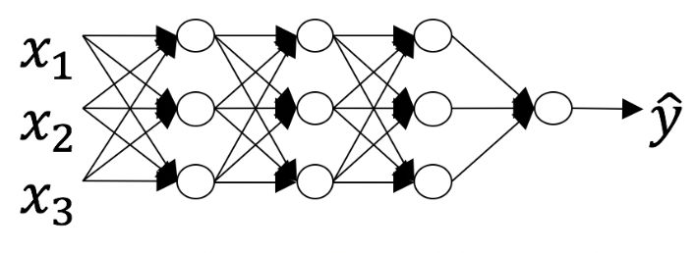

**How many layers does this network have?**

(***X***)The number of layers L is 4. The number of hidden layers is 3.

The number of layers *L* is 3. The number of hidden layers is 3.

The number of layers *L* is 4. The number of hidden layers is 4.

The number of layers *L* is 5. The number of hidden layers is 4.

**Question 7: During forward propagation, in the forward function for a layer *ll* you need to know what is the activation function in a layer (Sigmoid, tanh, ReLU, etc.). During backpropagation, the corresponding backward function also needs to know what is the activation function for layer L, since the gradient depends on it. True/False?**

(***X***)True

False

**Question 8 There are certain functions with the following properties:**

**(i) To compute the function using a shallow network circuit, you will need a large network (where we measure size by the number of logic gates in the network), but (ii) To compute it using a deep network circuit, you need only an exponentially smaller network. True/False?**

True

(***X***)False

**Question 9: Consider the following 2 hidden layer neural network:**

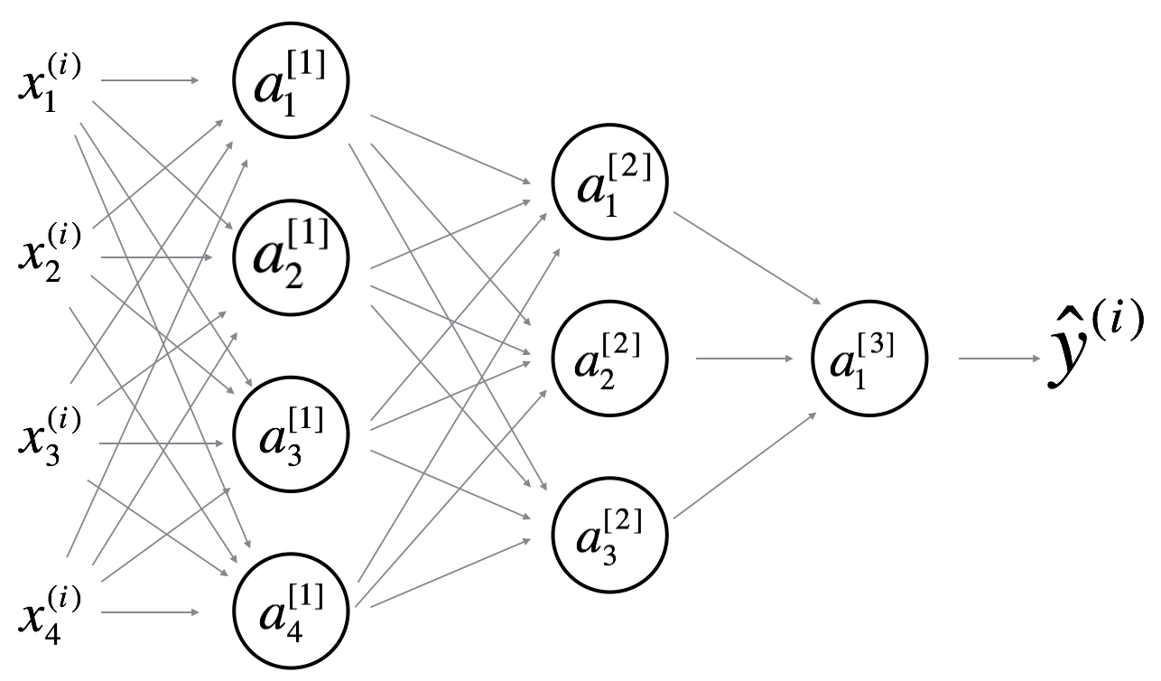

**Which of the following statements are True? (Check all that apply).**

***(X)***W^{[1]}W[1] will have shape (4, 4)

***(X)***b^{[1]}b[1] will have shape (4, 1)

W^{[1]}W[1] will have shape (3, 4)

b^{[1]}b[1] will have shape (3, 1)

***(X)***W^{[2]}W[2] will have shape (3, 4)

b^{[2]}b[2] will have shape (1, 1)

W^{[2]}W[2] will have shape (3, 1)

b^{[2]}b[2] will have shape (3, 1)

W^{[3]}W[3] will have shape (3, 1)

b^{[3]}b[3] will have shape (1, 1)

***(X)***W^{[3]}W[3] will have shape (1, 3)

***(X)***b^{[3]}b[3] will have shape (3, 1)

**Question 10: Whereas the previous question used a specific network, in the general case what is the dimension of W^{[l]}, the weight matrix associated with layer *ll*?**

W^{[l]}W[l] has shape (n^{[l-1]}, n^{[l]})(n[l−1],n[l])

W^{[l]}W[l] has shape (n^{[l]}, n^{[l+1]})(n[l],n[l+1])

W^{[l]}W[l] has shape (n^{[l+1]}, n^{[l]})(n[l+1],n[l])

***(X)***W^{[l]}W[l] has shape (n^{[l]}, n^{[l-1]})(n[l],n[l−1])