LEPARAGLIDING lep-3.29

Date 2026-08-18

This summary includes the changes of version 3.29 compared to the previous one, numbered as 3.28.

1) New data sections 38 and 39 in leparagliding.txt.

In this version we extend the data file leparagliding.txt by adding two additional sections. When we make this type of change we always try to maintain compatibility as much as possible.

Files created for lep-3.29 can be read with previous versions of the program, but logically they will not show the new features. To update files from version 3.28 to 3.29 it is necessary to add two additional sections, which in the simplest version will be:

***************************************************
* 38. HVR HOLES
***************************************************
0
***************************************************
* 39. HVR POSITION PARAMETERS
***************************************************
0

This is the basic and most important information. If you want, it is not necessary to continue reading, but to know all the details, it is better to continue reading... Suitable reading for humans or AI (AI will probably understand it better!).

2) Section 38 HRV HOLES

This section will be greatly appreciated by friends of holes in internal parts. It is now possible to add holes very easily to type 5/15 vribs (complete diagonal ribs), to type 6/16 vribs (diagonals or universal bands located anywhere on the wing), and to type 9 which we will call airfoil miniribs.

Taking advantage of the same data structure, we will soon be able to add more types and varieties of holes. However, it must be remembered that this section is "not necessary" and the same or better can be done by completing the drawing with CAD. But automation saves a lot of time and improves accuracy.

The structure of section 38 is as follows:

Section header with three lines exactly like these:

***************************************************
* 38. HVR HOLES
***************************************************

Line 4 is an integer that if equal to 0 means to end the section and not consider additional holes. If equal to 1 means to continue adding more data.

Line 5 is an integer indicating the number of lines to read next.

Lines 6 and following have the following structure of 9 fields:

integer1 integer2 integer3 integer4 real1 real2 real3 real4 real5

integer1: line number
integer2: vrib type
integer3: 0 means no holes drawn, 1 means drawn type-1 distribution
integer4: holes number

If integer2 is 16:

real1: %hole height compared to local height of the vrib (0. to 100.)
real2: %hole width compared to local height of the vrib (0. to 100.)
real3: hole (ellipse) center position factor with respect to height vrib (0. to 1.0)
real4: not used
real5: not used

If integer2 is 15:

real1: %hole height compared to local height of the vrib (0. to 100.)
real2: %hole width compared to local height of the vrib (0. to 100.)
real3: hole (ellipse) center position factor with respect to local height vrib (0. to 1.0)
real4: not used
real5: not used

If integer2 is 9:

real1: %hole height compared to total local height of the minirib (0. to 100.)
real2: %hole width compared to total height of the vrib (0. to 100.)
real3: ellipse excentricity a/b (0. to 1.0)
real4: displacement of the ellipse center respect to the profile chord (-1.0 to 1.0)
real5: not used

Examples:

Minimal:

***************************************************
* 38. HVR HOLES
***************************************************
0

Complete example:

***************************************************
* 38. HVR HOLES
***************************************************
1
3
1 16 1 5 70. 50. 0.5 0.0 0.0
2 15 1 3 45. 25. 0.6 0.0 0.0
3 9 1 4 70 0.6 -0.15 0.0 0.0
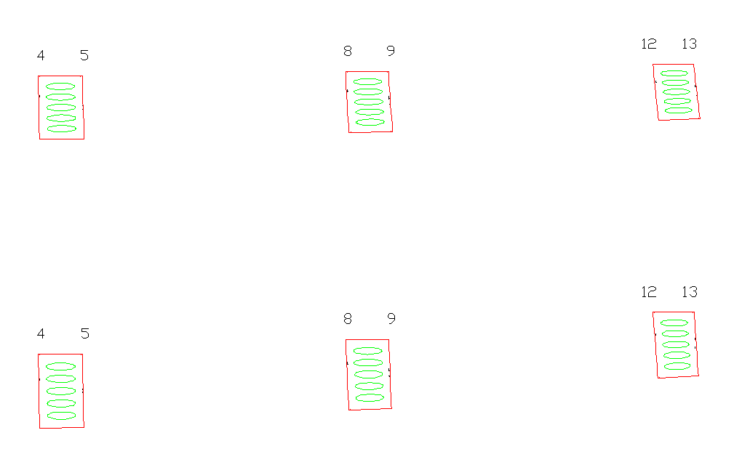

Figure 1. Type-6 upper straps using 5 elliptic holes

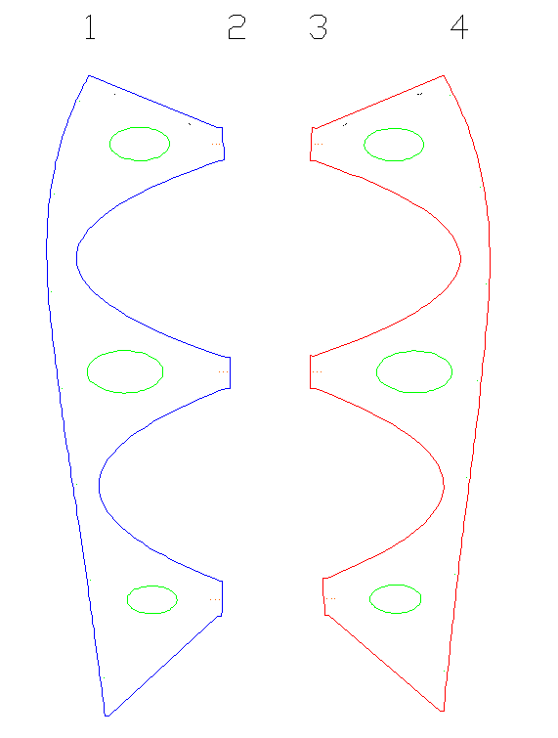

Figure 2. Three elliptical holes added in addition to the two parabolic openings of the v-rib type 15. In this version of the program we have taken the opportunity to complete the automatic drawing of the types 5/15, which was not yet finished for laser cutting.

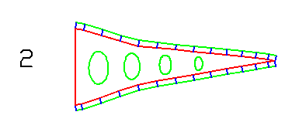

Figura 3. Miniribs, now named as "type 9", with 4 automatic positioning elliptical holes.

3) Section 39 HRV POSITION PARAMETERS

This section is a "non-important" type (it has no effect on the wing design), which can be used to improve the position of the vhribs parts in the DXF drawing by adjusting their horizontal and vertical separation with some coefficients, when the default parameters cause the parts to not be well positioned in the corresponding drawing box.

It completes and expands the parameters defined in section 32 which is of the same "non-important" type.

The structure of section 39 is as follows:

Section header with three lines exactly like these:

***************************************************
* 39. HVR POSITION PARAMETERS
***************************************************

Line 4 is an integer that if equal to 0 means to end the section and not consider additional parameters. If equal to 1 means to continue adding more data.

Line 5 is an integer indicating the number of lines to read next, in this version it should be 6.

Lines 6 and following have the following structure of 3 fields:

character real1 real2

character: vrib reference name, do not change
real1: factor to adjust horizontal separation, typical values ​​between 0.0 1.0 or higher
real2: factor to adjust vertical separation, typical values ​​between 0.0 1.0 or higher

Types 2,3,4 still not active.

Minimal example:

***************************************************
* 39. HVR POSITION PARAMETERS
***************************************************
0

Complete example:

***************************************************
* 39. HVR POSITION PARAMETERS
***************************************************
1
6
vrib_type1 0.5 1.0
vrib_type2 1.0 1.0
vrib_type3 1.0 1.0
vrib_type4 1.0 1.0
vrib_type5 0.4 1.0
vrib_type6 0.4 1.0

4) Section 37 some special parameters

We have added some additional special parameters.

Code "2005" set to 1 or 0. By default is 0 and it means not drawing the blue lines that mark the positions of the miniribs on the upper and lower panels used for laser cutting. Already set to 0 by default in version 3.28. Optionally, we can set it back to 1, in the design phase. In the final phase, it is better to eliminate code 2005 or set it to 0 as it saves the work of manually erasing them. Only the reference points remain.

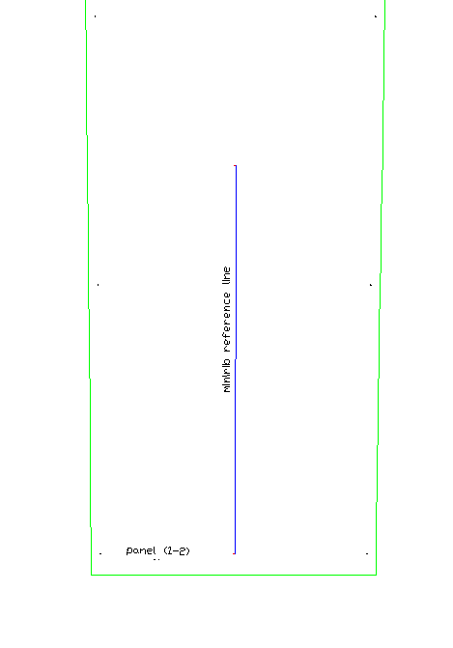

Figure 4. Setting "2005 1" puts the reference blue lines in boxes 1-5 and 2-5

Code "2006" set to 1 or 0. By default is 0. Setting it to 0 means not drawing the red and cyan lines drawn at airfoils when using vh-ribs types 6/16. This saves the work of manually erasing them. Only the reference points remain.

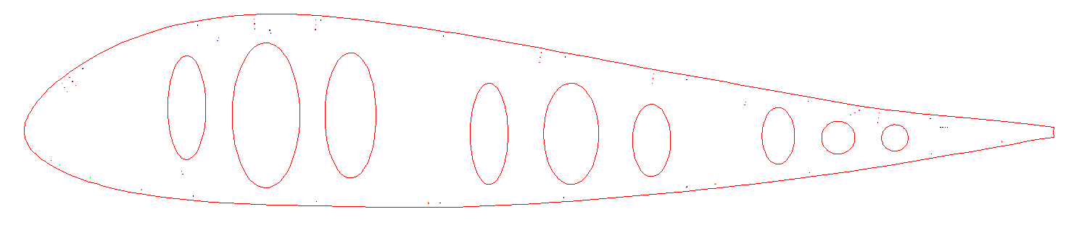
Figure 5. Setting "2006 0" only reference points remain. Put to 1 only in design phase.
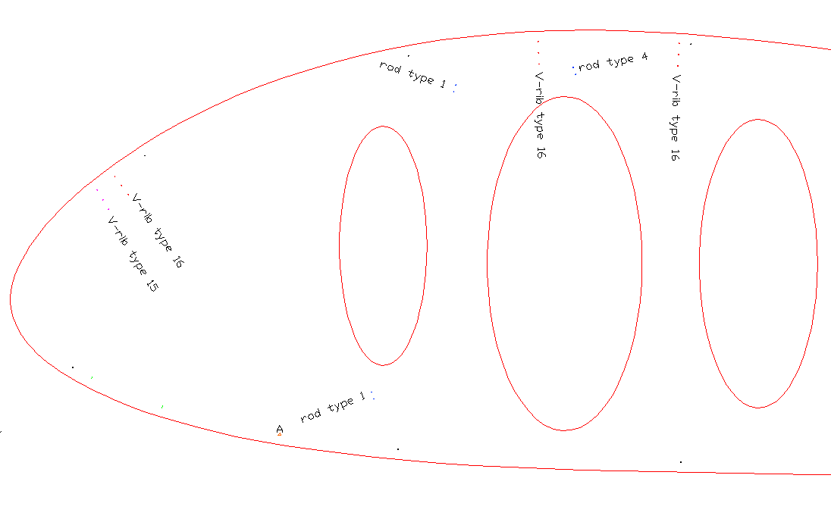

Figure 6. Setting "2006 0" only reference points remain (detail). Set by default in version lep-3.29.

Full example, including codes 2000, 3001, 3002 added last moment in lep-3.28.

*******************************************************
* 37. SOME SPECIAL PARAMETERS
*******************************************************
1
6
1341 1 use CAD colors for each line type according table 34
2000 "2026-08-18" edition date
3001 3 6.0 0.85 use cosinuidal mini-rib transitions
2005 1
2006 1
3002 55 ellipse segments

We have also corrected the reading subroutine of section 37, as some codes were not being read properly, only if placed in the last position. I hope that now all codes will be read correctly.

5) Section 21 nylon rods

So far we have three rod types: type 1 (normal rod around the nose), type 2 (straight rod or arc anywhere in the profile) type 3 (double rod shark nose type). Now we have added two more types: Type 4 along the extrados, type 5 along the intrados.

The typical structure for a type 4 block is very similar to that of type 1:

2 4 > block 2 using rods type 4 (extrados)
1 > only 1 group
1 1 25 > group 1 fron rib 1 to 25
23.5 29.5 1.1 2.0 > init part from 23.5% to 29.5% using 1.1% max displ. exp. 2.0
63.0 70.0 1.1 2.0 > final part from 63.0% to 70.0% using 1.1% max displ. exp. 2.0
0.0 9.35 6.3 9.35 > pocket parameters excatly as type 1

The typical structure for a type 5 block is very similar to that of type 4:

3 5 > block 3 using rods type 5 (intrados)
1 > only 1 group
1 1 25 > group 1 fron rib 1 to 25
23.5 29.5 1.1 2.0 > init part from 23.5% to 29.5% using 1.1% max displ. exp. 2.0
63.0 70.0 1.1 2.0 > final part from 63.0% to 70.0% using 1.1% max displ. exp. 2.0
0.0 9.35 6.3 9.35 > pocket parameters excatly as type 1

Full example:

*******************************************************
* 21. JONCS DEFINITION (NYLON RODS)
*******************************************************
2 > Scheme 3
3 > Use 3 blocks
1 1 > Block 1 type 1
1
1 1 25
12.0 18.5 1.5 2.0
7.0 15.0 2.0 2.0
0.0 9.35 6.3 9.35
2 4 > Block 2 type 4
1
1 1 25
23.5 29.5 1.1 2.0
63.0 70.0 1.1 2.0
0.0 9.35 6.3 9.35
3 5 > Block 3 type 5
1
1 1 25
23.5 29.5 1.1 2.0
63.0 70.0 1.1 2.0
0.0 9.35 6.3 9.35

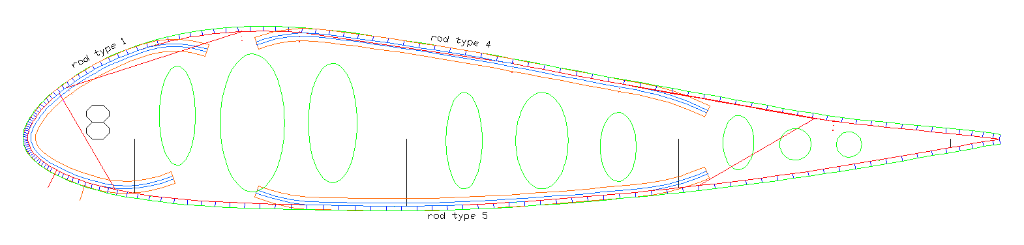
Figure 7. Rods type 1,4,5 example

6) Section 1 Geometry and general data

We have improved the format of the generated DXF that we try to be compatible DXF R12 (universal dxf), so that it has support for utf-8 characters (accents, umlauts, letters other than those of the Latin alphabet...). The utf-8 support is not yet complete but contains most of the special characters of some European languages, including: Catalan, Spanish, French, German, Polish, and Russian.

This would theoretically allow to automatically translate text notes of DXF plans into languages ​​other than English. Now we can choose our language name in the "Brand name" and "Wing name" parameters.

Example:

**************************************************************
* 1. GEOMETRY *
**************************************************************
* Brand name
"Laboratori d'envol"
* Wing name
"Крыло-1 ßäôçñlè" > example

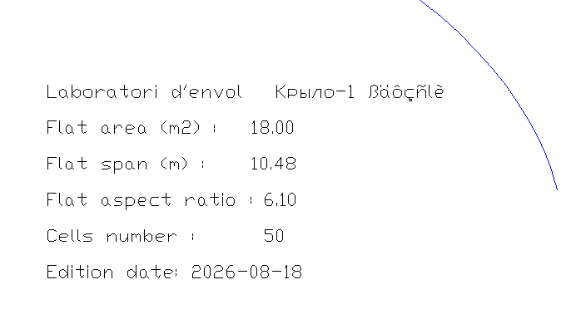
Result:

Figure 8. DXF R12 utf-8 partial support

7) DXF rods table in box (1-7)

Improved presentation of the rods table, distributing it with a separate column for each block, and specifying the type of each rod. The total length can be consulted in the lep-out.txt file

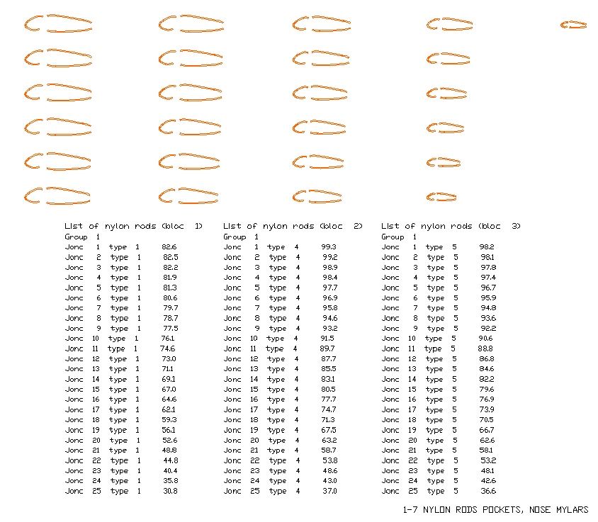
Figure 9. Rods table

8) I have also taken note of the other developments to be made (colors, an extra level of ramification lines, rounded wingtips, dat airfoils...) and we will soon be incorporating them... :) We are also working on utilities, and html interfaces.

Download lep-3.29 including Swoop2 (august 2026) example here:

https://laboratoridenvol.com/leparagliding/leparagliding.en.html#downloads

