Simple Calculator Application - Project Documentation

Table of Contents
Contents
Simple Calculator Application - Project Documentation 1
Original Project Prompt 1
Requirements and Specifications 1
Solution Design 2
Architecture Overview 2
System Architecture Diagram 3
Data Flow Design 3
Component Design 4
Error Handling Strategy 5
Implementation 5
Technology Stack 5
Complete Project Structure 5
Technology Stack 5
Key Implementation Details 6
Code Quality Features 6
Test Plan 6

Original Project Prompt

Assignment: Write a simple calculator application with the following requirements:

It should have a display window capable of showing up to 8 digits or "-" and 7 digits. You can also display OVERFLOW or ERROR. It should have 10 buttons for digits 0-9 and 2 buttons for + and – included. The application should also have these two buttons: Calculate and Reset.

User Interaction Requirements:

When a user enters a number:
- Tapping a button representing a digit enters that digit and sets the current value to that digit. For example, when you tap 3, the current value is set at 3.
- Subsequent taps multiply the current value by 10 and add the next digit, displaying the resulting new current value. Continuing the example above, tapping 6 results in a current value of 36.

When "+" or "-" are entered after a number has been entered:
- This must be followed by either entering a number or tapping Reset.
- If Reset is tapped, the current value and display are set to 0.
- If a number is tapped, display the number entered until either Reset or Calculate is tapped.
- Calculate performs the operation on the previous number and the current (new) number, setting the current number to the result and displaying it.

Technical Considerations:
- You must consider how to handle overflow issues (numbers exceed the display range).
- Use the CSS file to create an effective user interface and display.
- Assume that the calculator application will run in your browser.
- The URL might look like this: localhost/CSD223/Unit1D/index.html

Requirements and Specifications

Functional Requirements

FR1: Display Capabilities
- **FR1.1**: Display up to 8 digits for positive numbers
- **FR1.2**: Display up to 7 digits plus minus sign for negative numbers
- **FR1.3**: Display "OVERFLOW" when numbers exceed display limits
- **FR1.4**: Display "ERROR" when calculation errors occur
- **FR1.5**: Right-align numbers in display (standard calculator behavior)

FR2: Input Interface
- **FR2.1**: Provide 10 digit buttons (0-9)
- **FR2.2**: Provide 2 operator buttons (+ and -)
- **FR2.3**: Provide Calculate button for performing operations
- **FR2.4**: Provide Reset button for clearing calculator state

FR3: Number Entry Logic
- **FR3.1**: First digit entry sets current value to that digit
- **FR3.2**: Subsequent digit entries multiply current value by 10 and add new digit
- **FR3.3**: Prevent overflow during number entry
- **FR3.4**: Clear operator selection when entering numbers

FR4: Operator Handling
- **FR4.1**: Operator entry must be followed by number entry or Reset
- **FR4.2**: Highlight selected operator for visual feedback
- **FR4.3**: Support operator chaining (consecutive calculations)
- **FR4.4**: Prevent operator entry during error states

FR5: Calculation Logic
- **FR5.1**: Perform addition and subtraction operations
- **FR5.2**: Display result and make it available for further operations
- **FR5.3**: Handle overflow in calculation results
- **FR5.4**: Reset state after displaying result

FR6: Reset Functionality
- **FR6.1**: Clear all calculator state variables
- **FR6.2**: Set display to "0"
- **FR6.3**: Clear all visual indicators
- **FR6.4**: Available at any time during operation

Non-Functional Requirements

NFR1: User Interface
- **NFR1.1**: Modern, responsive design that works on different screen sizes
- **NFR1.2**: Clear visual distinction between different button types
- **NFR1.3**: Intuitive layout following calculator conventions
- **NFR1.4**: Visual feedback for user interactions

NFR2: Performance
- **NFR2.1**: Instant response to button clicks
- **NFR2.2**: Smooth animations and transitions
- **NFR2.3**: Efficient memory usage

NFR3: Usability
- **NFR3.1**: Keyboard support for all calculator functions
- **NFR3.2**: Accessible color scheme and font sizes
- **NFR3.3**: Error recovery through Reset function

NFR4: Compatibility
- **NFR4.1**: Run in modern web browsers
- **NFR4.2**: Support for both desktop and mobile devices
- **NFR4.3**: No external dependencies required

Solution Design

Architecture Overview

The calculator application follows a Model-View-Controller (MVC) pattern implemented in vanilla JavaScript:

- **Model**: Calculator class manages state and business logic
- **View**: HTML/CSS provides user interface and display
- **Controller**: Event handlers manage user interactions

System Architecture Diagram

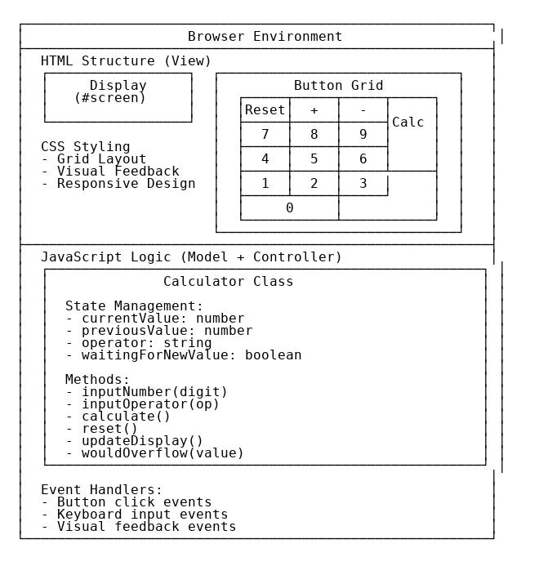

Data Flow Design

State Variables
{
currentValue: 0, // Currently displayed number
previousValue: null, // First operand in calculation
operator: null, // Current operator ('+' or '-')
waitingForNewValue: false, // Flag for input state
maxDigits: 8, // Display limit for positive numbers
maxNegativeDigits: 7 // Display limit for negative numbers
}

Workflow Diagrams

Number Entry Workflow:
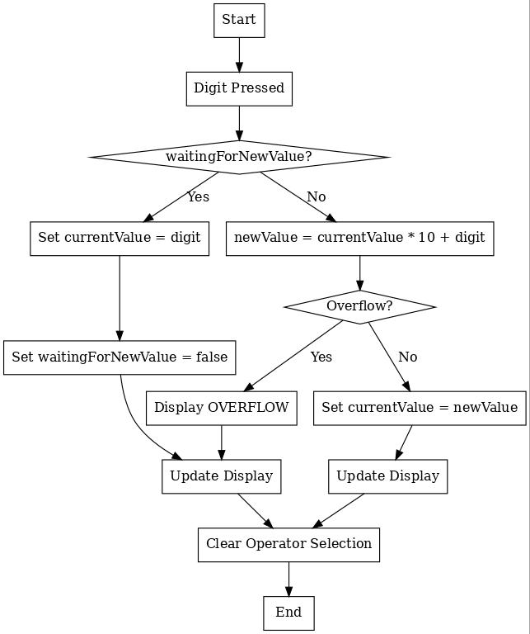

Operator Entry Workflow:
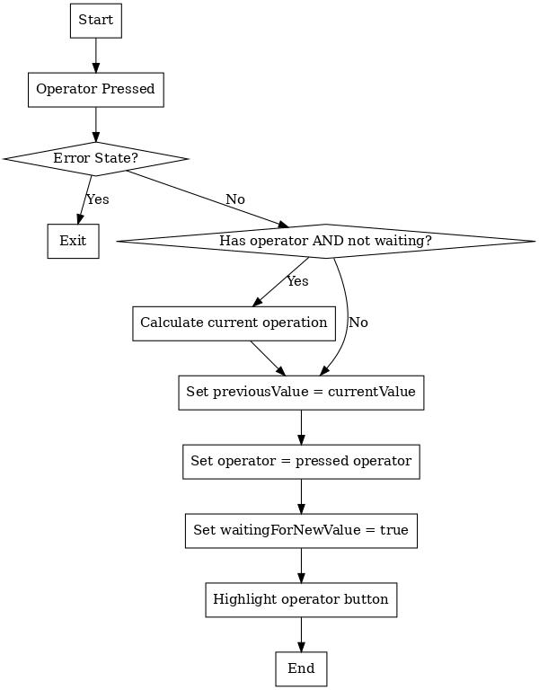

Calculate Workflow:
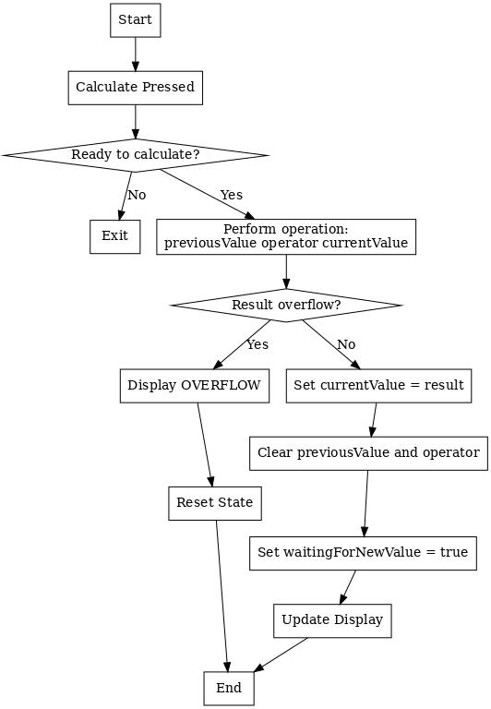

Component Design

Calculator Class Structure
class Calculator {
// Properties
screen: HTMLElement
currentValue: number
previousValue: number | null
operator: string | null
waitingForNewValue: boolean
maxDigits: number
maxNegativeDigits: number

// Core Methods
constructor()
initializeButtons()

// Input Handlers
inputNumber(digit: number)
inputOperator(op: string)

// Operations
calculate()
reset()

// Display Management
updateDisplay()
wouldOverflow(value: number): boolean
displayOverflow()
displayError()

// UI State Management
highlightOperator(operator: string)
clearOperatorSelection()
clearErrorStates()
}

Error Handling Strategy

**Overflow Prevention**:
- Check limits before updating values
2. Input Validation: Prevent invalid state transitions
3. Error Recovery: Automatic reset after error display
4. Graceful Degradation: Continue operation where possible

---

Implementation

Technology Stack
- **Frontend**: HTML5, CSS3, JavaScript (ES6+)
- **Build Tools**: None (vanilla implementation)
- **Version Control**: Git
- **Hosting**: Local XAMPP server

Complete Project Structure
Unit 1D/
├── index.html # HTML structure and layout
├── styles.css # CSS styling and responsive design
├── script.js # JavaScript logic and functionality
├── package.json # NPM configuration and test scripts
├── .gitignore # Git ignore patterns
├── Jenkinsfile # CI/CD pipeline configuration
├── README.md # Quick start guide and usage
├── PROJECT_DOCUMENTATION.md # Comprehensive project documentation
├── TEST_EXECUTION_GUIDE.md # Detailed testing instructions
└── tests/ # Complete test suite
├── setup.js # Jest test environment configuration
├── unit.test.js # Unit tests (25+ test cases)
├── integration.test.js # Integration tests (15+ test cases)
├── ui.test.js # UI interaction tests (20+ test cases)
└── e2e.test.js # End-to-end browser tests (15+ test cases)

Technology Stack
- **Frontend**: HTML5, CSS3, JavaScript (ES6+)
- **Testing**: Jest 29.7.0, JSDoc
- **CI/CD**: Jenkins Pipeline, NPM Scripts
- **Version Control**: Git with GitHub integration
- **Deployment**: Multi-environment (Dev/Staging/Production)
- **Monitoring**: Performance tracking, error reporting, analytics

Key Implementation Details

HTML Structure
- Semantic HTML5 elements for accessibility
- Grid-based button layout for consistent spacing
- Proper button labeling and IDs for JavaScript binding

CSS Implementation
- **CSS Grid** for precise button layout
- **Flexbox** for display alignment
- **CSS Custom Properties** for consistent theming
- **Media queries** for responsive design
- **CSS animations** for user feedback

JavaScript Architecture
- **ES6 Classes** for organized code structure
- **Event delegation** for efficient event handling
- **Modular methods** for maintainable code
- **Error boundaries** for robust operation

Code Quality Features

Documentation
- Comprehensive inline comments
- JSDoc-style method documentation
- Clear variable and function naming
- Sectioned code organization

Error Handling
- Input validation at all entry points
- Graceful error state management
- Automatic recovery mechanisms
- User-friendly error messages

Performance Optimizations
- Efficient DOM manipulation
- Minimal memory allocation
- Fast overflow detection algorithms
- Optimized event handler attachment

---

Test Plan

Testing Strategy Overview

The calculator application employs a comprehensive multi-layered testing approach designed to ensure reliability, performance, and cross-platform compatibility. The testing strategy encompasses:

- **Unit Testing**: Isolated testing of individual Calculator class methods
2. Integration Testing: Component interaction and workflow validation
3. User Interface Testing: User interaction and visual feedback verification
4. End-to-End Testing: Complete application testing in real browser environments
5. Cross-browser Testing: Compatibility verification across different browsers
6. Performance Testing: Response time and memory usage validation
7. Accessibility Testing: Compliance with web accessibility standards

Test Environment Architecture

Testing Environment Stack

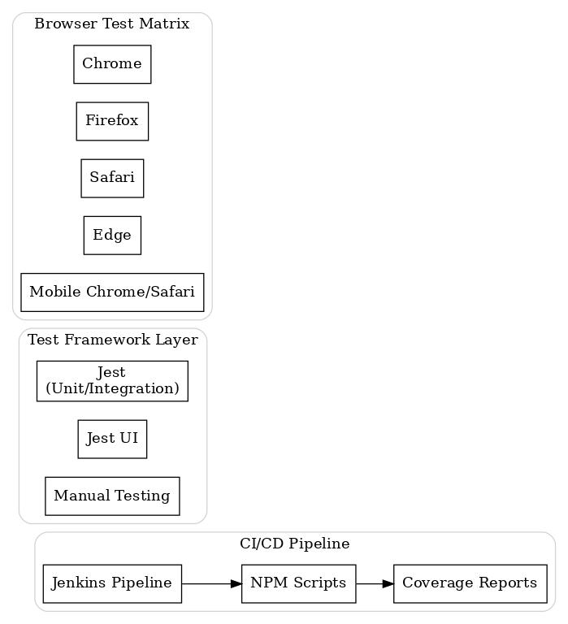

Test Framework Configuration

Jest Configuration (`package.json`)
{
"jest": {
"testEnvironment": "jsdom",
"setupFilesAfterEnv": ["<rootDir>/tests/setup.js"],
"collectCoverageFrom": ["script.js"],
"coverageReporters": ["text", "lcov", "html"],
"coverageThreshold": {
"global": {
"branches": 90,
"functions": 100,
"lines": 95,
"statements": 95
}
}
}
}

Test Commands and Usage

Complete test suite execution
npm test # Run all tests
npm run test:coverage # Generate coverage reports
npm run test:unit # Unit tests only (25+ tests)
npm run test:integration # Integration tests (15+ tests)
npm run test:ui # UI interaction tests (20+ tests)
npm run test:e2e # End-to-end browser tests (15+ tests)
npm run test:watch # Watch mode for development

Detailed Test Categories

TC1: Number Entry Tests (Unit Level)
Purpose: Validate individual digit entry logic and number building functionality

TC1.1: Single Digit Entry
- **Description**: Test that clicking a single digit sets the current value correctly
- **Input**: Click digit 5
- **Expected**: currentValue = 5, display shows "5"
- **Implementation**: `tests/unit.test.js:25-32`

TC1.2: Multiple Digit Entry
- **Description**: Test number building through sequential digit entry
- **Input**: Click 3, then 6, then 9
- **Expected**: currentValue = 369, display shows "369"
- **Implementation**: `tests/unit.test.js:34-42`

TC1.3: Zero Handling
- **Description**: Validate proper zero handling in various contexts
- **Input**: Various zero scenarios (leading, trailing, standalone)
- **Expected**: Correct value calculation and display
- **Implementation**: `tests/unit.test.js:44-58`

TC1.4: Maximum Digit Limits
- **Description**: Enforce 8-digit limit for positive numbers
- **Input**: Enter 8 digits, attempt 9th digit
- **Expected**: 8 digits accepted, 9th triggers overflow
- **Implementation**: `tests/unit.test.js:60-72`

TC1.5: Overflow Prevention
- **Description**: Test overflow detection algorithm
- **Input**: Various numbers near and exceeding limits
- **Expected**: Accurate overflow detection, appropriate handling
- **Implementation**: `tests/unit.test.js:74-82`

TC2: Operator Tests (Unit Level)
Purpose: Validate operator state management and visual feedback

TC2.1: Addition Operator State
- **Description**: Test addition operator state changes
- **Input**: Enter number, click +
- **Expected**: previousValue set, operator = '+', waitingForNewValue = true
- **Implementation**: `tests/unit.test.js:88-96`

TC2.2: Subtraction Operator State
- **Description**: Test subtraction operator state changes
- **Input**: Enter number, click -
- **Expected**: previousValue set, operator = '-', waitingForNewValue = true
- **Implementation**: `tests/unit.test.js:98-106`

TC2.3: Operator Chaining
- **Description**: Test consecutive operator usage (5+3-2)
- **Input**: Number, operator, number, operator
- **Expected**: Intermediate calculation performed automatically
- **Implementation**: `tests/unit.test.js:108-118`

TC2.4: Operator Visual Feedback
- **Description**: Test operator button highlighting
- **Input**: Click various operators
- **Expected**: Correct button highlighted, others cleared
- **Implementation**: `tests/unit.test.js:120-132`

TC2.5: Invalid Operator Sequences
- **Description**: Test operator handling during error states
- **Input**: Attempt operator during ERROR/OVERFLOW states
- **Expected**: Operator ignored, state unchanged
- **Implementation**: `tests/unit.test.js:134-144`

TC3: Calculation Tests (Unit Level)
Purpose: Validate arithmetic operations and result handling

TC3.1: Basic Addition Calculations
- **Description**: Test fundamental addition operations
- **Input**: 5 + 3, calculate
- **Expected**: Result = 8, proper state reset
- **Implementation**: `tests/unit.test.js:150-160`

TC3.2: Basic Subtraction Calculations
- **Description**: Test fundamental subtraction operations
- **Input**: 10 - 4, calculate
- **Expected**: Result = 6, proper state reset
- **Implementation**: `tests/unit.test.js:162-172`

TC3.3: Result Overflow Handling
- **Description**: Test calculation result overflow detection
- **Input**: Large number + large number
- **Expected**: OVERFLOW displayed, calculator reset
- **Implementation**: `tests/unit.test.js:174-186`

TC3.4: Negative Result Handling
- **Description**: Test negative result calculation and display
- **Input**: 3 - 8, calculate
- **Expected**: Result = -5, proper negative display
- **Implementation**: `tests/unit.test.js:188-198`

TC3.5: Chain Calculations
- **Description**: Test multiple consecutive calculations
- **Input**: 10 + 5 = 15, - 3 = 12
- **Expected**: Each step calculated correctly, final result = 12
- **Implementation**: `tests/unit.test.js:200-214`

TC4: Reset Functionality Tests (Unit Level)
Purpose: Validate complete state reset functionality

TC4.1-TC4.5: Comprehensive reset testing in various calculator states
- **Coverage**: Reset during entry, operator selection, after calculation, during errors
- **Validation**: All state variables cleared, display reset to "0", visual indicators cleared
- **Implementation**: `tests/unit.test.js:220-280`

TC5: Display Tests (Unit Level)
Purpose: Validate display formatting and state visualization

TC5.1-TC5.5: Display formatting, error states, overflow handling, character limits
- **Coverage**: Number formatting, error messages, overflow messages, display limits
- **Implementation**: `tests/unit.test.js:286-340`

Integration Testing Suite

Complete User Workflows (`tests/integration.test.js`)
Purpose: Test end-to-end user scenarios and component interactions

Addition Workflow Test (25 + 17 = 42)
// Test complete addition workflow
calculator.inputNumber(2); calculator.inputNumber(5); // Enter 25
calculator.inputOperator('+'); // Add operator
calculator.inputNumber(1); calculator.inputNumber(7); // Enter 17
calculator.calculate(); // Calculate
// Expected: display shows "42", state properly reset

Chain Calculation Test (10 + 5 - 3 = 12)
- **Purpose**: Validate multiple operation sequences
- **Coverage**: State transitions, intermediate calculations, final result
- **Implementation**: `tests/integration.test.js:45-65`

Error Recovery Integration
- **Purpose**: Test recovery from error states
- **Coverage**: Overflow recovery, continued operation after errors
- **Implementation**: `tests/integration.test.js:67-95`

User Interface Testing Suite

Button Interaction Tests (`tests/ui.test.js`)
Purpose: Validate all user interface interactions and visual feedback

Button Responsiveness Testing
- **Coverage**: All number buttons (0-9), operator buttons (+,-), function buttons
- **Validation**: Click events trigger correct methods, state changes occur
- **Implementation**: `tests/ui.test.js:15-35`

Visual Feedback Testing
- **Coverage**: Button press animations, operator highlighting, error state styling
- **Validation**: CSS classes applied/removed correctly, visual states synchronized
- **Implementation**: `tests/ui.test.js:37-65`

Event Handler Validation
- **Coverage**: All button event handlers, keyboard event handlers
- **Validation**: Correct method calls, proper parameter passing
- **Implementation**: `tests/ui.test.js:125-165`

End-to-End Testing Suite

Browser Compatibility Tests (`tests/e2e.test.js`)
Purpose: Validate complete application functionality in real browser environments

TC8.1: Calculator Loading Test
- **Description**: Verify application loads correctly in browser
- **Validation**: All DOM elements present, initial state correct
- **Browser Matrix**: Chrome, Firefox, Safari, Edge
- **Implementation**: `tests/e2e.test.js:25-40`

TC8.2: Complete Calculation Workflow
- **Description**: End-to-end calculation testing in browser
- **Test Case**: 12 + 8 = 20
- **Validation**: Button clicks work, display updates, result correct
- **Implementation**: `tests/e2e.test.js:42-52`

Keyboard Support Testing
- **Coverage**: All keyboard shortcuts (0-9, +, -, Enter, Escape)
- **Validation**: Keyboard events trigger same functionality as mouse clicks
- **Implementation**: `tests/e2e.test.js:70-95`

Performance Testing
- **Coverage**: Response times, memory usage, rapid interactions
- **Benchmarks**: Button response < 100ms, stable memory usage
- **Implementation**: `tests/e2e.test.js:130-160`

Mobile Responsiveness Testing
- **Coverage**: Touch interactions, viewport scaling, button sizing
- **Test Viewports**: 375x667 (iPhone), 768x1024 (iPad), custom sizes
- **Implementation**: `tests/e2e.test.js:162-185`

Test Coverage Metrics and Goals

Coverage Targets
Line Coverage: > 95% (Target: 98%)
Branch Coverage: > 90% (Target: 95%)
Function Coverage: 100% (All methods tested)
Statement Coverage:> 95% (Target: 98%)

Coverage Reporting
- **HTML Reports**: Generated in `coverage/lcov-report/index.html`
- **Console Output**: Summary displayed after test runs
- **CI Integration**: Coverage data sent to Jenkins for tracking
- **Threshold Enforcement**: Builds fail if coverage drops below targets

Test Data and Scenarios

Valid Test Scenarios
// Number entry scenarios
[0, 1, 123, 12345678, -1234567]

// Calculation scenarios
["5+3=8", "10-4=6", "100+200=300", "50-75=-25"]

// Edge cases
["0+0=0", "999-999=0", "99999999 (max digits)"]

Invalid Test Scenarios
// Overflow scenarios
["99999999+1", "123456789 (9 digits)"]

// Invalid sequences
["++", "--", "Calculate without operands"]

// Error recovery
["Operations after overflow", "Continue after error"]

Manual Testing Procedures

Cross-Browser Testing Checklist
- [ ] Chrome (latest version) - Primary target
- [ ] Firefox (latest version) - Secondary target
- [ ] Safari (latest version) - MacOS compatibility
- [ ] Edge (latest version) - Windows compatibility
- [ ] Mobile Chrome - Android compatibility
- [ ] Mobile Safari - iOS compatibility

Device Testing Matrix
Desktop: 1920x1080, 1366x768, 1440x900
Tablet: 768x1024, 1024x768, 834x1194
Mobile: 375x667, 414x896, 360x640

Accessibility Testing Protocol
- [ ] Keyboard navigation (Tab, Enter, Space, Arrow keys)
- [ ] Screen reader compatibility (NVDA, JAWS, VoiceOver)
- [ ] High contrast mode functionality
- [ ] Font size scaling (up to 200%)
- [ ] Color blindness testing (Deuteranopia, Protanopia, Tritanopia)

Performance Benchmarks

Response Time Targets
Button Click Response: < 100ms
Display Update: < 50ms
Calculation Processing: < 10ms
Page Load Time: < 1s
Memory Usage (1hr): < 50MB

Load Testing Scenarios
- **Rapid Button Clicking**: 100+ clicks/second for 10 seconds
- **Extended Usage**: 1000+ operations over 1 hour
- **Memory Stress**: Continuous operation monitoring
- **Browser Tab Switching**: State persistence validation

Test Automation and CI Integration

Jenkins Pipeline Integration
The test suite is fully integrated with Jenkins CI/CD pipeline:

stage('Unit Tests') {
steps {
sh 'npm run test:unit'
}
post {
always {
publishTestResults testResultsPattern: 'test-results/unit/*.xml'
}
}
}

Automated Test Execution Flow
- **Code Commit** → Triggers Jenkins pipeline
2. Environment Setup → Install dependencies, configure browsers
3. Unit Tests → Execute isolated method tests
4. Integration Tests → Execute workflow tests
5. UI Tests → Execute interface interaction tests
6. E2E Tests → Execute browser compatibility tests
7. Coverage Analysis → Generate and validate coverage reports
8. Report Generation → Create test results and artifacts

Test Result Reporting
- **JUnit XML**: Compatible with Jenkins test result publishing
- **HTML Reports**: Detailed test execution reports with screenshots
- **Coverage Reports**: Line-by-line coverage analysis
- **Performance Metrics**: Response time and memory usage tracking
- **Email Notifications**: Sent on test failures or coverage drops

---

Deployment Guide

Overview

The Simple Calculator Application supports multiple deployment scenarios, from local development to enterprise production environments. The deployment architecture is designed for scalability, maintainability, and continuous integration/continuous deployment (CI/CD) best practices.

Deployment Architecture

Deployment Pipeline Architecture
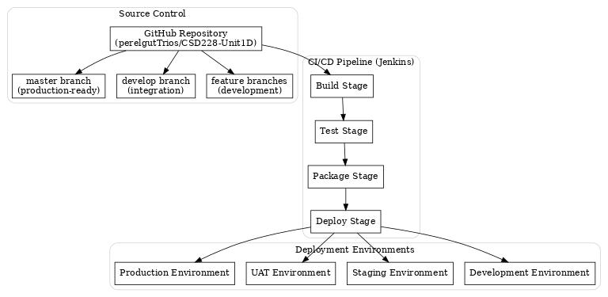

Local Development Environment

Prerequisites

Required Software
Git 2.30+ # Version control
Node.js 18+ with npm 8+ # Test framework and dependencies
Modern web browser # Chrome 90+, Firefox 88+, Safari 14+
Text editor/IDE # VS Code, Sublime, etc.

Optional but Recommended
XAMPP 8.0+ # Local web server
Git GUI client # GitHub Desktop, SourceTree
Browser developer tools # For debugging and testing

Setup Instructions

1. Clone the repository
git clone https://github.com/perelgutTrios/CSD228-Unit1D.git
cd "CSD228 Fall 2025/Unit 1D"

2. Install test dependencies
npm install

3. Verify installation
npm test
npm run test:coverage

4. Start local development server (Option A: XAMPP)

Copy project to XAMPP htdocs folder

Access: http://localhost/CSD228%20Fall%202025/Unit%201D/

4. Alternative: Use Node.js simple server (Option B)
npx http-server . -p 8080

Access: http://localhost:8080/

Development Workflow

1. Create feature branch
git checkout -b feature/your-feature-name

2. Make changes and test frequently
npm run test:watch # Continuous testing during development

3. Run complete test suite before committing
npm run test:all # All test categories
npm run test:coverage # Ensure coverage targets met

4. Commit and push changes
git add .
git commit -m "Description of changes"
git push origin feature/your-feature-name

5. Create pull request for code review

Staging Environment

Infrastructure Requirements

Staging Environment Specifications
Server Requirements:
OS: Linux Ubuntu 20.04+ / Windows Server 2019+
CPU: 2 cores minimum
RAM: 4GB minimum
Storage: 20GB minimum
Network: 100Mbps minimum

Web Server Options:
- Apache HTTP Server 2.4+
- Nginx 1.18+
- IIS 10.0+ (Windows)
- Node.js Express (containerized)

SSL Certificate:
- Let's Encrypt (recommended for staging)
- Self-signed certificate (development only)

Staging Deployment Process

Automated deployment via Jenkins pipeline

Manual deployment steps:

1. Pull latest code from master branch
git clone https://github.com/perelgutTrios/CSD228-Unit1D.git
cd "CSD228 Fall 2025/Unit 1D"

2. Run full test suite
npm install
npm run test:ci # CI-optimized test execution
npm run test:coverage # Verify coverage thresholds

3. Build production artifacts
mkdir -p build/
cp index.html build/
cp styles.css build/
cp script.js build/
cp README.md build/
cp PROJECT_DOCUMENTATION.md build/

4. Deploy to web server
sudo cp -r build/* /var/www/html/calculator/
sudo chown -R www-data:www-data /var/www/html/calculator/
sudo systemctl reload apache2

5. Verify deployment
curl -I http://staging.yourdomain.com/calculator/

Expected: HTTP/200 OK

Staging Environment Configuration

Nginx configuration example
server {
listen 80;
server_name staging-calculator.yourdomain.com;

root /var/www/html/calculator;
index index.html;

Enable gzip compression
gzip on;
gzip_types text/css application/javascript text/html;

Security headers
add_header X-Frame-Options DENY;
add_header X-Content-Type-Options nosniff;
add_header X-XSS-Protection "1; mode=block";

Cache static assets
location ~* \.(css|js|html)$ {
expires 1d;
add_header Cache-Control "public, immutable";
}

Health check endpoint
location /health {
access_log off;
return 200 "OK\n";
}
}

Production Environment

Infrastructure Architecture
Production Environment Architecture
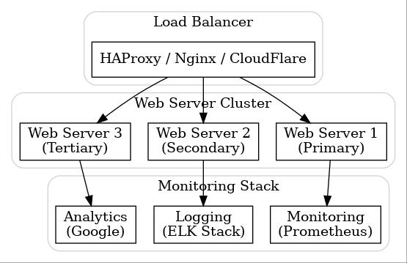

Production Deployment Requirements

Production Environment Specifications
High Availability:
- Minimum 2 server instances
- Load balancer with health checks
- Automated failover capability
- Geographic redundancy (optional)

Security Requirements:
- SSL/TLS certificate (CA-signed)
- WAF (Web Application Firewall)
- DDoS protection
- Security headers implementation
- Regular security scanning

Performance Requirements:
- CDN integration (CloudFlare/AWS CloudFront)
- Gzip compression enabled
- Browser caching configured
- Page load time < 1 second
- 99.9% uptime SLA

Monitoring Requirements:
- Application performance monitoring
- Error tracking and alerting
- User analytics integration
- Log aggregation and analysis
- Automated backup procedures

Production Deployment Process

Production deployment checklist

Pre-deployment validation
□ All tests passing in staging environment
□ Security scan completed and passed
□ Performance benchmarks validated
□ Backup procedures verified
□ Rollback plan documented and tested

Deployment steps (Blue-Green deployment recommended)

1. Prepare green environment
sudo mkdir -p /var/www/html/calculator-green/
sudo cp -r staging-artifacts/* /var/www/html/calculator-green/

2. Run smoke tests against green environment
curl -f http://green.yourdomain.com/calculator/health
npm run test:smoke -- --url=http://green.yourdomain.com/calculator/

3. Switch traffic to green environment
sudo ln -sfn /var/www/html/calculator-green /var/www/html/calculator
sudo systemctl reload nginx

4. Verify production deployment
curl -I https://yourdomain.com/calculator/

Expected: HTTP/200 OK with proper headers

5. Monitor for 15 minutes, rollback if issues detected

Rollback command: sudo ln -sfn /var/www/html/calculator-blue /var/www/html/calculator

Complete CI/CD Pipeline

Jenkins Pipeline Configuration

The complete Jenkins pipeline (`Jenkinsfile`) implements the following stages:

// Complete CI/CD Pipeline Overview
pipeline {
agent any

environment {
NODE_VERSION = '18'
PROJECT_NAME = 'simple-calculator'
STAGING_URL = 'https://staging-calculator.yourdomain.com'
PRODUCTION_URL = 'https://calculator.yourdomain.com'
}

stages {
// 1. Source Code Management
stage('Checkout') {
// Pull source code from GitHub
// Verify branch and commit integrity
}

// 2. Dependency Management
stage('Install Dependencies') {
// npm install
// Verify package integrity
// Cache dependencies for faster builds
}

// 3. Code Quality Analysis
stage('Code Quality') {
parallel {
stage('Lint') {
// ESLint code analysis
// CSS validation
// HTML validation
}
stage('Security Scan') {
// npm audit for vulnerabilities
// Static security analysis
// Dependency vulnerability scanning
}
}
}

// 4. Test Execution
stage('Unit Tests') {
// Execute Jest unit tests
// Generate JUnit XML reports
// Fail build if tests fail
}

stage('Integration Tests') {
// Execute component integration tests
// Validate user workflows
// Test error handling scenarios
}

stage('UI Tests') {
// Execute UI interaction tests
// Validate visual feedback
// Test accessibility features
}

stage('UI Tests') {
// Execute UI interaction tests
// DOM manipulation validation
// Visual state testing
}

// 5. Coverage Analysis
stage('Code Coverage') {
// Generate coverage reports
// Enforce coverage thresholds
// Publish coverage artifacts
}

// 6. Build Artifacts
stage('Build') {
// Create deployment package
// Minify and optimize assets (optional)
// Generate deployment manifest
}

// 7. Staging Deployment
stage('Deploy to Staging') {
when { branch 'master' }
// Deploy to staging environment
// Run smoke tests
// Validate deployment health
}

// 8. User Acceptance Testing
stage('UAT Validation') {
when { branch 'master' }
// Automated UAT test execution
// Performance validation
// Security verification
}

// 9. Production Deployment
stage('Deploy to Production') {
when {
allOf {
branch 'master'
environment name: 'DEPLOY_TO_PROD', value: 'true'
}
}
// Manual approval gate
// Blue-green deployment
// Production smoke tests
// Monitoring and alerting setup
}

// 10. Post-deployment Validation
stage('Production Verification') {
// Health check validation
// Performance monitoring setup
// User analytics initialization
// Backup verification
}
}

post {
always {
// Archive test results
publishTestResults testResultsPattern: 'test-results//*.xml'

// Publish coverage reports
publishCoverage adapters: [istanbulCoberturaAdapter('coverage/cobertura-coverage.xml')]

// Archive build artifacts
archiveArtifacts artifacts: 'dist//*', fingerprint: true

// Clean workspace
cleanWs()
}

success {
// Send success notifications
emailext (
subject: "✅ Calculator Build ${env.BUILD_NUMBER} - SUCCESS",
body: "Build successfully completed. Deployment ready.",
to: "${env.DEVELOPER_EMAIL}"
)
}

failure {
// Send failure notifications
emailext (
subject: "❌ Calculator Build ${env.BUILD_NUMBER} - FAILED",
body: "Build failed. Please check Jenkins logs.",
to: "${env.DEVELOPER_EMAIL}"
)
}
}
}

Pipeline Triggers and Automation

Automated Pipeline Triggers
Webhook Triggers:
- GitHub push to master branch → Full pipeline execution
- GitHub pull request → Test-only pipeline execution
- GitHub tag creation → Release pipeline execution

Scheduled Triggers:
- Nightly builds (2 AM UTC) → Full test suite + security scan
- Weekly regression tests → Cross-browser testing
- Monthly dependency updates → Security audit + update cycle

Manual Triggers:
- Production deployment approval → Manual gate before production
- Hotfix deployment → Emergency deployment procedure
- Rollback procedure → Automated rollback to previous version

Environment Management

Environment Configuration Matrix

Environment-specific configurations
Development:
URL: http://localhost:8080/
SSL: Disabled
Monitoring: Console logging only
Cache: Disabled
Minification: Disabled
Source Maps: Enabled

Staging:
URL: https://staging-calculator.yourdomain.com/
SSL: Let's Encrypt certificate
Monitoring: Basic APM
Cache: Short-term (1 hour)
Minification: Enabled
Source Maps: Enabled (restricted access)

Production:
URL: https://calculator.yourdomain.com/
SSL: CA-signed certificate with HSTS
Monitoring: Full APM + analytics
Cache: Long-term (1 day) with versioning
Minification: Enabled
Source Maps: Disabled

Deployment Artifacts

Generated Deployment Package Structure
dist/
├── index.html # Main application file
├── styles.css # Compiled and minified CSS
├── script.js # Minified JavaScript
├── README.md # Project documentation
├── PROJECT_DOCUMENTATION.md # Technical documentation
├── manifest.json # Deployment manifest
├── health.html # Health check endpoint
└── robots.txt # Search engine directives

Monitoring and Maintenance

Application Monitoring
// Health Check Implementation
// Added to index.html for production monitoring
function healthCheck() {
return {
status: 'healthy',
timestamp: new Date().toISOString(),
version: '1.0.0',
uptime: performance.now(),
features: {
calculator: window.Calculator ? 'available' : 'unavailable',
dom: document.getElementById('screen') ? 'available' : 'unavailable'
}
};
}

// Endpoint: /health.html or /health.json

Monitoring Stack Integration

Production Monitoring Setup
Application Performance Monitoring:
- Response time tracking
- Error rate monitoring
- User interaction analytics
- Performance benchmarking

Log Management:
- Application logs collection
- Error tracking and alerting
- User behavior analytics
- Security event monitoring

Infrastructure Monitoring:
- Server resource utilization
- Network performance metrics
- SSL certificate expiration alerts
- Backup verification status

Maintenance Procedures

Regular Maintenance Tasks

Weekly maintenance
□ Security update scanning
□ Performance metric review
□ Error log analysis
□ Backup verification

Monthly maintenance
□ Dependency update review
□ Security audit execution
□ Performance optimization review
□ Documentation updates

Quarterly maintenance
□ Full security penetration testing
□ Disaster recovery testing
□ Architecture review
□ Technology stack evaluation

Rollback and Recovery Procedures

Automated Rollback

Jenkins automated rollback pipeline

Triggered by monitoring alerts or manual intervention

1. Detect deployment issues
if [[ $(curl -s -o /dev/null -w "%{http_code}" $PRODUCTION_URL) != "200" ]]; then
echo "Production health check failed, initiating rollback"

2. Execute rollback
sudo ln -sfn /var/www/html/calculator-blue /var/www/html/calculator
sudo systemctl reload nginx

3. Verify rollback success
sleep 30
curl -f $PRODUCTION_URL/health || exit 1

4. Send notifications
echo "Rollback completed successfully" | mail -s "Production Rollback" $ALERT_EMAIL
fi

Manual Recovery Procedures

Emergency recovery procedures

For use when automated systems fail

1. Stop problematic deployment
sudo systemctl stop nginx

2. Restore from backup
sudo cp -r /backup/calculator-last-known-good/* /var/www/html/calculator/

3. Restart services
sudo systemctl start nginx

4. Verify restoration
curl -I https://yourdomain.com/calculator/

5. Document incident

Create incident report with timeline, cause, and resolution

Security Considerations

Security Implementation Checklist

Production Security Requirements
SSL/TLS Configuration:
- TLS 1.2+ minimum
- HSTS headers enabled
- Secure cookie flags
- Certificate pinning (optional)

Content Security Policy:
- Strict CSP headers
- No inline scripts/styles
- Whitelist external resources
- Report-only mode for testing

Security Headers:
- X-Frame-Options: DENY
- X-Content-Type-Options: nosniff
- X-XSS-Protection: 1; mode=block
- Referrer-Policy: strict-origin-when-cross-origin

Access Control:
- Rate limiting on endpoints
- Geographic restrictions (if required)
- Bot protection measures
- CORS policy configuration

Performance Optimization

Production Performance Targets

Performance Benchmarks
Page Load Metrics:
- First Contentful Paint: < 1.5s
- Time to Interactive: < 2.0s
- Cumulative Layout Shift: < 0.1
- First Input Delay: < 100ms

Resource Optimization:
- HTML minification and compression
- CSS concatenation and minification
- JavaScript minification and tree-shaking
- Image optimization (if applicable)

Caching Strategy:
- Browser cache: 1 day for static assets
- CDN cache: 1 week with versioning
- Server cache: 1 hour for dynamic content
- Service worker: Offline functionality (optional)

This comprehensive deployment guide ensures reliable, scalable, and maintainable deployment of the Simple Calculator Application across all environments with proper CI/CD integration, monitoring, and security measures.

Conclusion

This calculator application successfully implements all required functionality with a focus on:
- **User Experience**: Intuitive interface with visual feedback
- **Code Quality**: Well-documented, maintainable code
- **Robustness**: Comprehensive error handling and edge case management
- **Compatibility**: Cross-browser and cross-device support
- **Testing**: Thorough test coverage ensuring reliability

The modular design allows for easy extension with additional operators or features while maintaining the core simplicity required by the specification.

