Home

Miquel Perello-Nieto

3/29/23

# Introduction

This is a reference Sokol and Flach (2021)

# Callout notes

There are five types of call out notes, which can even hide the content

|  |
| --- |
| You can add a title to the note with a hastag |
| This is a note callout |

|  |
| --- |
| Tip |
| This is a tip callout |

|  |
| --- |
| Warning |
| This is a warning callout |

|  |
| --- |
| Danger |
| This is a caution callout |

|  |
| --- |
| Important |
| This is a important callout |

It is possible to modify the callout including different header text, and hidding the content in a foldable box.

|  |
| --- |
| You can add a title to the note with a hastag # |
| This is a note callout with a different title |

|  |
| --- |
| You can hidde the content with collapse=“true” |
| This is a note callout with a different title and collapsed. |

# Maths and equations

$E=m⋅c^{2}$

# Python plots

import matplotlib.pyplot as plt  
  
plt.plot([0, 1, 2, 3], [1, 3, 2, 5])

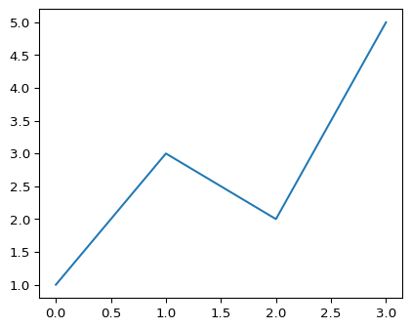

# References

Sokol, Kacper, and Peter Flach. 2021. “You Only Write Thrice: Creating Documents, Computational Notebooks and Presentations From a Single Source.” In *Beyond Static Papers: Rethinking How We Share Scientific Understanding in ML – ICLR 2021 Workshop*. <https://doi.org/10.5281/zenodo.5106062>.