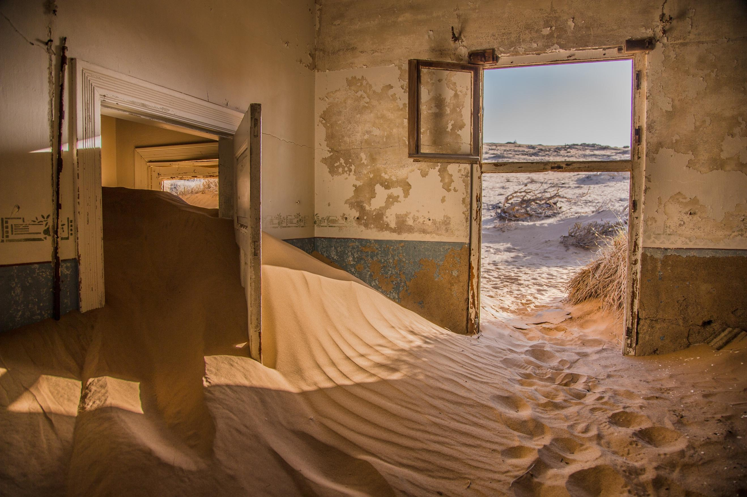

Wind-whipped ocean spray roadside motel room lost in time. Sunrise alarm clock rouses sand-crusted eyelids. Sea foam paint peeling in the thick, briny air. Roll out of bed. Slide down the dunes and out the door.

Sand between the toes is the least of one’s concerns. The finely-ground crystals, infinitesimal specs of Earth, radiate the same ancient soul they’ve possessed since the star dust settled so long ago. Billions of years, waiting patiently to form the footpath leading to this morning’s continental breakfast.

Turn left and walk down the beach to the self-serve waffle station. Turn right for orange juice and stale cereal. Walk straight on ’til dawn to return to the silent depths from which life sprang. Wave after wave of frothy truth lapping the toes, reminding the lungs to inhale, exhale. Pull in the salty breeze and remember what it’s like to be a cosmic blip, tiny and infinite.