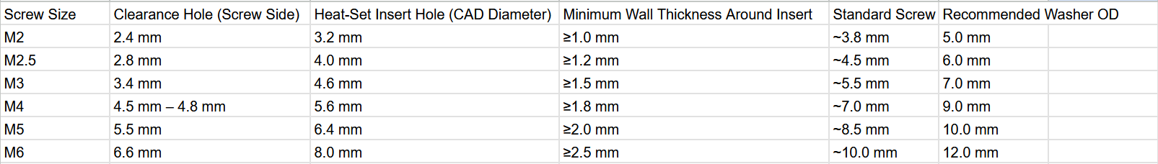
M screws standard:

The Clearance Hole Rule:
- Clearance Hole = Screw Diameter + $0.3\text{ mm}$ to $0.8\text{ mm}$
- Why: Ensures smooth pass-through on 3D printers (which naturally contract slightly when printing inner diameters) while leaving maximum landing area for the screw head.
The Heat-Set Insert Hole Rule:
- Insert CAD Hole = Insert Outer Body Knurl Diameter minus $0.5\text{ mm}$ to $0.7\text{ mm}$
- Why: This precise interference fit gives the melting plastic enough material to flow into the knurl grooves without bulging outward or squishing inward into the thread area.
The Insert Chamber Depth:
- Always model the insert hole $1.0\text{ mm}$ to $1.5\text{ mm}$ deeper than the physical length of the brass insert. This prevents molten plastic squeezed ahead of the tip from clogging the bottom threads.
The Entry Lead-in:
- Always add a ${45}^{∘}$ chamfer at the mouth of the insert hole (matching the insert's outer diameter). It cradles the insert so it stays vertical before you apply the soldering iron.
- Thread inserts M2: Outer diameter = 3.2mm, Height = 4mm
- Thread inserts M3: Outer diameter = 4.6 mm, Height 5.7mm
- Thread inserts M4: Outer diameter = 6.3mm, Height = 8.1 MM
- Thread inserts M5: Outer diameter = 7mm, Height = 9.5mm
- Threat inserts we do 0.1 mm less for a snug fit for it to melt into.

