Meme Clip Catalog — cats (C) and dogs (D)
Every usable green-screen clip, numbered. When planning a video, Claude lists the clip numbers it will use (e.g. 'Mom = C7, Me = C6, Doctor = D28'). Pictures are the middle frame of each clip. 'Sound' is what the clip's own audio is — the video plays it while that character talks.

Cat clips

1. Clip C1 — White cat with huge round 'huh?' eyes peeking up

Good for: shock, confusion, 'huh?'
Time in cat_pack.mp4: 0.00–6.73 s (6.7 s)
Sound: low voice ~124 Hz (human or bark - check)

2. Clip C2 — Fluffy orange cat sitting, looking up
Good for: hoping, waiting, wishing
Time in cat_pack.mp4: 6.73–13.93 s (7.2 s)
Sound: low voice ~88 Hz (human or bark - check)

3. Clip C3 — Small orange cat sitting and meowing
Good for: calling out, asking
Time in cat_pack.mp4: 13.93–19.83 s (5.9 s)
Sound: animal sound (~500 Hz)

4. Clip C4 — White & brown cat standing, meowing loudly
Good for: demanding, complaining, kid asking
Time in cat_pack.mp4: 19.83–24.67 s (4.8 s)
Sound: animal sound (~1067 Hz)

5. Clip C5 — Same white & brown cat, close, meowing

Good for: pleading, arguing
Time in cat_pack.mp4: 24.67–28.53 s (3.9 s)
Sound: animal sound (~1067 Hz)

6. Clip C6 — Big-eyed orange kitten peeking from the side
Good for: innocent child, curious, worried (audio: a woman laughing then talking - user flagged)
Time in cat_pack.mp4: 28.53–38.37 s (9.8 s)
Sound: low voice ~258 Hz (human or bark - check)

7. Clip C7 — Sad tabby (calico) looking down
Good for: sad, tired, guilty, quiet sacrifice
Time in cat_pack.mp4: 38.37–43.67 s (5.3 s)
Sound: animal sound (~421 Hz)

8. Clip C8 — Cream cat standing on hind legs, paws together
Good for: polite, begging, cute request
Time in cat_pack.mp4: 43.67–53.87 s (10.2 s)
Sound: animal sound (~1231 Hz)

9. Clip C9 — Angry white cat and tabby hissing/screaming (rapid cuts)
Good for: angry, yelling, fighting
Time in cat_pack.mp4: 53.87–58.87 s (5.0 s)
Sound: low voice ~260 Hz (human or bark - check)

10. Clip C10 — Black & white kitten wrapped in a towel, held
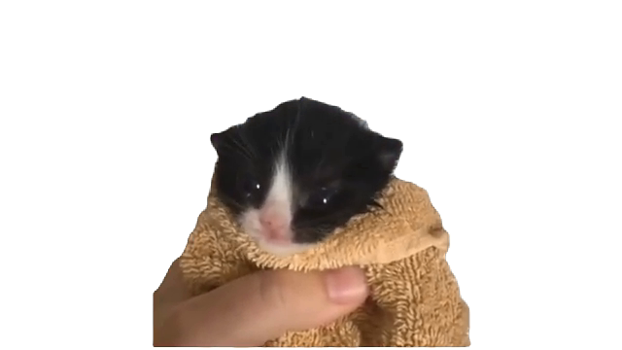
Good for: baby, newborn, fragile
Time in cat_pack.mp4: 58.87–63.73 s (4.9 s)
Sound: animal sound (~464 Hz)

11. Clip C11 — Orange cat turning away, being held
Good for: ignoring, upset, walking away
Time in cat_pack.mp4: 63.73–70.00 s (6.3 s)
Sound: low voice ~348 Hz (human or bark - check)

12. Clip C12 — Small dark cat jumping/climbing far away
Good for: tiny in distance, playing
Time in cat_pack.mp4: 70.00–74.43 s (4.4 s)
Sound: animal sound (~405 Hz)

13. Clip C13 — Cat peeking from the edge with sad big eyes
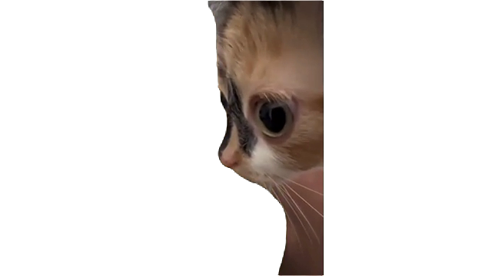
Good for: spying, secretly watching, worried
Time in cat_pack.mp4: 74.43–79.37 s (4.9 s)
Sound: animal sound (~842 Hz)

14. Clip C14 — Grey striped kitten with paws up, screaming
Good for: panicking, tantrum, crying out
Time in cat_pack.mp4: 79.37–83.17 s (3.8 s)
Sound: animal sound (~762 Hz)

15. Clip C15 — Chubby white cat sitting, small in frame

Good for: waiting, lonely, calm
Time in cat_pack.mp4: 83.17–92.43 s (9.3 s)
Sound: low voice ~151 Hz (human or bark - check)

16. Clip C16 — Dark tabby standing still, staring
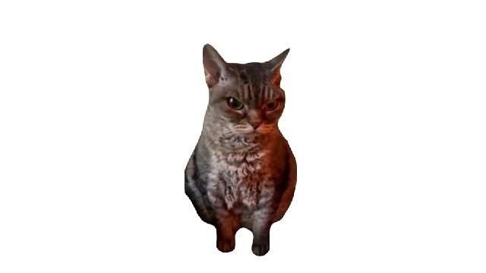
Good for: serious, stern, shocked silence
Time in cat_pack.mp4: 92.43–95.77 s (3.3 s)
Sound: animal sound (~889 Hz)

17. Clip C17 — Scottish fold behind a cream cat
Good for: comforting, hugging, together
Time in cat_pack.mp4: 95.77–103.87 s (8.1 s)
Sound: silent

18. Clip C18 — Dark cat crying, tongue out, blurry close-up
Good for: crying, heartbroken, tears of joy
Time in cat_pack.mp4: 103.87–110.70 s (6.8 s)
Sound: animal sound (~1231 Hz)

19. Clip C19 — White cat standing and waving/dancing
Good for: happy, excited, celebrating, greeting
Time in cat_pack.mp4: 110.70–118.53 s (7.8 s)
Sound: silent

20. Clip C20 — Cat sitting eating from a metal bowl
Good for: eating, hungry, leftovers
Time in cat_pack.mp4: 118.53–124.10 s (5.6 s)
Sound: low voice ~356 Hz (human or bark - check)

21. Clip C21 — White cat driving a car (steering wheel) + pop cat (mixed)
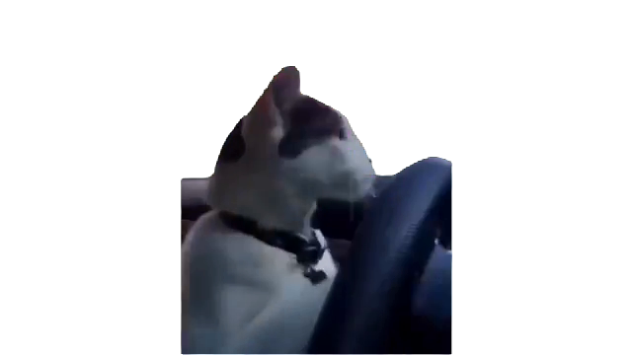
Good for: driving, picking someone up
Time in cat_pack.mp4: 124.10–132.10 s (8.0 s)
Sound: animal sound (~1231 Hz)

22. Clip C22 — Orange cat close-up, sleepy/annoyed face
Good for: tired, unimpressed
Time in cat_pack.mp4: 132.10–136.97 s (4.9 s)
Sound: animal sound (~1000 Hz)

23. Clip C23 — Orange cat 'singing', eyes half-closed
Good for: talking, singing, proud (audio is a human singing)
Time in cat_pack.mp4: 136.97–152.60 s (15.6 s)
Sound: low voice ~286 Hz (human or bark - check)

24. Clip C24 — Cat in a blue cap standing on hind legs
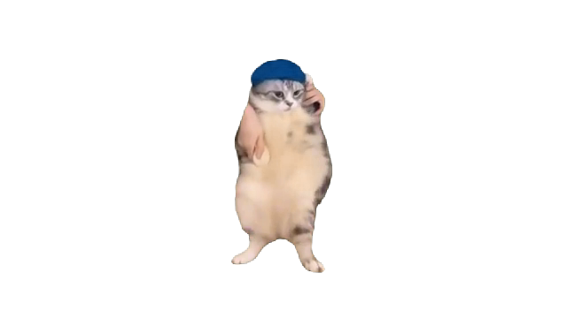
Good for: worker, delivery, playful
Time in cat_pack.mp4: 152.60–155.60 s (3.0 s)
Sound: silent

25. Clip C25 — Tabby in a costume dancing (pink wings/skirt)
Good for: party, celebration, silly
Time in cat_pack.mp4: 155.60–162.03 s (6.4 s)
Sound: silent

26. Clip C26 — Tabby sitting up with a shocked face
Good for: shocked, surprised, frozen
Time in cat_pack.mp4: 162.03–168.50 s (6.5 s)
Sound: low voice ~183 Hz (human or bark - check)

27. Clip C27 — Teary-eyed tabby held up by hands
Good for: heartbroken, sad, about to cry
Time in cat_pack.mp4: 168.50–175.77 s (7.3 s)
Sound: low voice ~117 Hz (human or bark - check)

28. Clip C28 — Fluffy white cat lying, rolling
Good for: relaxed, lazy, comfy
Time in cat_pack.mp4: 175.77–181.20 s (5.4 s)
Sound: animal sound (~485 Hz)

29. Clip C29 — Brown cat standing on hind legs
Good for: waiting, standing guard, determined
Time in cat_pack.mp4: 181.20–194.63 s (13.4 s)
Sound: animal sound (~421 Hz)

Dog clips

1. Clip D1 — Fluffy white chihuahua, eyes closed, standing
Good for: smug, proud, ignoring
Time in dog_pack.mp4: 0.00–6.43 s (6.4 s)
Sound: low voice ~208 Hz (human or bark - check)

2. Clip D2 — Jack Russell jumping with tongue out
Good for: happy, excited, running to greet
Time in dog_pack.mp4: 6.43–14.50 s (8.1 s)
Sound: animal sound (~615 Hz)

3. Clip D3 — German shepherd with a butterfly on its nose
Good for: calm, gentle, butterfly / spirit
Time in dog_pack.mp4: 14.50–21.47 s (7.0 s)
Sound: low voice ~229 Hz (human or bark - check)

4. Clip D4 — Husky nose close-up staring into camera
Good for: curious, sniffing, shocked zoom
Time in dog_pack.mp4: 21.47–32.10 s (10.6 s)
Sound: animal sound (~727 Hz)

5. Clip D5 — Small dog wrapped in a blanket
Good for: sick, cold, cozy, cared for
Time in dog_pack.mp4: 32.10–38.60 s (6.5 s)
Sound: low voice ~356 Hz (human or bark - check)

6. Clip D6 — Chihuahua squinting, tongue out
Good for: disgusted, sassy, teasing
Time in dog_pack.mp4: 38.60–43.67 s (5.1 s)
Sound: animal sound (~892 Hz)

7. Clip D7 — Black dog side-eye, close
Good for: suspicious, judging
Time in dog_pack.mp4: 43.67–51.43 s (7.8 s)
Sound: silent

8. Clip D8 — Pug walking
Good for: walking away, arriving
Time in dog_pack.mp4: 51.43–61.00 s (9.6 s)
Sound: animal sound (~543 Hz)

9. Clip D9 — Rottweiler-type dog with a bow tie, sitting
Good for: groom, formal, polite gentleman
Time in dog_pack.mp4: 61.00–67.83 s (6.8 s)
Sound: low voice ~126 Hz (human or bark - check)

10. Clip D10 — Black & white dog sitting, serious
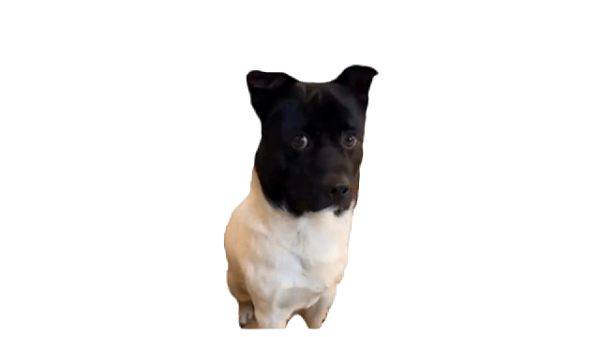
Good for: serious, listening
Time in dog_pack.mp4: 67.83–75.57 s (7.7 s)
Sound: low voice ~225 Hz (human or bark - check)

11. Clip D11 — Bug-eyed chihuahua close-up
Good for: shocked, scared, 'what?!'
Time in dog_pack.mp4: 75.57–83.07 s (7.5 s)
Sound: animal sound (~552 Hz)

12. Clip D12 — Small white dog grinning with teeth
Good for: nervous smile, awkward
Time in dog_pack.mp4: 83.07–86.57 s (3.5 s)
Sound: low voice ~189 Hz (human or bark - check)

13. Clip D13 — Corgi smiling, small in frame
Good for: happy, friendly
Time in dog_pack.mp4: 86.57–97.33 s (10.8 s)
Sound: silent

14. Clip D14 — Chocolate lab with a goofy face
Good for: funny, silly, surprised
Time in dog_pack.mp4: 97.33–104.20 s (6.9 s)
Sound: animal sound (~842 Hz)

15. Clip D15 — Corgi puppy eating watermelon
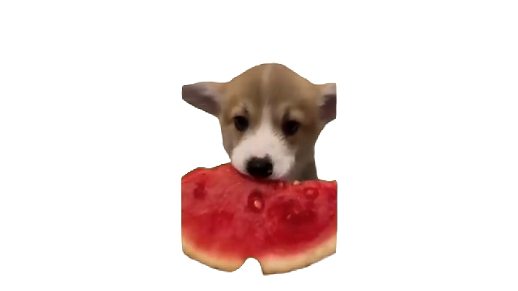
Good for: eating, hungry, happy child
Time in dog_pack.mp4: 104.20–111.00 s (6.8 s)
Sound: silent

16. Clip D16 — Beagle grimace/smile close-up

Good for: awkward, guilty grin
Time in dog_pack.mp4: 111.00–117.20 s (6.2 s)
Sound: low voice ~179 Hz (human or bark - check)

17. Clip D17 — Dog in a straw hat talking on a phone
Good for: phone call, farmer, grandpa
Time in dog_pack.mp4: 117.20–123.30 s (6.1 s)
Sound: animal sound (~390 Hz)

18. Clip D18 — Tan dog close-up, serious stare
Good for: stern, disappointed
Time in dog_pack.mp4: 123.30–129.73 s (6.4 s)
Sound: animal sound (~1143 Hz)

19. Clip D19 — Pointer standing on long legs
Good for: standing, waiting, guard
Time in dog_pack.mp4: 129.73–136.50 s (6.8 s)
Sound: silent

20. Clip D20 — Same pointer, closer
Good for: standing, waiting
Time in dog_pack.mp4: 136.50–139.17 s (2.7 s)
Sound: silent

21. Clip D21 — Husky howling upward
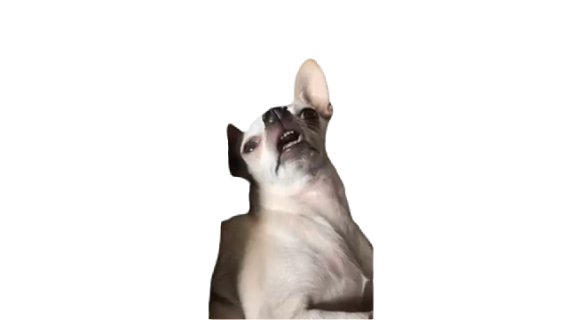
Good for: crying out, singing, missing someone
Time in dog_pack.mp4: 139.17–145.63 s (6.5 s)
Sound: animal sound (~400 Hz)

22. Clip D22 — Boston terrier sitting with collar
Good for: polite, waiting, listening
Time in dog_pack.mp4: 145.63–155.43 s (9.8 s)
Sound: animal sound (~593 Hz)

23. Clip D23 — Dog standing on hind legs (from behind)
Good for: begging, reaching up
Time in dog_pack.mp4: 155.43–158.73 s (3.3 s)
Sound: silent

24. Clip D24 — Tiny fluffy puppy far away
Good for: baby, small, lost
Time in dog_pack.mp4: 158.73–162.00 s (3.3 s)
Sound: noise / effects (no clear voice)

25. Clip D25 — Small black dog walking
Good for: small, lonely, walking
Time in dog_pack.mp4: 162.00–167.57 s (5.6 s)
Sound: silent

26. Clip D26 — Bull terrier in a green hood
Good for: cozy, silly, child
Time in dog_pack.mp4: 167.57–175.13 s (7.6 s)
Sound: animal sound (~1143 Hz)

27. Clip D27 — Dog sitting like a person, leaning
Good for: relaxed, boss, chilling
Time in dog_pack.mp4: 175.13–179.13 s (4.0 s)
Sound: silent

28. Clip D28 — Golden retriever with headset and tie
Good for: office worker, call center, doctor, boss
Time in dog_pack.mp4: 179.13–185.57 s (6.4 s)
Sound: low voice ~130 Hz (human or bark - check)

29. Clip D29 — White dog sitting and howling
Good for: crying, singing, lonely
Time in dog_pack.mp4: 185.57–191.37 s (5.8 s)
Sound: low voice ~195 Hz (human or bark - check)

