Assignment 2

Deadline: Sunday 11/04/2021 @ 23:59

**[Total Marks for this Assignment are 5]**

`

***Computer Programming I***

***CS140***

**Instructions:**

* You must submit two separate copies **(one Word file and one PDF file)**using the Assignment Template on Blackboard via the allocated folder. These files **must not be in compressed format**.
* It is your responsibility to check and make sure that you have uploaded both the correct files.
* Zero mark will be given if you try to bypass the SafeAssign (e.g. misspell words, remove spaces between words, hide characters, use different character sets or languages other than English or any kind of manipulation).
* Email submission will not be accepted.
* You are advised to make your work clear and well-presented. This includes filling your information on the cover page.
* You must use this template, failing which will result in zero mark.
* You MUST show all your work, and text must not be converted into an image, unless specified otherwise by the question.
* Late submission will result in ZERO mark.
* The work should be your own, copying from students or other resources will result in ZERO mark.
* Use **Times New Roman** font for all your answers.

Student Details:

|  |  |  |
| --- | --- | --- |
|  |  |  |
| **Name:**###  **CRN:**### |  | **ID:**### |
|  |  |  |

# Question One

***1.75 Marks***

*Learning Outcome(s):*

Develop a program based on specification using programming language elements including syntax, data types, conditional statement, control structures, procedures and arrays

**Write a full Java program that does the following:**

1. Read two integer inputs entered by the user and store them in compatible variables.
2. Print the sum of the two numbers.
3. Using a while loop, ask the user whether he or she wishes to perform the operation again. If so, the loop should repeat; otherwise, it should terminate.

**Example Run:**

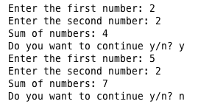

Show a **screenshot** of the output (if there is no screenshot of the output, the student shall get a zero mark for this question).

**Answer**

**Code:**

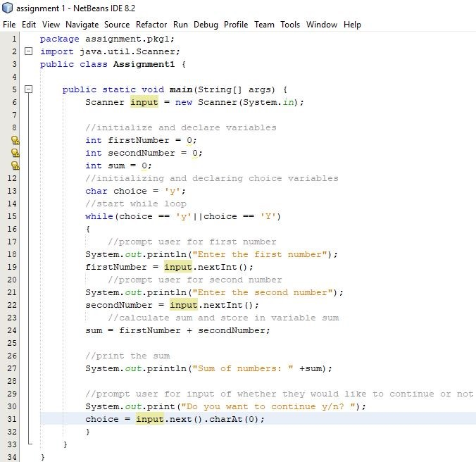

**Output**

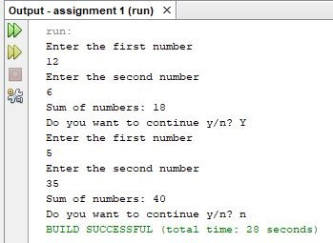

# Question Two

***1.25 Mark***

*Learning Outcome(s):*

Develop a program based on specification using programming language elements including syntax, data types, conditional statement, control structures, procedures and arrays.

**Write a full Java program that does the following:**

1. Generates two random numbers between 1 and 9 inclusive.
2. Prints the two generated numbers.
3. Prints the sum of these numbers.
4. Prints the maximum and the minimum number.

**Example runs:**

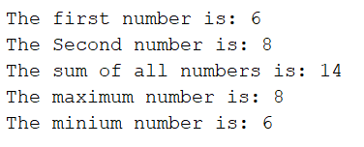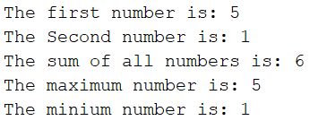

Show a **screenshot** of the output (if there is no screenshot of the output, the student shall get a zero mark for this question).

**Answer**

**Code:**

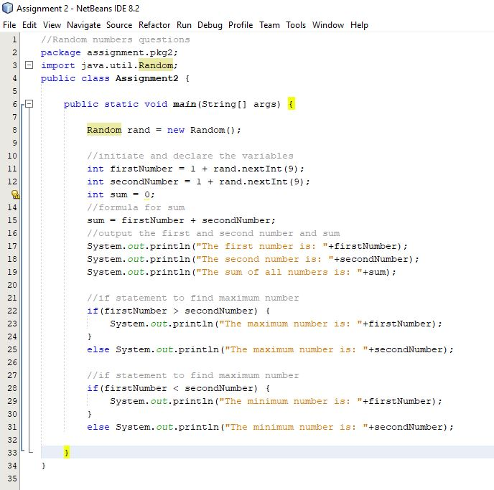

**Output:**

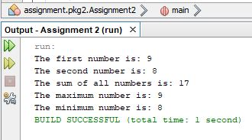

# Question Three

***2 Marks***

*Learning Outcome(s):*

Develop a program based on specification using programming language elements including syntax, data types, conditional statement, control structures, procedures and arrays.

**Write a full Java program that does the following:**

1. Asks the user to input temperature for 10 consecutive days and stores it in an array of type double.

**Note:** The temperature values entered by the user from keyboard must be in the range [-15 to 50]. In case the temperature value is not within the allowed range, the program must display the following messages and asks the user to enter the value of the temperature of that particular day again until the user enters a correct value within the stated range.

Please enter the temperature in the range [-15 to 50].

Enter the temperature for Day 1:

1. Calculate and display the average temperature based on 10-day data available in the form of array.
2. Calculate and display the number of days for which the temperature was above the average temperature.
3. Calculate and display the number of days for which the temperature was below the average temperature.

Sample output of the program is provided below for reference.

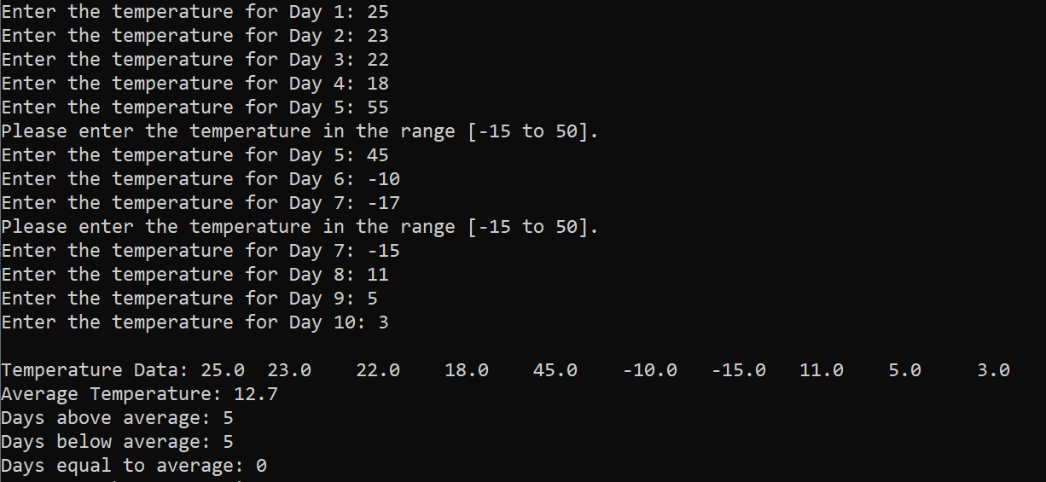

Show a **screenshot** of the output (if there is no screenshot of the output, the student shall get a zero mark for this question).

**Code:**

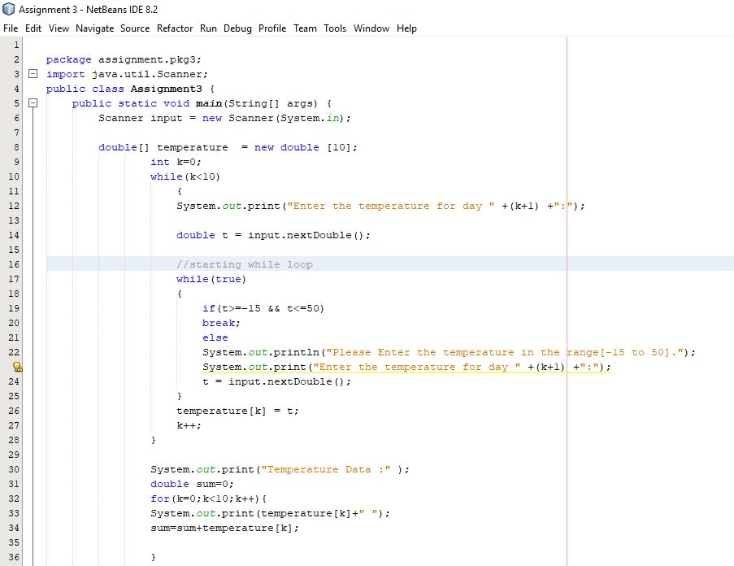

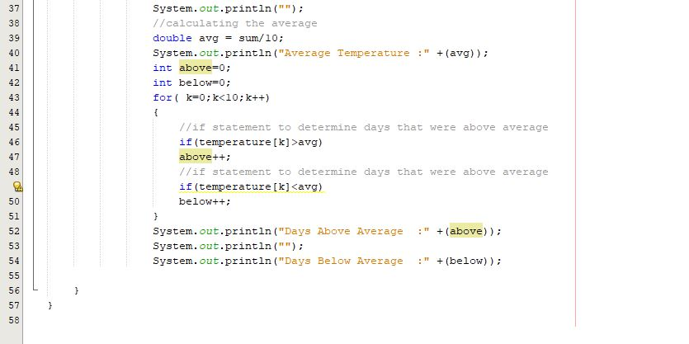

**Output:**

