Assignment 1

Classification and Regression

Prepared by:

|  |  |
| --- | --- |
| 7818 | Mohamed Hussein Elzohiry |
| 7721 | Alaa Mohamed Elkhouly |

**SUBJECT: Machine Learning PROFFESSOR: DR. Marwan Torki**

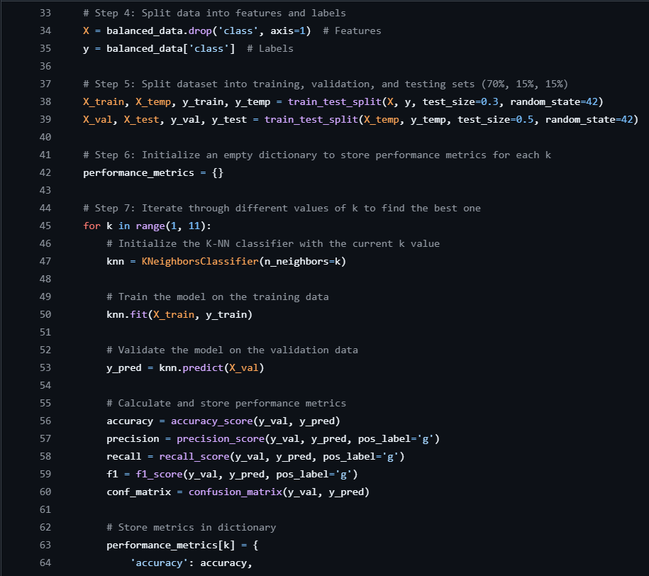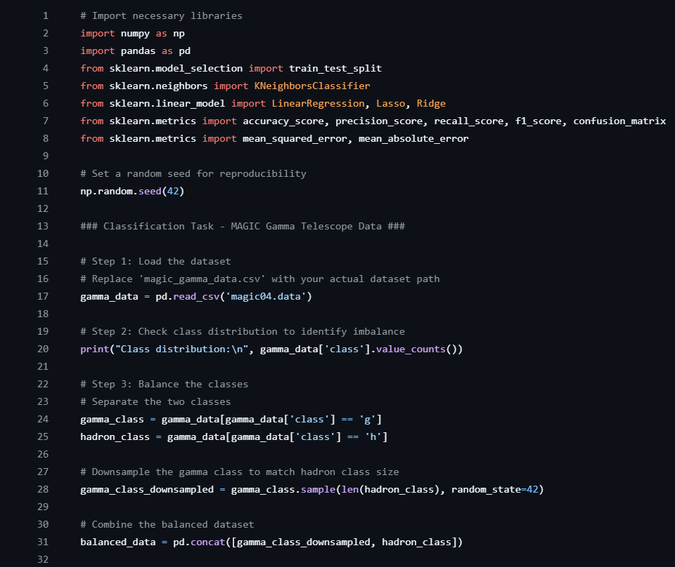Problem Statement 1 (Classification):

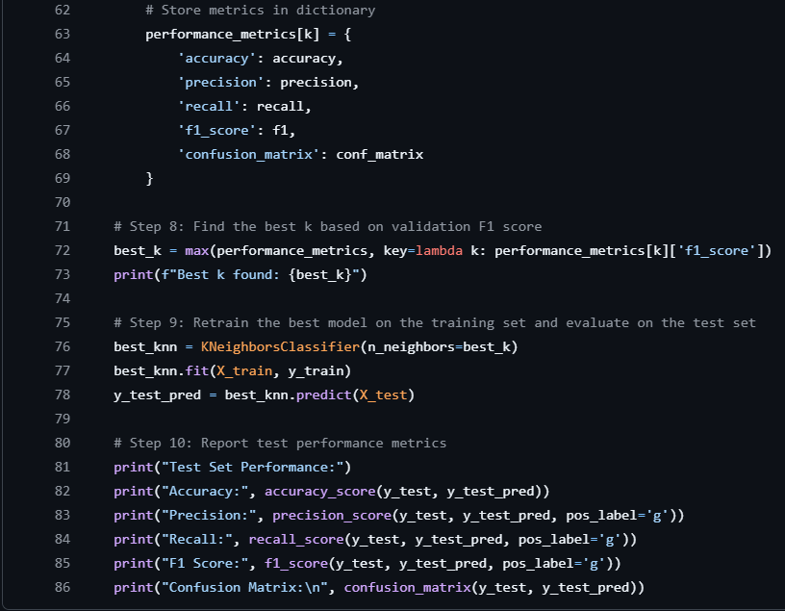

Code’s flow:

Code Explanation:

**Lines 1 to 9:**

Imports necessary libraries

* **NumPy** & **Pandas** 🡪 data manipulation and handling.
* From **sklearn.model_selection**:
  + **train_test_split 🡪** split the data into training, validation, and test sets
  + **KNeighborsClassifier 🡪** apply the K-Nearest Neighbors (K-NN) classification algorithm.
  + **Others 🡪** evaluating the model's performance

**Lines 10 to 12:**

Set a random seed for reproducibility

* Setting a random seed ensures reproducibility, so running the code multiple times will yield the same results for random sampling or splits.

**Lines 13 to 18:**

Load the dataset and replace 'magic_gamma_data.csv' with your actual dataset path.

**Lines 19 to 21:**

Check class distribution to identify imbalance

* checks the number of instances for each class (gamma and hadron) in the dataset.
* the output will show how many examples belong to each class (For the imbalance).

**Lines 22 to 26:**

* Balance the classes
* Separate the two classes: divides dataset into two subsets:
  + **gamma_class** for the 'g' class
  + **hadron_class** for the 'h' class

**Lines 27 to 32:**

Downsample the gamma class to match hadron class size:

* uses the sample method to randomly select a subset of gamma events equal in size to the number of hadron events, achieving balance.

Combine the balanced dataset

* creates balanced dataset “**balanced_data**” by concatenating the downsampled gamma events and all hadron events.

**Lines 33 to 36:**

Split data into features and labels

* x contains the features (all columns except for class).
* y contains the labels (the class column).

**Lines 37 to 40:**

Split dataset into training, validation, and testing sets (70%, 15%, 15%)

* train_test_split first divides the data into:
  + training (70%)
  + temporary (X_temp and y_temp) (30%) sets.
* temporary set is split further into validation and testing sets, each 15% of the original data.
* The final split results in 70% for training, 15% for validation, and 15% for testing

**Lines 41 to 43:**

* Initializes an empty dictionary to store model’s performance metrics for each value of k tested
* allows comparison across different k values to find the optimal one

**Lines 44 to 70:**

Iterate through different values of k to find the best one

* Initialize the K-NN classifier with the current k value
* A loop iterates over k values from 1 to 10 to testing each as a possible number of neighbors for the K-NN classifier

For each k:

* A K-NN classifier is initialized with n_neighbors=k.
* Train the model on the training set
* Validate the model (predictions are made) on the validation data
* Calculate and store performance metrics (accuracy, precision, recall, F1 score, and confusion matrix)
* Store metrics in performance_metrics dictionary under the key for each k value.

**Lines 71 to 74:**

Find the best k based on validation F1 score

* selects the k value with the highest **F1 score** from the validation results stored in performance_metrics, providing the optimal k for balanced performance across precision and recall.

**Lines 75 to 79:**

Retrain the best model on the training set and evaluate on the test set

* a **K-NN model** is retrained using this best k on the **entire training set**.
* Predictions are then made on the test set to assess the final model’s performance.

**Lines 80 to 86:**

Report test performance metrics

* Calculate the performance metrics on the test set
* These metrics reflect how well the model generalizes to unseen data.

What is F1 score?

The F1 score is a measure of a model's accuracy.

It’s calculated as the harmonic mean of precision (the proportion of true positives among predicted positives) and recall (the proportion of true positives among actual positives).

The formula for F1 score is:

$$F1 Score=2×\frac{precision × Recall}{precision + Recall}$$

The F1 score ranges from 0 to 1:

* 1 means perfect precision and recall.
* 0 means the model missed all correct classifications or had only incorrect ones.

This score is especially valuable when the data is imbalanced or when false positives and false negatives carry similar costs.

* Problem Statement 2 (Regression):

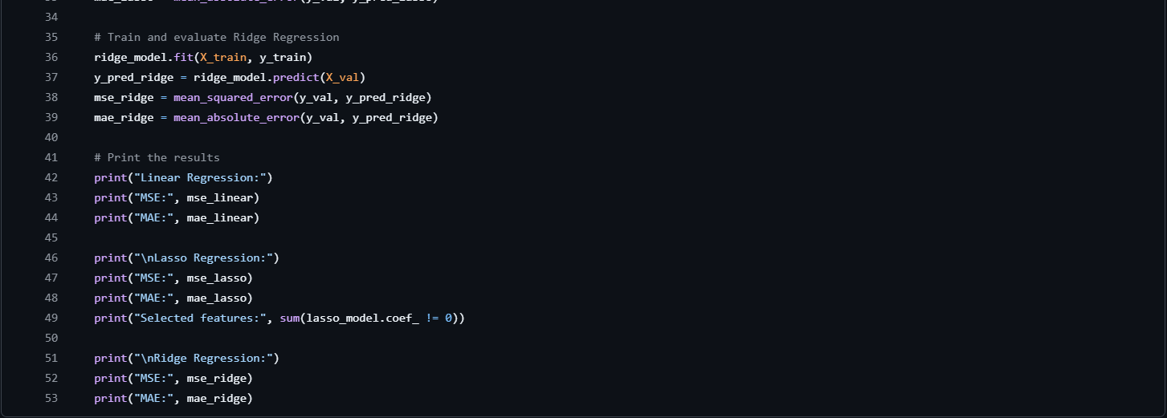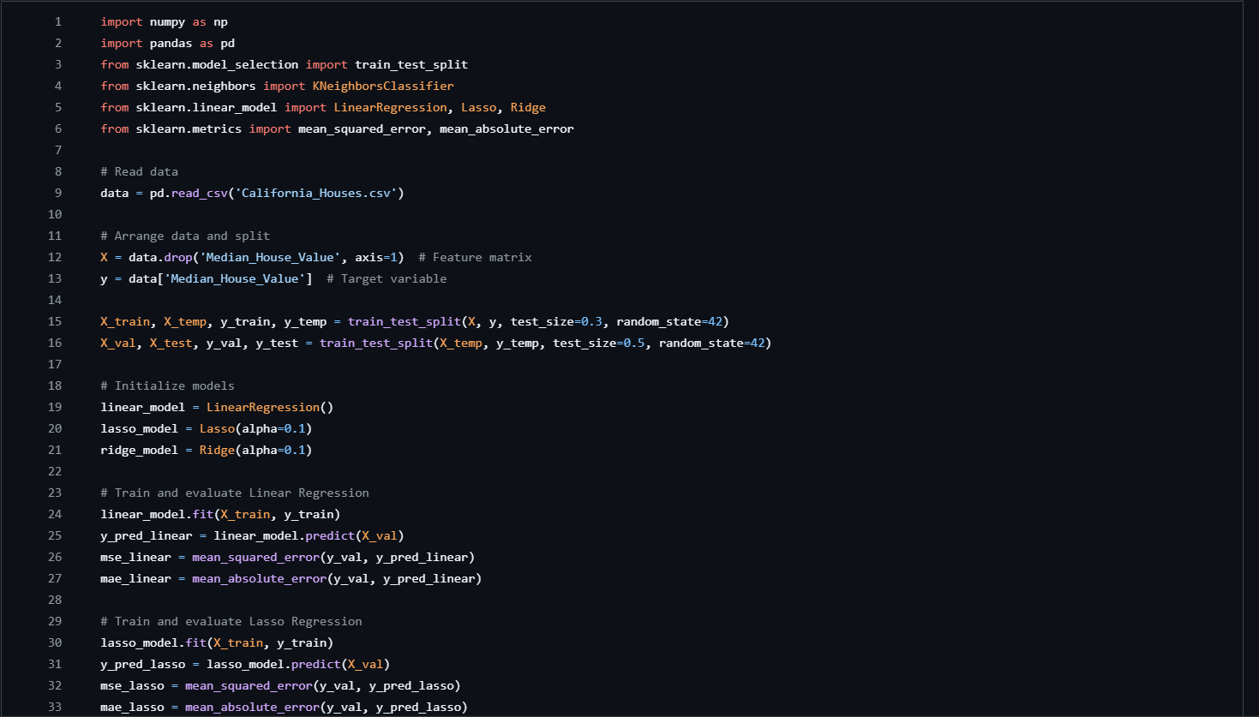

Code’s Flow:

Code Explanation:

**Lines 1 to 7:**

Imports necessary libraries

* **numpy** 🡪 for handling large arrays and numerical computations.
* **pandas** 🡪for data manipulation and analysis (provides the Data Frame structure for easy handling of datasets).
* From **sklearn.model_selection**:
  + **train_test_split 🡪** split the data into training, validation, and test sets
  + **LinearRegression, Lasso, Ridge 🡪** regression models
    - **LinearRegression 🡪** performs basic linear regression
    - **Lasso 🡪** Least Absolute Shrinkage and Selection Operator is a regression technique that adds regularization (penalty) to reduce model complexity by eliminating certain features
    - **Ridge 🡪** another regularization method that penalizes large coefficients
  + **mean_squared_error & mean_absolute_error 🡪** evaluating the model's accuracy by measuring the prediction error

**Lines 8 to 10:**

Reads data

loads the dataset from a CSV file named California_Houses.csv into a Data Frame called data

**Lines 11 to 14:**

Splitting Features and Target Variable

* x: All columns except Median_House_Value are treated as features (independent variables).
* y: Median_House_Value is selected as the target variable (dependent variable) since it’s what the model aims to predict.

**Lines 15 to 17:**

Data splitting

* splits the data into training (70%) and temporary (30%) sets.
* The random_state=42 ensures reproducibility by using the same random seed each time.
* temporary set is further split into validation and test sets, each with 15% of the total data, for validating and testing the model.
* Validation is used for tuning, and the test set is used to evaluate the model's performance on unseen data.

**Lines 18 to 22:**

Initialize models

* linear_model: Basic linear regression model.
* lasso_model: Lasso regression with a regularization strength (alpha) of 0.1, which adds a penalty to large coefficients, encouraging some to become zero and performing feature selection.
* ridge_model: Ridge regression with a regularization strength (alpha) of 0.1, which penalizes large coefficients, reducing overfitting but without setting coefficients to zero.

**Lines 23 to 28:**

Train and evaluate Linear Regression

* Trains the model on the training data.
* Predicts house values on the validation set.
* Compute the MSE and MAE of predictions against the actual values in the validation set, measuring model accuracy. Lower values indicate a better fit:
  + MSE (Mean Squared Error): Measures average squared differences between predicted and actual values.
  + MAE (Mean Absolute Error): Measures the average absolute difference between predicted and actual values, less sensitive to outliers.

**Lines 29 to 34:**

* Train and evaluate Lasso Regression
  + Trains the Lasso regression model on the training data.
  + Predicts house values on the validation set using Lasso.
  + mse_lasso and mae_lasso: Compute the error metrics for Lasso predictions. The Lasso model can drive some coefficients to zero, effectively excluding some features.

**Lines 35 to 40:**

* Train and evaluate Ridge Regression
  + Trains the Ridge regression model.
  + Predicts house values on the validation set using Ridge regression.
  + mse_ridge and mae_ridge: Calculate error metrics, similar to the previous models. Ridge penalizes large coefficients, reducing their magnitude but not setting them to zero.

**Lines 41 to 53:**

Print the results

* Print statement outputs the performance metrics (MSE and MAE) for each model.
* Also counts the number of non-zero coefficients in the Lasso model, showing how many features Lasso considered important.