Math Image to LaTeX Extraction Results

Result for: test2.png
Original Upload:
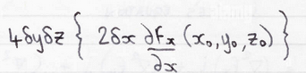
Rendered Math Equation:
(Could not fetch rendered image from API)
Raw LaTeX Code:
{\downarrow\leq\uparrow\uparrow\uparrow}\\ {\downarrow\uparrow\uparrow}\end{array}\bigg\langle\mathrm{~\uparrow~}\Sigma\S_{\infty}\ <{\vartheta\uparrow\downarrow\downarrow\atop\downarrow\downarrow\downarrow\uparrow\leq\rangle}\bigg\rangle\bigg\rangle

Result for: test1.png
Original Upload:
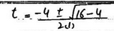
Rendered Math Equation:
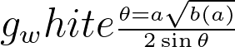
Raw LaTeX Code:
\scriptstyle{\frac{\theta=a{\sqrt{b(a)}}}{2\sin\theta}}\,

Result for: test3.png
Original Upload:
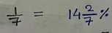
Rendered Math Equation:
(Could not fetch rendered image from API)
Raw LaTeX Code:
\begin{array}{r l}{{\frac{1}{\pi}}}&{{}=_{\circ}}&{{}|2|{\frac{x_{\circ}}{T}}\chi}\\ {\equiv}&{{}=\sin\theta\sin\theta}\end{array}

