Name: Perfect Yayra

Surname: Gidisu

Matricola: 898420

Date: 20th October, 2017

**Master in Economics and Finance**

Portfolio Optimization – Project 1

Question 1 and 2

Using Matlab I computed the expected return, variance and covariance matrix for the data given. (The code is attached).

|  |  |  |  |  |  |  |
| --- | --- | --- | --- | --- | --- | --- |
| Stock | S1 | S2 | S3 | S4 | S5 | S6 |
| Average(Expected Value) | 0.5920 | 0.1760 | 0.3960 | 0.3900 | 0.1900 | 0.5540 |
| Variance | 0.1999 | 0.0024 | 0.0063 | 0.0080 | 0.0055 | 0.0073 |

|  |  |  |  |  |  |  |
| --- | --- | --- | --- | --- | --- | --- |
| Covariance | | | | | | |
|  | S1 | S2 | S3 | S4 | S5 | S6 |
| S1 | 0.1999 | 0.0179 | 0.0200 | 0.0192 | -0.0261 | 0.0336 |
| S2 | 0.0179 | 0.0024 | 0.0018 | 0.0021 | -0.0032 | 0.0041 |
| S3 | 0.0200 | 0.0018 | 0.0063 | 0.0037 | -0.0048 | 0.0030 |
| S4 | 0.0192 | 0.0021 | 0.0037 | 0.0080 | -0.0033 | 0.0031 |
| S5 | -0.0261 | -0.0032 | -0.0048 | -0.0033 | 0.0055 | -0.0055 |
| S6 | 0.0336 | 0.0041 | 0.0030 | 0.0031 | -0.0055 | 0.0073 |

Question 2

Goal programming in terms of portfolio selection is an analytical approach devised to address financial decision-making problems where goals have been assigned to the attributes of a portfolio and where the decision maker is interested in minimizing the non-achievement of the corresponding goals.

The weighted goal programming (WGP) for portfolio model usually lists the unwanted deviational variables, each weighted according to their importance and minimizes the sum of the unwanted weighted deviations. In this project, the objective function in WGP model for portfolio selection seeks to minimize risk and maximize return by penalizing shortfalls in return $(D_{1}^{-}$) and excess risk ( $D_{2}^{+}$), relative to the respective goals. Therefore, lower levels of risk and higher levels of return are not penalized ( $D_{1}^{+}$ and $D_{2}^{-}$). In this regard I set the” EqualityGoalCount” to 0 thus making the objectives lesser (in the case of variance) or more (the case of expected return) than the goals. And also to ensure that the same percentage of under or over-attainment in the active objectives at the solution, I set the weighting matrix to “abs (goal)”.

The mathematical structure of this problem is written as follows

MIN $D_{1}^{-}$ + $D_{2}^{+}$

Subject to

- + =0.47($F_{ER}$ is expected return function)

- + =0.0025 ( $F_{V}$ is the variance function)

$D_{1}^{+}$, $D_{1}^{-}$, $D_{2}^{-}$, $D_{2}^{+}≥$ 0

$\sum_{i=1}^{6}{∝_{i}}$ =0

0 $≤$ $∝_{i} ≤$ 1

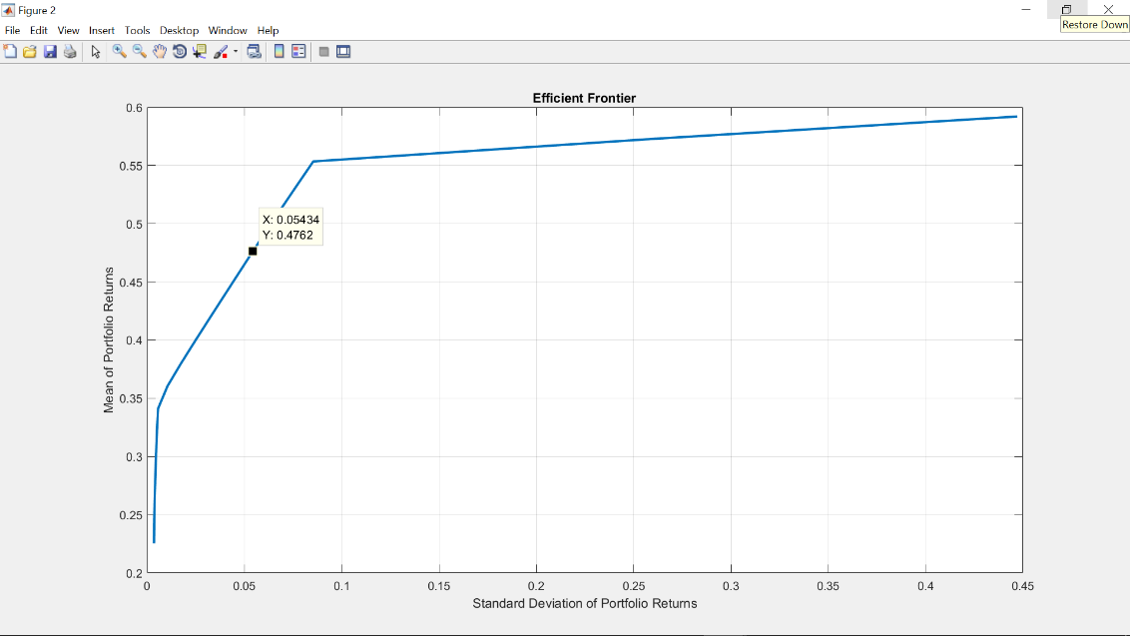The goal is to have an expected return of the portfolio to be at least 47% and the variance to be at most 0.25%. My choice of the goals was influenced by the highest and lowest expected return and variance that one could achieved based on the respective expected return and variance of each stock and also the fact that ${ S}_{5}$ has a negative correlation with the other stocks. I also looked at the plot of efficient frontier for the data given to have a fair idea of what my portfolio return and variance would be. This is to prevent the situation of unrealistic goals (too high or too low). Looking at the variance and expected return of the individual stocks, even though ${ S}_{1}$ had the highest value for expected return its variance was very high as compared to the other stocks, the second highest in terms of expected return was ${ S}_{6}$ and its variance was also relatively low. This was the most desirable stock to me so I chose my initial value for the weights of stock as [0 0 0 0 0 1]. I expect to have a portfolio made of at least ${ S}_{6}$ and ${ S}_{5}$ and I set my variance goal lesser than what was on the plot because of the negative correlation among the two stocks so the risk will reduce.

The attainment factor of result for the above problem in matlab indicates that each of the objectives has been overachieved by at least 8.47% over the original design goals. Thus the expected portfolio return and variance are 50.98% and the 0.23% respectively. It was noted that the variance achieved is lower than the lowest of the individual stock variance (0.24%). The stocks that are to be include in this portfolio are about 12.14% of $S_{5}$ and 87.86% of ${ S}_{6}$. Thus using a budget of $100,000, $12140 should be invested in stock 5 and $87,360 should be invested in stock 6 at the beginning of the year and it will be worth $150980 at the end of the year with a standard deviation of 5.29%.

Question 4

The ultimate objective of optimal portfolio selection is to determine and hold a portfolio which offers the minimum possible variance for a given or desired expected return. The mathematical structure is that of minimizing a quadratic function subject to linear constraints (expected return equation and the budget). The result of this problem in matlab is a variance of 0 and portfolio return of 22.66%. Thus investing $100,000 in this portfolio at the beginning of the year will be worth $122,660 with no risk. With the stocks in the portfolio comprising of 39.22% of $S_{2}$, 19.94% of ${ S}_{3}$, 40.56% of ${ S}_{5}$ and 0.27% of $S_{6}$. The variance of 0 was expected since the desired expected return is lower than the expected return of the individual stock. I would like to point out that the expected return equation is in actual sense not a constraint since you get the same result in the absence of it.

NB: I also decided to use lingo to solve question 3 and 4 just to compare, I realized result for question 4 was almost the same but that of question was a bit different.

Matlab Code.

Data= [0.10 0.12 0.30 0.40 0.30 0.45

0.11 0.15 0.40 0.30 0.20 0.50

0.90 0.17 0.50 0.45 0.15 0.55

0.86 0.19 0.34 0.30 0.20 0.60

0.99 0.25 0.44 0.50 0.10 0.67];

ER=mean(Data);%Expected Return of each stock

ER

V=var(Data); %Variance of each stock

V

CovM=cov(Data); %Covariance Matrix

CovM

portopt(ER, CovM,20);

A=ER; %Expected Return Matrix constraint

b=12;

Aeq=ones(1,6);%Sum of weights matrix constraint

beq=1;

lb=zeros(1,6);%lower bound for each stock

ub=ones(1,6); %upper bound for each stock

goal=[-0.47 0.0025];%desired outcome

weight=abs(goal);%level of importance attached to the goals

%GOAL PROGRAMMING;

g = @(w)[ -ER*transpose(w),1/2*w*CovM*transpose(w)];

options=optimoptions('fgoalattain','EqualityGoalCount', 0,'Display','iter');

[w,fval,attainfactor]=fgoalattain(g,[0 0 0 0 0 1],goal,weight,[],[], Aeq, beq, lb, ub,[], options);

w

fval

attainfactor

%MINIMUM VARIANCE PORTFOLIO

options = optimoptions('quadprog','Algorithm','interior-point-convex','Display','iter');

[weightsP,sigmaP] = quadprog(CovM,[],A,b,Aeq,beq,lb,ub,[],options);

PortfolioReturn=ER*weightsP;

sigmaP

weightsP

PortfolioReturn

Lingo Code

!Goal Programming

MODEL:

SETS:

STOCK/1..6/: RETURN, UB, A;

COVM( STOCK, STOCK): V;

ENDSETS

DATA:

! Expected return of each asset;

RETURN = 0.5920 0.1760 0.3960 0.3900 0.1900 0.5540;

! Upper bound on each stock;

UB = 1 1 1 1 1 1;

! Covariance matrix;

V = 0.1999 0.0179 0.0200 0.0191 -0.0261 0.0336

0.0179 0.0024 0.0018 0.0021 -0.0032 0.0041

0.0200 0.0018 0.0063 0.0037 -0.0048 0.0030

0.0191 0.0021 0.0037 0.0080 -0.0032 0.0031

-0.0261 -0.0032 -0.0048 -0.0032 0.0055 -0.0055

0.0336 0.0041 0.0030 0.0031 -0.0055 0.0073;

ENDDATA

! The model;

! Min the deviations;

[DEVIATION] MIN = D1M + D2P;

!Constraints

! Must be fully invested;

[FULL] @SUM( STOCK: A) = 1;

! Upper bounds on each;

@FOR( STOCK: @BND( 0, A, UB));

D1M>=0;

D1P>=0;

D2P>=0;

D2M>=0;

!Desired variance;

[VAR] (@SUM( COVM( I, J): 0.5* A( I) * V( I, J) * A( J)))-D2P + D2M =0.0025;

! Desired return;

[RET] (@SUM( STOCK: RETURN * A))-D1P + D1M =0.47;

END

!Minimum Variance Portfolio

! The model;

! Minimize the variance;

[VAR] MIN = @SUM( COVMATRIX( I, J):0.5* A( I) * V( I, J) * A( J));

! Must be fully invested;

[FULL] @SUM( STOCK: A) = 1;

! Upper bounds on each;

@FOR( STOCK: @BND( 0, A, UB));

! Desired return;

[RET] @SUM( STOCK: RETURN * A) >= 0.12;

END