Locking and Concurrency Control in libpcp
Ken McDonell
Historically, all code in PCP (including libpcp) was single-threaded, meaning there was no need for locking and concurrency control. This was a conscious design decision, driven by a non-negotiable goal of minimizing the CPU load that PCP services would impose on the system being monitored.
In early 2011, as machines became faster and PCP was increasingly being used in high node-count clusters and networks, there was a move to make libpcp more friendly and thread-safe for possible multi-threaded applications using the PMAPI.
This involved a lot of refactoring and changes to libpcp as outlined below. Unfortunately we were constrained to maintain the syntax and semantics of the existing API and ABI, with changes constrained to adding some additional routines and internal rework; this is less than ideal, as a libpcp designed for multi-threaded use from the outset could have been quite different.
But note that at that time there was no intent to broaden the scope of this work to include other PCP libraries or core daemons like pmcd. Today there is still no convincing argument to add multi-threading support outside libpcp and indeed the problems with the libpcp thread-safe work are a barrier to any expansion of the multi-threading support, as every application and library in PCP is built on libpcp at the lowest level.

Locking Technology
It was decided that the mutex services of the pthread library provided the most portable solution for locking and concurrency control.
But because at the time we were unsure of the availability of pthreads support across all platforms we encapsulate all related operations in macros that do nothing or almost nothing if the macro PM_MULTI_THREAD is undefined (and PM_MULTI_THREAD is set by configure logic in the build).
The key mutex-related macros are as follows:
macro | use
__pmMutex | declaration for a mutex, which is a pthread_mutex_t if we have pthreads else a void *
PM_INIT_LOCKS | call __pmInitLocks() to initialize global mutexes and thread-private storage pool – must be called before any other locking operation
PM_LOCK | call __pmLock() to lock a mutex
PM_UNLOCK | call __pmUnlock() to unlock a mutex
PM_MULTIPLE_THREADS | call __pmMultiThreaded() to check if more than one thread is trying to use a specific libpcp service scope (see Some libpcp Services Can Never be Thread-Safe below)

It turns out that PM_MULTI_THREAD is defined for all the common PCP build platforms.
We need some mechanism for supporting thread-private data, and if the macro HAVE___THREAD is defined, then we’re using gcc (or similar) and the __thread storage class is supported. Otherwise we roll our own thread-private storage pool using pthread_getspecific(). All of the access to thread-private (scalar) variables is hidden in the PM_TPD(x) macro which can be used as an lval or a rval to set or get the value of the thread-private variable x.
Current thread-private variables are:
variable | use
curcontext | the current PMAPI context
derive_errmsg | the error message buffer from the derived metric parser
curr_pmns | the current PMNS
useExtPMNS | the current PMNS comes from an external PMNS file (not from pmcd or a PCP archive)

Global Data Structures
In an approach that is akin the “big kernel lock” from the olden days of Linux (and Unix before that), we added the __pmLock_libpcp mutex to be used to protect all global data structures against concurrent access.
Within libpcp there existed some serious nesting, where libpcp routine pmX() may call another libpcp routine pmY(), and at the same time any PMAPI client application could also call either or both of pmX() and pmY(). This means the __pmLock_libpcp mutex needs to allow recursive locking for a single thread. But recursive locks cannot be initialized at compile time on all platforms, which is one of the reasons the entry points into libpcp are liberally laced with PM_INIT_LOCKS() macro calls before there is any possible use of the __pmLock_libpcp mutex;
Because there is a risk of new global data structures being introduced without appropriate concurrency controls, the check-statics script was added to the libpcp source directory and if this finds an unexpected change to the static data in the binaries used to make libpcp the build fails.

System Calls
For those system and libc calls that are classified as not thread-safe, __pmLock_libpcp is also used to prevent concurrent execution across multiple threads.
This is probably overkill because the routines that need protection come in groups, and one mutex per group would provide the same protection while allowing increased concurrency. But more seriously, access to global data structures in libpcp is blocked while any of these thread-unsafe routines are being called, and some of them may take a while to complete; so a separate mutex for calls to all external routines that are not thread-safe would reduce the contention on __pmLock_libpcp.
Suggested Change
Introduce a new mutex just for the thread-unsafe calls outside libpcp.

Contexts
The __pmContext structure holds a rich collection of information (and associated linked structures) that are critical for the operation of libpcp. Uncontrolled access to a __pmContext structure from multiple concurrent threads would be bad, so the c_lock mutex field was introduced. This mutex also needs to be recursive for the same reasons as described above for the __pmLock_libpcp mutex, namely the deeply nested call-graph structure of libpcp.
Context locking is a tricky business. Fortunately, the data structures that support the __pmContext structures and control to them was already encapsulated in context.c, and the only way that other libpcp routines could access a __pmContext structure was by calling __pmHandleToPtr() to map a context number (as used above the PMAPI) to the address of a __pmContext structure. So it was decided that on success __pmHandleToPtr() would return the address of the __pmContext structure with c_lock locked.
The caller is responsible for:
- ensuring __pmLock_libpcp is not held before calling __pmHandleToPtr() to prevent deadlock from lock inversion, and
- unlocking c_lock when the caller has finished accessing the fields of the __pmContext structure
It turns out this was a mistake. By not holding the __pmLock_libpcp mutex at the time the c_lock mutex is locked, we introduce a window in which a concurrent thread can be destroying a context at the same time we’re trying to lock it.
Suggested Change
We need a new locking regime private to context.c that controls concurrent access to the global contexts array and contexts_len and allows safe locking of the c_lock mutex and does not introduce lock inversion (and hence possible deadlock).
Paticularly nasty here is the nested code path from pmDupContext() into pmNewContext().
Note that the management of __pmContext structures in context.c ensures that once allocated, a __pmContext structure is never moved or destroyed, so the address from __pmHandleToPtr() has long-term validity, even in the presence of concurrent requests to create, duplicate, destroy, etc. contexts. c_lock may be unlocked at will, but should never be locked other than as a side-effect of a call to __pmHandleToPtr().

IPC with pmcd
For “host” contexts, the PDU protocol between a PMAPI client and pmcd is inherently synchronous. So a thread must be able to send a request PDU and receive the response PDU from pmcd with no other thread concurrently communicating with the same pmcd.
From the __pmContext structure, the c_pmcd field identifies a __pmPMCDCtl structure that is shared by all contexts communicating with the same pmcd. Within the __pmPMCDCtl structure the pc_lock field is a mutex (not recursive) that is used to ensure mutual exclusion during a PDU round-trip.
The pc_lock mutex is only locked and unlocked while the c_lock (context) mutex is locked, ensuring lock inversion and deadlock cannot happen between these two mutexes.
TODO
Check that pc_lock lock-unlock blocks are always covered by a prior __pmHandleToPtr() to lock c_lock.
What other locks are acquired/released while pc_lock is locked? These are potential lock inversion problems and/or deadlock candidates, especially since c_lock maybe held at the same time.

Some libpcp Services Can Never be Thread-Safe
There are some parts of libpcp where multi-threaded use either makes no sense or cannot safely be implemented. These areas of functionality are grouped into a number of scopes and guarded by tests against the PM_MULTIPLE_THREADS(scope) macro; if more than one thread evluates PM_MULTIPLE_THREADS() for a specific scope, the libpcp routine will return PM_ERR_THREAD immediately.
PM_MULTIPLE_THREADS() is a thinly discguised wrapper around a call to __pmMultiThreaded().
The scopes are as follows:
Scope | PMAPI routine(s) | Explanation
PM_SCOPE_DSO_PMDA | Most routines when using a context of type PM_CONTEXT_LOCAL. | Because a “local” context involves loading and calling the PMDA DSOs directly, all bets are off. The man page for pmNewContext() contains this caveat: “applications using a PM_CONTEXT_LOCAL context must be single-threaded because the various DSO PMDAs may not be thread-safe”.
PM_SCOPE_ACL | __pmAccAddOp, __pmAccSaveHosts, __pmAccSaveUsers, __pmAccSaveGroups, __pmAccRestoreHosts, __pmAccRestoreUsers, __pmAccRestoreGroups, __pmAccFreeSavedHosts, __pmAccFreeSavedUsers, __pmAccFreeSavedGroups, __pmAccAddGroup, __pmAccAddUser, __pmAccAddHost, __pmAccAddClient, __pmAccDelClient, __pmAccAddAccount, __pmAccDelAccount, __pmAccDumpHosts, __pmAccDumpUsers and __pmAccDumpGroups | There are some very complicated global data structures to support ACLs, and they are ony used in the following places: pmcd, pmproxy and pmlogger (all are single-threaded), and a handful of PMDAs (that are also single-threaded).
PM_SCOPE_AF | __pmAFsetup, __pmAFunregister, __pmAFblock and __pmAFunblock | The asynchronous event services rely on system services like setitimer() that are inherently not thread-safe. These routines are only used in the following places: pmlogger (which is single-threaded) and a number of PMDAs, either directly or via the PMDA main loop in run() for every Perl-based PMDA (and all of these are single-threaded, at least when calling into libpcp).
PM_SCOPE_LOGPORT | __pmLogFindLocalPorts and__pmLogFindPort | The services to locate pmlogger control ports require some complicated global data structures, and they are only used in the following places: pmlc and the pmcd PMDA (both of which are single-threaded).

Derived Metrics
Derived metrics were added to libpcp in late 2009 (so before the multi-threading support), but the thread implications of the derived metrics implementation were not properly understood until sometime later.
Derived metrics are complicated (in this threading context) by several factors:
- There is a global control structure (registered) that is used to hold the definition of all derived (and anonymous) metrics. This is updated by calls to pmRegisterDerived() and pmRegisterDerivedMetric() and __pmRegisterAnon(), all of which end up at registerderived(). The registered.mutex is used to prevent concurrent access to the global control structure while updates are being processed.
- Updates to the global control structure via pmLoadDerivedConfig() are a trivial wrapper around calls to
- Because we decided to add implicit derived metrics that “magically” appear without calling any of the routines in (a) or (b), there are other “one-trip” initializations that build the global control structure from __dminit() and __dminit() is called on the code path for the PMAPI routines that access the PMNS, possibly without a current context, so TraversePMNS(), pmGetChildren(), pmGetChildrenStatus(), pmLookupName(), pmNameID() and pmNameAll().
- For the same reasons, __dminit() is also called from pmNewContext() and pmReconnectContext().
- Each context also contains a copy of the global structure accessed via the c_dm field of the __pmContext structure. This initialized in __dmopencontext() which is called whenever a PMAPI context is created or connection is re-established with pmcd, so when calling pmNewContext() or (a successful) pmReconnectContext(). We need to hold the registered.mutex during this time to prevent concurrent updates from (a) thru (d). But at this time we’re also binding the nodes in the derived metric expression trees to real metrics with real metadata, so there is a lot of PMAPI calls, particularlly pmLookupName() and pmLookupDesc().
Points (c) and (e) are particularly nasty in terms of nesting and the potential for lock conflict.
Suggested Change
It may be possible to split (e) into 2-phases, one where registered.mutex held while the data structure copying occurs but no other PMAPI calls are made, then a second where registered.mutex is released and the PMAPI calls are made to complete the population of the expression trees and the semantic checking.

Visualization Assistance
The relationship between the routines in libpcp and in particular the relationship in terms of mutex locking is really complicated.
So, I’ve been experimenting with using some scripting around cscope and some GraphViz tools (dot(1) in particular) to construct the static call graph over libpcp to show lock-and-call dependencies, as in the figure below which just for getClientIds() in access.c (the first file in lexicographic order using PM_LOCK()).
Red boxes are the routines where at least one mutex is held and the box label is the routine name and the locks acquired therein (libpcp is short for __pmLock_libpcp and derived is short for registered.mutex), unshaded oval nodes are routines in libpcp that do not acquire any locks, the grey oval nodes are routines external to libpcp and are shown in blue if that routine is known to be thread-safe (these may be omitted as in the graph below), else red for thread-unsafe routines.
This view is pessimistic because the static call graph does not capture any run-time conditionals, and so some of the calls froma routine may occur before the lock is acquired, or after the lock is released, or not called while the lock is held.
Even so, there is insight here, namely for this case the potential lock conflicts are all below __pmNotifyErr() and hence associated with the error branches in the code.
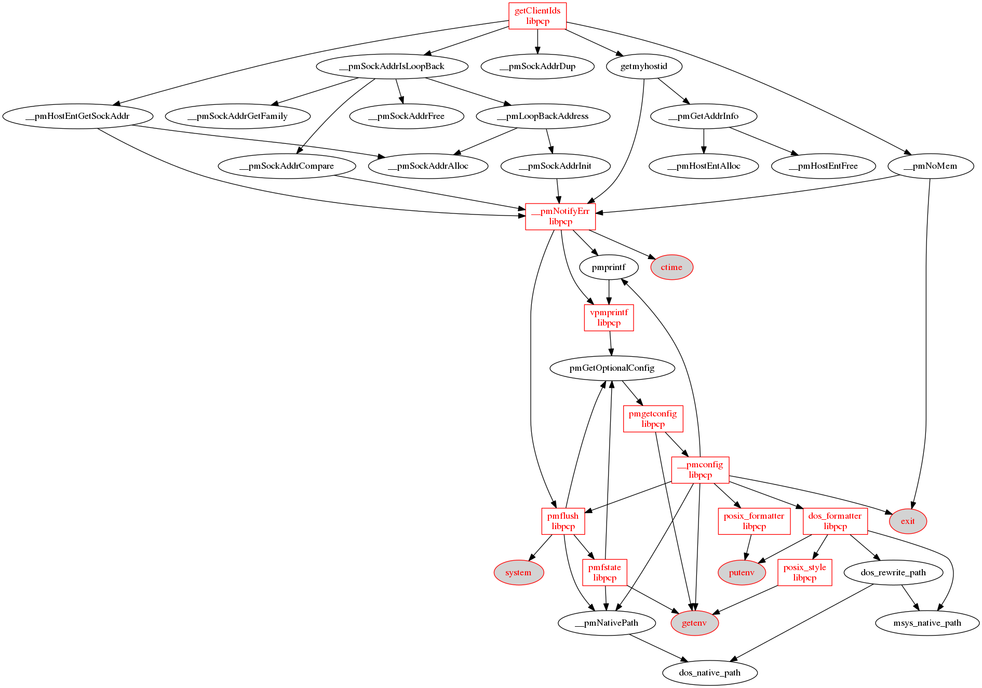
Which lead to a refinement of the call graph generator to stop the recursive descent below designated routines. This produces the easier to understand graph below, where the __pmNotifyErr node is shown in green marked with an asterix to indicate there is more of the call graph below here (presumably on another page!).
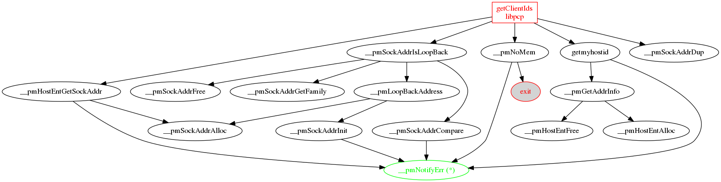

Service Discovery
There are some local mutexes in probe.c, but of more concern are the calls back into other parts of libpcp with potential lock conflicts as the partial call graph below shows (good luck with this!):
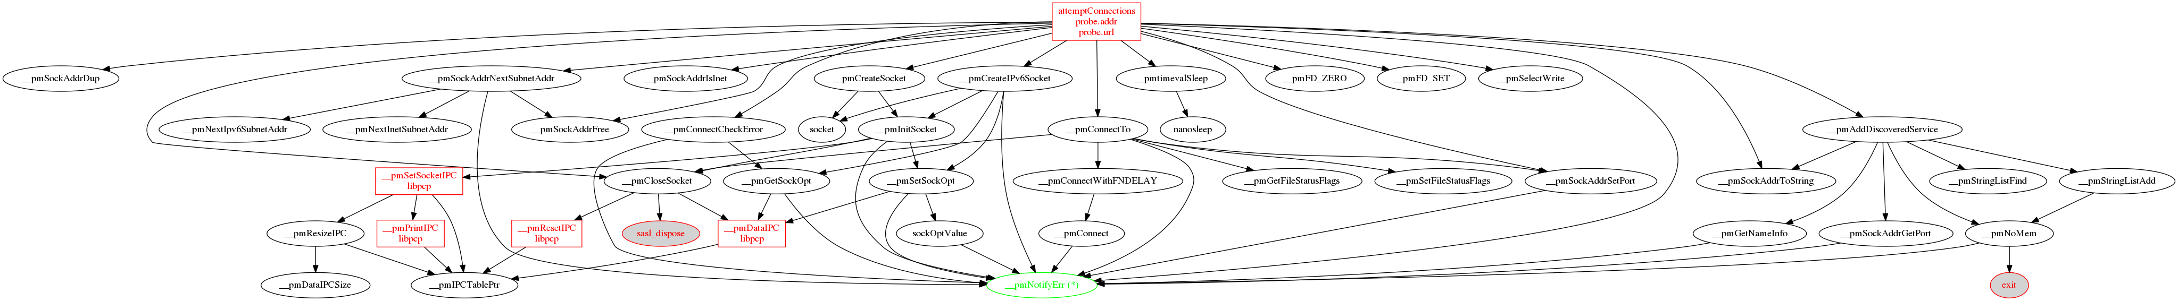

Debugging
If the macro PM_MULTI_THREAD_DEBUG is defined, then some additional functionality is enabled in libpcp by augmenting the wrappers PM_LOCK() and PM_UNLOCK(). This is done when libpcp_fault is built (see src/libpcp_fault).
The pmDebug flags LOCK and APPL0, APPL1 and APPL2 may be used to control reporting of lock/unlock operations against the __pmLock_libpcp (APPL0), c_lock (APPL1) and all other (APPL2) mutexes respectively. Setting LOCK and none of the APPL? flags for pmDebug will report all lock/unlock operations. Each time a mutex is locked or unlocked the source file context in libpcp, the mutex, the operation and the top of the call stack are reported.
For example:
$ export PCP_DERIVED_CONFIG=
$ export LD_PRELOAD=./libpcp_fault.so pminfo -Dlock,appl2 -m sample.bin
derive.c:2090 lock(derived_metric)
backtrace:
./libpcp_fault.so(+0x53645) [0x7f4050819645]
./libpcp_fault.so(__pmLock+0xb2) [0x7f4050819982]
./libpcp_fault.so(+0x4ea1f) [0x7f4050814a1f]
./libpcp_fault.so(pmNewContext+0x8c2) [0x7f40507dbc1c]
pminfo() [0x401a7d]
/lib/x86_64-linux-gnu/libc.so.6(__libc_start_main+0xf0) [0x7f4050198830]
pminfo() [0x401d59]
derive.c:1519 lock(derived_metric) [count=1]
backtrace:
./libpcp_fault.so(+0x53645) [0x7f4050819645]
./libpcp_fault.so(__pmLock+0xb2) [0x7f4050819982]
./libpcp_fault.so(+0x4cdec) [0x7f4050812dec]
./libpcp_fault.so(__pmRegisterAnon+0x1a4) [0x7f405081353b]
./libpcp_fault.so(+0x49b30) [0x7f405080fb30]
./libpcp_fault.so(+0x4ea24) [0x7f4050814a24]
./libpcp_fault.so(pmNewContext+0x8c2) [0x7f40507dbc1c]
pminfo() [0x401a7d]
/lib/x86_64-linux-gnu/libc.so.6(__libc_start_main+0xf0) [0x7f4050198830]
pminfo() [0x401d59]
derive.c:1572 unlock(derived_metric) [count=2]
backtrace:
./libpcp_fault.so(+0x53645) [0x7f4050819645]
./libpcp_fault.so(__pmUnlock+0xb2) [0x7f4050819a42]
./libpcp_fault.so(+0x4d154) [0x7f4050813154]
./libpcp_fault.so(__pmRegisterAnon+0x1a4) [0x7f405081353b]
./libpcp_fault.so(+0x49b30) [0x7f405080fb30]
./libpcp_fault.so(+0x4ea24) [0x7f4050814a24]
./libpcp_fault.so(pmNewContext+0x8c2) [0x7f40507dbc1c]
pminfo() [0x401a7d]
/lib/x86_64-linux-gnu/libc.so.6(__libc_start_main+0xf0) [0x7f4050198830]
pminfo() [0x401d59]
...
pmns.c:2618 lock(ctx 0 ipc channel)
backtrace:
./libpcp_fault.so(+0x53645) [0x7f4050819645]
./libpcp_fault.so(__pmLock+0xb2) [0x7f4050819982]
./libpcp_fault.so(+0x23212) [0x7f40507e9212]
pminfo() [0x4019b3]
/lib/x86_64-linux-gnu/libc.so.6(__libc_start_main+0xf0) [0x7f4050198830]
pminfo() [0x401d59]
pmns.c:2635 unlock(ctx 0 ipc channel)
backtrace:
./libpcp_fault.so(+0x53645) [0x7f4050819645]
./libpcp_fault.so(__pmUnlock+0xb2) [0x7f4050819a42]
./libpcp_fault.so(+0x2327c) [0x7f40507e927c]
pminfo() [0x4019b3]
/lib/x86_64-linux-gnu/libc.so.6(__libc_start_main+0xf0) [0x7f4050198830]
pminfo() [0x401d59]
…

Potential Deadlock Issues
Given the number of locks in play and the complicated call-graph structure, we have the potential for creating deadlock scenarios either in the base code today, or as the result of some subsequent changes to libpcp.
The use of each mutex falls into three basic groups:
- There is no other lock obtained between the PM_LOCK() and the PM_UNLOCK().
- Between the PM_LOCK() and the PM_UNLOCK() the same lock is re-obtained later and that lock is recursive. It would be nice to reduce the number of cases where this happens as a step towards making the lock not recursive which would help long-term (better tools for diagnosis, more confidence in correctness).
- Between the PM_LOCK() and the PM_UNLOCK() a different lock is obtained later. This introduces a lock ordering between the first lock and the subsequent lock. We need to document and enforce the correct hierarchy for these, to ensure there is no lock ordering inversion.
The (a) and (b) groups are entirely safe. The (c) group requires detailed and careful analysis. But even the (b) group can be painful in the extreme.

TODO
Complete the tables below.

The following mutex uses are in group (a).
Routine | Source File | Mutex | Use
AFinit | AF.c | __pmLock_libpcp | guard global data on Windows platforms

The following mutex uses are in group (b).
Routine | Source File | Mutex | Subsequent Locks
getClientIds | access.c | __pmLock_libpcp | __pmLock_libpcp, all at or below __pmNotifyErr(), vpmprintf(), pmflush(), pmfstate(), pmgetconfig() and __pmconfig().

The following mutex uses are in group (c).
Routine | Source File | Mutex | Subsequent Locks

If the PCP code was not fast enough to get all of its work done in a single thread context then PCP was likely to be a measurable contributor to system load, and perceived as part of the problem rather than part of the solution for system performance analysis.

