**Secant method**

**201710793 박진홍**

1. **What is Secant Method?**

* Secant Method is one of the root finding algorithm.

1. **설명**

* Secant Method uses a succession of roots of secant lines to better approximate a root of a function. It is very similar to Newton’s Method, and even can be thought of as a finite difference approximation of Newton’s Method.

Using not derivative but two point of function is the difference from Newton’s Method. Next is the formula of Secant Method.

* 

1. **Pseudo Code**

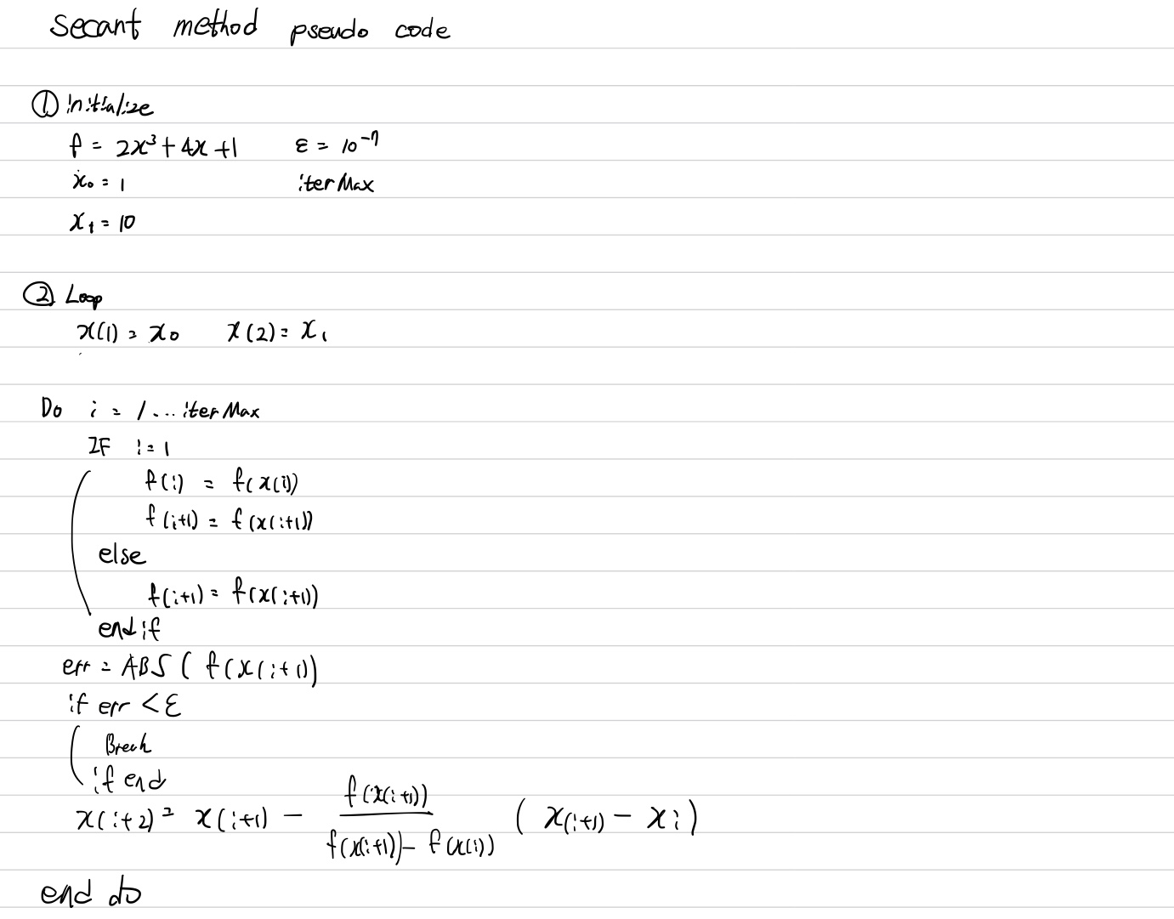

1. **Code (Fortran)**

|  |
| --- |
| **MAIN** |
| PROGRAM SECANT_MAIN  !--------------------------------------------------------------------------------------------------------------------  IMPLICIT NONE  !--------------------------------------------------------------------------------------------------------------------  INTEGER :: Kp, ITERMAX  INTEGER :: NFile_Out  !  DOUBLE PRECISION :: XX(100000)  DOUBLE PRECISION :: FF(100000)  DOUBLE PRECISION :: FFD(100000)  DOUBLE PRECISION :: E  DOUBLE PRECISION :: error  DOUBLE PRECISION :: X0  DOUBLE PRECISION :: X1  !--------------------------------------------------------------------------------------------------------------------  X0 = 1  X1 = 10  E = 10E-7  ITERMAX = 10000  NFile_Out = 1000  OPEN(NFile_Out, FILE = 'OUT_NR.m')  WRITE(NFile_Out,*) ' result = ['  XX(1) = X0  XX(2) = X1  DO Kp=1,ITERMAX  IF (Kp==1) THEN  CALL function_SECANT(XX(Kp),FF(Kp))  CALL function_SECANT(XX(Kp+1),FF(Kp+1))  ELSE  CALL function_SECANT(XX(Kp+1),FF(Kp+1))  END IF  error = ABS(FF(Kp+1))  IF (error < E) THEN  EXIT;  END IF    WRITE(NFIle_Out, 106) Kp, XX(Kp), FF(Kp), error  XX(Kp+2) = XX(Kp+1)-(FF(Kp+1)/(FF(Kp+1)-FF(Kp)))*(XX(Kp+1)-XX(Kp))  END DO  WRITE(NFile_Out,*) '];'  106 FORMAT(2X, I8, 100(5X, E16.8))  !--------------------------------------------------------------------------------------------------------------------  END PROGRAM SECANT_MAIN |
| **FUNCTION** |
| SUBROUTINE function_SECANT(XX, FF)  !------------------------------------------------------------------------------------------  IMPLICIT NONE  !------------------------------------------------------------------------------------------  DOUBLE PRECISION :: XX, FF  !------------------------------------------------------------------------------------------  FF = 2*XX**3 + 4*XX + 1  RETURN  END |