**INSTRUCTIONS for R-Cormas**

# Under Windows, open R as super-user (administrator) :

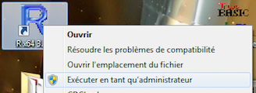

# Install the following Packages: httr and xml2

> install.packages('httr')

--- « Please, select a CRAN miror for this session » ---

R will ask you to select a miror site for download (ex : Colombie (Cali)).

> install.packages('xml2')

Proceed in the same way for ggplot2, dplyr and tidyr (for viewing graphics).

**Configure the folder where the cormas scripts are located**

Normally, the files (cormas-func.R et r-cormas-example.R) are into vw7.6nc/cormas/R-Cormas/

> setwd('C:\\Users\\Pierre BOMMEL\\Google Drive\\vw7.6nc\\cormas\\R-Cormas')

(Warning: under Windows you must double the \\)

# Execute the file

> source("cormas-func.R")

(Load the source code into R)

# Running a Cormas simulation

**In VW, open a server:**

Integrated: Menu ‘simulation’ 🡪 ‘Analysis’ 🡪 ‘Cormas <-> R’ 🡪 ‘Start WebService for R’

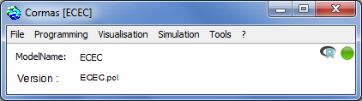

Or, manually:

CormasWSServer new inspect , then start (or CormasWSServer start)

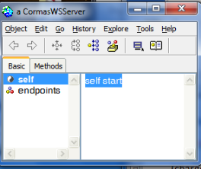

**Then, from R:**

Setting the IP address. By default, it is *LocalHost*. For a remote machine, type:

> ADDRESS <- "172.16.22.11"

Then use the following commands:

> r <- openCormas()

> r <- openModel("ECEC")

> r <- setInit("fragmentedEnv")

> r <- setStep("step:")

> r <- runSimu()

2 answers:

> r[[1]]

[1] "<SOAP-ENV:Envelope xmlns:ns=\"urn:vwservices\" xmlns:SOAP-ENV=\"http://schemas.xmlsoap.org/soap/envelope/\"><SOAP-ENV:Body><ns:RunSimu> <ns:duration>100</ns:duration></ns:RunSimu></SOAP-ENV:Body> </SOAP-ENV:Envelope>"

> r[[2]]

Response [http://localhost:4920/CormasWS]

Date: 2017-03-04 11:34

Status: 500

Content-Type: text/xml;charset=utf-8

Size: 414 B

<?xml version="1.0" encoding="UTF-8"?>

Or more verbose:

> content(r[[2]],"text")

[1] "<?xml version=\"1.0\" encoding=\"UTF-8\"?>\n<SOAP-ENV:Envelope xmlns:SOAP-ENV=\"http://schemas.xmlsoap.org/soap/envelope/\" xmlns:ns=\"urn:vwservices\"><SOAP-ENV:Body><ns:LoadModelFromParcelNameResponse><ns:result>true</ns:result></ns:LoadModelFromParcelNameResponse></SOAP-ENV:Body></SOAP-ENV:Envelope>"