CONTROLPLANE

Explainable Authorization
A user experience and runtime proposal
Draft v0.1 | 7 November 2026

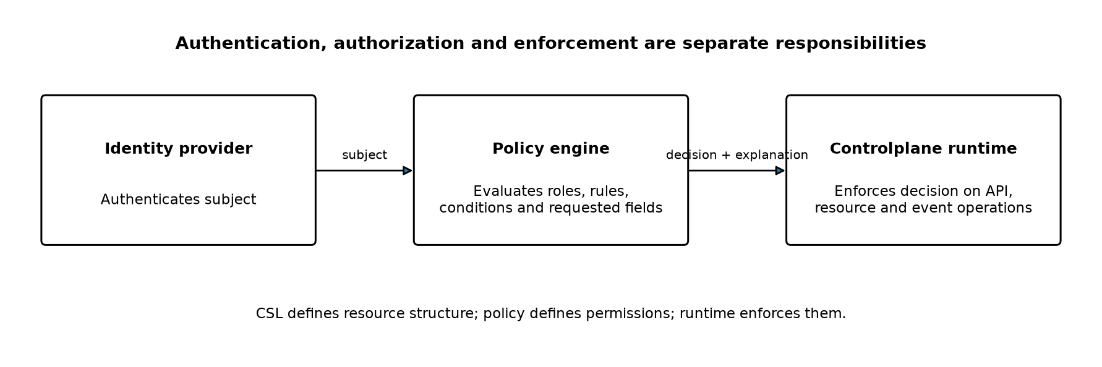
Figure 1. Separation of authentication, policy evaluation and runtime enforcement.

1. Executive summary
Authorization is not only a policy-evaluation problem. It is also an administration and comprehension problem. Operators must be able to understand who can access a resource, what they can do, why they can do it, and what will change when a policy or role assignment is modified.
Controlplane should treat explainability as a first-class authorization requirement. Policy definitions remain declarative and machine-evaluable, while the product presents their effective consequences through visual exploration, decision explanations, audits and simulations.
This proposal takes inspiration from Infisical's visual access-management concepts, particularly its Access Tree and permission-audit approach. It does not propose copying Infisical's resource hierarchy or authorization model. Controlplane's experience should be resource-centric, identity-centric and capable of explaining individual decisions.

2. Goals
- Answer who can access a particular resource and what operations they can perform.
- Answer what resources and operations are available to a particular user, group or service identity.
- Explain why a specific request is allowed or denied, including role assignments and evaluated conditions.
- Preview the impact of policy and role changes before activating them.
- Apply the same authorization semantics to API operations, partial updates, list results and event/watch delivery.
- Avoid requiring administrators to read policy source code to understand effective access.

3. Separation of responsibilities
The authorization architecture should keep authentication, policy evaluation and enforcement distinct. CSL defines resource structure and validation. Policy defines permissions and conditions. The identity provider establishes the authenticated subject. The policy engine evaluates the request, and the Controlplane runtime enforces the result.
Figure 2. The same structured decision can power API enforcement and administrator-facing explanations.
Concern | Responsibility
CSL | Defines resource kinds, fields, types, desired state and observed state.
Authentication | Establishes the subject and trusted identity attributes.
Policy | Defines which subjects may perform which operations, subject to conditions.
Policy engine | Evaluates a request and produces a decision with an explanation trace.
Runtime | Enforces the decision on resource APIs, partial updates, lists and event streams.
Administration UI | Explains effective permissions, decision reasons and policy-change impact.

4. Core user experiences

4.1 Access Explorer — resource-centric view
An administrator opens a resource and selects its Access view. The view lists identities with effective access to that resource, including users, groups, roles and service identities. Permissions should be summarized in human-readable terms and grouped by resource section or operation.
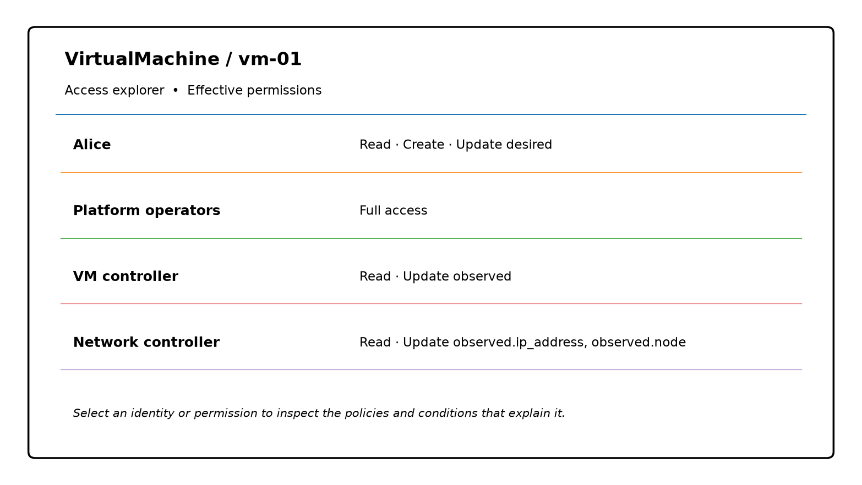
Figure 3. Illustrative Access Explorer for a VirtualMachine resource.
The resource-centric view should answer:
- Which users, groups and service identities can access this resource?
- Can they read, create, update, delete, list or watch it?
- Can they update desired state, observed state, or particular fields?
- Are permissions conditional, for example limited to a tenant?
- Which role assignments and policy rules are responsible?

4.2 Identity Explorer — identity-centric view
An administrator selects a user, group or service identity and sees its effective access across resource kinds and, where practical, individual resources. The view should make inherited access through group membership and role assignment visible rather than flattening it into an unexplained permission list.
Identity | Example effective access
Alice | VirtualMachine: read, create, update desired; Database: read, list
Platform operators | Full access to selected platform resource kinds
VM controller | VirtualMachine: read, watch, update observed
Network controller | VirtualMachine: read, watch, update selected observed fields

The identity-centric view should also show important exclusions, such as operations that are not granted, and distinguish 'not granted' from an explicit denial where the policy model supports explicit deny.

4.3 Explain Access — decision trace
Every authorization decision should be explainable. Selecting a permission or a denied request should show the path from authenticated identity to group membership, role assignment, matching policy rule and evaluated conditions. The explanation should identify the policy version used.
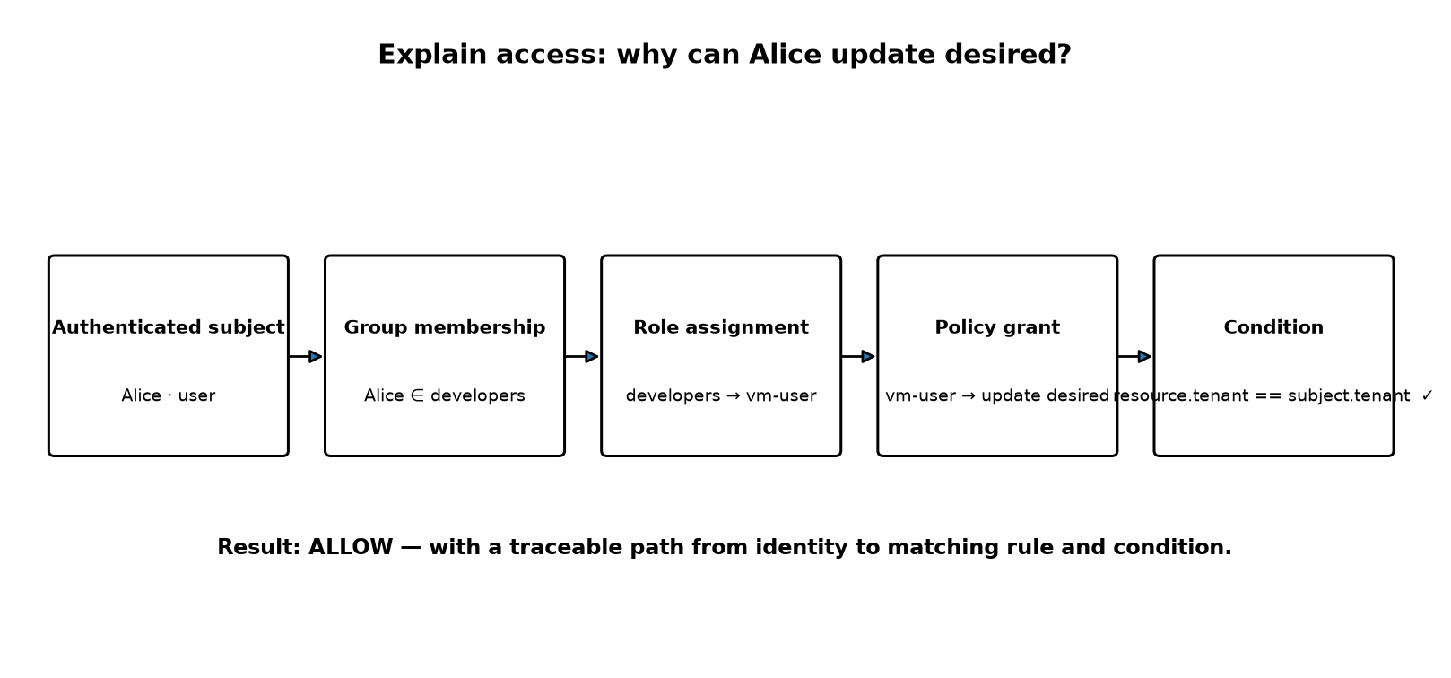
Figure 4. Illustrative explanation trace for an allowed update.
A decision explanation should include:
- Allow or deny result.
- Authenticated subject and relevant trusted attributes.
- Resource kind and identifier.
- Requested operation and exact fields being changed.
- Matching policy rules and applicable role/group assignments.
- Conditions evaluated, their outcomes and relevant values where safe to disclose.
- Explicit denial or override, if applicable.
- Policy revision or snapshot used for the decision.

4.4 Policy Simulator — change impact
Before activating a policy change, an administrator should be able to preview its consequences. The simulator should compare current and proposed effective access using the actual policy evaluator and a defined snapshot of identities, role assignments and resources. It should not rely on rough estimates based only on role names.
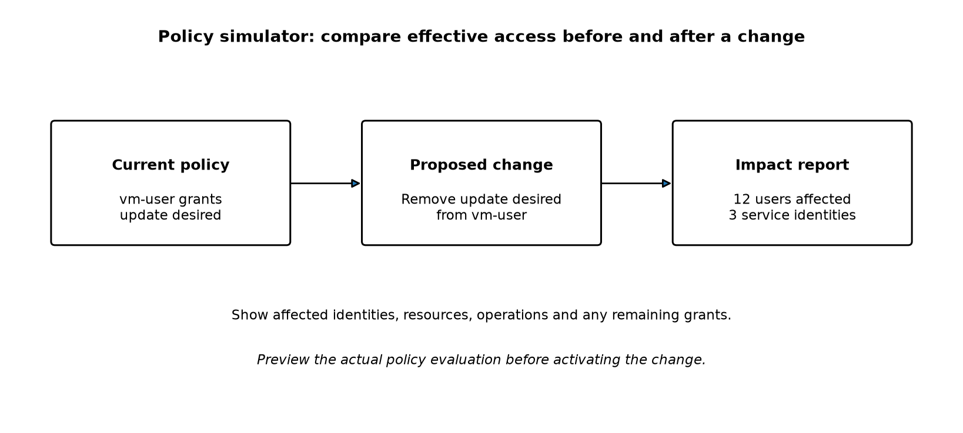
Figure 5. Illustrative policy-change simulation.
An impact report should identify:
- Identities that gain or lose permissions.
- Resources affected.
- Operations and fields affected.
- Whether access remains through another role or policy.
- Changes to tenant or attribute-based restrictions.
- Potentially disruptive effects on controllers and integrations.

5. Structured authorization decision
The policy engine should return a structured decision rather than a bare Boolean. This is a key architectural requirement: the UI should explain the same decision that the runtime enforces, not independently reconstruct authorization logic.
{
"decision": "allow",
"subject": {
"id": "user:alice",
"type": "user"
},
"resource": {
"uid": "runtime-generated-uid",
"kind": "VirtualMachine"
},
"operation": "update",
"fields": ["desired.cpu"],
"policy_revision": "policy-revision-42",
"matched_rules": [
{
"role": "vm-user",
"permission": "update desired",
"condition": {
"expression": "resource.tenant == subject.tenant",
"result": true
}
}
],
"reason": "A matching role grants the requested update and its tenant condition is satisfied."
}
This is an illustrative response shape, not a finalized API contract. The implementation should distinguish information safe for the requesting subject from richer diagnostic details visible only to authorized administrators.

6. Partial updates and authorization
Controlplane supports partial updates. Authorization must therefore apply to the exact set of fields changed, not merely to the resource as a whole. A caller permitted to update desired.cpu must not gain permission to modify observed.ready by including it in the same patch.
- Determine the exact changed-field set, including explicit removals.
- Authorize every changed field or section.
- Evaluate conditions against the existing resource and the proposed resulting state as appropriate.
- Validate the complete candidate resource against its CSL schema.
- Commit atomically only if authorization and validation both succeed.

7. List, watch and event visibility
Authorization must apply beyond direct get and update operations. List results, pagination metadata, counts, watch subscriptions and subsequent event delivery can all disclose resource information. The runtime must filter or reject unauthorized access consistently and avoid leaking unauthorized resource existence through side channels.

8. Auditability
Controlplane should record policy changes, role assignments and relevant authorization decisions. Audit records should identify the subject, operation, resource, decision, policy revision and timestamp. Sensitive attribute values should not be copied into logs unnecessarily.
Administrators should be able to move from an audit event to its explanation and the policy revision that produced the decision, subject to their own permissions.

9. Product requirements
Capability | Minimum requirement
Access Explorer | Show effective access to a selected resource, with identity and permission provenance.
Identity Explorer | Show effective access for a selected user, group or service identity.
Explain Access | Explain a specific allow/deny decision and its matching rules and conditions.
Policy Simulator | Compare effective access before and after a proposed policy change.
Audit | Record policy and assignment changes and link decisions to policy revisions.
Consistency | Use the same evaluator and decision semantics for enforcement and explanation.

10. Security and correctness requirements
- Fail closed when policy evaluation fails or required trusted attributes are unavailable.
- Use trusted identity attributes; do not accept authorization attributes directly from untrusted clients.
- Ensure policy explanations do not disclose secrets or protected attributes to unauthorized viewers.
- Apply authorization consistently to API operations, partial updates, list operations and event delivery.
- Make policy evaluation deterministic and bounded.
- Use a consistent policy snapshot for each operation.
- Prevent time-of-check/time-of-use gaps between authorization, validation and commit.
- Ensure simulations clearly identify the snapshot and assumptions used.

11. Relationship to the Policy Language proposal
The proposed Controlplane Policy Language remains separate from CSL. It can express role grants such as 'read', 'create', 'update desired' and 'update observed', with conditions such as tenant equality. This document adds requirements for how those policies are explored, explained, audited and simulated.
The policy syntax and the choice of policy engine are still open design decisions. An adapter-based architecture could preserve a Controlplane-facing policy model while allowing evaluation through an established engine such as OPA or Cedar, subject to a separate technical evaluation.

12. Open design questions
- Should policy composition use additive grants with explicit deny precedence, or another deterministic model?
- Should field-level read restrictions be part of the first implementation?
- How should role and group assignments be represented and managed?
- Which policy engine best supports the required decision explanations and simulation?
- What is the exact boundary between administrator diagnostics and information safe to reveal to an ordinary caller?
- How should simulations handle very large resource populations and dynamic identity attributes?

13. Recommendation
Make explainable authorization a first-class Controlplane capability. Build the authorization engine and runtime around structured, traceable decisions, then use those decisions to power Access Explorer, Identity Explorer, Explain Access, audit views and Policy Simulator. The guiding product principle is:
No administrator should need to read policy source code to understand who has access to a resource or why.

Reference and inspiration
Infisical is an inspiration for visual access management, including its Access Tree and permission-audit concepts. This proposal adapts the general usability ideas to Controlplane's resource-oriented model; it is not a claim that Infisical implements the exact features or semantics proposed here.
Further reading: Infisical documentation on RBAC, Access Tree and permission auditing.

