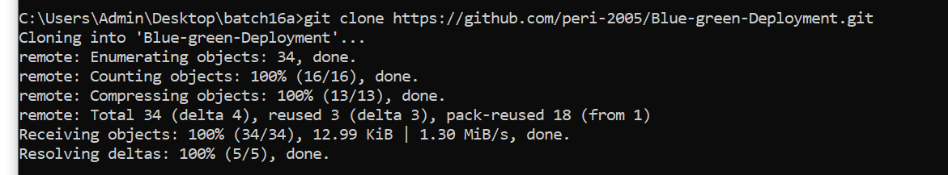

Forked the Repository and cloned it to local
In this skill test, you will demonstrate your ability to deploy, containerize, and manage a Node.js application with blue-green deployment capabilities using Docker and Kubernetes (Minikube).
The application consists of:
- A backend Express server with MongoDB integration
- Two frontend implementations (Basic and Enhanced)
- Blue-green deployment infrastructure

Prerequisites
- Git
- Node.js and npm
- Docker
- Minikube with kubectl
- MongoDB (local installation or container)

Instructions
The code for a blue-green deployment application has been provided to you. Your task is to:
- Get the application running locally
- Containerize all components
- Deploy the application to a Minikube cluster
- Implement blue-green deployment functionality in Kubernetes
- Document your process and implementation decisions

Tasks and Marking Scheme

Part 1: Local Deployment (10 marks)
- Clone the repository and set up the environment
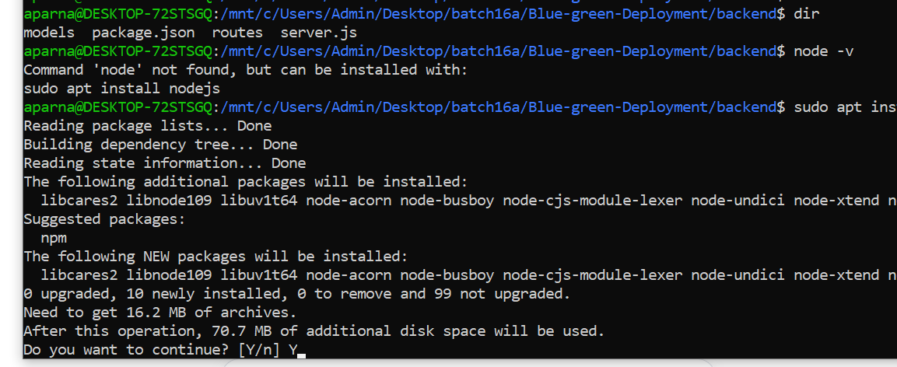
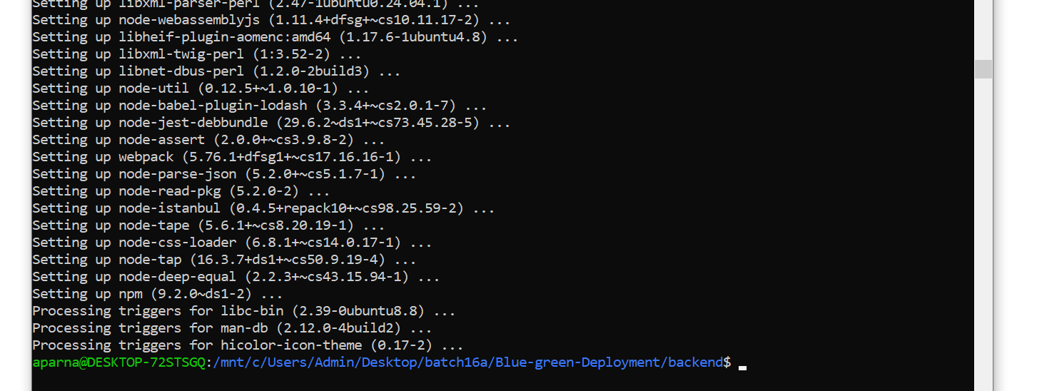

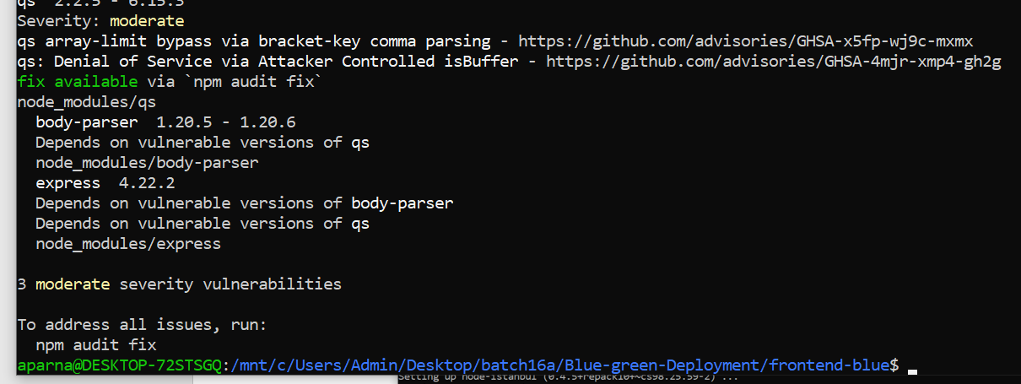
- Install dependencies for the backend and both frontends
- Configure MongoDB connection
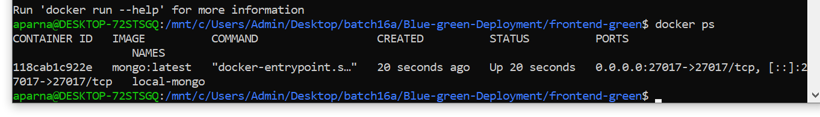
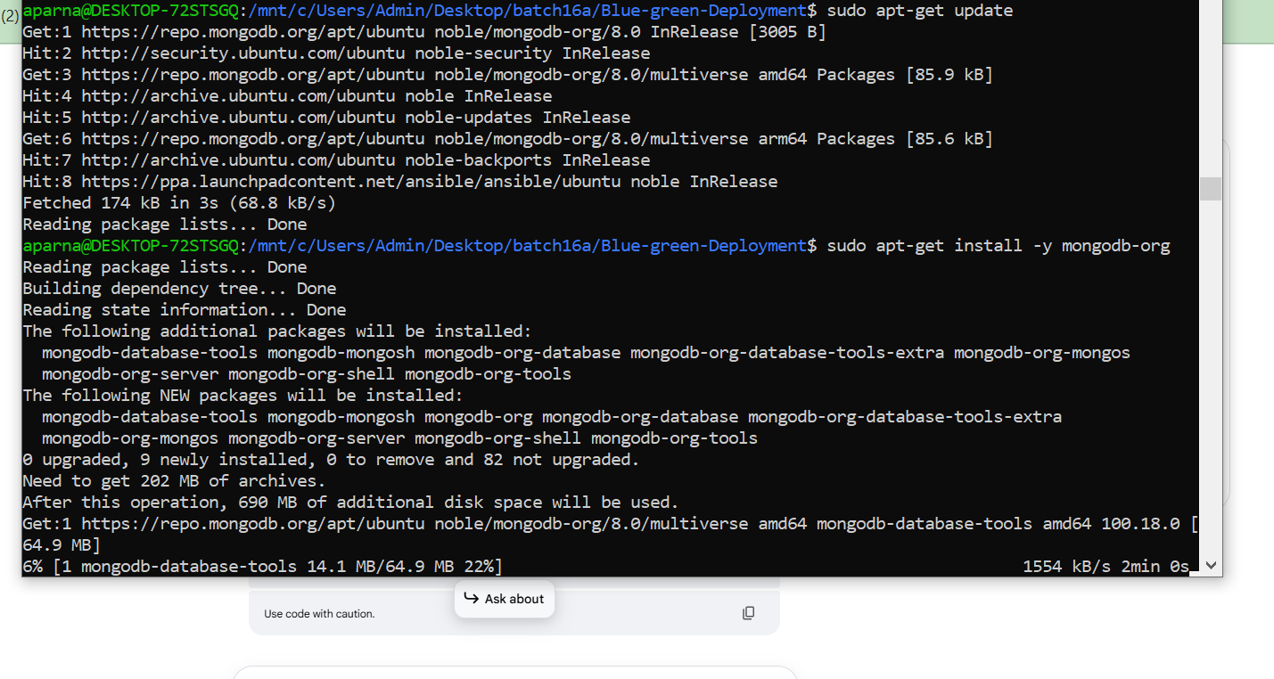

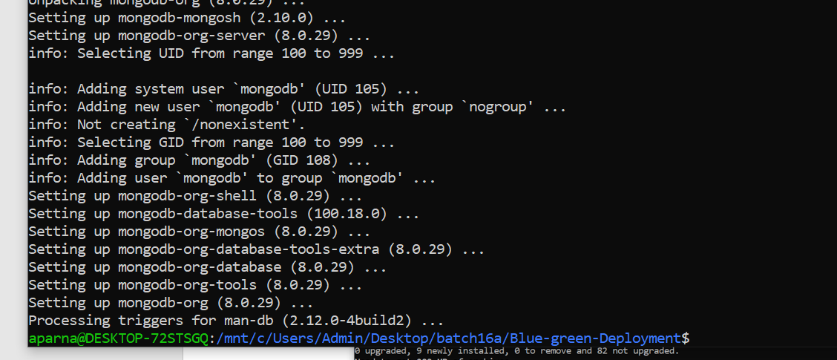

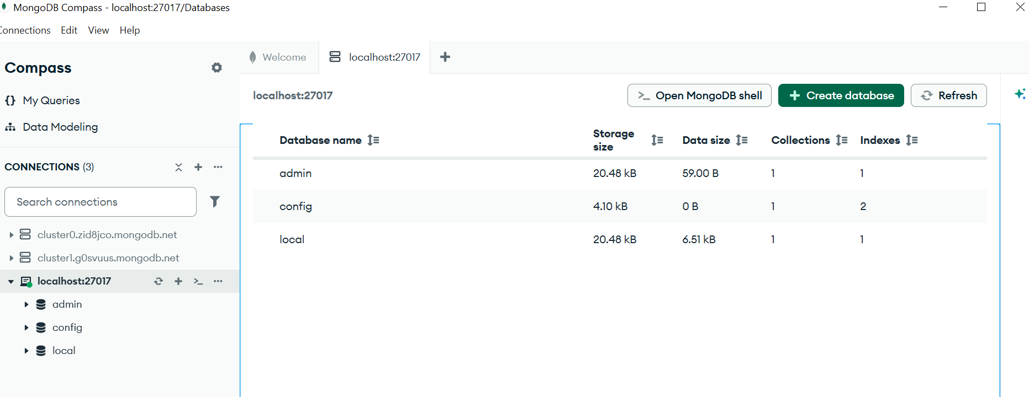

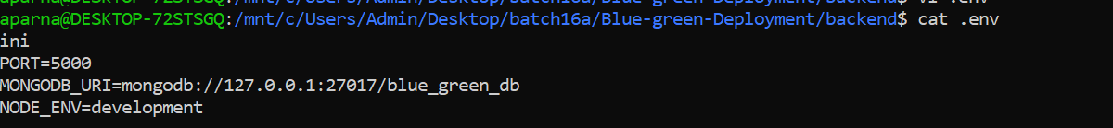
- Start all services and demonstrate that they are working correctly

  - Backend server running and responding to health checks
  - Both frontends accessible and able to register users
  - Data successfully stored in MongoDB

Part 2: Containerization (15 marks)
- Create a Dockerfile for the backend service
- Create Dockerfiles for both frontend services
- Create a docker-compose.yml file that runs all services together
- Build and run the containers locally to verify functionality

Part 3: Kubernetes Deployment (15 marks)
- Create Kubernetes deployment manifests for all services
- Create Service resources for the applications
- Deploy the application to Minikube
- Configure proper health checks and readiness probes
- Verify that all components are working correctly in the cluster

Part 4: Blue-Green Deployment Implementation (10 marks)
- Create two separate deployments for the basic and enhanced frontends
- Implement a service that can switch between the two frontend versions
- Demonstrate a successful blue-green deployment switch
- Explain your blue-green deployment strategy in your documentation

Submission Requirements
Submit the following items:
- All Dockerfiles and Kubernetes manifest files
- docker-compose.yml file
- A README.md documenting:
  - Your setup and deployment process
  - Any challenges faced and how you overcame them
  - Your blue-green deployment strategy and implementation
  - Commands used for switching between blue and green deployments
- Screenshots showing:
  - Local deployment working
  - Docker containers running
  - Kubernetes pods and services running in Minikube
  - Blue-green deployment switch in action

