Docker installation:
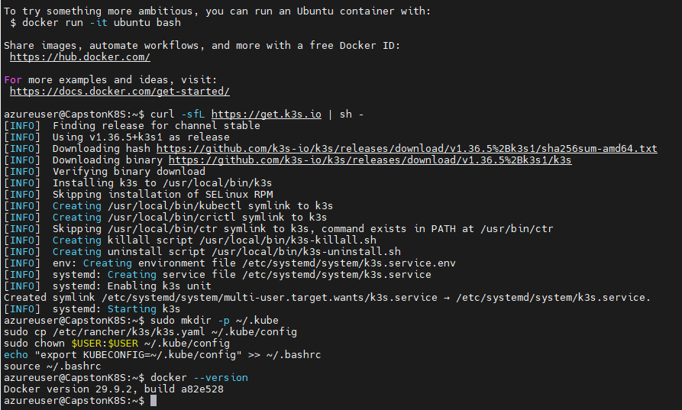
Cluster installed:
Helm Installed:
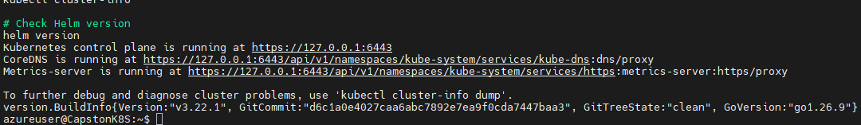
kubectl get pods -n monitoring
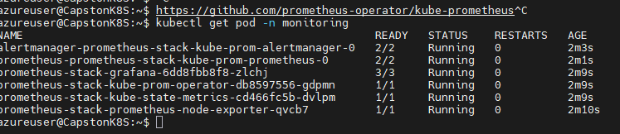
Grafana Dashboard:

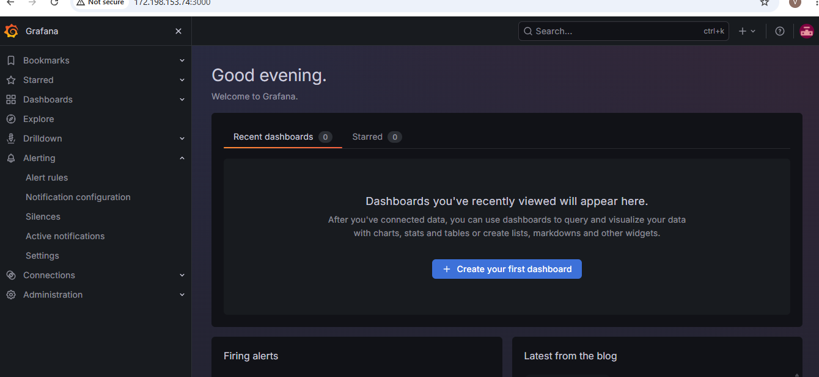

Added the data source:
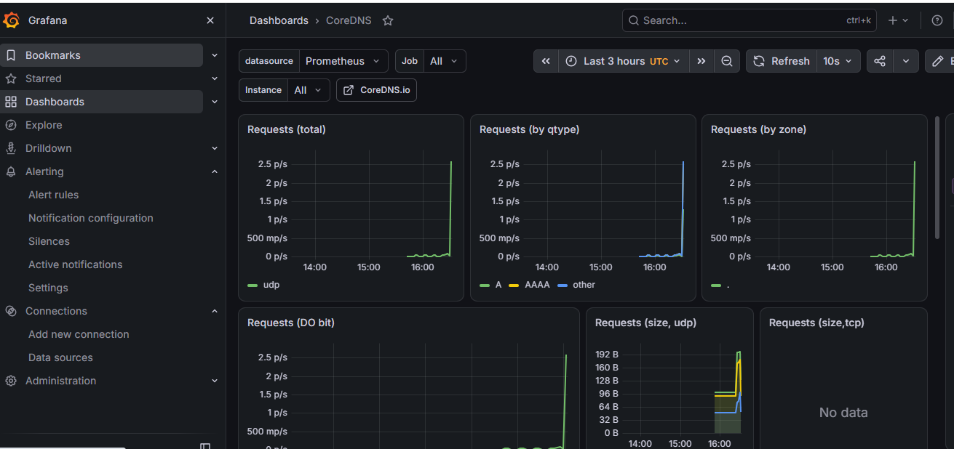
Building the Go Self-Healing Agent:
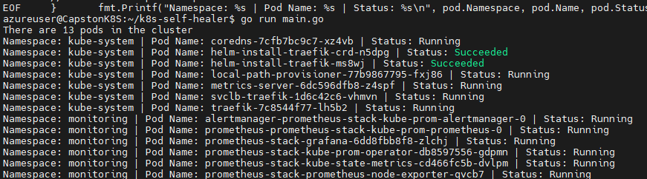

Build the Docker image:
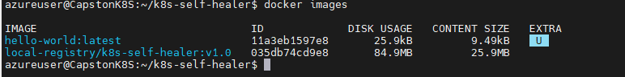

Self-healing agent logs:
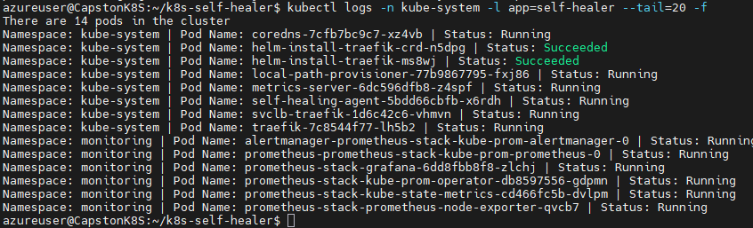
Self-Healing Agent started. Monitoring cluster pods...
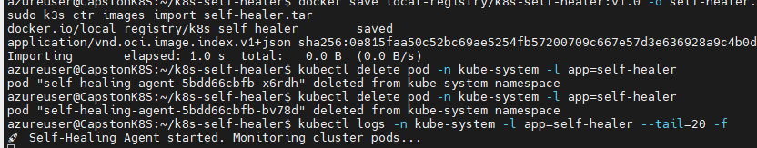

ssh -L 3000:localhost:3000 azureuser@http://172.198.153.74
http://172.198.153.74:3000
Self-Healing Agent Observations. Monitoring cluster pods...
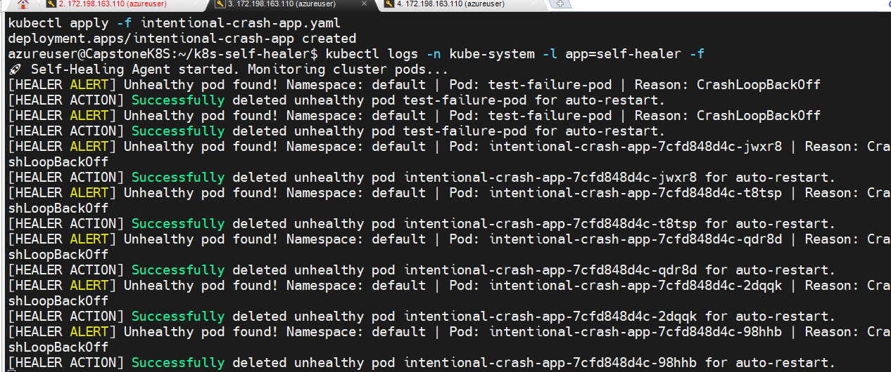
Alertmanager dashboard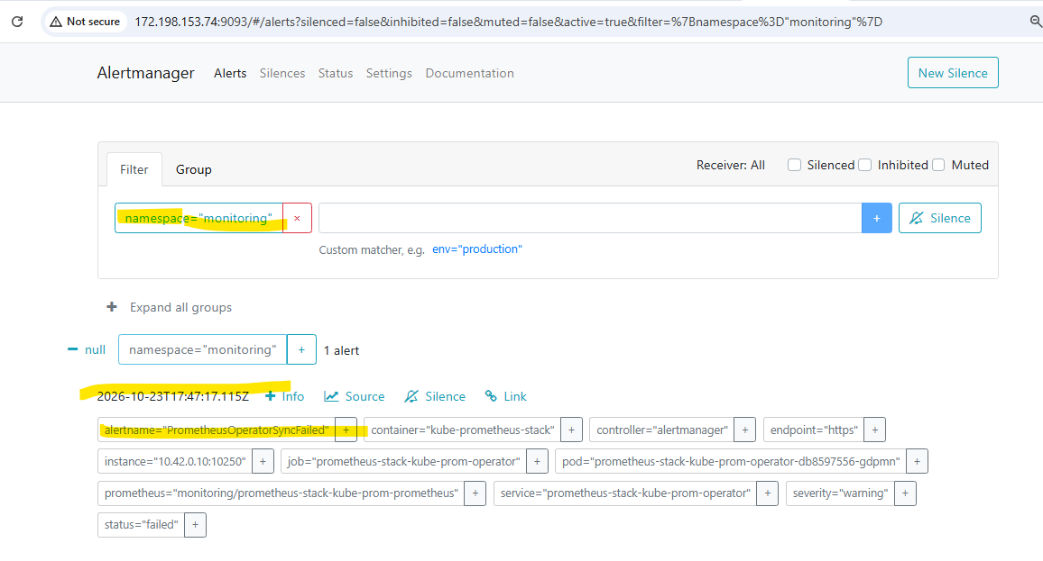

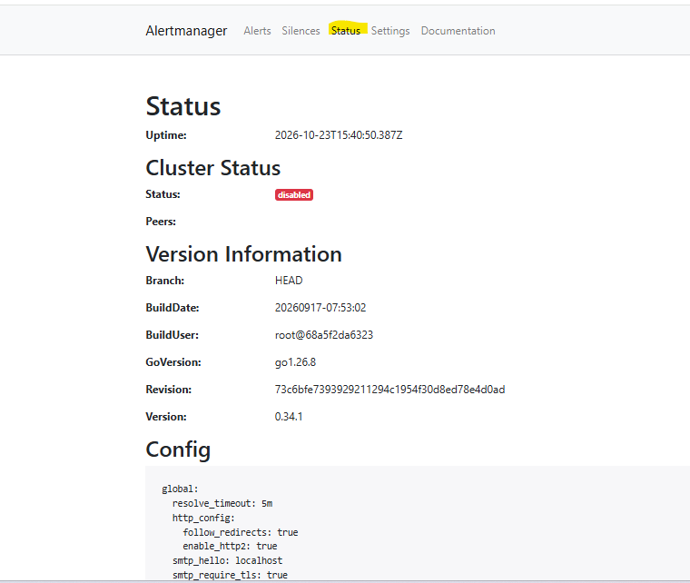

- Self-Healing Agent Active: The Go-based self-healing agent is running in kube-system, actively monitoring and auto-recovering failed/crashing pods in the Azure k3s cluster.
- Full Stack Visibility:
  - Grafana: Exposed and accessible at [http://172.198.153.74:30384](http://172.198.153.74:30384) for live cluster and pod metrics visualization.
  - Alertmanager: Exposed and accessible at [http://172.198.153.74:9093](http://172.198.153.74:9093), actively capturing firing alerts.
- Alert Routing Status: The current Alertmanager configuration is set to a default "null" receiver, meaning alerts are captured internally but require a valid Slack Webhook URL in alertmanager-config.yaml to trigger external notifications.

🎯 Conclusion
- Self-Healing Capable: Your k3s cluster is now fully capable of detecting pod crashes and triggering automated remediation without manual intervention.
- End-to-End Monitoring: The full monitoring stack (Prometheus, Grafana, Alertmanager) is deployed and verified on Azure.
- Final Action Needed: Update alertmanager-config.yaml with your Slack Webhook URL and apply the Helm upgrade to enable live Slack notification
Testing the Self-Healing System
