VALUE ADDED COURSE PROJECT REPORT
AI-Powered Daily Routine Redesign
An energy-aware, machine-learning approach to scheduling a student's day
Submitted by
Periyannan Ratish N
B.Tech - Artificial Intelligence & Data Science (III Year)
Dhanalakshmi College of Engineering
October 2026

Abstract
Most students and professionals plan their day by habit rather than by evidence. Deep, demanding work is pushed into low-energy hours, meals and sleep drift, exercise is skipped, and screen time fills the gaps. This project presents an AI-powered system that redesigns a person's daily routine. The user supplies their tasks, durations, fixed commitments and sleep habits. The system then (i) models the person's circadian energy curve, (ii) rebuilds the schedule with a constraint-based optimizer that places deep-focus work in energy peaks, protects sleep, and inserts meals, exercise and breaks, and (iii) evaluates the old and new routine with two Gradient Boosting models that predict a Productivity score and a Wellbeing score.
On a representative engineering-student day, the redesign raised predicted productivity from 58.2 to 67.3 (out of 100) and predicted wellbeing from 50.9 to 64.0, while lifting the share of focus work done in high-energy windows from 37% to 58%. The prediction models reach R² of 0.76 (productivity) and 0.75 (wellbeing) on held-out data. The system is delivered as a Python library and an interactive Streamlit application.
Keywords: daily routine optimization, circadian rhythm, time-blocking, gradient boosting, constraint-based scheduling, productivity, wellbeing.

1. Introduction
Time is the one resource every student gets in equal amounts, yet outcomes differ widely depending on how the day is arranged. Research on sleep and cognition consistently shows that attention, memory and mood vary across the day and degrade sharply with insufficient or irregular sleep. Productivity methods such as time-blocking, the Pomodoro Technique and deep-work scheduling help, but they are generic: they do not account for an individual's energy pattern, their fixed timetable, or the trade-offs between study, health and rest.
Artificial intelligence can close this gap. A model can learn how routine features such as sleep duration, exercise, breaks and the timing of focus work relate to how productive and well a person feels, and an optimizer can then search for a better arrangement of the same tasks. This project builds such a system end to end.

1.1 Problem statement
Given a set of daily tasks with durations, priorities, concentration requirements and some fixed commitments, together with a person's chronotype and sleep habits, produce a feasible schedule that increases predicted productivity and wellbeing compared with the person's current routine, and explain why each change was made.

1.2 Objectives
- Model the person's daily energy rhythm for morning, neutral and night chronotypes.
- Train machine-learning models that predict productivity and wellbeing from routine features.
- Design a constraint-aware optimizer that rebuilds the day around energy, health essentials and priorities.
- Quantify the benefit by comparing the original and redesigned routines, including an ablation of what contributes most.
- Deliver a usable interactive application with transparent explanations.

1.3 Scope
The system plans a single day for one person. It does not integrate with calendars or wearables, and its prediction models are trained on simulated data derived from published findings (Section 4.1), so scores should be read as relative guidance, not clinical measurements.

2. Background and Related Concepts
- Circadian rhythm. Alertness follows a roughly 24-hour cycle with a late-morning peak, a post-lunch dip and a smaller early-evening peak. Chronotype shifts this curve earlier (morning types) or later (night types).
- Sleep. Consensus guidance recommends 7 to 9 hours of sleep for young adults (Hirshkowitz et al., 2015). Short or irregular sleep reduces attention and mood.
- Deep work and time-blocking. Demanding cognitive work benefits from long uninterrupted blocks placed when focus is highest (Newport, 2016).
- Breaks. Short breaks between focus sessions, as in the Pomodoro Technique (Cirillo, 2006), help sustain performance.
- Gradient boosting. An ensemble of shallow decision trees built sequentially to correct earlier errors (Friedman, 2001); effective on small tabular data and able to expose feature importances.

3. System Architecture
The system has four stages that run in sequence, each implemented as a function in the engine module and surfaced through the web interface.
Stage | Component | What it does
1 | Input layer | User enters tasks (duration, priority 1-5, focus 1-3, fixed or current start), chronotype, current and target sleep times.
2 | Energy model | Generates a 96-slot (15-minute) circadian energy curve for the chosen chronotype.
3 | Optimizer | Places tasks using constraints and energy matching; adds meals, exercise and breaks.
4 | Evaluator | Converts any schedule into 11 features and predicts Productivity and Wellbeing; produces the before/after comparison and explanations.

4. Methodology

4.1 Dataset
Real, fine-grained routine data linked to outcome scores is private and hard to collect, so a synthetic dataset of 3,000 daily logs was generated. Each log contains 11 routine features and two outcome scores. The relationships built into the generator follow widely reported findings: productivity and wellbeing peak near 8 hours of sleep and fall off on either side; study time has diminishing returns beyond roughly 8 hours; exercise, regular meals and regular sleep help; heavy screen time and frequent task switching hurt; and working in high-energy windows raises productivity. Gaussian noise was added so that the learning problem is not trivially deterministic.
Feature | Meaning
sleep_hours | Hours of sleep between bed time and wake time
sleep_consistency | Regularity of sleep schedule (0-1)
study_hours | Total hours of study and work
peak_focus_ratio | Share of focus work done when energy >= 60%
exercise_min | Minutes of exercise
screen_hours | Estimated daily screen time
break_count | Short breaks after focus blocks
meal_regularity | How evenly spaced and complete the meals are (0-1)
leisure_hours | Hours of leisure
task_switches | Number of separate activities in the day
free_buffer_min | Unscheduled minutes (slack for overruns)

4.2 Prediction models
Two Gradient Boosting regressors (scikit-learn; 250 trees, depth 3, learning rate 0.06) were trained on an 80/20 train-test split, one for Productivity and one for Wellbeing. On the held-out 20%, the Productivity model achieved R² = 0.76 with a mean absolute error of 3.1 points, and the Wellbeing model achieved R² = 0.75 with an MAE of 2.9 points. The remaining variance is the injected noise, which no model should recover.
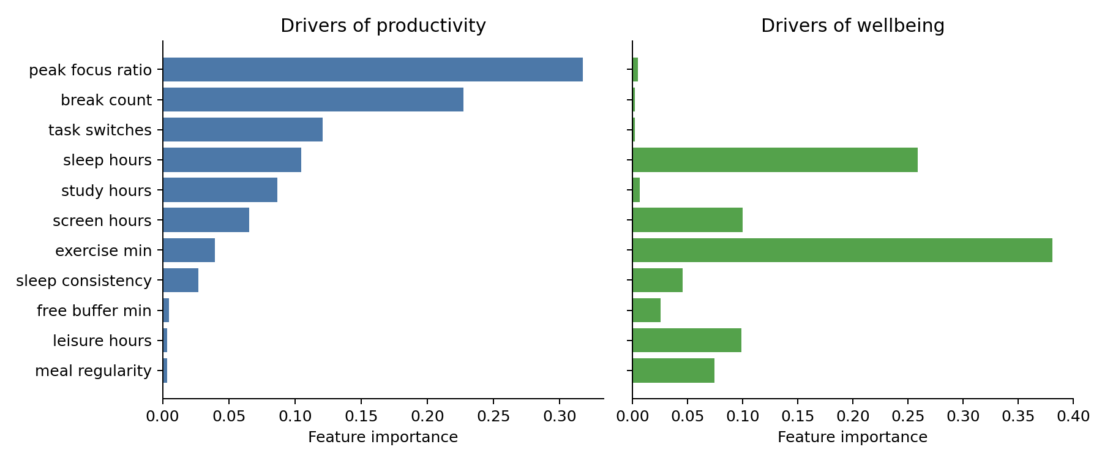
Figure 1: Feature importance of the Productivity and Wellbeing models
Figure 1 shows that productivity is driven mainly by when focus work happens and by taking breaks, while wellbeing is driven mainly by exercise and sleep duration. These are the levers the optimizer then acts on.

4.3 Energy model
Energy is modelled as a sum of Gaussian components: a late-morning peak, a smaller early-evening peak, a post-lunch dip and a deep overnight trough. Shifting the curve earlier by 1.5 hours or later by 2.5 hours produces morning and night chronotypes (Figure 2).
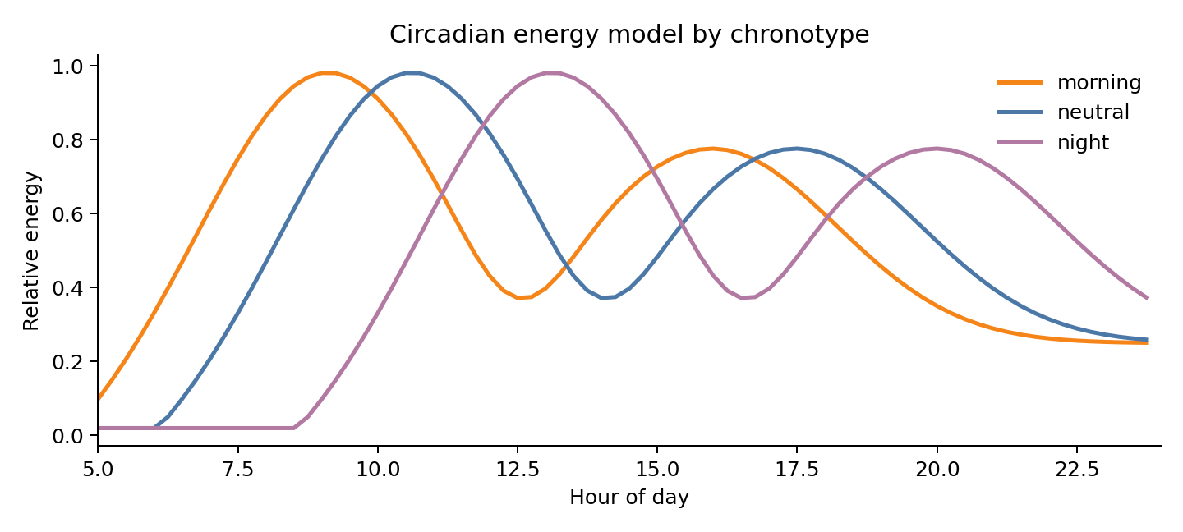
Figure 2: Circadian energy model by chronotype

4.4 Optimizer
The scheduler works on a 15-minute grid between the target wake and bed times. It follows these steps:
- Reserve fixed tasks such as lectures and commutes; they never move.
- Add essentials if missing: breakfast, lunch, dinner and 30 minutes of exercise.
- Anchor meals near regular times (07:30, 13:00, 19:30) to raise meal regularity.
- Rank the remaining tasks by 2 x focus + priority so that the most demanding, important work chooses its slot first.
- Score every feasible start time. Deep-focus tasks maximise average energy weighted by focus and priority; exercise targets moderate energy and avoids very early hours; light tasks (chores, leisure) are steered into low-energy windows, with leisure kept after 17:00 as a wind-down activity.
- Insert a 15-minute break after every focus block of an hour or more.
- Report anything that does not fit instead of silently overloading the day.
This greedy, priority-ordered strategy is fast, deterministic and easy to explain. It is not guaranteed to find the global optimum; Section 7 discusses stronger alternatives.

4.5 Evaluation protocol
Both the person's current schedule and the redesigned schedule are converted into the same 11 features and scored by the trained models. A fixed set of sample tasks representing a typical engineering-student day was used: 6 hours of lectures, two commutes, a coding assignment, note revision, a blockchain course, social media, gaming, chores and two meals. The current day was given realistic but unplanned start times (late lunch, dinner at 23:15, deep work after 19:00, no exercise) and 6.5 hours of irregular sleep.

5. Implementation
The system is written in Python 3 using pandas, NumPy, scikit-learn and matplotlib, with Streamlit for the interface.
File | Role
engine.py | Task model, energy curve, synthetic data, model training, optimizer, evaluator
app.py | Streamlit interface: editable task table, sidebar for sleep and chronotype, metrics, before/after timeline, explanations
run_experiment.py | Reproduces every figure and number in this report
data/ | Synthetic dataset (CSV) and results (JSON)
requirements.txt, README.md | Dependencies and run instructions

To run the application: install the requirements and execute `streamlit run app.py`. The app trains the models once on start-up (a few seconds), then lets the user edit tasks and press “Redesign my day”. The interface displays predicted score changes, a coloured before/after timeline overlaid on the energy curve, both schedules as tables, and plain-language reasons for the changes.

6. Results and Discussion

6.1 Redesign of the sample day
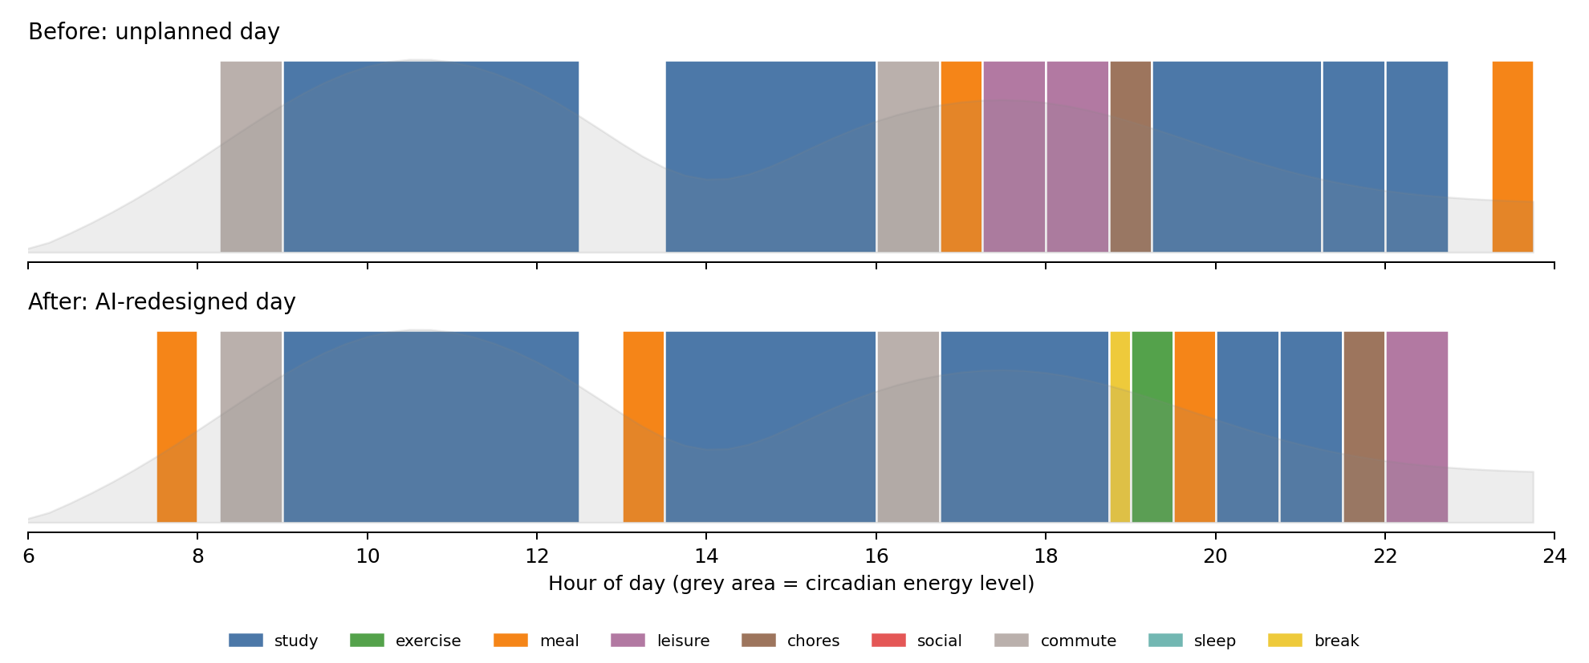
Figure 3: Original (top) versus AI-redesigned (bottom) day for a neutral chronotype
In the original day the coding assignment is done between 19:15 and 21:15 and the internship course at 22:00, when energy is already falling. Lunch is at 16:45, dinner at 23:15, and there is no exercise or break. In the redesigned day, the assignment moves to the 16:45 to 18:45 energy window (76% energy), a break and 30 minutes of exercise follow, meals sit at regular times, and chores and gaming move to the low-energy end of the evening. Bedtime moves to 22:45.
Time | Task | Energy
07:30 - 08:00 | Breakfast | 36%
08:15 - 09:00 | Commute to college | 61%
09:00 - 12:30 | Morning lectures | 89%
13:00 - 13:30 | Lunch | 52%
13:30 - 16:00 | Afternoon lectures | 46%
16:00 - 16:45 | Commute home | 70%
16:45 - 18:45 | Assignment / coding project | 76%
18:45 - 19:00 | Short break | 70%
19:00 - 19:30 | Exercise (walk/workout) | 65%
19:30 - 20:00 | Dinner | 58%
20:00 - 20:45 | Blockchain internship course | 49%
20:45 - 21:30 | Revise lecture notes | 40%
21:30 - 22:00 | Household chores | 34%
22:00 - 22:45 | Gaming / series | 30%
Table: redesigned schedule for the neutral chronotype.
One trade-off is worth stating plainly. The day is almost fully booked, so the optimizer could not fit the 45-minute social-media block while also protecting sleep, a meal pattern and exercise. It reported this instead of hiding it. Because leisure time is part of wellbeing, a real user may prefer to shorten another task to keep it.

6.2 Change in predicted scores
Chronotype | Productivity before | Productivity after | Wellbeing before | Wellbeing after
Morning | 61.1 | 71.7 | 50.7 | 64.6
Neutral | 58.2 | 67.3 | 50.9 | 64.0
Night | 60.2 | 67.9 | 50.7 | 64.8

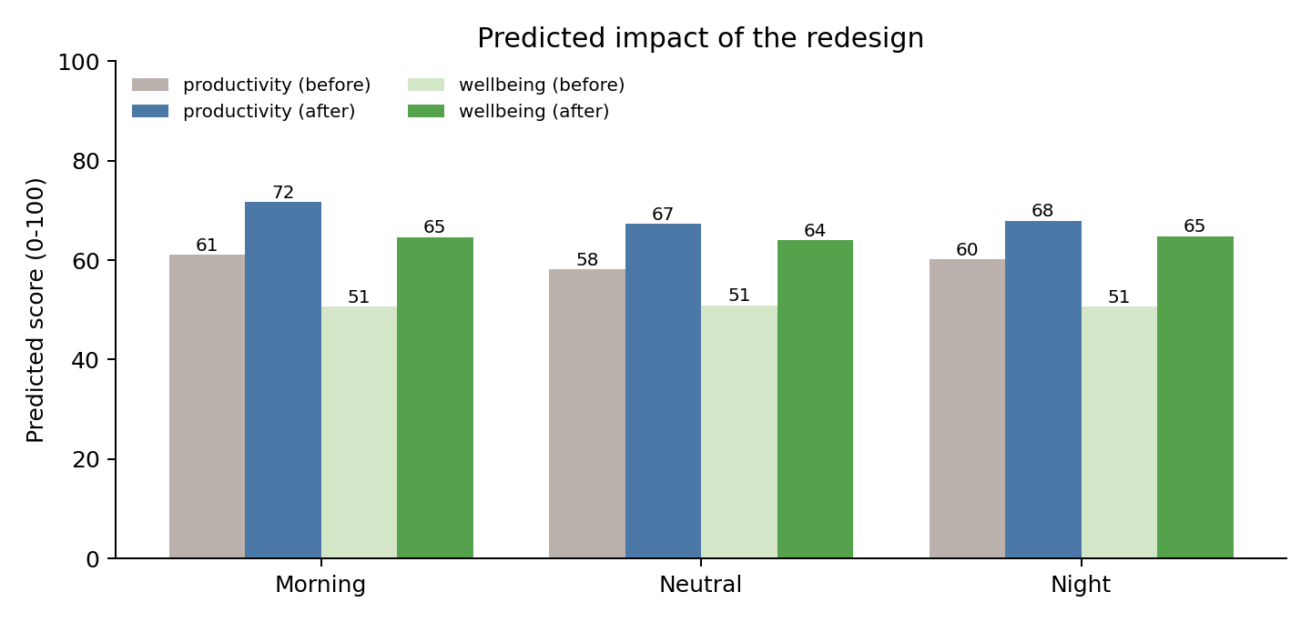
Figure 4: Predicted productivity and wellbeing before and after redesign
For all three chronotypes productivity rose by roughly 7 to 11 points and wellbeing by roughly 13 to 14 points. For the neutral chronotype the gains are +9.1 productivity and +13.1 wellbeing.

6.3 What changed in the features
Feature | Before | After
sleep hours | 6.5 | 7.75
sleep consistency | 0.4 | 0.9
peak focus ratio | 0.37 | 0.58
exercise min | 0 | 30
break count | 0 | 1
meal regularity | 0.47 | 0.92
leisure hours | 1.5 | 0.75
screen hours | 8.45 | 8.07
free buffer min | 90 | 45

6.4 Ablation: which change matters most?
To separate the effect of better sleep from the effect of a better schedule, the models scored four versions of the day (Figure 5).
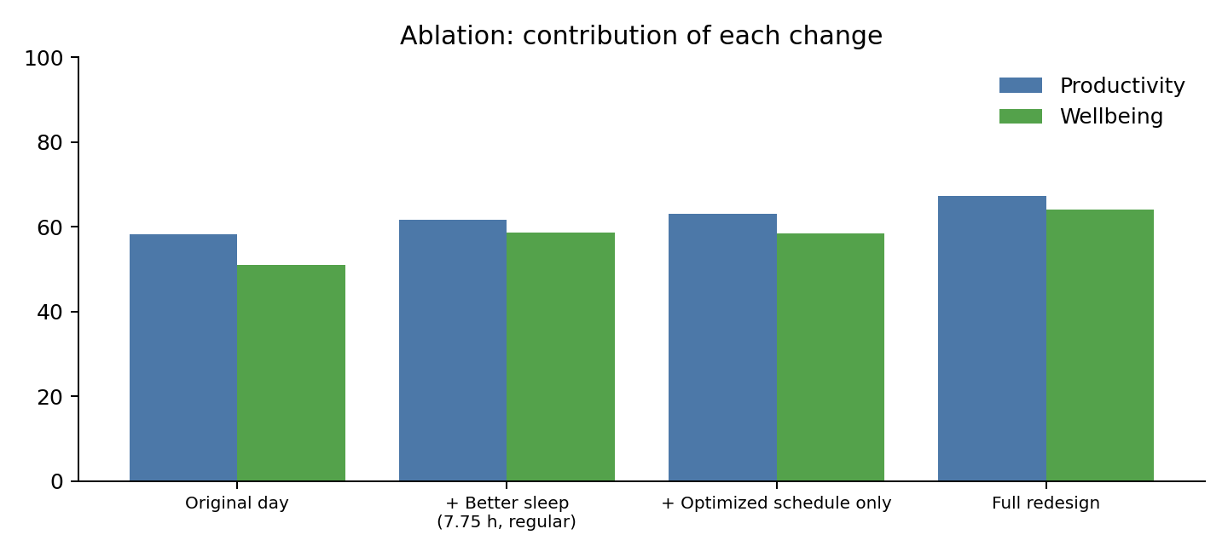
Figure 5: Contribution of each change to predicted scores
Improving sleep alone lifts wellbeing from 50.9 to 58.7 but productivity only from 58.2 to 61.6. Rescheduling alone gives a larger productivity gain (63.1) and a similar wellbeing gain. The two together are best (67.3 and 64.0), so the recommendations reinforce each other.

6.5 Limitations
- The training data is simulated. The direction of the effects follows published research, but the exact magnitudes are assumptions, so the predicted gains are not proof of real-world improvement.
- The optimizer is greedy and schedules one day at a time; it can be beaten by a global search on tightly packed days.
- Screen time and sleep consistency are estimated from the plan, not measured.
- The energy curve is a population-style template; individuals differ.
- The tool gives planning guidance, not medical advice.

7. Future Scope
- Replace the synthetic data with real logs from a consented pilot study or wearable data, and retrain the models.
- Use integer linear programming, genetic algorithms or reinforcement learning to search schedules globally.
- Personalise the energy curve from the user's own self-ratings across days.
- Integrate with Google Calendar and phone usage statistics.
- Generate weekly plans with deadline awareness and spaced revision.
- Add a conversational interface using a large language model to explain and negotiate the plan.

8. Conclusion
This project demonstrates a complete pipeline for AI-assisted routine design: an energy model, predictive models, a constraint-based optimizer and an explanatory interface. On a realistic student day, the redesigned routine was predicted to improve productivity by 9.1 points and wellbeing by 13.1 points by moving deep work into energy peaks, adding exercise, breaks and regular meals, and protecting sleep. The ablation shows that scheduling and sleep each help and help most together. With real user data, the same framework can become a practical personal planning assistant.

References
Cirillo, F. (2006). The Pomodoro Technique. Self-published.
Friedman, J. H. (2001). Greedy function approximation: A gradient boosting machine. Annals of Statistics, 29(5), 1189-1232.
Hirshkowitz, M., et al. (2015). National Sleep Foundation's sleep time duration recommendations: methodology and results summary. Sleep Health, 1(1), 40-43.
Newport, C. (2016). Deep Work: Rules for Focused Success in a Distracted World. Grand Central Publishing.
Pedregosa, F., et al. (2011). Scikit-learn: Machine learning in Python. Journal of Machine Learning Research, 12, 2825-2830.

