These instructions are for reading and writing the fuse bytes on an ATmega328 using the "USBtiny" / "USBtinyISP" programmer (Pocket AVR Programmer from Sparkfun)

Ensure latest version of avrdude-x.x-mingw32.zip is downloaded from:

http://download-mirror.savannah.gnu.org/releases/avrdude/

Navigate to the directory containing the downloaded avrdude.exe:

To view chip data:

avrdude -c usbtiny -p m328 -v

To view current fuse bytes:

avrdude.exe -c usbtiny -p m328

To write low fuse byte:

avrdude -c usbtiny -p m328 -U lfuse:w:0x##:m

To write high fuse byte to preserve EEPROM through chip erase:

avrdude -c usbtiny -p m328 -U hfuse:w:0xD6:m

Default fuses from chip: (E:FD, H:DE, L:FF)

Default fuses from datasheet?: (E:FF, H:D9, L:62)

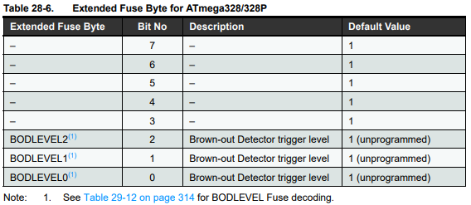View datasheet here: [ATmega48A/PA/88A/PA/168A/PA/328/P](https://ww1.microchip.com/downloads/aemDocuments/documents/MCU08/ProductDocuments/DataSheets/ATmega48A-PA-88A-PA-168A-PA-328-P-DS-DS40002061B.pdf#page=290)



