

Readme

Azure Management Cmdlets

|  |  |  |  |  |  |
| --- | --- | --- | --- | --- | --- |
| |  |  | | --- | --- | | Version: | 1.0.0 | | Last updated: | 11/2/2009 | |  |

## Contents

Overview 2

Getting Started with the Azure Services Management Tools 2

Task 1 – Build and Install the Azure Services Management Tools 2

Task 2 - Listing Installed Cmdlets 5

Using the PowerShell cmdlets 8

Task 1 - Using the Windows Azure Hosted services cmdlets 10

Overview

The Azure Services Management Tools includes a set of cmdlets that enable a user to configure and manage several Windows Azure operations including: Azure Services and Azure Storage.

These tools can be helpful when developing and testing applications that use Azure Services. For instance, using these tools you can easily create a new deploy of your services, change configuration for a specified role, etc.

# Key Features

* 1. The Azure Services Management Tools are designed to be usable tools for browsing, configuring, and managing several of the Azure Services. However, they are also provided in source code form to enable you to better understand how to use the Azure Services Platform. Some of the key features demonstrated include:
  + Windows Azure Service Management API
  + Windows Azure SDK
  + Windows Powershell

Getting Started with the Azure Services Management Tools

* 1. The Azure Services Management Tools are provided in source code form. Before you can use the tools they need to be compiled and installed.

Task 1 – Build and Install the Azure Services Management Tools

To get started using the Azure Services Management, complete the following steps:

* 1. Run the **StartHere.cmd** command script located in the directory where you extracted the Azure Services Management Tools package.
  2. The **StartHere.cmd** script will launch the Configuration Wizard. The Configuration Wizard is designed to check your machine to ensure that it is properly configured with all of the dependencies to build and use the Azure Services Platform Management Tools.
     1. 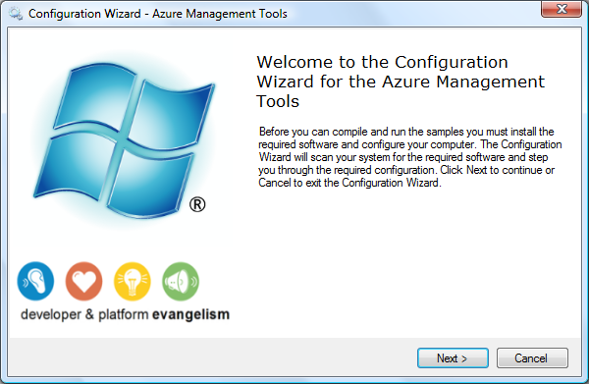
  3. The next step involves checking your machine for the required software and configuration. If you don’t have the require configuration or dependencies, then in most cases you will be provided with a link to download them.
     1. 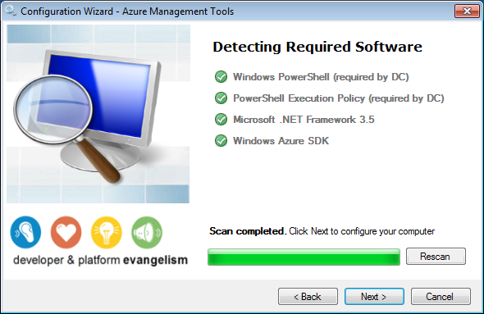
  4. After the dependency check is complete, press the **Next** button to proceed in the Configuration Wizard.
  5. The next step in the Configuration Wizard involves building and installing the Azure Services Management Tools. The Configuration Wizard will execute the **installPSSnapIn.cmd** command script located in the **\setup\dependency_checker\scripts\tasks** folder where you extracted the Azure Services Management Tools.
     1. **Note:** The \setup\dependency_checker\scripts\tasks folder for this tools includes scripts for building, installing, and uninstalling the Azure Services Management Powershell SnapIn. You can run these files in case you need to troubleshoot a problem with the automated Configuration Wizard.
     2. 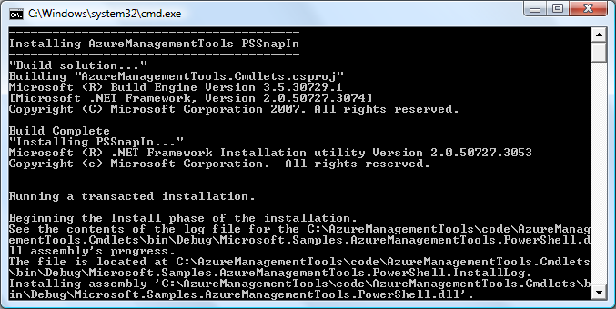
  6. Finally, after building and installing the Azure Services Management Tools, the Configuration Wizard will be complete.
     1. 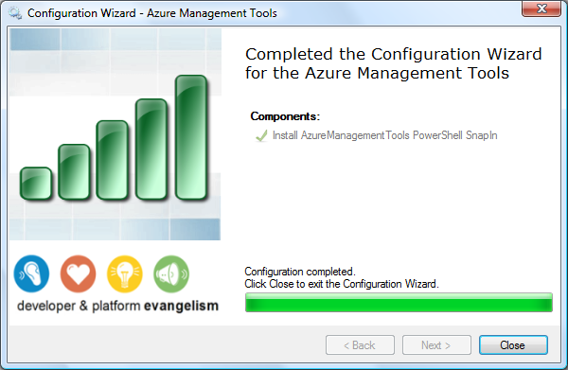

Task 2 - Listing Installed Cmdlets

The Azure Management Tools is a set of Windows PowerShell cmdlets for performing all of the operations related with administration and management of Azure services and storage.

The set of PowerShell cmdlets provided with ECF can be retrieved using a Powershell script:

* 1. Open PowerShell console from **Start | All Programs | Windows PowerShell | Windows PowerShell**. The Powershell console should open.
     1. 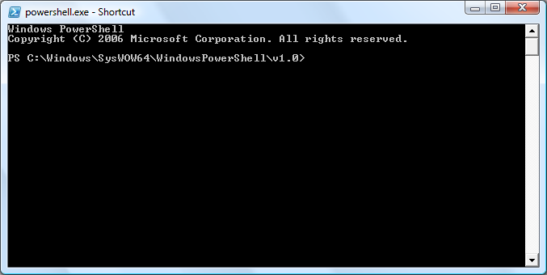
     2. Figure 1
     3. PowerShell Console
  2. Add the AzureManagement snapin typing the following command:
     1. PowerShell
     2. Add-PSSnapin AzureManagementToolsSnapIn
  3. Retrieve all cmdlets typing the following command:
     1. PowerShell
     2. Get-Command -PSSnapin AzureManagementToolsSnapIn
     3. 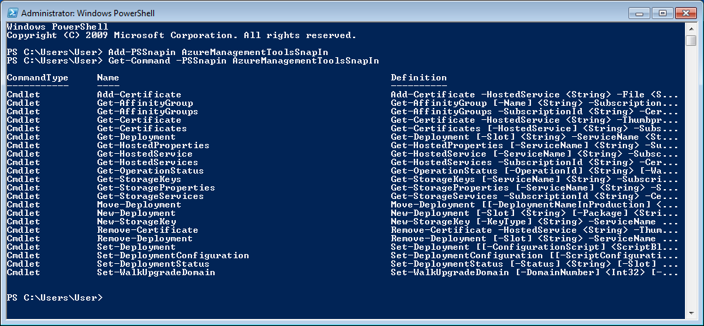
     4. Figure
     5. Listing the available cmdlets

Displaying Cmdlets Help

When using individual cmdlets you will probably need to know detailed information about how to use each cmdlet.

To get help information about a particular cmdlet follow the next steps:

* 1. Open PowerShell console from **Start | All Programs | Windows PowerShell | Windows PowerShell**. The PowerShell console should open.
     1. 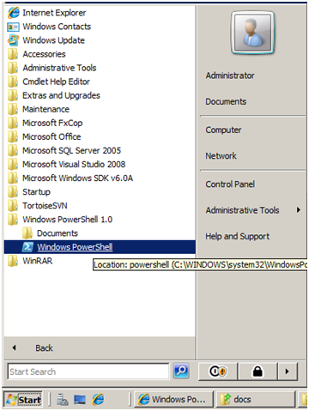
     2. Figure
     3. Opening the PowerShell console
  2. Add the **AzureManagementTools** snapin typing the following command:
     1. PowerShell
     2. Add-PSSnapin AzureManagementToolsSnapIn
  3. Retrieve help information using the **Get-Help** command. For example, to get help for the **New-Deployment** cmdlet you can type:
     1. PowerShell
     2. Get-Help New-Deployment
     3. 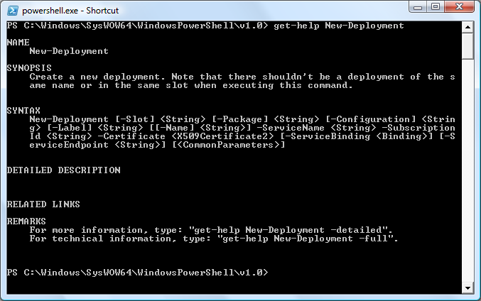
     4. Figure
     5. Opening the PowerShell console
  4. **Note:** To get more detailed information about a particular cmdlet you can execute the **Get-Help** cmdlet with the **–Detailed** or the **–Full** option. This will give information about parameters, usage examples, etc.
  5. For example:
  6. Get-Help Move-Deployment –Detailed

Using the PowerShell cmdlets

The Azure Services Management Tools PowerShell cmdlets can be used to run unattended scripts to configure and manage the Azure Services. The PowerShell cmdlets provided with this package include the following:

**Windows Azure Hosted Services**

|  |  |
| --- | --- |
| Name | Description |
| Get-Deployment | View details of a specified deployment. |
| Get-HostedProperties | List the properties for the specified hosted account. |
| Get-HostedService | Retrieve a specified hosted account. |
| Get-HostedServices | Lists all hosted services underneath the subscription. |
| Move-Deployment | Swaps the deployments in production and stage. |
| New-Deployment | Create a new deployment. Note that there shouldn't be a deployment of the same name or in the same slot when executing this command. |
| Remove-Deployment | Deletes the specified deployment. Note that the deployment should be in suspended state. |
| Set-Deployment | Initiates an in-place upgrade of the specified deployment. |
| Set-DeploymentConfiguration | Change the deployment's configuration. |
| Set-DeploymentStatus | Change deployment status to running or suspended. |
| Set-WalkUpgradeDomain | Walks the specified upgrade domain. |

**Windows Azure Storage**

|  |  |
| --- | --- |
| Name | Description |
| Get-StorageKeys | Displays the primary and secondary keys for the account. Should have  the storage account resource specified. |
| Get-StorageProperties | List the properties for the specified storage account. |
| Get-StorageServices | Lists all storage services underneath the subscription. |
| New-StorageKey | Regenerates storage keys with the key-type parameter specifying which key to regenerate. Should have the storage account resource specified. |

**Windows Azure Affinity Groups**

|  |  |
| --- | --- |
| Name | Description |
| Get-AffinityGroup | List the properties for the specified affinity group. |
| Get–AffinityGroups | Lists all affinity groups in the subscription. |

**Windows Azure Service Certificates**

|  |  |
| --- | --- |
| Name | Description |
| Get-Certificates | List the certificates for the specified hosted service. |
| Get–Certificate | Retrieve a specified service certificate. |
| Add-Certificate | Upload a service certificate. |
| Remove-Certificate | Deletes the specified service certificate. |

Task 1 - Using the Windows Azure Hosted services cmdlets

In this task, you will see a few examples demonstrating how to use the PowerShell cmdlets for accessing and managing Azure Hosted services.

* 1. First, start Powershell if it is not already running by selecting **Windows Powershell** from the start menu.
  2. Within the Windows PowerShell command prompt, enter the following command to add the Azure Services Management cmdlets to the console’s scope, if you have not already done so:
     1. PowerShell
     2. Add-PSSnapin AzureManagementToolsSnapIn
  3. First, let’s see how to deploy a new package using the PowerShell cmdlet. The following command demonstrates how to create a new deploy named TestDeploy on staging. You can get the subscription ID and API certificate from Windows Azure portal (Account section).
     1. PowerShell
     2. New-Deployment -subscriptionId %SubscriptionId% -certificate (get-item cert:\CurrentUser\MY\%thumbprintInUpperCase%) -serviceName %serviceName% -slot staging -package http://%storageServiceName%.blob.core.windows.net/%container%/testPackage.cspkg -configuration config\TestServiceConfiguration.cscfg -name TestDeploy -label TestLabelStaging
  4. Run the following command to retrieve the deploy created in the step 3.
     1. PowerShell
     2. Get-HostedServices -subscriptionId %SubscriptionId% -certificate (get-item cert:\CurrentUser\MY\%thumbprintInUpperCase%) | where {$_.ServiceName -eq "%serviceName%"} | Get-Deployment staging
  5. Finally, to delete a deploy you can use the Remove-Deployment cmdlet. The following example removes the deployment on staging. Deployment that we deployed in the previous steps:
     1. PowerShell
     2. Get-HostedService "%serviceName%" -subscriptionId %SubscriptionId% -certificate (get-item cert:\CurrentUser\MY\%thumbprintInUpperCase%) | Get-Deployment staging | Remove-Deployment