Breast Cancer Prediction Using Machine Learning

Project Title
Breast Cancer Prediction Using Machine Learning and Streamlit
Objective
The objective of this project is to predict whether a breast tumor is Benign or Malignant using Machine Learning algorithms and provide predictions through a Streamlit web application.
Project Description
This project uses medical measurements such as Radius Mean, Texture Mean, Perimeter Mean, and Area Mean to predict breast cancer. A Random Forest Classifier model is trained using the dataset and saved as a pickle file. The trained model is integrated with Streamlit to create an interactive web application.
Dataset Information
The dataset contains features related to breast cancer diagnosis.
Features
- Radius Mean
- Texture Mean
- Perimeter Mean
- Area Mean
Target
- 0 = Malignant
- 1 = Benign

Libraries Used
pandas
numpy
scikit-learn
streamlit
pickle
Files in Project
- breast_cancer_train_model.ipynb
- breast_cancer_model.pkl
- breast_cancer_streamlit_app.py
- breast-cancer.data
- breast-cancer.names
- breast_cancer_requirement.txt
Model Used
Random Forest Classifier
Code Implementation Process
- Load Dataset
- Split Features and Target
- Train Random Forest Model
- Save Model Using Pickle
- Create Streamlit Interface
- Load Saved Model
- Predict Cancer Type

Expected Output
The application accepts user inputs and predicts:ss
- Benign Tumor
or
- Malignant Tumor
Before:
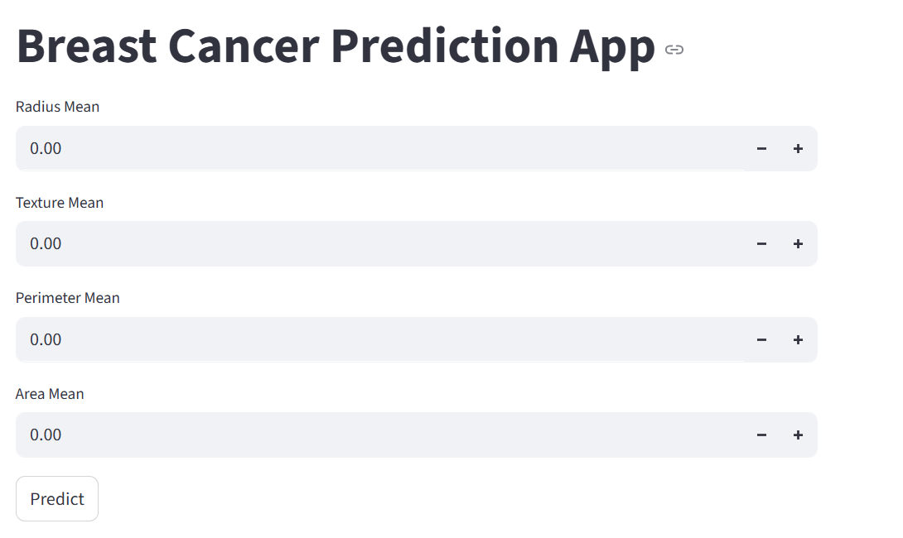

After:
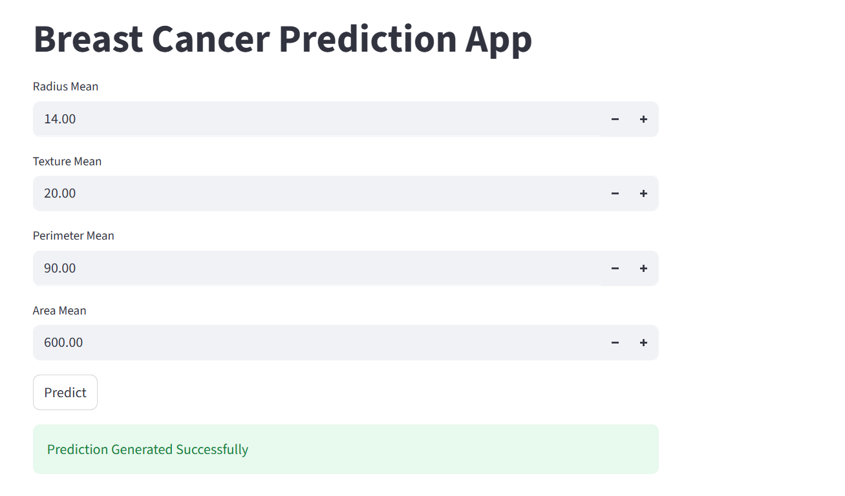
Conclusion
This project demonstrates the use of Machine Learning and Streamlit for healthcare prediction systems. The model helps in predicting breast cancer based on input medical measurements.

