SMART ATTENDANCE SYSTEM

1. Introduction
The Smart Attendance System is a web-based application developed using FastAPI and Streamlit. The system allows users to mark student attendance through a simple user interface and stores attendance information through API communication between the frontend and backend.

2. Objective
The objective of this project is to develop an attendance management system that:
- Accepts student names.
- Marks attendance automatically.
- Displays attendance status.
- Demonstrates FastAPI and Streamlit integration.

3. Technologies Used
- Python
- FastAPI
- Streamlit
- Requests
- Uvicorn
- Pydantic

4. Project Structure
smart_attendance_system/
├── backend/
│ ├── main.py
│ ├── requirements.txt
│ └── .env
│
└── frontend/
├── app.py
└── requirements.txt

5. Backend Implementation
main.py
The FastAPI backend handles attendance requests.
Functions:
- API endpoint for attendance marking.
- Accepts student names.
- Returns attendance status.
requirements.txt
Required libraries:
- fastapi
- uvicorn
- pydantic

.env
Stores project configuration variables.
Example:
APP_NAME=Smart Attendance System

6. Frontend Implementation
app.py
The Streamlit frontend provides:
- Student name input field.
- Attendance marking button.
- Attendance status display.
requirements.txt
Required libraries:
- streamlit
- requests

7. Execution Steps
Step 1: Run Backend
Open terminal inside backend folder.
Command:
uvicorn main:app --reload
Expected Output:
INFO: Uvicorn running on http://127.0.0.1:8000
Application startup complete.

Step 2: Run Frontend
Open terminal inside frontend folder.
Command:
streamlit run app.py
Expected Output:
Local URL: http://localhost:8501

8. Input and Output
Sample Input
Student Name:
Pravallika
Sample Output
Student: Pravallika
Status: Present

9. Expected Output
The application displays a Smart Attendance System interface where users can enter a student's name and click the "Mark Attendance" button. The system successfully records attendance and displays the attendance status as Present.

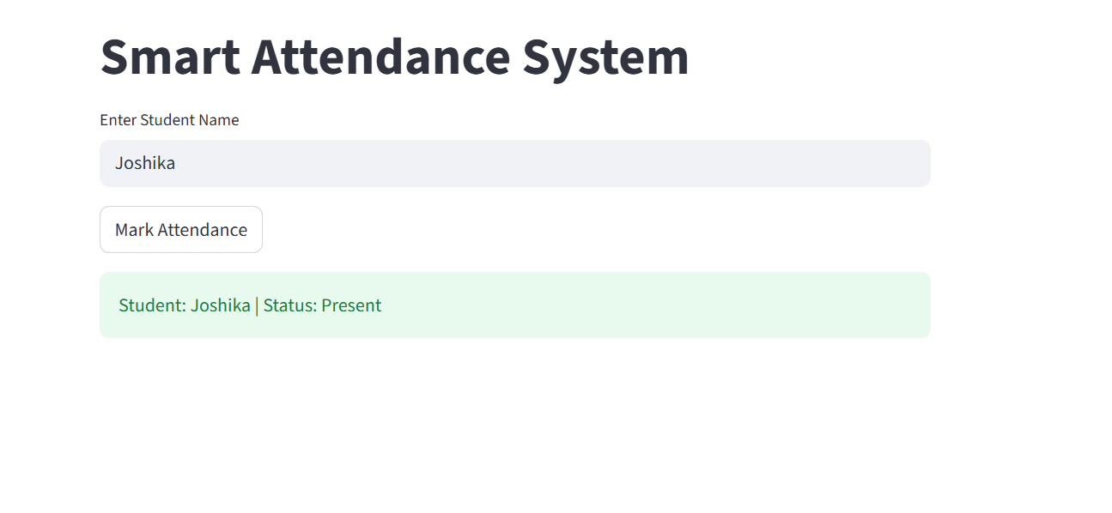

10. Advantages
- Easy attendance management.
- Simple and user-friendly interface.
- Fast API communication.
- Easy integration with databases.
- Scalable for future enhancements.

11. Future Enhancements
- Face Recognition Attendance.
- QR Code Attendance System.
- Attendance Reports.
- Database Integration.
- Student Login and Authentication.

12. Conclusion
The Smart Attendance System was successfully developed using FastAPI and Streamlit. The application demonstrates API communication between frontend and backend components and provides an efficient way to manage student attendance. The system can be enhanced further by integrating facial recognition and database technologies.

