

#### ST. PAUL’S UNIVERSITY

#### Private Bag - 00217 Limuru, Kenya

#### Tel. Office: 020-2020505/10; Mobile: 0728-669000

#### Website: www.spu.ac.ke

**FACULTY OF BUSINESS COMPUTER SCIENCE AND COMMUNICATION STUDIES**

**software engineering**

**Bobitlmr264917**

**LIMURU CAMPUS**

**COVID-19 APPLICATION DOCUMENTATION AND REPORT**

**INTRODUCTION**

The new and ongoing coronavirus (COVID-19) pandemic, caused by a new strain of coronavirus, has resulted in extraordinary measures around the world to contain, slow the pace, or reduce the impact of the virus. The ministry has decided to build a contact tracing application which will help in efforts to mitigate the virus and flatten the spread curve through a faster response to new infections.

**APPLICATION MOCK UPS**

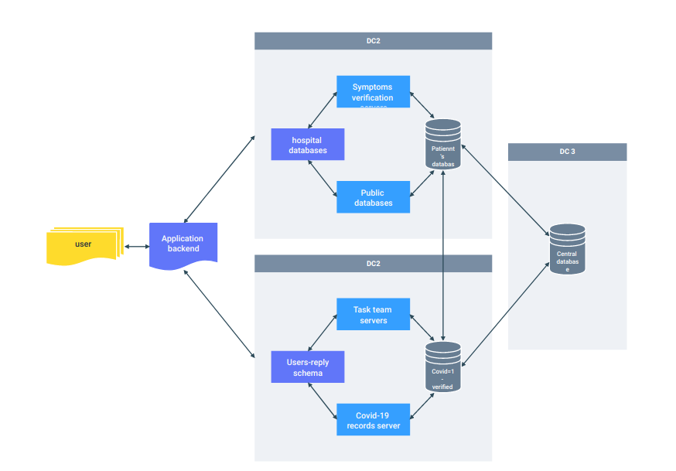

**APPLICATION REQUIREMENTS**

**-**To run the application, you are required to have the following installed in the operating system you are using;

Python 2.6 -3.7

Flask==0.10.1

code editing tools e.g IDE like pycharm, atom, sublime text

a modern browser

**HOW TO RUN THE APPLICATION**

Once you have the above requirements ready, open your code editing software eg. Pycharm.

-Import the folder containing the whole application

-navigate to main.py and open it

-run the main.py to start the application

-open a browser window and navigate to the local host server and the port the app is running on.

**TEST PLAN AND RESULTS**

Through use of publicly available data, a test run of the project was done, the results where as intended, the application run smoothly, and was able to do the automated tasks as intended, After several successful test runs the project was green lighted to go live.

**APPLICATION PROS**

-Easy contact tracing

-It is easy to locate anyone as all the information is submitted through the form

-ease of use

-does not require a lot of things to set it up

-runs in a website so it is able to be accessed anywhere and on any device

**APPLICATION CONS**

**-**Sensitive information is shared through the form