Ovary

Definition
Ovaries are female gonad
From modern Latin ovarium, from Latin ovum ‘egg’

Location
In the ovarian fossa of the lateral pelvic wall
In multiparous women, the location varies

Ovarian fossa
Shallow recess in the lateral wall of pelvis
Bounded by
Superiorly by - external iliac vessels and obturator nerve
Anteriorly by - attachment of broad ligament to the lateral pelvic wall
Posteriorly by - internal iliac vessels and ureter
Relations of the ovary
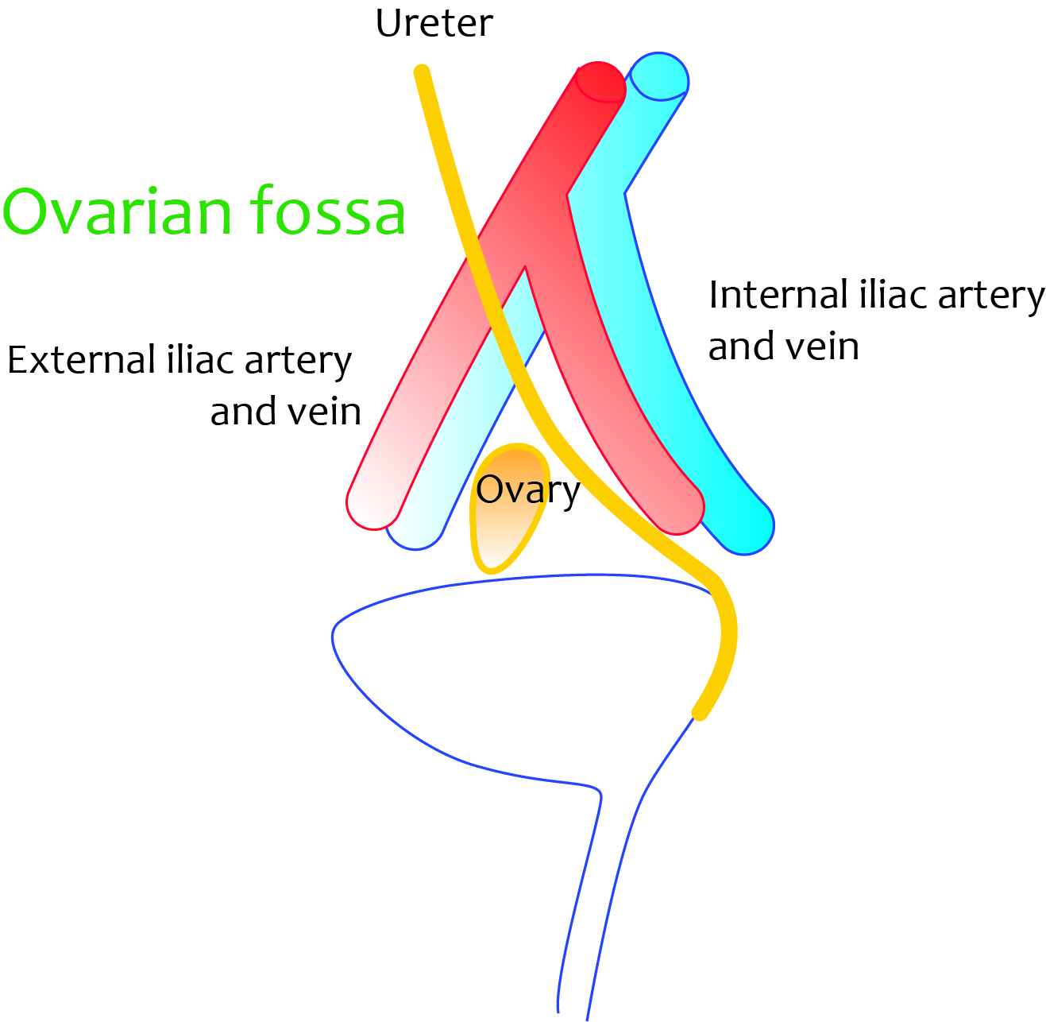

Relations of the ovary
​​​​​​​Relations - lateral and medial relations
Superficial to deep the structures related to lateral wall of the ovary are
- Parietal peritoneum
- Obturator nerve and vessels
- Obturator fascia
- Obturator internus muscle
Medial surface of the ovary is in contact with fimbrial end of uterine tube

Measurements
- Almond shaped
- 1 cm X 2 cm x 3 cm

- Weigh approximately 4 to 5 grams
- White in color
- Right ovary usually larger than left

Features of the ovary

Borders
Anterior border - related to mesovarium
Posterior border - is free

Poles
Upper pole - related to uterine tube, and to infudibulo-pelvic ligament
Lower pole - connected to lateral wall of the uterus by utero-ovarian ligament
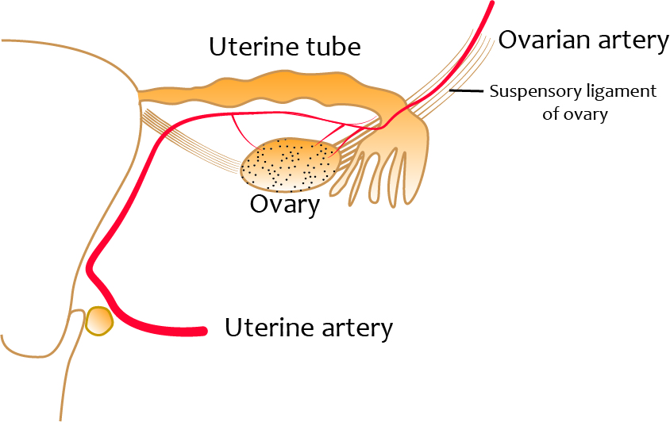

Ligaments of ovary
- Utero-ovarian ligament (proper ligament of ovary / ovarian ligament)
- Mesovarium
- Suspensory ligament of ovary (infundibulo-pelvic ligament)

Utero-ovarian ligament (proper ligament of ovary / ovarian ligament)
Cord-like structure made of connective tissue and smooth muscles
Extends from the lower pole of the ovary to the lateral wall of the uterus
Located between the mesovarium and mesosalphix
Gubernaculum of ovary forms ligament of ovary

Mesovarium
Fold of peritoneum suspending the ovary from the posterior and superior aspect of the broad ligament.
Mesovarium do not cover the ovary.
It attaches the ovary the anterior border of the ovary to the posterior aspect of the broad ligament
It carries blood vessels from broad ligament to the ovary

Suspensory ligament of ovary (infundibulo-pelvic ligament)
Is the fold of the peritoneum covering the vessels, nerves and lymphatics to the lateral pelvic wall
Extends from upper pole of the ovary to the lateral pelvic wall via infundibulum of the uterine tube

Arterial supply
Ovarian arteries - branches of abdominal aorta
Supply the ovary and lateral parts of uterine tubes
Anastomose on the lateral aspects of the uterus with uterine arteries
Travel through the infundibulo-pelvic ligament

Venous drainage
Right side - vein drains into the inferior vena cava
Left side - vein drains into the left renal vein

Lymphatics
Lymphatics drain into the lateral aortic (para-aortic) group of lymph nodes

Innervation
Visceral sensory fibres - travel through splanchnic nerves to reach T10, T11 and T12 segments
Visceral sympathetic innervation - aorticorenal plexus - travel via sympathetic nerves to T10 to T12 segments
Ovarian pain is referred to the lower abdomen and pubic region
Parasympathetic fibres (S2, S3, and S4) - by inferior hypogastric plexus via pelvic splanchnic nerves

