Perineum

Etymology
Region of the body between the anus and the genital organs
L.L. Perineum (c.440), from gk. Perinaion, perinaios,
From peri- "near" (see peri-) + inan "to carry off by evacuation"

Anatomical definition
Perineum is the region at the lower end of the trunk in the interval between two thighs

Working definition
In males - the region between the scrotum and anus
In females - the region between the vulva and anus

Superficial boundaries

Anteriorly:
- Scrotum(m)
- Mons pubis(f)

Posteriorly:
- Gluteal region

On each side:
- The upper part of the medial side of the thigh.

Deep boundaries of perineum
Deep boundaries of perineum are the same as those of pelvic outlet

Divisions of perineum
A transverse line joining the anterior parts of ischial tuberosities divides the perineum into 2 triangular areas.
- An anterior urogenital triangle.
- Posterior anal triangle.
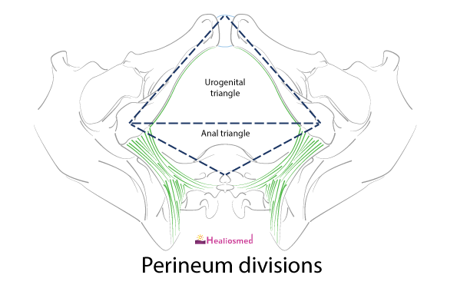

Urogenital triangle
The urogenital triangle consists of
- Skin
- Fatty layer of superficial fascia.
- Membranous layer of superficial fascia (Colles’ fascia).
- Superficial perineal pouch.
- Perineal membrane.
- Deep perineal pouch.
- Urogenital diaphragm and its fasciae.
It consists of
In the midline
- Perineal body
- Termination of anal canal
- Anococcygeal raphe
On each side
- A fascial lined wedge-shaped space - the ischioanal fossa.

Pudendal canal = Alcock’s canal
Pudendal canal is a fascial tunnel in the lateral wall of ischioanal fossa.
It is within the fascia of the obturator internus muscle
It contains the neurovascular bundle of perineum.
Structures present in this canal are
Pudendal nerve
Internal pudendal vessels (artery and vein)

Superficial fascia
Superficial fascia is made up of 2 layers as in the lower part of anterior abdominal wall.
- A superficial fatty layer
- A deep membranous layer (Colles’ fascia)
On each side Colles’ fascia is attached to the ischiopubic rami.

Colles’ fascia

Posteriorly:
Attached to the posterior border of perineal membrane.
Hence it does not extend to the anal triangle.

Anteriorly:
It is continuous with the fascia of scrotum containing the dartos, fascia of penis and with the fascia of scarpa of anterior abdominal wall.
Colles’ fascia defines the external limits of superficial perineal pouch.
In the lower lateral abdominal wall, it is attached to the deep fascia (lata) of thigh.
Clinical relevance
Since it is continuous up the anterior abdominal wall, fluids or infected material that accumulates in the superficial pouch can track out of the perineum & onto the lower abdominal wall.
This material will not track into the anal triangle or the thigh because the fascia fuses with the deep fasciae at their borders.
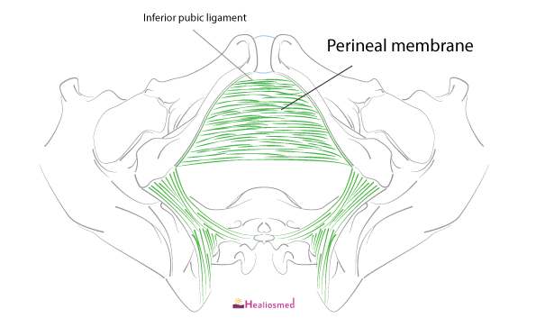

Perineal membrane – extension
It is a strong sheet of fascia extending across the pubic arch.
It is triangular in shape with apex directed anteriorly.
It separates the superficial perineal pouch from the deep pouch.
In males it is tough due to the attachment of root of the penis & associated perineal muscles.

Perineal membrane – attachments
Laterally: periosteum of ischiopubic rami.
Anteriorly: thickened to form transverse perineal ligament.
Posteriorly: fused to the deep parts of perineal body & is continuous with the fascia over deep transverse perinei

Structures piercing perineal membrane
Near the apex:
- Dorsal A of penis/clitoris.
In the middle:
- Deep A of penis/clitoris.
At the base:
- 2 posterior scrotal/ labial vessels & nerves on each side.
In the midline:
- Urethra
- Duct of bulbourethral glands
- Artery to the bulb of penis on each side of urethra (in males)
- Vagina behind urethra (in females).

Gap between arcuate pubic ligament & transverse perineal ligament
3 structures pass in the small triangular gap between arcuate pubic ligament & transverse perineal ligament.
- A deep dorsal vein of penis/ clitoris (midline).
- Dorsal nerve of penis/clitoris on each side.

Perineal body
It is a pyramidal fibromuscular node situated in the median plane about 1.25cm in front of the anal margin.
10 muscles of perineum converge & interlace in the perineal body.

Muscles converging in perineal body

Paired
- Bulbospongiosus.
- Superficial transverse perinei
- Deep transverse perinei
- Levator ani

Unpaired
- External anal sphincter.
- Fibres of longitudinal muscle coat of anal canal.

Perineal body - 3 strata
Deep:
- Levator ani.
Intermediate:
- Deep transverse perinei
- Deep part of external anal sphincter
Superficial:
- Bulbospongiosus
- Superficial transverse perinei
- Superficial part of external anal sphincter.
The apex receives the attachment of rectovesical fascia.

Clinical importance
Perineal body may be torn in female during parturition.
If it is incompletely repaired, hiatus urogenitalis becomes wider when levator ani contracts.
Through this gap pelvic viscera may descend causing prolapse of uterus.

Pudendal canal
It is a fascial tunnel in the lateral wall of ischioanal fossa
Located 2.5 cm above the ischial tuberosity.
It extends from lesser sciatic notch to the posterior border of perineal membrane.
It is a space between obturator fascia & lunate fascia.
Contents are pudendal nerve, internal pudendal artery & vein.
Pudendal N is the chief nerve of perineum & external genitalia.
Originates from the sacral plexus (S2, 3, 4)
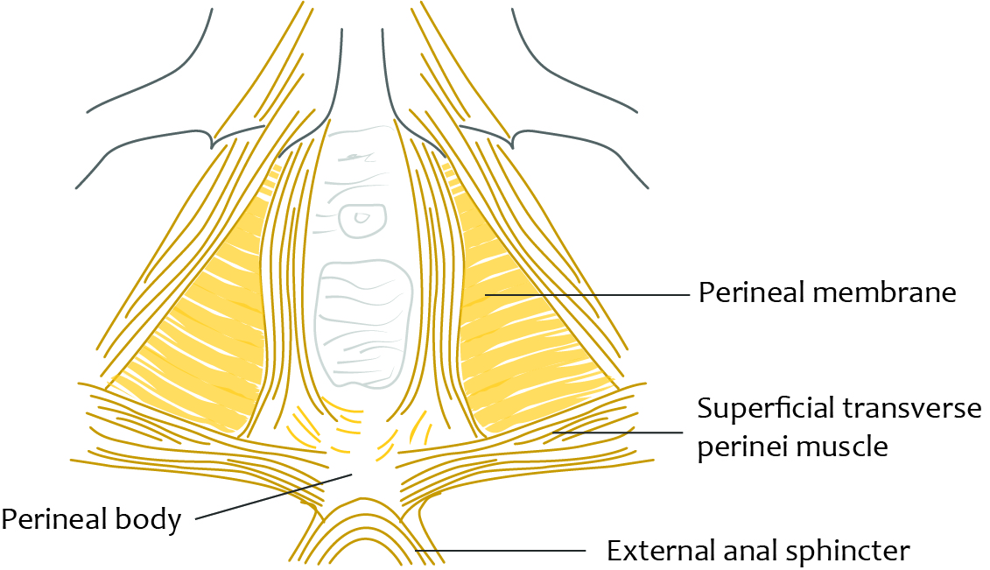

Clinical importance - perineal tear
During childbirth, a tear or laceration may happen in perineum
Classification
1. First-degree tear - the laceration is limited to perineal skin or vaginal mucosa
2. Second - degree tear - laceration extends into the perineal muscles and fascia
3. Third - degree tear - laceration extends into the external anal sphincter
4. Fourth - degree tear - along with laceration of anal sphincter, it also involves rectal mucosa

Clinical importance – episiotomy
Episiotomy is the incision made in the perineum in order to enlarge the opening for the baby to pass through
It is done during second stage of labour, just before the delivery of the baby
Routine episiotomies are no longer recommended
If episiotomy is done - it is done in mediolateral incision

