Uterus

Etymology
From Latin uterus "womb, belly" (plural uteri)
Uterus is a fibromuscular organ

Location
In the pelvis
- Anteriorly - urinary bladder
- Posteriorly - rectum
- Laterally - right and left broad ligament

Size and shape
Varies according to age and parity
Usually - 8 cm (from external os to the top of the fundus)
Weighs - 40 to 60 grams

Parts of uterus
Three parts
Fundus, body and cervix
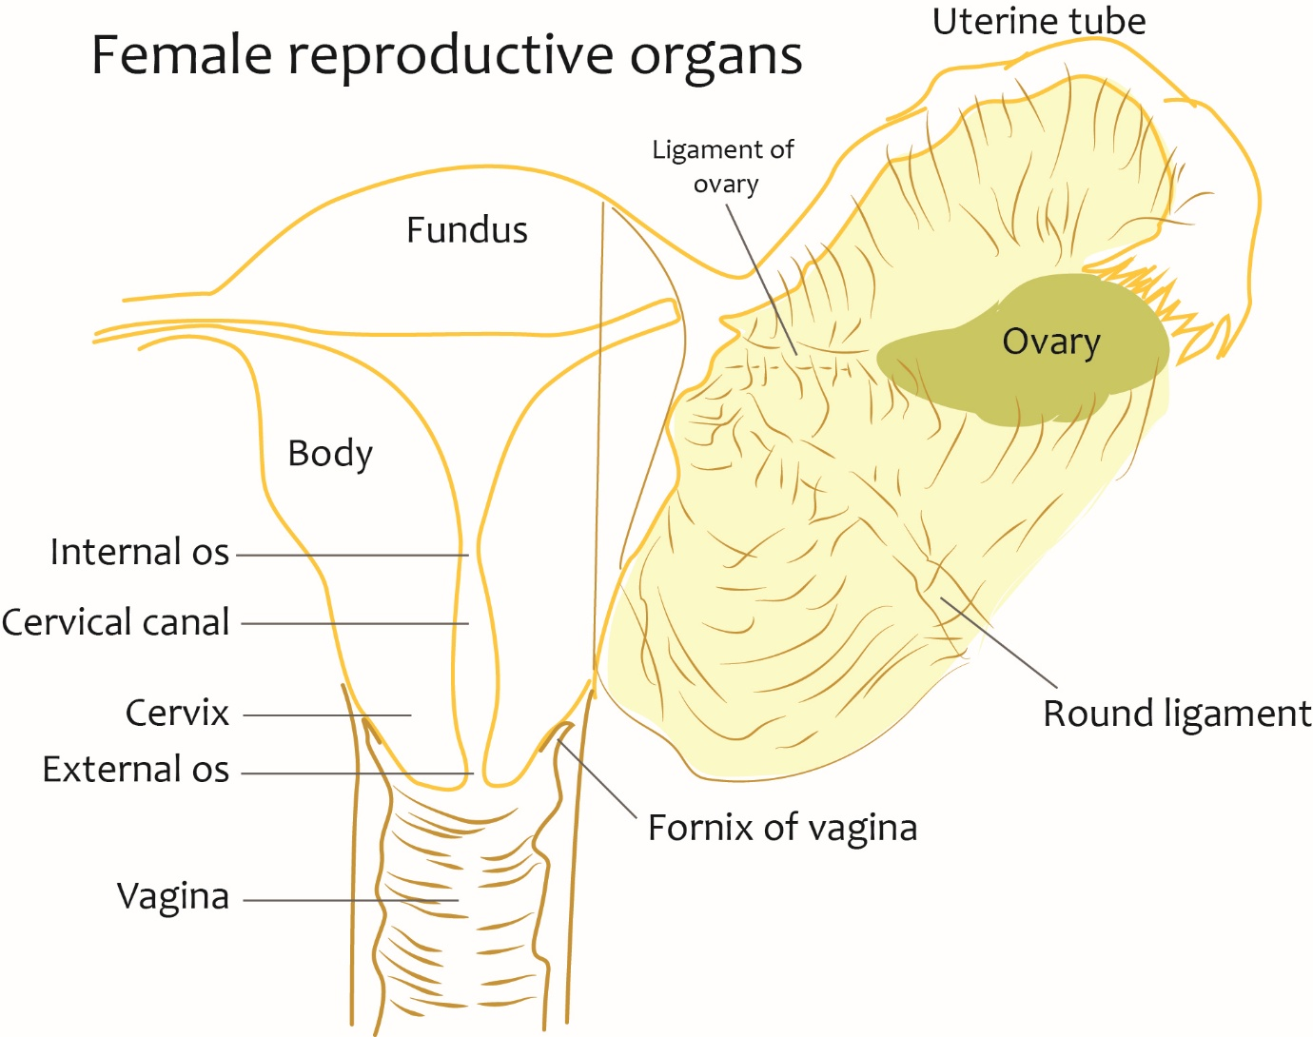

Position

Normal position
- Normally uterus is anteflexed and anteverted
- Anteflexion - angle between long axis of the body of uterus and long axis of cervix
- The angle measures about 120 to 170 degrees
- Anteversion - angle between long axis of the body of the cervix and long axis of the vagina
- The angle measures about 90 degrees
- Due to these angles - the uterus is bent forwards

Other terms in relation to position
​​​​​​​Retroversion - the uterus is inclined posteriorly toward the rectum. In retroverted position, cervix faces anteriorly.
Retroflexion - the body of the uterus is curved posteriorly at the isthmus of the uterus. In the retroflexed position, cervix is in its normal position.
Various combinations of retroflexion and retroversion can occur.
The content of the bladder and rectum plays a major role in the position of the uterus

Relations
​​​​​​​Anterior
- Vesicouterine pouch
- Some loops of small bowel
- Supravaginal and intravaginal cervix
- Anterior fornix of vagina

Posterior
- Rectouterine pouch of Douglas with small bowel loops

Lateral
- Broad ligament with the anatomic entities enveloped
- Ureter with uterine vessels and nerves
- Vesical vessels and nerves

Cavity of uterus
Triangular in profile in the upper part
Cavity narrows towards the isthmus
Isthmus or lower uterine segment - the area where endocervical canal opens into the endometrial cavity
Endometrial cavity: triangular shaped mucosal surface of the uterine body
Its epithelium is columnar. It undergoes cyclical changes

Peritoneal relations
- From the anterior surface of the uterus, the peritoneum is reflected at the level of the isthmus to the superior surface of the urinary bladder. This forms a shallow - vesicouterine pouch or uterovesical pouch
- From the posterior surface of the uterus and cervix, the peritoneum is reflected at the level of posterior fornix to the anterior surface of the rectum. This forms a deep rectouterine pouch or pouch of Douglas

Cervix
Extent
Lower 2-3 cms of the uterus, extending from internal os to external os

Parts

Supravaginal part
Anterior surface - rests on the urinary bladder
Surrounded by a dense pubocervical fascia, uterosacral ligament and cardinal ligament
This endopelvic fascial covering forms pericervical fascial ring
This is the key support of the uterus
Lateral relation - 2 cm from its lateral border, uterine artery is located. Here uterine artery crosses the ureter anteriorly
Posterior surface - covered with peritoneum of the rectouterine pouch. Related to the rectum

Vaginal part
Located within the upper part of the vagina
Appreciated with speculum examination of vagina

Cervical canal
Extends from isthmus of the uterus to external os
Glands located here (cervical glands) are branched tubular and secrete mucus rich in fructose
This mucus collection forms the cervical plug
Folds of the anterior and posterior walls of the cervix closes the cervical canal

Functional isthmus
Upper part of the cervix including the internal os
Forms the lower uterine segment after the second month of pregnancy
This segment is incised during lower segment cesarian section (LSCS)

Lower uterine segment
Definition:
The lower portion of uterus, lying below the loose fold of peritoneum that lies between the uterus and bladder.
LUS is formed late during pregnancy
LUS is less contractile than the rest of the uterus.
A Caesarean section is performed through the lower segment.

Arterial supply of the uterus
​​​​​​​Uterine arteries
- Branch of anterior division of the internal iliac artery
- Located in the caudal aspect of the broad ligament
- Related at 2 cm lateral to the cervix
- Ascends up along lateral margin of the uterus
- End by anastomosing with the ovarian artery in the infundibulo-pelvic ligament
Branches of uterine artery
- Branches to ureter, vagina and cervix - at the lateral fornix of the vagina
- Arcuate arteries - multiple, arise along the lateral margin of the uterus
- Branches to uterine tube and ovary

Relation of uterine artery and ureter
At risk relation
At the lateral fornix of the vagina - uterine artery crosses over the ureter superiorly (water under the bridge)
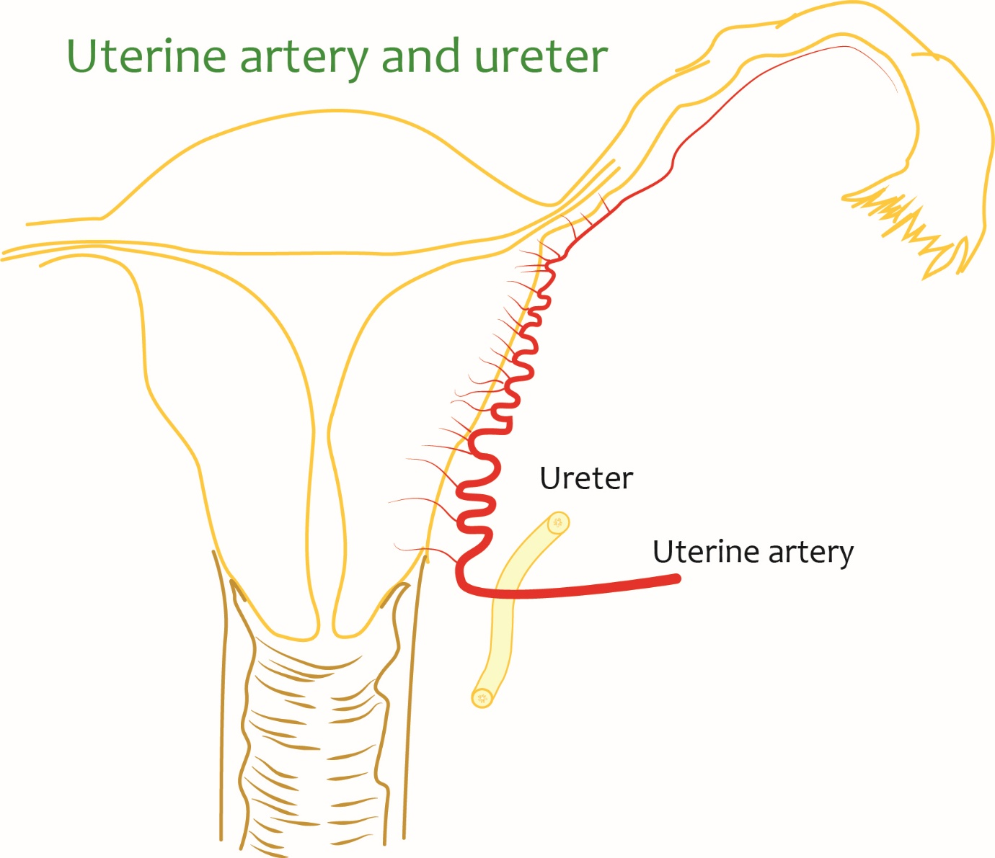

Identification of uterine artery during surgery

​​​​​​​Lateral approach
- Pararectal space is entered lateral to the ovary
- Internal iliac artery or ureter is traced anterograde fashion

Medial approach
- Pararectal space is entered medial to ovary
- Ureter is followed to the point where it crosses under the uterine artery

Cervical approach
- At the level of cervix, parametrium is opened and artery is identified

Blood supply of the uterus

Venous drainage
Uterine vein drain into the internal iliac vein

Lymphatic drainage
Fundus - along ovarian vessels to para-aortic and pre-aortic group of lymph nodes
Angle of the uterus - to the superficial inguinal group along round ligament of uterus
Body - along broad ligament - external iliac group of lymph nodes
Cervix - external iliac group of lymph nodes and to paracervical nodes
Enlarged paracervical nodes may compress the ureter
Along uterine vessels - internal iliac lymph nodes
Few run posteriorly - to sacral lymph nodes

Nerve supply
Sympathetic innervation - T12 to L1
Parasympathetic innervation - S2 to S4
Pain sensation from cervix - passes through pelvic splanchnic nerves (parasympathetic nerves to S2 to S4)
Pain sensation from uterus - passes through sympathetic lumbar splanchnic nerves

Ligaments of uterus and cervix
- Broad ligament
- Round ligament
- Cardinal ligament
- Uterosacral (sacrocervical) ligament
- Anterior uterine (uterovesical) ligament
- Posterior uterine (rectovaginal) ligament
- Pubocervical fascia
- Utero-ovarian ligament
- Rectouterine ligament

Change in size of the uterus during pregnancy
Normal uterus is totally pelvic organ
During pregnancy - there is great increase in size of the uterus
Till 12 weeks of gestation - uterus largely confined to the pelvis
At 16 weeks - reaches 3 fingers above the pubic symphysis
At 20 weeks - at 3 fingers belowe the umbilicus
At 24 weeks - at umbilicus
At 32 weeks - Between umbilicus and xyphoid process
At 36 weeks - at costal arch
At 40 weeks - 1/2 finger below the costal arch
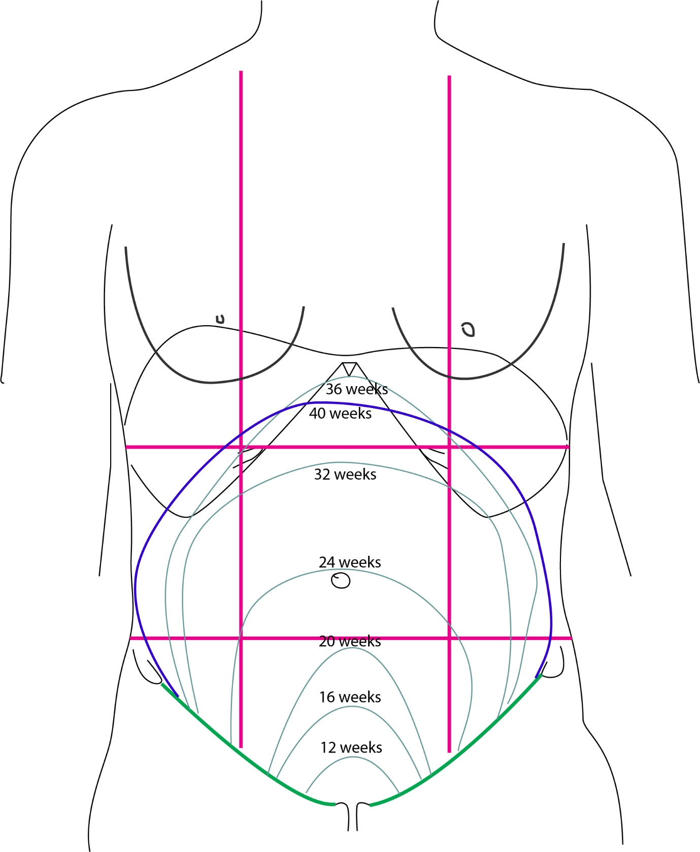

Visualization of uterus during ultrasonography
Transabdominal ultrasonography
Urine in the bladder - creates an acoustic window through which pelvic organs can be evaluated
Transvaginal ultrasonography
Cervix can be more accurately seen with transvaginal approach

