Vagina

Etymology
From Latin, literally ‘sheath, scabbard’.
The muscular tube leading from the external genitals to the cervix of the uterus

Extent and location
Extent - between the vestibule of the vulva and upto the cervix of uterus
Location - between bladder (anterior) and rectum (posterior)

Profile
Profile is H shaped
Each angle is attached to white fascial sheath (arcus tendineus fasciae pelvis)

Walls
Anterior wall
Cervix projects at its upper part
Length 7 cm
Posterior wall
9-10 cm - longer

Orientation of vagina
In the normal standing position,
Bladder, upper two third of vagina and rectum lie in the same horizontal level

Vaginal supports
Are mainly by
Arcus tendineus fasciae pelvis
Cardinal ligament / uterosacral ligament complex
Levator ani
Perineal body
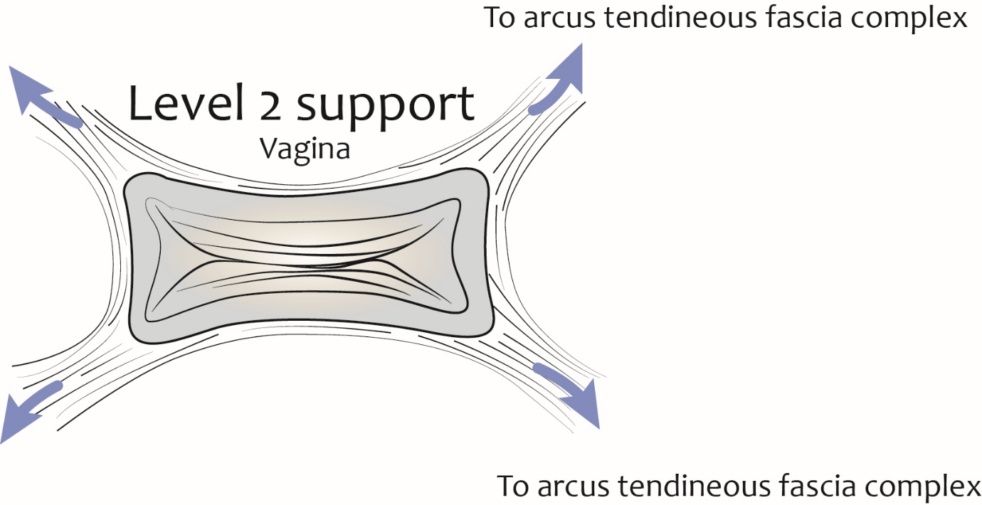

Arterial supply
Upper part of vagina - branches of uterine artery
Middle part of vagina - branches of vaginal artery and branches of middle rectal arteries
Branches vaginal artery and middle rectal artery forms longitudinal arterial anastomoses on the anterior and posterior vaginal wall - called azygos arteries of vagina
Lower part of vagina - branches of vaginal artery and branches from bulb of vestibule

Venous drainage
Vaginal venous plexus
Uterine veins
Vesicular veins
All veins drain into internal iliac veins

Lymphatics
Upper part - external and internal iliac lymph nodes
Middle part - internal iliac nodes
Lower part - sacral and common iliac nodes

Innervation
Uterovaginal plexus - derived from inferior hypogastric plexus
Sensory innervation - (only distal part) by branches of pudendal nerve

Epithelium
​​​​​​​Mucosa is lined with stratified squamous epithelium

Vaginal fornix
Recesses formed due to vaginal part of the cervix
Anterior fornix - Related to vesico-uterine pouch
two lateral fornices - smaller recesses
Posterior fornix - larger recess related to recto-uterine pouch

Pap test (Papanicolaou test)
Screening method to detect the cancerous and precancerous conditions of the uterine cervix
Ayre spatula is used to collect the cells during the pap smear
Broad end - collects vaginal cells
Narrow end - collects cervical cells
