Peritoneum
Covering of the abdominal cavity
Two layers – parietal and visceral peritoneum
[TIP]Mesentery is fold of peritoneum suspending gut tube
[TIP]Watch video to understand formation of retroperitoneal organs
[YOUTUBE] https://youtu.be/FhjXFdijf7k
[TIP]Watch the video
[YOUTUBE] https://youtu.be/-gix6s2dW58

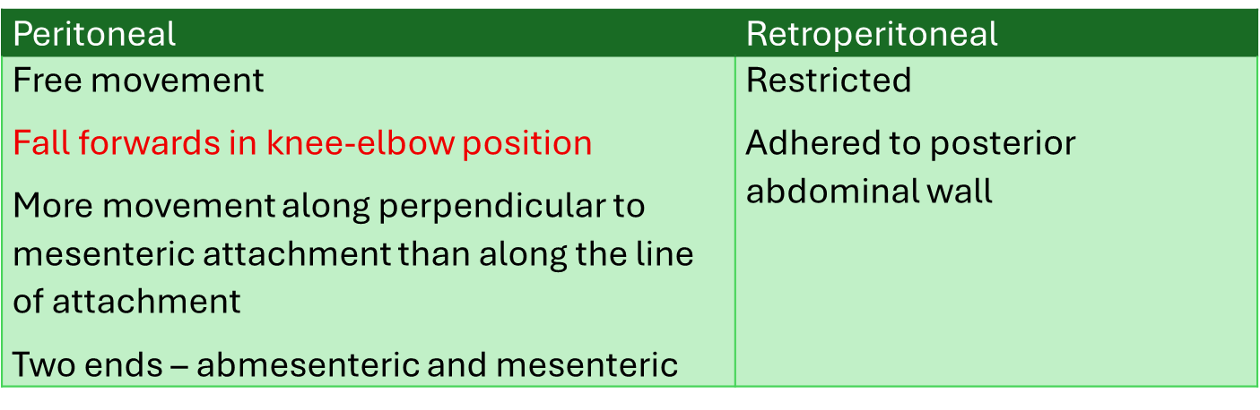
[YOUTUBE] https://youtu.be/0IstSBkn5Zo

[TIP]Most of the ventral mesentery disappears – except ventral mesogastrium

[CLINICAL]Fold of peritoneum between anterior abdominal wall and liver forms – falciform ligament

[CLINICAL]Fold of peritoneum between liver and stomach forms lesser omentum
[CLINICAL]Fold of dorsal mesogastrium caudal to stomach forms greater omentum

[CLINICAL]Fold of dorsal mesogastrium between spleen and stomach forms gastroslenic ligament transmitting short gastric arteries

[CLINICAL]Fold of dorsal mesogastrium between spleen and kidney forms lienorenal ligament and transmits splenic artery

