Penis

Etymology and definition
From Latin penis (“tail, penis”)
Penis is the male copulatory organ
Erect penis is considered as anatomical position.
Surfaces are defined as ventral and dorsal in the erect position.

Parts
- Root of the penis
- Body of the penis
- Glans penis
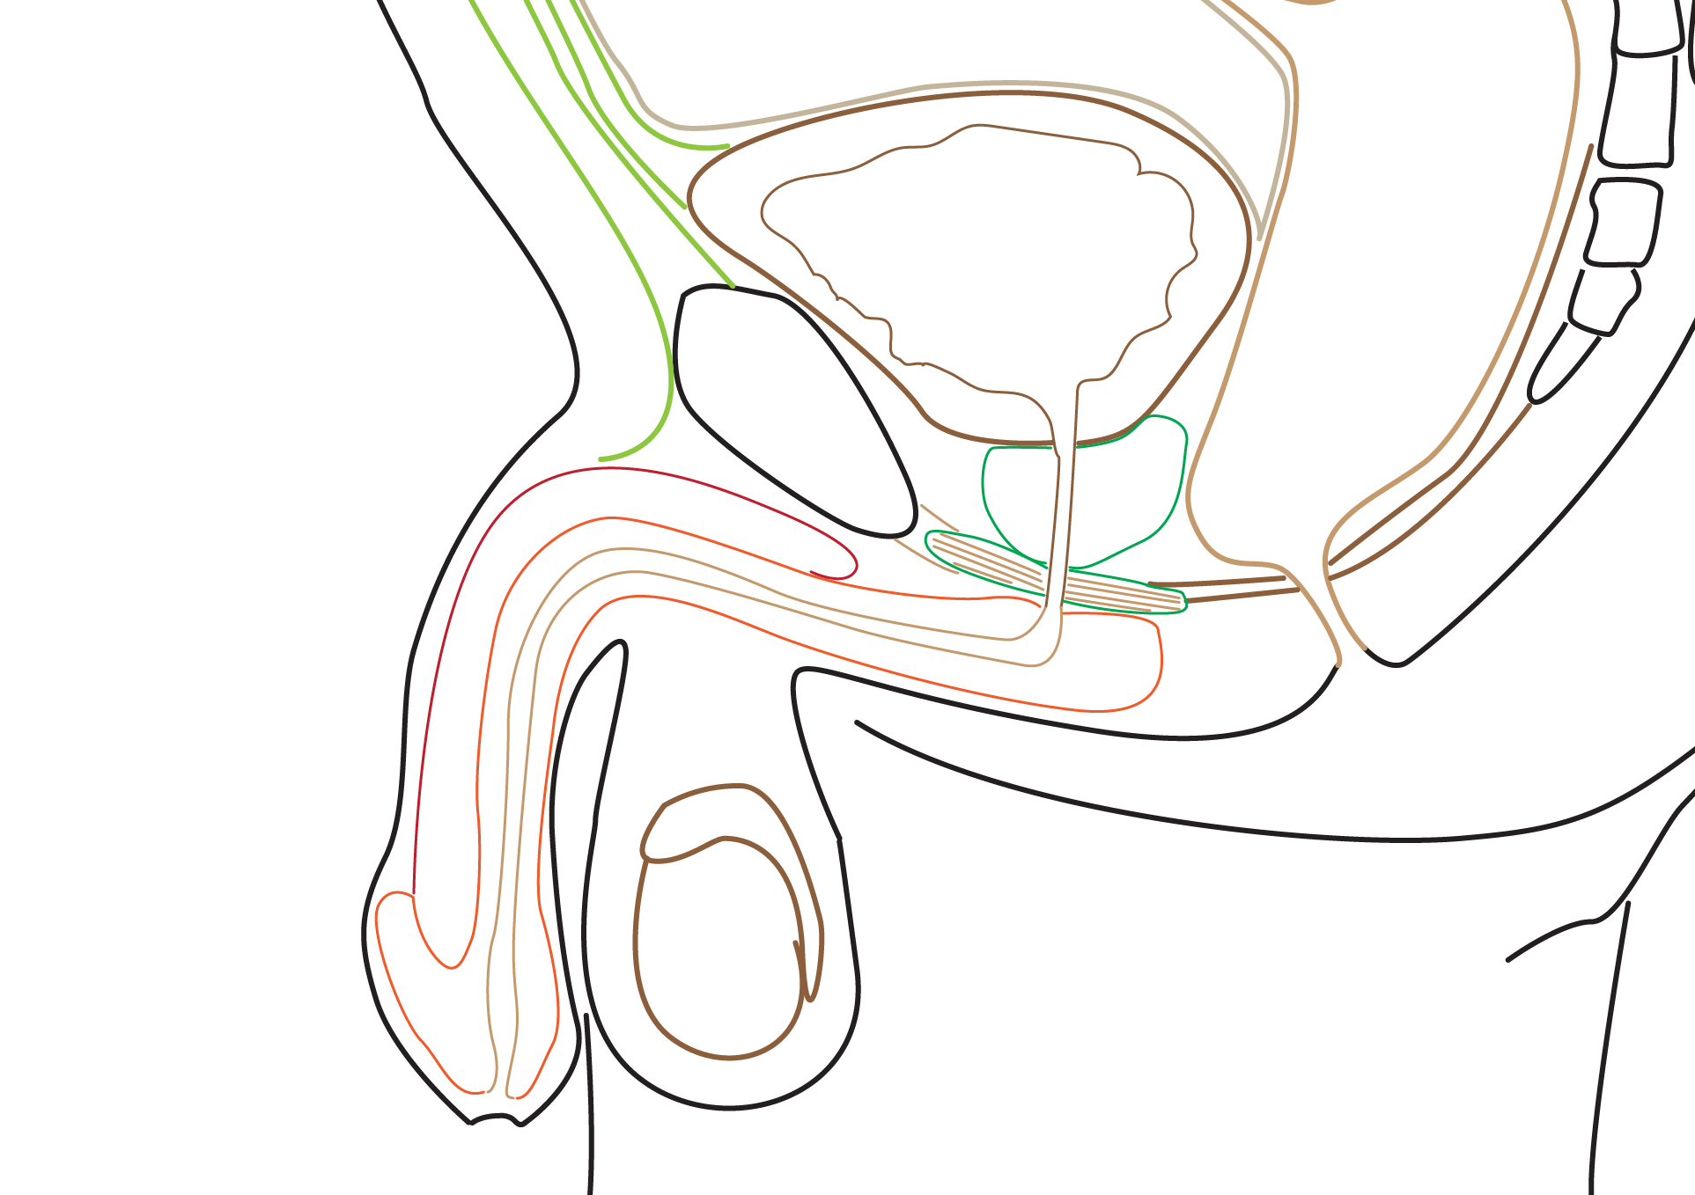

Root of the penis
Located within the bulb of the penis
Formed by three erectile tissues - Midline bulb of penis and on either side crus of penis

Body of the penis
Has three erectile masses
Crura continue as corpora cavernosa
Bulb of penis continues as corpora spongiosum. This carries penile urethra

Glans penis
Distal end of corpora spongiosum enlarge as glans

Coverings of penis

Skin
- loose, thin and hairless
- Over the glans the skin forms prepuce or fore skin
- Prepuce is attached to the ventral surface of the glans by frenulum of prepuce

Superficial fascia
- Has no fat
- Has superficial dorsal vein

Fascia of penis or Buck’s fascia
- Covers three corpora
- Do not cover the glans

Structures deep to the Buck’s fascia
Deep dorsal vein of penis (single, in the centre)
Dorsal arteries (one on either side)
Dorsal nerves (one on either side)

Supports of penis
Fundiform ligament - extends from linea alba and merge with scrotal septum after splitting into two
Suspensory ligament - begins from the anterior aspect of the pubic symphysis. Its lower end merges with the Buck’s fascia

Arterial supply - Erection is a vascular process.
Each corpora cavernosa - receive blood through deep artery of the penis
Corpora spongiosum - receive blood through artery of bulb of the penis
Superficial part of penis - receive blood through dorsal arteries of the penis
In the erect state, the engorged corpora compress the nearby veins to retard the venous return

Venous drainage
Three sets of veins - superficial, intermediate and deep

Deep system
- Drains into deep dorsal vein
- Consists of cavernous, bulbar and crural veins
- Deep dorsal vein - drains glans and corpora (both cavernosa and spongiosum)
- Deep dorsal vein passes between the transverse pubic ligament and arcuate pubic ligament

Intermediate system
- Located under the Buck’s fascia
- Drain glans, corpus cavernosa, and corpus spongiosum
They consist of
- Deep dorsal vein
- Circumflex vein
- Prostatic plexus
- Lateral venous plexus
- Retrocoronal plexus
All these veins terminate as deep dorsal vein or veins
From them the blood is drained into the internal iliac veins

Superficial system
- Superficial dorsal veins - drains the prepuce and skin of the shaft

Lymphatics
Skin and prepuce - drain into the superficial inguinal lymph nodes
Glans and penile urethra - drain into the deep inguinal (nodes of Cloquet) and external inguinal lymph nodes

Innervation

Somatic innervation
- Dorsal nerve of penis (arise from pudendal nerve within Alcock's canal) - supply skin of shaft, prepuce and glans
- Perineal nerves and their branches - innervate the vessels and erectile tissues of the penis
- Sensory nerves - enter S2 to S4
- Bulbospongiosus and ischiocavernosus - supplied by deep/muscular branch of the perineal nerve, which is a branch of the pudendal nerve.
- Ilioinguinal nerve supply - skin of the root of the penis

Autonomic innervation
- Parasympathetic nerves from S2, S3 and S4 (nervi erigentes) reach through cavernous nerves (arise from the prostatic nerve plexus).
- Parasympathetic innervation produces vasodilation and results in erection
- Sympathetic nerves from L1 and L2 - reach through inferior hypogastric plexus

Physiology of tumescence and detumescence
Erection of the penis occurs as the cavernous bodies become rigid.
Erection is principally parasympathetic action
However, the corpus spongiosum is not as dense as corpora cavernosus. It will allow the passage of the seminal fluid during ejaculation
Ejaculation is principally sympathetic action
After ejaculation, the sympathetic activity causes vasoconstriction and detumescence

Circumcision
Is the procedure of removal of redundant part of the prepuce

Phimosis
Is a condition, where foreskin is too tight and cannot be pulled over the glans easily

