Scrotum

Definition
Sac protecting the testis - is scrotum
On each side, scrotum has testis, epididymis, part of spermatic cord and cremastric muscle

Layers
- Skin
- Dartos
- External spermatic fascia (from external oblique muscle)
- Cremasteric fascia (from internal oblique muscle)
- Internal spermatic fascia (from transversalis fascia)

Skin
- Corrugated and highly pigmented.

Dartos fascia
- Dartos fascia - has dartos muscle and fascia. Dortos muscle (smooth muscle) brings corrugations on the scrotal skin
- Corresponds to superficial fascia (fascia Camper and fascia Scarpa)

Similar sounding muscles
- Dortos - muscle in the scrotal skin
- Detrussor - muscle of urinary bladder wall
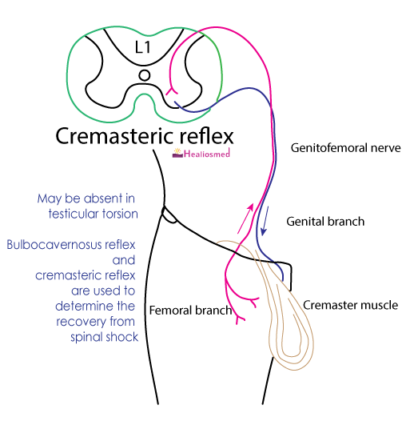

Cremaster muscle
Etymology - rom Greek kremastēr, from krema- ‘hang’
Striated muscle covering testis and spermatic cord
Located between the external spermatic fascia and internal spermatic fascia
In its upper part, cremastric fascia is continuous with internal oblique fascia
Supplied by cremateric artery (branch of interior epigastic artery) - a content of spermatic cord
It is innervated by genital branch of genitofemoral nerve
Takes part in cremasteric reflex
Function: retracts or raises testis up during cold environment, arousal or during heightened sympathetic activity (fight or flight)

Functions of scrotum
- Protection of testes
- Temperature regulation
Spermatogenesis happens best at little lower temperature than the regular body temperature
Reason for external testis
Activation hypothesis: Lower temperatures as happen in externally placed testis in scrotum prevent premature activation of the sperms. When sperms enters the cervix, increased temperature enable them with increased motility to reach uterine tube.
Externally placed testes are more pain sensitive. Sensitivity to pain leads to extra care of the testes from damage.
For more information refer Gallup. https://journals.sagepub.com/doi/pdf/10.1177/147470490900700402
Endothermic pulse hypothesis: Lower body temperatures prevailed in Cenozoic era. During evolution, as an adaptation to the climate change and to cursoriality (ability to run) led to increased body temperature. This led to externally placed testis at a lower temperature.
For more information refer Lovegrove. https://onlinelibrary.wiley.com/doi/full/10.1111/jeb.12373

