Trapezius

Origin:
- Superior nuchal line
- External occipital protuberance
- Ligamentum nuchae
- Spine of C7 and all thoracic vertebrae

Insertion:
- Superior fibres: posterior border of lateral 1/3rd of clavicle
- Middle fibres: medial margin of acromion and upper lip of spine of scapula
- Lower fibres: deltoid tubercle at the junction of medial and lateral third of spine of scapula
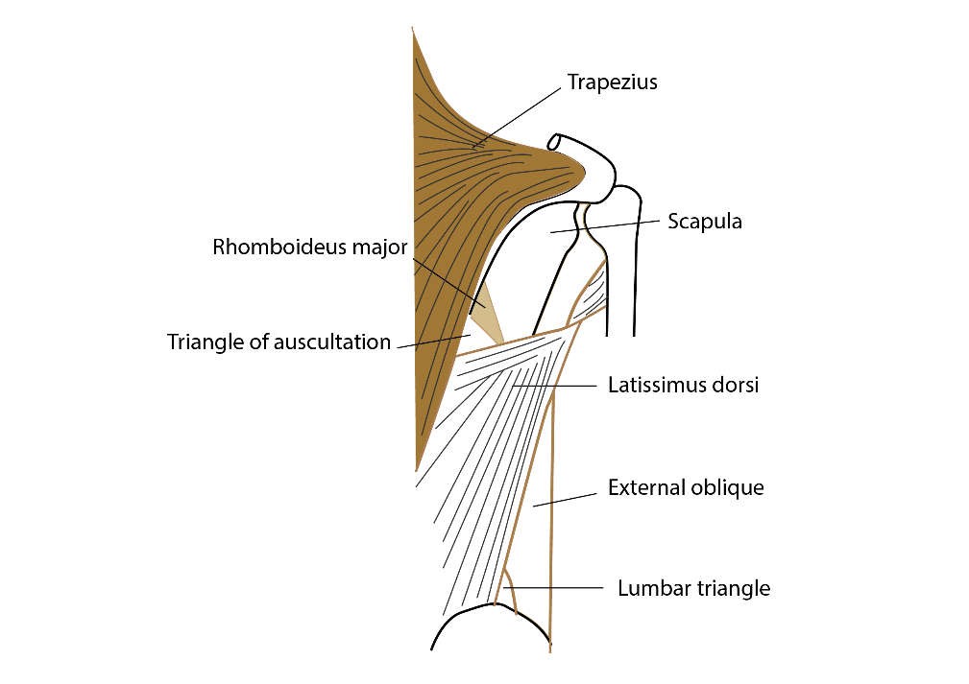

Nerve supply:
- motor – spinal part of accessory nerve
- proprioception – ventral rami of C3 and C4

Action:
- Shrugging of shoulders - Upper fibres + levator scapulae
- Taking the shoulder back – middle fibres + rhomboids
- Rotation of scapula: beyond 90⁰ – along with serratus anterior
[CLINICAL]Clinical testing
- Ask the patient to shrug the shoulder and apply resistance with hands (by standing behind while patient is seated). Compare the strength of muscles on both sides.

