Fertilization
Fusion of male gamete with the female gamete to form zygote

Site: The usual site of fertilization is the ampulla-isthmus of the uterine tube

Process is species – specific.
[TIP] Binding: ZP3 initiates, SED1 stabilizes

ZP3 and SED1 are involved in earlier adhesion and signaling events related to the zona pellucida.

JUNO-IZUMO1 pair mediates the essential adhesion phase just prior to membrane fusion, after the sperm has bypassed the zona pellucida.

The process of meiosis II will complete because of this calcium wave as the metaphase arrest is taken off.

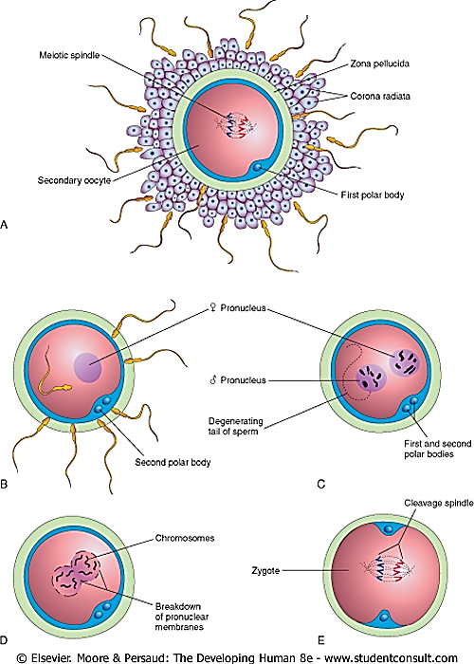

Three important sequences of events for fertilization:
- Capacitation: Sperm maturation in female tract (bicarb/Ca²⁺ influx → cAMP rise); stabilizes plasma membrane for acrosome reaction
- Acrosome reaction:
  - Vesicle fusion releases hybrid matrix
  - Hyaluronidase (corona dispersion), acrosin (ZP proteolysis). Intact sperm head fuses with oolemma
  - tail remains external.
- Zona reaction: Entry of one sperm into hardens ZP via exocytosis; perivitelline space Ca²⁺ wave reinforces

[YOUTUBE] https://www.youtube.com/watch?v=HuWCwyRiaUI

Outcome of fertilization
- Secondary oocyte completes meiosis II
- Acrosomal reaction – prevents polyspermy
- Pronuclei fusion (syngamy) forms zygote. Restores 46 chromosomes; paternal/maternal imprinting established
- Male centriole (absent in oocyte) initiates spindle
- The sex of the zygote is determined
- The cleavage commences and zygote is formed

Clinical relevance
- ICSI for Male Infertility: Bypasses capacitation or acrosome defects (e.g., globozoospermia); injects sperm directly, rescuing ~70% cases but risks imprinting errors (e.g., Beckwith-Wiedemann).
- Antisperm Antibody Testing: Blocks ZP binding/capacitation; post-coital tests guide immunosuppression or IUI, improving natural conception rates by 20-30%.
- Triploidy/Polyspermy Risks: Failed zona reaction → partial moles (hydatidiform); hCG monitoring post-fertilization detects, with suction curettage preventing choriocarcinoma.
- Preimplantation Genetic Testing (PGT): Screens zygote diploidy post-syngamy; for sex determination, avoids X-linked diseases (e.g., hemophilia) in at-risk families.
- Sperm Selection in ART: Hyaluronan-binding assays select capacitated sperm; boosts IVF implantation by 15%, per 2025 ASRM guidelines.
[YOUTUBE]https://youtu.be/Dcta8zUnwJs

