Meiosis
Meiosis is a reductive division in germ cells producing four genetically diverse haploid gametes (2n → n), essential for sexual reproduction and genetic variation via recombination and independent assortment.

Stages of Meiosis
Divided into Meiosis I (reductional) and Meiosis II (equational, similar to mitosis).

Meiosis I:
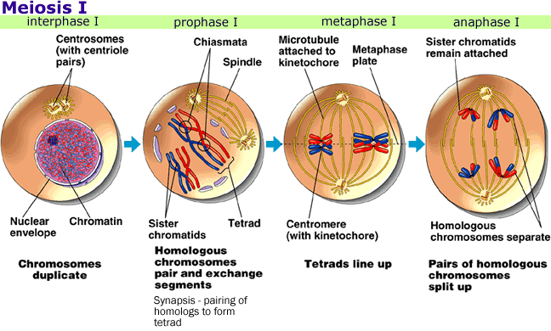
  - Prophase I: Longest phase; chromosomes pair (synapsis) forming tetrads; crossing over at chiasmata exchanges genetic material (recombination).
  - Metaphase I: Tetrads align at equator; homologous chromosomes attach to spindle.
  - Anaphase I: Homologs separate to poles (no centromere split), reducing ploidy.
  - Telophase I: Nuclei reform; cytokinesis yields two haploid cells.

Prophase I
Prophase I is the longest phase of meiosis (~90% of total time), crucial for genetic recombination. It consists of five sequential sub-stages, enabling synapsis and crossing over between homologous chromosomes.
- Leptotene: Chromosomes condense and become visible as thin threads; axial elements form (initiation of synaptonemal complex); no pairing yet.
- Zygotene: Homologous chromosomes pair via synapsis, forming synaptonemal complex; bouquet stage (telomeres cluster at nuclear envelope).
- Pachytene: Full synapsis complete; tetrads (bivalents) form; crossing over occurs at chiasmata via recombination nodules.
- Diplotene: Synaptonemal complex disassembles; homologs separate slightly but held by chiasmata; chromosomes thicken.
- Diakinesis: Chromosomes further condense and shorten; chiasmata terminalize; nuclear envelope begins to break down.
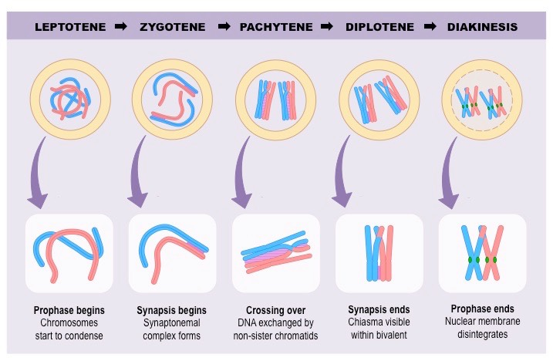
[TIP]Mnemonic: "Lazy Zippers Pack Dirty Diapers" (Leptotene, Zygotene, Pachytene, Diplotene, Diakinesis).
[WARNING]Significance: Ensures genetic diversity; errors lead to aneuploidy (e.g., Klinefelter syndrome).
[YOUTUBE]https://youtu.be/y83jo4NkOH4

Meiosis II:
  - Prophase II: Chromosomes recondense; new spindles form.
  - Metaphase II: Chromosomes align singly at equator.
  - Anaphase II: Sister chromatids separate to poles.
  - Telophase II: Nuclei reform; cytokinesis produces four haploid gametes (spermatocytes or ova).
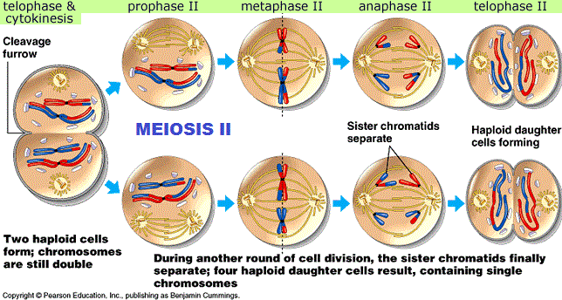

Key Features
- Genetic variation: Crossing over (30-50/chromosome) + independent assortment (2^n possibilities).
- In females: Unequal cytokinesis forms one ovum + polar bodies.
- Regulated by cyclins and checkpoints; errors cause nondisjunction (e.g., Down syndrome).
[WARNING]Clinical Relevance: Meiotic errors lead to aneuploidy (e.g., trisomy 21); infertility treatments target meiotic defects.
[YOUTUBE] https://www.youtube.com/watch?v=kQu6Yfrr6j0

Non - disjunction
It is non-separation of chromosomes during meiosis.
This Nonseparation of chromosomes may take place during meiosis I or non- separation of chromatids during meiosis II,
As a result, cells with abnormal number (either loss or gain of one or more chromosomes are formed.

